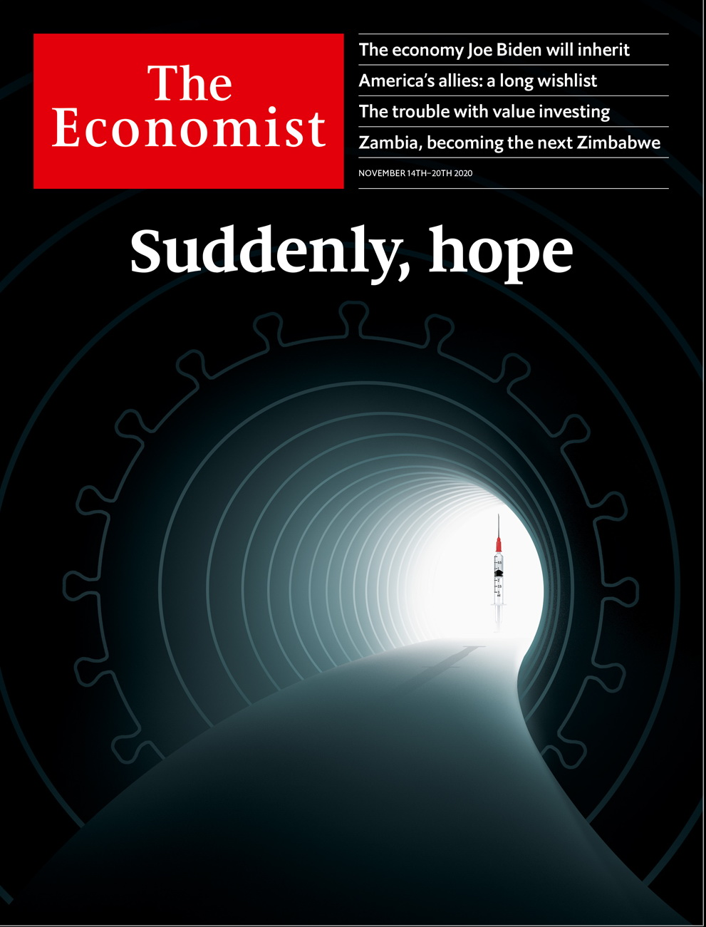

# Table of Contents

The world this week

Politics this week

Business this week

KAL's cartoon

Leaders

Vaccines: Suddenly, hope

The world and Joe Biden: Great expectations

America’s new president: The economy Biden inherits

Asset management: Beyond Buffett

Democracy in Africa: Zambia’s descent

Letters

Letters to the editor: On transgender sports, diplomacy, Facebook, management, Armenia, avatars, Brazil

Briefing

Covid-19 vaccines: Bullseye

Investment strategies: Diminished value

Asia

Politics in Kyrgyzstan: A crowd-sourced commander-in-chief

Australia’s trade with China: Down under and out

State elections in India: Against daunting odds

Myanmar’s election: Mother knows best

Banyan: Money but not a class

China

Politics in Hong Kong: Leaving in despair

Self-help books: Highly effective people’s republic

Chaguan: Tea before dawn

United States

Covid-19 and the next president: Transmission and the transition

Digesting the election: Nothing to see here

Firings and hirings: Going, going, Pentagone

Fox News and Donald Trump: Season two is cancelled

Rewilding the prairie: Where the wild things are

The urban-rural divide: City v hills

Lexington: A Democratic defeat in victory

Middle East & Africa

South Africa: Ace in the hole?

Zambia: Slouching towards Zimbabwe

Feminism in Egypt: Speaking up about sex crimes

Saeb Erekat: A negotiator in winter

The Americas

Peru: Early retirement

Central America: Greek tragedy

Bello: The problem of proxy presidents

Europe

Nagorno-Karabakh: Peace, for now

Ukraine: Judge not, that ye be not judged

Europe’s recovery fund: Turn on the spigot

France in the Sahel: Mission impossible but necessary

Britain

Protest: Small-town revolution

Foreign-investment rules: For your protection

Brexit negotiations: Joe calling

Public spending: Chumocracy

Phone-hacking: Hanging on the telephone

Energy: Chain reaction

Financial services: London calling, at last

Bagehot: A populist in the palace

International

American foreign policy: What does the world want from Joe Biden?

Special report

Asset management: The money doctors

Index funds: Passive attack

Agency problems: Double trouble

Capital allocation: Stewards’ inquiry

Private markets: Taking back control

Venture capital: Frogs and princes

China: The Shanghai Open

The end-game: Doctor’s prescriptions

Business

Chinese private enterprise: The intimidation game

Disney: The streaming kingdom

Pasta: On board the spaghetti express

Royal Enfield: Kickstart

Schumpeter: The big McComeback

Finance & economics

America’s economy: Giant jab

Booster shot: News of an effective vaccine injects optimism into markets

Buttonwood: Coming out of the ultracold

Turkey: Comings and goings

Commodities: Amber wave

Klarna: Smooth shopping

Free exchange: Field excursion

Science & technology

Fast diagnosis for covid-19: Test match

Planetary science: Questions of life

Materials science: Would you like sugar cane in that?

Books & arts

Home truths: The human stain

Street style: Fashion statements

American society: All for one

Hollywood fiction: Ready for his close-up

Johnson: On natural declension

Economic & financial indicators

Economic data, markets and commodities

Graphic detail

Polling in America: Déjà vu all over again

Obituary

James Randi: The woo-woo catcher



Friday, November 13, 2020

|  |  |
| --- | --- |
| The world this week | 3 |
| Leaders | 5 |
| Letters | 1 |
| Briefing | 2 |
| Asia | 5 |
| China | 3 |
| United States | 7 |
| Middle East & Africa | 4 |
| The Americas | 3 |
| Europe | 4 |
| Britain | 8 |
| International | 1 |
| Special report | 8 |
| Business | 5 |
| Finance & economics | 7 |
| Science & technology | 3 |
| Books & arts | 5 |
| Economic & financial indicators | 1 |
| Graphic detail | 1 |
| Obituary | 1 |

|  |  |  |
| --- | --- | --- |
|  | Sections | Leaders |

The world this week

### 加迪迪QQ1562739651问外刊群群号

Politics this week

.

Business this week

.

KAL's cartoon

.

|  |  |  |
| --- | --- | --- |
|  | Sections | Leaders |

|  |  |  |  |
| --- | --- | --- | --- |
|  | Articles | Sections | Next |

# Politics this week

Nov 12th 2020 |

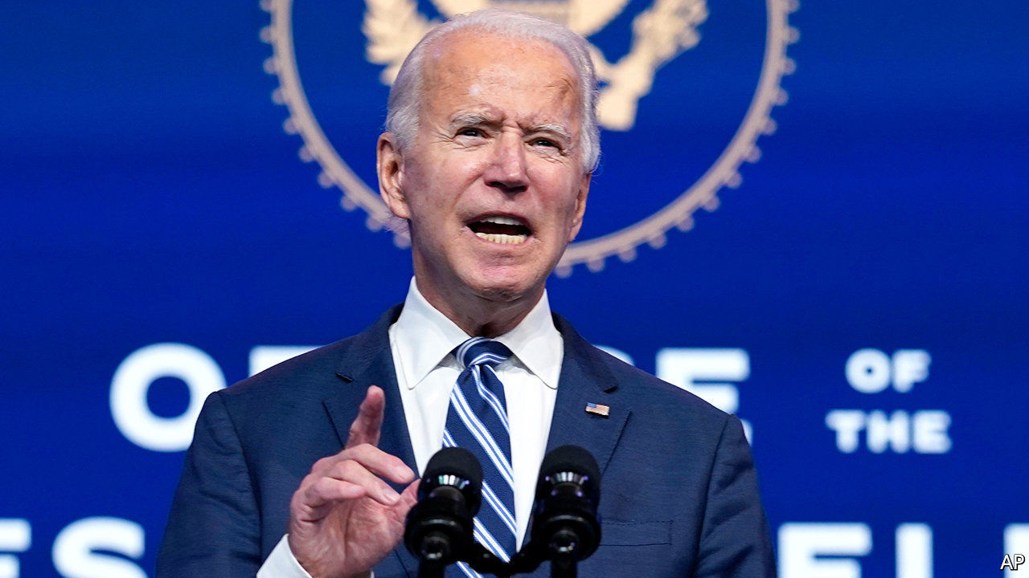

Donald Trump refused to concede defeat in America’s election, despite Joe Biden’s passing the required 270 electoral-college votes. The president is pursuing several legal challenges to states’ results. None is expected to succeed. Mr Biden’s transition team is considering suing to obtain federal funds and information usually granted to incoming administrations. See [article](https://www.economist.com/node/21795305).

World leaders queued up to congratulate Mr Biden. Among the strongmen who have so far demurred are Vladimir Putin of Russia, Xi Jinping of China and Jair Bolsonaro of Brazil. Mr Bolsonaro railed against Mr Biden’s proposals to punish Brazil for not protecting the Amazon rainforest, saying, “Diplomacy alone won’t work. Once the saliva runs out, you have to have gunpowder.”

Joe Biden announced a covid-19 advisory board to deal with the pandemic. He said his response would be led “by science and by experts”. See [article](https://www.economist.com/node/21795298).

Donald Trump tweeted that he had “terminated” his defence secretary, Mark Esper. In June Mr Esper publicly disagreed with the president about the use of troops to quash protests. See [article](https://www.economist.com/node/21795307).

Peru’s Congress removed from office the president, Martín Vizcarra. He has been accused of taking bribes when he was a governor, which he denies. The legislature’s speaker, Manuel Merino, succeeded Mr Vizcarra as president. See [article](https://www.economist.com/node/21795303).

Luis Arce was sworn in as Bolivia’s president. He was the candidate of the Movement to Socialism, founded by Evo Morales, who was forced into exile last year after protests against his re-election. After Mr Arce took office Mr Morales returned overland to Bolivia from Argentina. See [article](https://www.economist.com/node/21795318).

Eta, this year’s strongest hurricane, killed at least 130 people in Central America. Perhaps 300,000 lost their homes. Eta broke a record set in 2005 for the number of named storms in a season. See [article](https://www.economist.com/node/21795320).

Britain’s House of Lords voted to amend a bill that would allow the government to rewrite parts of its European Union withdrawal treaty, including provisions about Northern Ireland. The government says it will override the changes. Joe Biden warned Boris Johnson, Britain’s prime minister, not to imperil peace in Ireland. See [article](https://www.economist.com/node/21795332).

After weeks of fighting over Nagorno-Karabakh, Armenia and Azerbaijan agreed to a peace deal. Armenia surrendered the districts surrounding the enclave, though a corridor linking Armenia and Nagorno-Karabakh will be placed under Russian control. Protesters demanded the resignation of Armenia’s prime minister, Nikol Pashinyan. See article.

The European Parliament reached an agreement with EU member states over the creation of a €1.8trn ($2.1trn) spending package for the next seven years, including a €750bn recovery fund which will be raised on the capital markets by the EU itself, not by individual countries. See [article](https://www.economist.com/node/21795294).

Bihar, one of the poorest parts of India, voted for an alliance led by the party of Narendra Modi, the prime minister, in state elections. It was the first big state poll since covid-19 swept the country and induced a deep recession. Voters in Bihar, at least, do not seem to blame Mr Modi. See [article](https://www.economist.com/node/21795324).

The National League for Democracy, led by Aung San Suu Kyi, retained power in Myanmar’s election. Despite failing to end the country’s simmering civil wars, Ms Suu Kyi remains popular, especially among the ethnic-Bamar majority. See [article](https://www.economist.com/node/21795330).

China authorised Hong Kong’s government to disbar legislators deemed to oppose Chinese rule in the territory or to threaten national security. The local government promptly dismissed four pro-democracy lawmakers. Fifteen others said they would resign. See article.

America removed the East Turkestan Islamic Movement from its list of terrorist organisations. It said there was no credible evidence that the group, allegedly founded by Uyghur separatists, still existed. China reacted angrily, saying the organisation was a threat not only to China but to the world.

Several people were injured by a bomb at an Armistice Day ceremony in Jeddah, in Saudi Arabia. The event was attended by representatives of foreign consulates, including that of France. Emmanuel Macron, France’s president, has angered some Muslims by defending the right to publish caricatures of religious figures, including the Prophet Muhammad.

Saeb Erekat, a veteran Palestinian diplomat who was involved in three decades of negotiations with Israel, died after contracting covid-19. He was 65. See [article](https://www.economist.com/node/21795338).

Prince Khalifa bin Salman al-Khalifa, the hardline prime minister of Bahrain, also died. He had held the post since independence in 1971. Prince Khalifa was 84.

Hundreds of people were killed in fighting between Ethiopian government troops and forces loyal to the province of Tigray. Abiy Ahmed, the prime minister, ordered the army into Tigray after its leaders held regional elections in defiance of the federal government. See [article](https://www.economist.com/middle-east-and-africa/2020/11/04/ethiopia-lurches-towards-civil-war).

Police in Mozambique said jihadists had beheaded more than 50 people in Cabo Delgado, a province in the north.

## Coronavirus briefs

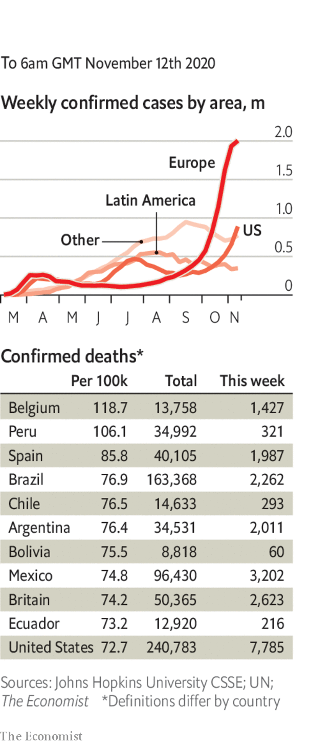

The European Commission agreed to buy up to 300m doses of the vaccine developed by Pfizer and BioNTech.

Russia’s claims that its homegrown “Sputnik V” vaccine is 92% effective in preventing infection, a similar success rate to Pfizer’s, were met with scepticism.

The number of people in hospital with covid-19 in America reached 65,000, a new record. Europe’s death toll from the virus passed 300,000.

Lebanon announced a new lockdown that will last until the end of November. Authorities in Tehran ordered restaurants and shops to close early amid rising cases.

Denmark’s government admitted it could not force mink farmers to cull livestock but recommended they do so, after new strains of covid-19 jumped from the animals to people. See [article](https://www.economist.com/europe/2020/11/10/a-covid-19-mutation-belatedly-forces-denmark-to-halt-mink-farming).

This article was downloaded by calibre from <https://www.economist.com/the-world-this-week/2020/11/12/politics-this-week>

|  |  |  |  |
| --- | --- | --- | --- |
|  | Articles | Sections | Next |

|  |  |  |  |
| --- | --- | --- | --- |
| Previous | Articles | Sections | Next |

# Business this week

Nov 12th 2020 |

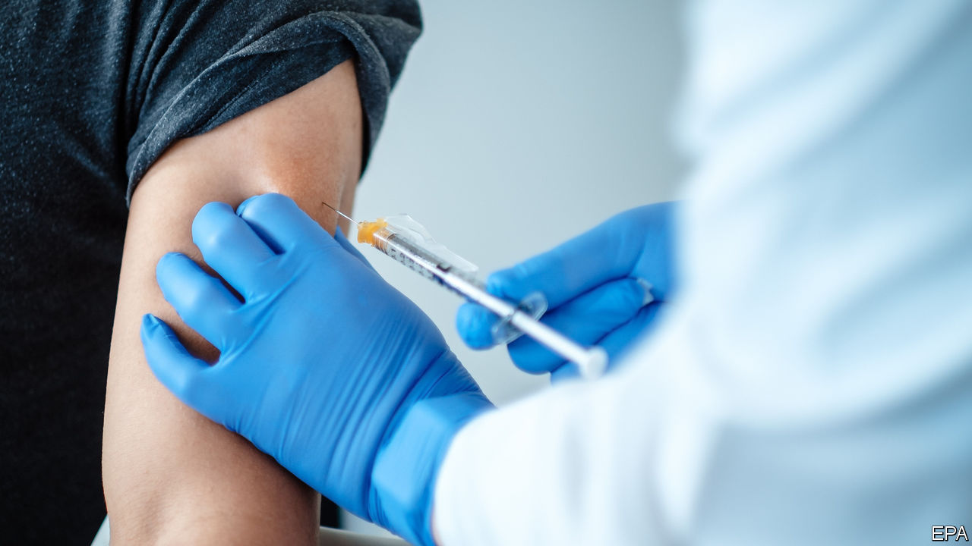

Pfizer and BioNTech, two pharmaceutical firms, announced that their vaccine against covid-19 is more than 90% effective, according to early results from trials. The high success rate raised hopes of a quicker return to normality than previously expected. Other pharmaceutical firms are also working on vaccines and are expected to make announcements in the coming weeks. Current projections suggest 50m doses of the Pfizer-BioNTech vaccine will be available in 2020, rising to 1.3bn the following year. On the day of the announcement, Pfizer’s and BioNTech’s share prices surged 8% and 14%, respectively. See article.

The news excited stockmarkets. In America the Dow Jones Industrial Average jumped by 2.9% on Monday. The S&P 500 rose sharply when it opened, before ending the day up 1.2%. The STOXX Europe 600 climbed 4%. Oil prices increased to $45 per barrel. By contrast, many technology firms that have been buoyed by the pandemic faced a sell-off, including Zoom, a video-conferencing firm, Ocado, a grocery delivery company, and Peloton, a maker of exercise bikes. See article.

Regulators continued to take aim at technology firms on antitrust grounds. The European Union brought charges against Amazon. After an investigation, the European Commission claimed that the tech giant uses data gathered from vendors to give its own products and services an unfair advantage. Amazon said that it disagrees with the commission’s findings.

Meanwhile, India’s competition watchdog has ordered a probe into Google’s app store. It fears that a requirement that consumers buy apps using the firm’s payment service smothers competition. In China regulators have drafted new antitrust rules aimed at technology firms. They will target a range of practices, including treating customers differently based on their spending behaviour and data. The move follows the suspension of the initial public offering of Ant Group, a fintech firm, days before its flotation in Hong Kong and Shanghai. See [article](https://www.economist.com/node/21795309).

## Out with the old

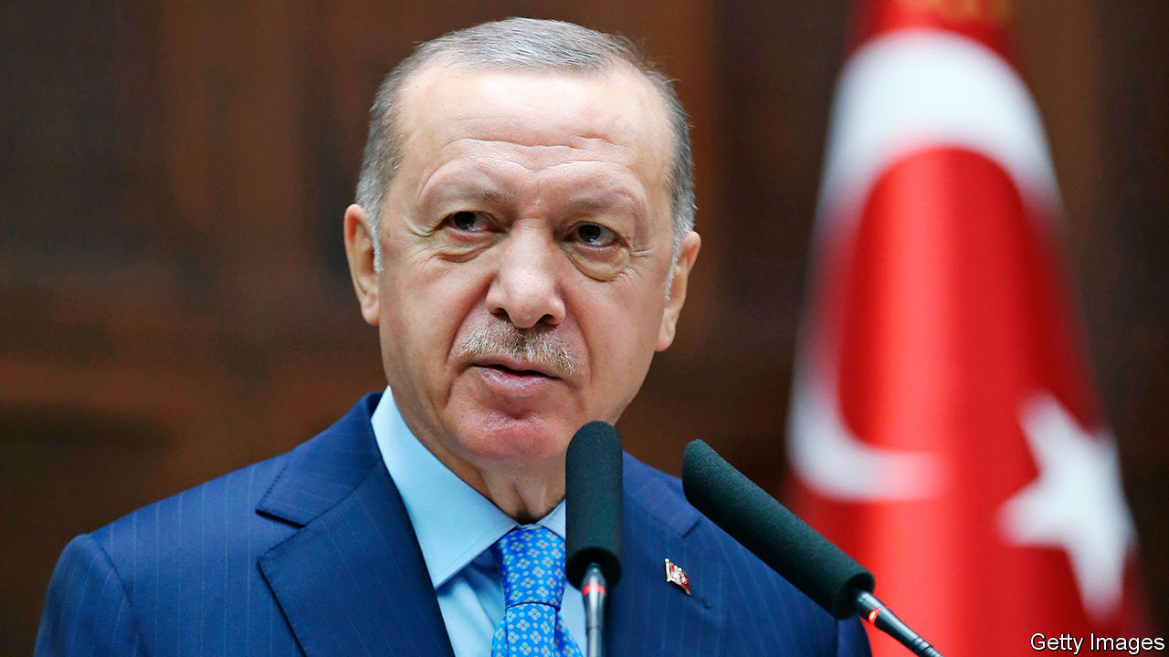

In a surprise shakeup Recep Tayyip Erdogan, Turkey’s president, fired the country’s central-bank governor, only 16 months after sacking his predecessor. One day later the Turkish finance minister, Mr Erdogan’s son-in-law, resigned supposedly because of a feud with the new central-bank governor. After the reshuffle, the banking regulator said it would curb restrictions on foreigners trading the Turkish lira, which were imposed last year. Investors seemed to welcome the changes. The lira rose by more than 7% against the dollar in the past week, reversing a long decline. See [article](https://www.economist.com/node/21795339).

Following two quarters of contraction, Britain’s GDP grew by 15.5% between July and September. The economy is still 8.2% smaller than it was before the virus struck and is likely to shrink again in the last three months of the year because of a second lockdown. Unemployment over the same period rose to 4.8%, up from 4.5%. Redundancies surged to a record high, as firms were forced to contribute more to the cost of furloughed workers.

Unemployment figures from America were better than expected. Non-farm employment rose by 638,000 in October. The unemployment rate fell by one percentage point to 6.9% in the same month.

China’s consumer-price index dropped to 0.5% in October, its lowest level in over a decade. That reflects low food prices, particularly of pork, supplies of which were hit by African swine fever but are now recovering thanks to record imports. Sluggish consumer demand is another factor.

SoftBank Group announced profits of $6.1bn in the three months to the end of September. The Japanese firm booked losses of $3.7bn with its foray into investing in publicly listed technology companies in America. But that was offset by an improved performance by its Vision Fund, which is now worth $1.4bn more than the costs of it 83 investments. SoftBank also removed several executives from its board, following investors’ concerns about governance.

McDonald’s reported revenues of $5.4bn in the latest quarter, down 2% from the same period last year but beating analysts’ expectations. It performed well in America where same-store sales grew by 4.6% from the previous quarter. See [article](https://www.economist.com/node/21795321).

Beyond Meat, an alternative protein provider, reported losses of $19.3m in the third quarter, compared with profits of $4.1m in the same period last year. An easing of covid-induced consumer stockpiling and falling sales to restaurants were blamed.

## What goes around

Singaporean holiday-makers itching for escape can now take a “cruise to nowhere”. Passengers undergo covid-19 tests before boarding and are required to carry contact-tracing devices. The ship idles in the waters off the city state for two days before returning to port.

This article was downloaded by calibre from <https://www.economist.com/the-world-this-week/2020/11/12/business-this-week>

|  |  |  |  |
| --- | --- | --- | --- |
| Previous | Articles | Sections | Next |

|  |  |  |  |
| --- | --- | --- | --- |
| Previous | Articles | Sections | Next |

# KAL's cartoon

Nov 12th 2020 |

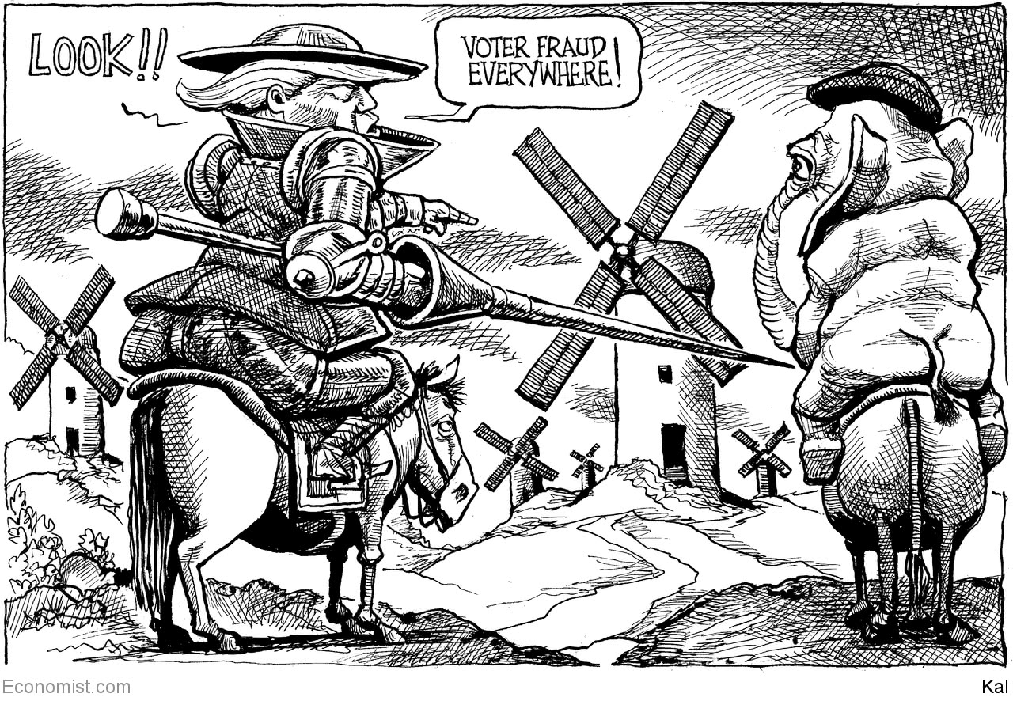

This article was downloaded by calibre from <https://www.economist.com/the-world-this-week/2020/11/12/kals-cartoon>

|  |  |  |  |
| --- | --- | --- | --- |
| Previous | Articles | Sections | Next |

|  |  |  |
| --- | --- | --- |
| The world this week | Sections | Letters |

Leaders

Vaccines: Suddenly, hope

.

The world and Joe Biden: Great expectations

.

America’s new president: The economy Biden inherits

.

Asset management: Beyond Buffett

.

Democracy in Africa: Zambia’s descent

.

|  |  |  |
| --- | --- | --- |
| The world this week | Sections | Letters |

|  |  |  |  |
| --- | --- | --- | --- |
|  | Articles | Sections | Next |

#### Suddenly, hope

# The promise of the new covid-19 vaccine is immense

But don’t underestimate the challenge of getting people vaccinated

Nov 14th 2020 |



Editor’s note: Some of our covid-19 coverage is free for readers of The Economist Today, our daily [newsletter](https://my.economist.com/user#newsletter). For more stories and our pandemic tracker, see our [hub](https://www.economist.com/news/2020/03/11/the-economists-coverage-of-the-coronavirus)

NINE LONG years elapsed between the isolation of the measles virus in 1954 and the licensing of a vaccine. The world waited for 20 years between early trials of a polio vaccine and the first American licence in 1955. Marvel, then, at how the world’s scientists are on course to produce a working vaccine against SARS-CoV-2, the virus that causes covid-19, within a single year.

And not just any vaccine. The early data from a final-stage trial unveiled this week by Pfizer and BioNTech, two pharma companies, suggests that vaccination cuts your chances of suffering symptoms by more than 90%. That is almost as good as for measles and better than the flu jab, with an efficacy of just 40-60% (see article). Suddenly, in a dark winter, there is hope.

Not surprisingly, Pfizer’s news on November 9th roused the markets’ bulls. Investors dumped shares in Clorox, Peloton and tech firms, which have all benefited from the coronavirus, and instead switched into firms like Disney, Carnival and International Consolidated Airlines Group, which will do well when the sun shines again (see article). The OECD, a club of mainly rich countries, reckons that global growth in 2021 with an early vaccine will be 7%, two percentage points higher than without.

There is indeed much to celebrate. Pfizer’s result suggests that other vaccines will work, too. Over 320 are in development, several in advanced trials. Most, like Pfizer’s, focus on the spike protein with which SARS-CoV-2 gains entry to cells. If one vaccine has used this strategy to stimulate immunity, others probably can, too.

Pfizer’s vaccine is also the first using a promising new technology. Many vaccines prime the immune system by introducing inert fragments of viral protein. This one gets the body to make the viral protein itself by inserting genetic instructions contained in a form of RNA. Because you can edit RNA, the vaccine can be tweaked should the spike protein mutate, as it may have recently in mink. This platform can be used with other viruses and other diseases, possibly including cancer, BioNTech’s original focus.

Listen on: [Apple Podcasts](https://itunes.apple.com/us/podcast/id1449631195?mt=2&ls=1) | [Spotify](https://open.spotify.com/show/12zKAMNyS2GNentUzxq9QN) | [Google](https://www.google.com/podcasts?feed=aHR0cHM6Ly9yc3MuYWNhc3QuY29tL3RoZWludGVsbGlnZW5jZXBvZGNhc3Q) | [Stitcher](https://www.stitcher.com/s?fid=357733&refid=stpr) | [TuneIn](https://tunein.com/podcasts/News--Politics-Podcasts/The-Intelligence-p1186979/)

So celebrate how far biology has come and how fruitfully it can manipulate biochemical machinery for the good of humanity (there will be time later to worry about how that power might also be abused). And celebrate the potency of science as a global endeavour. Drawing on contributions from across the world, a small German firm founded by first-generation Turkish immigrants has successfully worked with an American multinational company headed by a Greek chief executive.

Yet despite the good news, two big questions stand out, about the characteristics of the vaccine and how fast it can be distributed. These are early results, based on 94 symptomatic cases of covid-19 from among the 44,000 volunteers. Further answers must wait until the trial has gathered more data. It is, therefore, not clear whether the vaccine stops severe cases or mild ones, or whether it protects the elderly, whose immune systems are weaker. Nor is it known whether inoculated people can still cause potentially fatal infections in those yet to receive jabs. And it is too soon to be sure how long the beneficial effects will last.

Clarity will take time. In the next few weeks the trial should be declared safe, though further monitoring of the vaccine will be needed. The companies predict that immunity will last for at least a year. The 90%-plus efficacy is so high that this vaccine may offer at least some protection to all age groups.

While the world waits for data, it will have to grapple with distribution. Vaccine will be in short supply for most of next year. Although RNA jabs may prove easier to make at scale than those based on proteins, Pfizer’s requires two doses. The company has said that it will be able to produce up to 50m doses in 2020 and 1.3bn next year. That sounds a lot, but America alone has over 20m first responders, medical staff, care-home workers and active-duty troops. Perhaps a fifth of the world’s 7.8bn people, including two-thirds of those over 70, risk severe covid-19. Nobody has ever tried to vaccinate an entire planet at once. As the effort mounts, syringes, medical glass and staff could run short.

Worse, Pfizer’s shots need to be stored at temperatures of -70°C or even colder, far beyond the scope of your local chemist. The company is building an ultra-cold chain, but the logistics will still be hard. The vaccine comes in batches of at least 975 doses, so you need to assemble that many people for their first shot, and the same crowd again 21 days later for a booster. Nobody knows how many doses will be wasted.

So long as there is too little vaccine to go around, priorities must be set by governments. A lot depends on them getting it right, within countries and between them. Modelling suggests that if 50 rich countries were to administer 2bn doses of a vaccine that is 80% effective, they would prevent a third of deaths globally; if the vaccine were supplied according to rich and poor countries’ population, that share would almost double. The details will depend on the vaccine. Poor countries may find ultra-cold chains too costly.

The domestic answer to these problems is national committees to allocate vaccine optimally. The global answer is COVAX, an initiative to encourage countries’ equal access to supplies. Ultimately, though, the solution will be continued work on more vaccines. Some might survive in commercial refrigerators, others will work better on the elderly, still others might confer longer protection, require a single shot, or stop infections as well as symptoms. All those that work will help increase supply.

Only when there is enough to go around will anti-vaxxers become an obstacle. Early reports suggest the jab causes fevers and aches, which may also put some people off. The good news is that an efficacy of 90% makes vaccination more attractive.

## The tunnel ahead

The next few months will be hard. Global recorded death rates have surged past their April peak. Governments will struggle with the logistics of vaccination. America is rich and it has world-class medicine. But it risks falling short because the virus is raging there and because the transition between administrations could lead to needless chaos and delays. Squandering lives when a vaccine is at hand would be especially cruel. Science has done its bit to see off the virus. Now comes the test for society. ■

This article was downloaded by calibre from <https://www.economist.com/leaders/2020/11/14/the-promise-of-the-new-covid-19-vaccine-is-immense>

|  |  |  |  |
| --- | --- | --- | --- |
|  | Articles | Sections | Next |

|  |  |  |  |
| --- | --- | --- | --- |
| Previous | Articles | Sections | Next |

#### America and the world

# America’s allies should share the burden with Joe Biden

The Biden administration could do with a little more help from its foreign friends

Nov 14th 2020 |

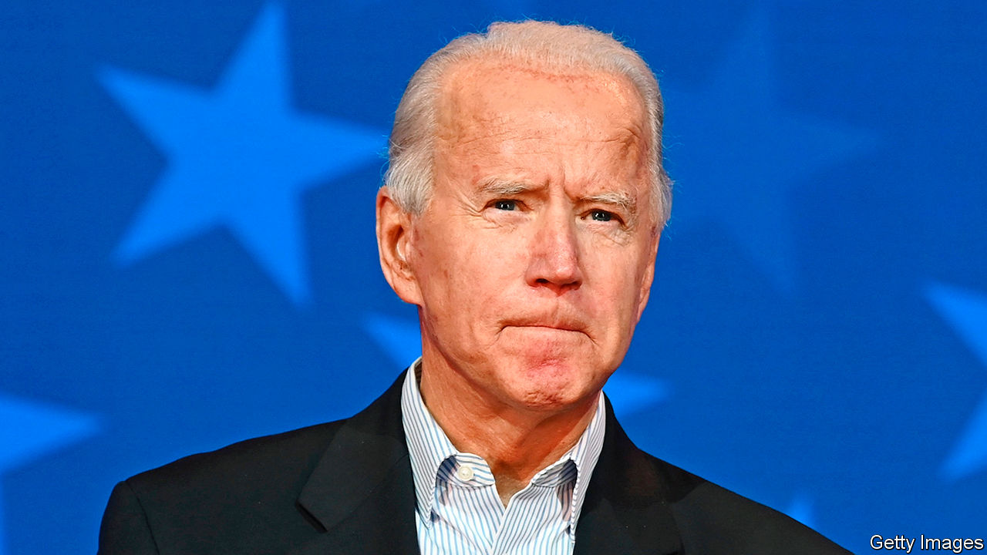

IN MUCH OF the world, and nowhere more so than among America’s allies, Joe Biden’s victory has come as a great relief. Under his presidency there will be no more bullying and threats to leave NATO. America will stop treating the European Union as a “foe” on trade, or its own forces stationed in South Korea as a protection racket. In place of Donald Trump’s wrecking ball, Mr Biden will offer an outstretched hand, working co-operatively on global crises, from coronavirus to climate change. Under Mr Trump, America’s favourability ratings in many allied countries sank to new lows. Mr Biden promises to make America a beacon again, a champion of lofty values and a defender of human rights, leading (as he put it in his acceptance speech) “not only by the example of our power but by the power of our example”.

Allies are central to Mr Biden’s vision. He rightly sees them as a multiplier of American influence, turning a country with a quarter of global GDP into a force with more than double that. He is also a multilateralist by instinct. On his first day in office he will rejoin the Paris agreement on climate change, which America formally left on November 4th. Unlike Mr Trump he believes it is better to lead the World Health Organisation than to leave it. He will reinvigorate arms control, a priority being to ensure that New START, the last remaining nuclear pact with Russia, is extended beyond February 5th. He would like to rejoin the nuclear deal with Iran that Mr Trump dumped, if he can persuade the Iranians to go back into compliance.

Inevitably, America’s friends have a long list of things they hope it will do as it re-embraces global leadership (see article). The demands stretch from places and organisations Mr Trump has abused, such as the UN and allies like Germany, to parts of the world he has ignored, such as much of Africa. Yet it will not all be smooth travelling. Not all countries are nostalgic for a return to Obama-era policies, when America “led from behind” and blurred its red lines. Several countries on NATO’s front line with Russia like the way defences have been beefed up under Mr Trump. And Asian allies like how Mr Trump has confronted China, talked of a “free and open Indo-Pacific” and worked on the “Quad” with Australia, India and Japan. Mr Biden needs to prove that he will not turn soft.

His priorities will be to quell the virus and improve the economy. On both counts he can count on little support, and much pushback, if the Senate is under Republican control, as is likely. Such troubles at home have probably also exacerbated the country’s reluctance to take on more foreign burdens. Who can be sure that world-wary Jacksonians won’t come galloping back in 2024, perhaps even with Mr Trump in the saddle?

So rather than pile demand upon needy demand, America’s allies should go out of their way to show that they have learned to pull their weight. NATO partners, for example, should not relax defence spending just because Mr Trump is no longer bullying them. Germany should pay heed to French efforts to build European defence capacity—there is scope to do so without undermining NATO. Europeans could lend a bigger hand to France in the Sahel (see article). In Asia the Quad could keep deepening naval and other co-operation. Japan and South Korea should restrain their feuding. Taiwan ought to make a more serious contribution to its own defence.

Allies should also work with America to repair the international order. They can support efforts to resist Chinese or Russian rule-bending. Many countries will want to join Mr Biden’s efforts at concerted carbon-cutting.

Mr Biden will face a world full of problems, but he will also start with strengths. Thanks to Mr Trump, he has sanctions on adversaries including Iran and Venezuela that he can use as bargaining chips. And among friends, he can seek to convert relief at renewed American engagement into stronger burden-sharing. His allies would be wise to answer that call with enthusiasm. ■

Dig deeper:  
For the latest on the election, see our [results page](https://www.economist.com/graphic-detail/2020/11/03/the-us-2020-election-results), read the [best of our 2020 campaign coverage](https://www.economist.com/us-election-2020) and then sign up for Checks and Balance, our [weekly newsletter](https://www.economist.com/checksandbalance/) and [podcast](https://www.economist.com/checks-and-balance-our-weekly-podcast-on-american-politics) on American politics.

This article was downloaded by calibre from <https://www.economist.com/leaders/2020/11/14/americas-allies-should-share-the-burden-with-joe-biden>

|  |  |  |  |
| --- | --- | --- | --- |
| Previous | Articles | Sections | Next |

|  |  |  |  |
| --- | --- | --- | --- |
| Previous | Articles | Sections | Next |

#### America’s economy

# President Joe Biden will face two extraordinary economic challenges

He must both fight a crisis and prepare for transformative change

Nov 14th 2020 |



Editor’s note: Some of our covid-19 coverage is free for readers of The Economist Today, our daily [newsletter](https://my.economist.com/user#newsletter). For more stories and our pandemic tracker, see our [hub](https://www.economist.com/news/2020/03/11/the-economists-coverage-of-the-coronavirus)

AMERICA’S VOTERS did not elect Joe Biden because they thought he would be the best steward of the economy. The economy may well define his presidency nonetheless. Mr Biden will take office in January amid a crisis brought about by the pandemic, which is capable of causing immensely more economic harm before vaccination is widespread. He will also inherit a business landscape in the throes of a once-in-a-generation shift, as technology becomes more embedded in everyday life and in more industries—a shift that has been simultaneously hastened and overshadowed by the disease. Whether Mr Biden succeeds or fails depends on how he manages these twin sources of change.

The good news is that GDP has rebounded impressively from its collapse in the spring. The unemployment rate has dropped much faster than most forecasters expected, from 14.7% in April to 6.9% in October. Were private-sector employment to keep growing at the pace of September and October it would return to its pre-pandemic level in less than a year. On most forecasts America’s economy will shrink by less than any other big rich country’s in 2020—the euro zone will take almost twice the hit, for example. So far there is little sign of the economic scarring that was feared at the onset of the crisis (see article).

Unfortunately this rebound is threatened by the winter wave of the virus. The logistics of rolling out a vaccine are daunting and at first only emergency workers and the most vulnerable will receive it. The spread of the disease will worsen before a mass inoculation can take place. Already more Americans are in hospital with covid-19 than at the peak of the outbreak in the spring, though many fewer are dying. Some parts of the country could soon face more restrictions and lockdowns. Others might experiment with letting the virus rip—an approach which could still bring about a sharp drop in consumer spending if people choose to stay at home in order to stay safe.

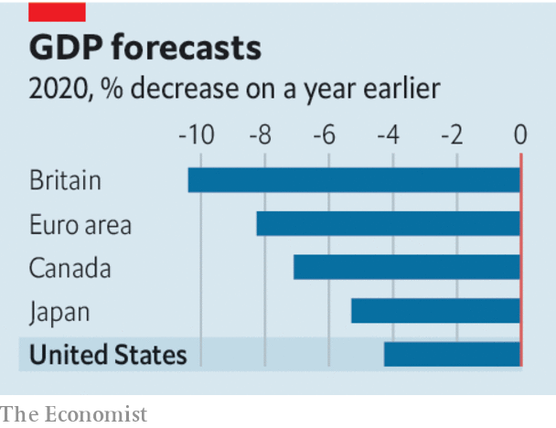

If the virus again puts the economy to the sword, it might not benefit from the life support it got in March in the form of lavish unemployment insurance and emergency loans for small businesses. Republicans in the Senate will probably support a limited second round of fiscal stimulus, but are in no mood for another blowout. A debate is raging about whether the Federal Reserve should extend its emergency lending into the new year. Job cuts by state and local governments, whose budgets have been hit by the pandemic, are already weighing down the labour market. They need a bail-out that Republicans do not want to give. Mr Biden’s first challenge will be to persuade Congress to keep the purse strings loose until the vaccine has brought about a full reopening.

At the same time the new president will need to grapple with the post-vaccine economy, which will look different from the one that entered the pandemic. The crisis has hastened the digitisation that was already poised to define business and investing in the 2020s. That trend will not fully reverse, even after the pandemic has subsided. Investors are still struggling to make sense of an economy in which intangible capital replaces the bricks-and-mortar kind, and in which network effects make incumbents more dominant and profits more enduring.

As technology permeates business, the nature of investment is changing. After the global financial crisis of 2007-09, the share of private non-residential investment flowing to intellectual property hit 30%. Soon it may breach the 40% threshold (see article). In this world, Walmart must become an e-commerce giant, Ford must compete with Tesla to make electric cars, and computers must allocate capital. Even McDonald’s has been working on its digital strategy (see article). The tech revolution will change the economy as much as the globalisation wave that defined Bill Clinton’s presidency in the 1990s. As it reshapes the labour market—blue- and white-collar jobs alike—it could tear at the social fabric, much as the automation of manufacturing jobs did.

America’s epidemic could be fading by the end of 2021. The tech surge will outlive Mr Biden’s presidency. Yet the same principle should guide him on both: that government must not resist economic change, but should instead help people adapt to it. One reason America’s economy is outperforming Europe’s is that its stimulus has done more to prop up household incomes than it has to preserve redundant jobs. Similarly, governments that respond to technological change by remaking safety-nets and rewriting social contracts for the new era will do better than those which seek to preserve obsolete models of capitalism and government.

There are thus reasons to worry that Mr Biden’s platform has a protectionist streak, a nostalgia for manufacturing jobs and an impulse to load firms with worthy social goals. One of his new-economy policies already looks like a flop: he wants to extend nationwide the regulations for gig-economy work that California voters rejected last week. To succeed, Mr Biden will need to show competent crisis management. But he also needs to recognise the deeper changes taking place in the economy, and to help Americans profit from them. That is the way to raise living standards—and, as it happens, to succeed as president. ■

Dig deeper:  
For the latest on the election, see our [results page](https://www.economist.com/graphic-detail/2020/11/03/the-us-2020-election-results), read the [best of our 2020 campaign coverage](https://www.economist.com/us-election-2020) and then sign up for Checks and Balance, our [weekly newsletter](https://www.economist.com/checksandbalance/) and [podcast](https://www.economist.com/checks-and-balance-our-weekly-podcast-on-american-politics) on American politics.

This article was downloaded by calibre from <https://www.economist.com/leaders/2020/11/14/president-joe-biden-will-face-two-extraordinary-economic-challenges>

|  |  |  |  |
| --- | --- | --- | --- |
| Previous | Articles | Sections | Next |

|  |  |  |  |
| --- | --- | --- | --- |
| Previous | Articles | Sections | Next |

#### Beyond Buffett

# Does value investing still work?

Asset management is in turmoil

Nov 14th 2020 |

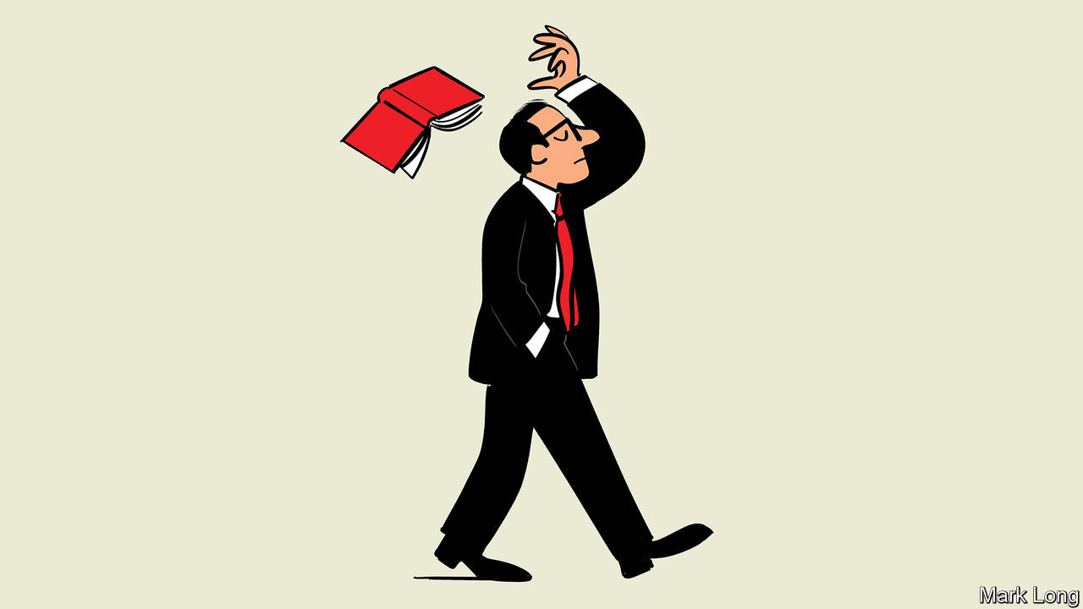

FOR A MOMENT this week investors could afford to ignore stockmarket superstars like Amazon and Alibaba. As news of a vaccine broke, a motley crew of more jaded firms led Wall Street higher, with the shares of airlines, banks and oil firms soaring on hopes of a recovery. The bounce has been a long time coming. So-called value stocks, typically asset-heavy firms in stodgy industries, have had a decade from hell, lagging behind America’s stockmarket by over 90 percentage points. This has led to a crisis of confidence among some fund managers, who wonder if their framework for assessing firms works in the digital age (see [article](https://www.economist.com/node/21795352)). They are right to worry: it needs upgrading to reflect an economy in which intangibles and externalities count for more.

For almost a century the dominant ideology in finance has been value investing. It has evolved over time but typically takes a conservative view of firms, placing more weight on their assets, cashflows and record, and less on their investment plans or trajectory. The creed has its roots in the 1930s and 1940s, when Benjamin Graham argued that investors needed to move on from the pre-1914 era, during which capital markets were dominated by railway bonds and insider-dealing. Instead he proposed a scientific approach of evaluating firms’ balance-sheets and identifying mispriced securities. His disciple, Warren Buffett, popularised and updated these ideas as the economy shifted towards consumer firms and finance in the late 20th century. Today measures of value are plugged into computers which hunt for “factors” that boost returns and there are investors in Shanghai loosely inspired by a doctrine born in Depression-era New York.

The trouble is that value investing has led to poor results. If you had bought value shares worth $1 a decade ago, they would fetch $2.50 today, compared with $3.45 for the stockmarket as a whole and $4.65 for the market excluding value stocks. Mr Buffett’s Berkshire Hathaway has lagged behind badly. Despite its efforts to modernise, value investing often produces backward-looking portfolios and as a result has largely missed the rise of tech. The asset-management industry’s business model is under strain, as our special report this week explains. Now one of its most long-standing philosophies is under siege, too.

Value investors might argue that they are the victims of a stockmarket bubble and that they will thus be proved right eventually. The last time value strategies did badly was in 1998-2000, before the dotcom crash. Today stockmarkets do indeed look expensive. But alongside this are two deeper changes to the economy that the value framework is still struggling to grapple with.

The first is the rise of intangible assets, which now account for over a third of all American business investment—think of data, or research. Firms treat these costs as an expense, rather than an investment that creates an asset. Some sophisticated institutional investors try to adjust for this but it is still easy to miscalculate how much firms are reinvesting—and firms’ ability to reinvest heavily at high rates of return is crucial for their long run performance. On a traditional definition, America’s top ten listed firms have invested $700bn since 2010. On a broad one, the figure is $1.5trn or more. Intangible firms can also often scale up quickly and exploit network effects to sustain high profits.

The second change is the rising importance of externalities, costs that firms are responsible for but avoid paying. Today the value doctrine suggests you should load up on car firms and oil producers. But these firms’ prospects depend on the potential liability from their carbon footprint, the cost of which may rise as emissions rules tighten and carbon taxes spread.

Value investing’s rigour and scepticism are as relevant as ever—especially given how frothy markets look. But many investors are still only just beginning to get their heads round how to assess firms’ intangible assets and externalities. It is a laborious task, but getting it right could give asset management a new lease of life and help ensure that capital is allocated efficiently. In the 1930s and 1940s Graham described how the old investing framework had become obsolete. Time for another upgrade.■

This article was downloaded by calibre from <https://www.economist.com/leaders/2020/11/14/does-value-investing-still-work>

|  |  |  |  |
| --- | --- | --- | --- |
| Previous | Articles | Sections | Next |

|  |  |  |  |
| --- | --- | --- | --- |
| Previous | Articles | Sections | Next |

#### The Mugabe model

# How to stop Zambia from turning into Zimbabwe

Neighbours and creditors should resist its slide into autocracy and economic collapse

Nov 14th 2020 |

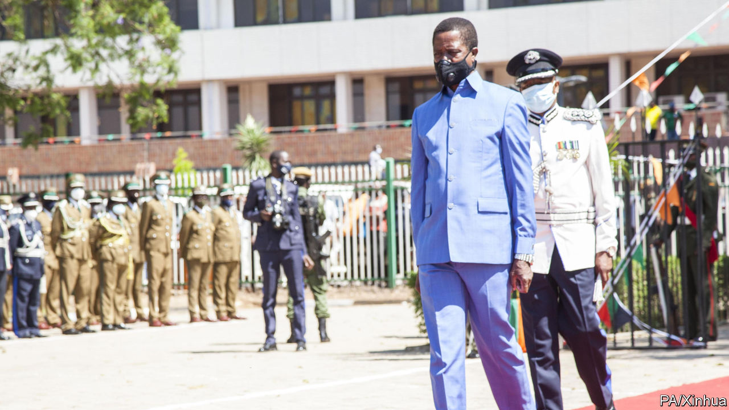

A DECADE AGO, as the rich world was struggling with the aftermath of the global financial crisis, much of Africa was surfing a wave of optimism. At the front was Zambia, which in the early 1990s was among the first African countries to ditch one-party rule and socialism. In 2012, after a decade of stunning economic growth, it joined the small club of African countries borrowing on international bond markets. Demand for its debt was so strong that it was able to borrow more cheaply than Spain.

Now Zambia finds itself at the front of another, less admirable pack. On November 13th it was poised to become the first African country to default since the IMF’s “heavily indebted poor countries” scheme in 2005 wiped clean the debts of 30 of the continent’s poorest countries.

Zambia is not the only indebted African state that is struggling. Because of covid-19, sub-Saharan Africa’s economy is expected to shrink by 3% this year, equivalent to 5.3% per person. The IMF reckons that six African countries are struggling to pay back loans and another 11 are thought to be at “high risk of debt distress”.

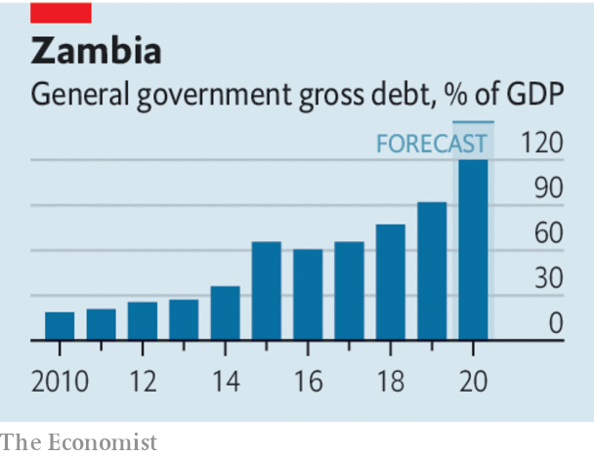

However, Zambia’s economic problems owe more to the disastrous presidency of Edgar Lungu than to the pandemic. When he took office in 2015 after the death of his predecessor, public debt stood at 32% of GDP. After five years of profligacy and theft by the ruling elite, debt has ballooned to 120%. Economic growth has tumbled—to 1.4% in 2019 owing in no small part to his government’s habit of scaring off investors by seizing mines and detaining mining bosses. A central-bank governor who resisted Mr Lungu’s hints that he print more money was fired in August.

Mr Lungu may be economically incompetent, but he is politically shrewd. Before a presidential election in 2016, his regime arrested opposition leaders and shut down the main independent newspaper. He won by the slenderest of margins; eked out by last-minute ballot-stuffing, according to the opposition. When it asked the constitutional court for a recount, the judges (many appointed by Mr Lungu) set a date for a hearing two weeks later. In the hearing they threw out the case, citing a constitutional provision that election petitions must be heard within 14 days.

Mr Lungu is taking few chances ahead of the next presidential poll in August 2021, which he would probably lose if it were free and fair (see [article](https://www.economist.com/node/21795322)). He has arrested and harassed Hakainde Hichilema, the main opposition leader, as well as journalists, musicians and other critics. The electoral commission is scrapping its voters’ roll and requiring all voters to register again in just 30 days. And if it turns out to be harder to register during the rainy season in the opposition’s rural strongholds than the ruling party’s urban ones, tough luck.

Many Zambians worry that their country is sliding into autocracy and economic ruin, like next-door Zimbabwe. To stop that slide, the region and the wider world need to start paying attention now, rather than just sending election observers a few weeks before the poll. South Africa, which has the most clout, needs to speak up. So does SADC, the regional bloc. And Zambia’s creditors should insist on cleaner and more democratic governance before agreeing to a bail-out. They wield a big stick. Zambia’s massive fiscal deficit of 12% of GDP means that it has to win their agreement if it is to keep borrowing in order to pay the salaries of soldiers, teachers and policemen.

Lenders—a disparate group that includes both Chinese construction firms and private bondholders—may object that it is not their job to safeguard democracy. Their main interest, quite reasonably, is to be repaid; or, in the case of the IMF, to help Zambia’s public finances get back on a sound footing. They do not want to be involved in politics. Yet Zambia’s economic crisis is caused mainly by its authoritarian and dysfunctional politics, not the pandemic or the slump in commodity prices. Its debt problem cannot be fixed without facing up to its political problem. Zambia’s next government will have to raise taxes and restrain spending to balance its books and repay creditors any more than a token amount. Only a government which Zambians see as legitimate can do this without sparking unrest. ■

This article was downloaded by calibre from <https://www.economist.com/leaders/2020/11/14/how-to-stop-zambia-from-turning-into-zimbabwe>

|  |  |  |  |
| --- | --- | --- | --- |
| Previous | Articles | Sections | Next |

|  |  |  |
| --- | --- | --- |
| Leaders | Sections | Briefing |

Letters

Letters to the editor: On transgender sports, diplomacy, Facebook, management, Armenia, avatars, Brazil

.

|  |  |  |
| --- | --- | --- |
| Leaders | Sections | Briefing |

|  |  |  |  |
| --- | --- | --- | --- |
|  | Articles | Sections | Next |

#### On transgender sports, diplomacy, Facebook, management, Armenia, avatars, Brazil

# Letters to the editor

A selection of correspondence

Nov 14th 2020 |



Letters are welcome via e-mail to

letters@economist.com

## The sporting life

The problem of ensuring fair competition in women’s sport goes wider and deeper than the question of whether trans women should compete as females (“[Scrum down](https://www.economist.com/science-and-technology/2020/10/17/a-ban-by-world-rugby-could-prove-influential-for-transgender-sports)”, October 17th). There really are big differences between men and women in genes and gene activity, size and strength, although there is a lot of variation and some overlap in any trait you can measure. These differences are largely, but not entirely, the result of androgen action during development, and are not obviated by anti-androgen treatment.

It is clear that athletes who were born and developed as males have the advantage of higher stature, more lean muscle and a bigger heart and lungs. But so, too, do female athletes with naturally high testosterone levels. It seems nonsensical to apply arbitrary limits to testosterone levels in sport, unless you were to ban athletes with unusually long legs, big hearts or lungs as well. Elite athletes are usually on the very edge of distributions of all sorts of qualities that enhance performance.

Few aspiring trans athletes will be tempted to compete as women, given the massive disadvantages they face. In the United States, trans women are twice as likely to live below the poverty line. Trans women of colour face higher risks of murder and other violence. That’s a poor swap for a leg up in the 100-metre sprint.

PETER JOHNSTON  
San Francisco

A bizarre fixation on sport dominates the conversation on trans rights. The only real advantage possessed by a trans woman would be that of testosterone if she has not begun hormone treatment. The International Olympic Committee suggests changing results based on testosterone levels. Given that these levels can vary among cis women, should this be imposed on them also? Or on men with different testosterone levels?

The supposed risk that women face from trans rights is as much a mirage as was the fear of homosexual indoctrination in the 1980s, which led to oppressive legislation, such as Britain’s Section 28.

THOMAS ROBERTSON  
Oxford

## Diplomatic dispatches

Thank you for introducing a new black humour section in your edition of October 24th. It is regrettable, though, that you had to sacrifice over two columns of your Letters page to a response from the Chinese embassy to your articles on the Uyghurs to do so.

IAN CARTWRIGHT  
Isle of Lewis, Outer Hebrides

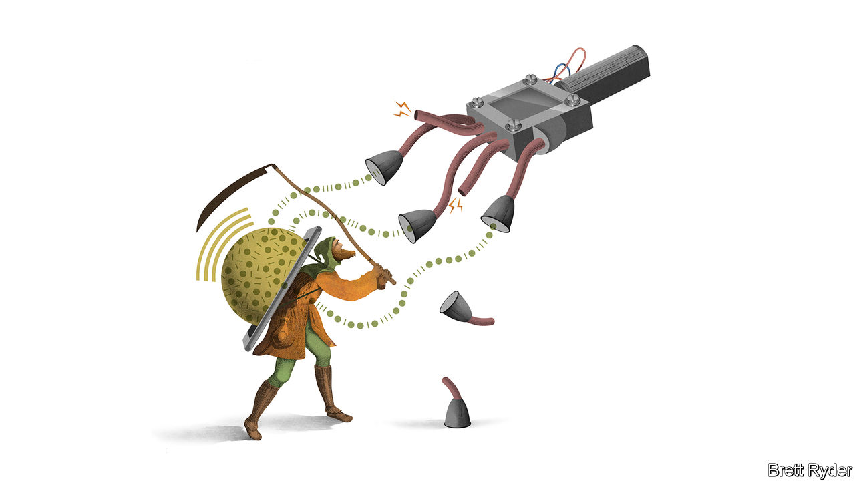

## Filter out the noise

[Schumpeter](https://www.economist.com/business/2020/10/22/who-owns-the-webs-data) missed a trick with regard to annoying advertisements and news feeds on Facebook (October 24th). Not only are ad blockers available, many other anti-spyware and tracker-blocking apps can easily be installed. In particular, an app known as FB Purity integrates with Facebook and enables me to block out not just annoying newsfeeds and adverts, but also irritating spam thanks to keyword-based text filtering.

NICHOLAS COOTE  
Devizes, Wiltshire



## Army training

[Bartleby’s](https://www.economist.com/business/2020/10/24/what-the-armed-forces-can-teach-business) column on what the armed forces can teach business scratched the surface of much deeper opportunities (October 24th). In the 1980s the strategy for the defence of western Europe was changed from positional defence to fighting a mobile defensive battle. This meant a high degree of uncertainty with the need for increased agility, a latter-day buzzword in business. As a battlefield commander I pushed the decisions I would normally take down to the lowest possible level. Some things that would take 30 minutes to accomplish could be done in an astonishing 30 seconds. The key is for leadership to move beyond being a role, position or competence (which are typically static) to a vibrant dynamic. This achieves agile self-organisation that can navigate uncertainty better, faster and with less stress.

Various companies around the world have since used this approach to good effect. In China, a team at Dow Chemical achieved a 25% increase in project productivity. In America two senior leaders of Nokia achieved six times in a few weeks what had taken a previous team many months.

Sadly, many see the armed forces in light of the movies, strictly “command and control”. The truth is far from that.

MAJOR (RET’D) PRINCE NICHOLAS OBOLENSKY  
Founder  
Complex Adaptive Leadership  
Bath

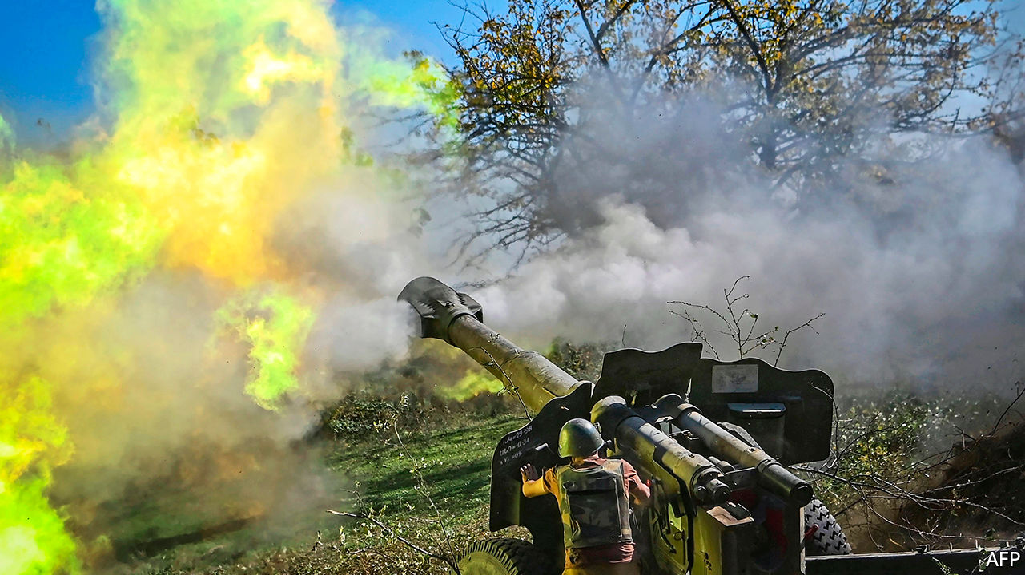

## Armenia responds

Your article on the fighting in Nagorno-Karabakh provided a distorted picture of the conflict (“[The wheel turns, this time](https://www.economist.com/europe/2020/10/29/the-fighting-in-nagorno-karabakh-reflects-decades-of-conflict)”, October 31st). The reality is that Artsakh (Nagorno-Karabakh) has always been populated overwhelmingly by Armenians and it has never been a part of independent Azerbaijan. In 1991 Nagorno-Karabakh voted for its independence based on the same legal framework as Azerbaijan.

Armenia has been consistent in its intentions for peace, by pushing for a compromise acceptable to the people of all parties: Artsakh, Armenia and Azerbaijan. This message has never been reciprocated, thus making it clear that Azerbaijan’s intention is neither negotiations nor peace, but war.

In the month of this latest conflict Azerbaijan, comprehensively backed by Turkey and with the use of international terrorist fighters, has consistently shelled Artsakh’s towns and villages. Civilian infrastructure, hospitals, schools and even kindergartens have been bombed and war crimes committed by the Azerbaijani armed forces.

The only alternative is a peaceful resolution, in which the security of Armenians of Artsakh finds its expression and their legitimate right for self-determination will be delivered.

ARAM ARARATYAN  
Press officer  
Embassy of Armenia  
London



## How might you feel?

[Technology Quarterly](https://www.economist.com/technology-quarterly/2020/10/01/computer-generated-realities-are-becoming-ubiquitous) reported on virtual realities (October 3rd), noting that in virtual worlds “users will often co-opt the avatars as almost real extensions of their own bodies”. One interesting experiment would be to use avatars to implement the veil of ignorance as set out by John Rawls in his “A Theory of Justice”. Let the subjects of the experiments make decisions about fairness and equity while inhabiting avatars with characteristics other than their own.

How might evangelical Christians feel about abortion if their avatars were rape victims? How might supporters of Black Lives Matter feel about police intervening in riots if their avatars were Korean grocery-store owners? How might rich people feel about tax reform if their avatars were poorer citizens?

CHRISTOPHER BRUCE  
Calgary, Canada

## Reaching the bottom of a case

I was intrigued to read in The world this week ([October 24th](https://www.economist.com/the-world-this-week/2020/10/22/politics-this-week)) that Brazilian police had raided a senator’s home and discovered about $5,000 wedged between his buttocks. He has denied diverting funds that were meant for the pandemic. If he is innocent then this is a most unfortunate case of a bum rap.

DAVID ROESSLER  
Hazel Park, Michigan

This article was downloaded by calibre from <https://www.economist.com/letters/2020/11/14/letters-to-the-editor>

|  |  |  |  |
| --- | --- | --- | --- |
|  | Articles | Sections | Next |

|  |  |  |
| --- | --- | --- |
| Letters | Sections | Asia |

Briefing

Covid-19 vaccines: Bullseye

.

Investment strategies: Diminished value

.

|  |  |  |
| --- | --- | --- |
| Letters | Sections | Asia |

|  |  |  |  |
| --- | --- | --- | --- |
|  | Articles | Sections | Next |

#### The technology of hope

# An effective covid-19 vaccine is a turning point in the pandemic

It is a breakthrough for the history books. But a lot still needs to be done

Nov 14th 2020 |



Editor’s note: Some of our covid-19 coverage is free for readers of The Economist Today, our daily [newsletter](https://my.economist.com/user#newsletter). For more stories and our pandemic tracker, see our [hub](https://www.economist.com/news/2020/03/11/the-economists-coverage-of-the-coronavirus)

DELIVERANCE, WHEN it arrives, will come in a small glass vial. First there will be a cool sensation on the upper arm as an alcohol wipe is rubbed across the skin. Then there will be a sharp prick from a needle. Twenty-one days later, the same again. As the nurse drops the used syringe into the bin with a clatter, it will be hard not to wonder how something so small can solve a problem so large.

On November 9th Pfizer and BioNTech, two firms working as partners on a vaccine against covid-19, announced something extraordinary about the first 94 people on their trial to develop symptoms of the disease. At least 86 of them—more than nine out of ten—had been given the placebo, not the vaccine. A bare handful of those vaccinated fell ill. The vaccine appeared to be more than 90% effective.

Within a few weeks the firms could have the data needed to apply for emergency authorisation to put the vaccine to use. The British and American governments have said that vaccinations could start in December. The countries of the EU have also been told it will be distributed quickly.

The news lifted spirits around the world, not to mention stockmarkets (see article). The end of the pandemic seemed in sight; scientific insight and industrial know-how had, in a bravura display of their power, provided an exit strategy. Pfizer and BioNTech have not just developed a vaccine against a previously unknown disease in a scant ten months. They have done so on the basis of an approach to vaccination never before used in people. And their novel vaccine has shown an unanticipated efficacy. Most in the field thought 70% efficacy was good as could be hoped for first time out; just 50% could have been good enough for regulatory approval. Exceeding 90% hits the virus for six.

Russia and China have been vaccinating some citizens against covid-19 for some time outside the scope of clinical trials. On November 11th the Russian Direct Investment Fund announced that data showed Russia’s vaccine, known as Sputnik V, to be 92% effective. Before the Pfizer announcement this would have seemed highly implausible. Now it may seem less so, though the evidence is weak compared with Pfizer’s. And neither Sputnik V nor the Chinese vaccines have yet had their safety and efficacy addressed by the stringent regulators at the Food and Drug Administration (FDA) in America and the European Medicines Agency (EMA).

Pfizer’s vaccine is now headed into that regulatory gamut with a small posse of followers hot on its heels (see table). Two other vaccines which are in phase-three trials—the sort of large, randomised trials designed to show the efficacy of a treatment—could submit data to the regulators fairly soon. Moderna, an American biotech firm, is expected to deliver interim findings about the efficacy of its vaccine in the next few weeks. AstraZeneca, a pharmaceuticals company working in partnership with the University of Oxford, should deliver results from its trial before the end of the year.

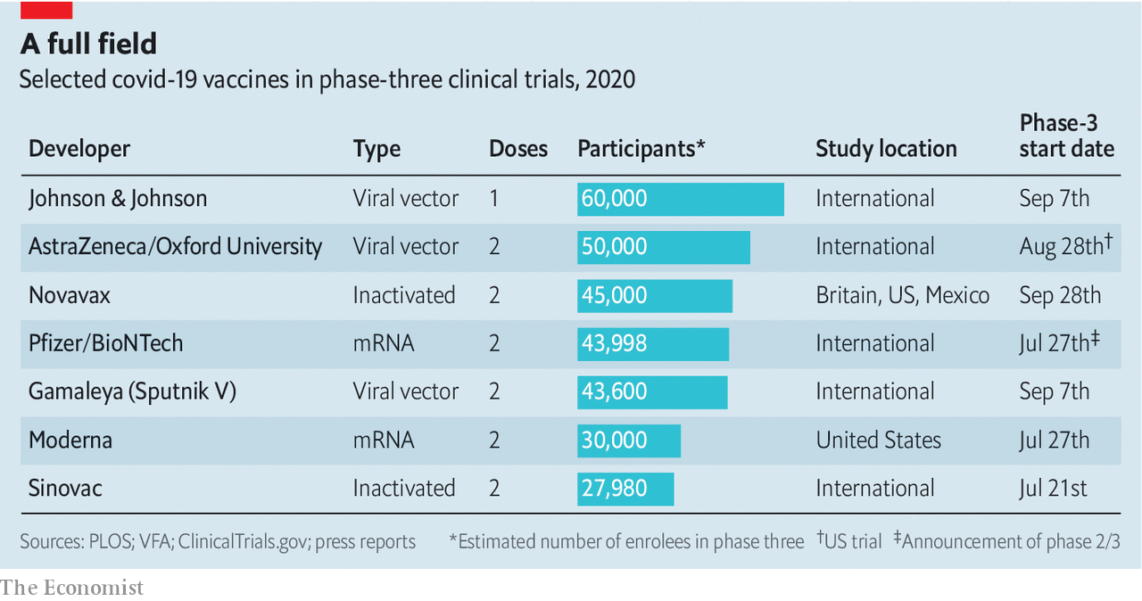

Challenges remain. Though the regulators will want to move quickly, they will still have to do their job. Missteps could erode confidence in the vaccine, as well as vaccination more generally. Plans for scaling up manufacture and for distribution on an unprecedented scale have been being made around the world for months, but it is hard to imagine that they will not require revision on the hoof. Even if the news continues to be good, the numbers vaccinated will remain small for months to come. But a fateful corner has been turned.

Listen on: [Apple Podcasts](https://itunes.apple.com/us/podcast/id1449631195?mt=2&ls=1) | [Spotify](https://open.spotify.com/show/12zKAMNyS2GNentUzxq9QN) | [Google](https://www.google.com/podcasts?feed=aHR0cHM6Ly9yc3MuYWNhc3QuY29tL3RoZWludGVsbGlnZW5jZXBvZGNhc3Q) | [Stitcher](https://www.stitcher.com/s?fid=357733&refid=stpr) | [TuneIn](https://tunein.com/podcasts/News--Politics-Podcasts/The-Intelligence-p1186979/)

## The technology of hope

Great speed has come from great efforts. Cath Green, the boss of the clinical biomanufacturing facility at the University of Oxford, remembers the pressure to get the first candidate-vaccine vials filled in April. Everyone was doing double shifts and working on weekends. “We knew it had to be this fast if we were to get a vaccine to people this year,” she says.

But it was not just hard work. New technology, a lack of financial constraint and a commitment to speeding up regulatory processes without sacrificing standards mattered, too.

Technology first. Vaccines against viruses used to be based on the virus particles they were meant to stymie. Some were strains of the virus “attenuated” so as not to cause disease; some were normal virus particles inactivated so that they could not reproduce at all. Design was somewhat hit and miss. Today vaccine development is based on viral genomes. Researchers look for a gene which describes a protein the immune system seems likely to recognise. Then they put that gene into a new context.

In the case of SARS-Cov-2, the virus that causes covid-19, the genome was published on January 10th. Understanding its structure on the basis of their experience with other coronaviruses, would-be vaccine-makers immediately homed in on the gene for the distinctive spike protein with which the virus’s membrane is studded: just the sort of thing, they reckoned, to provoke a response from the immune system.

At BioNTech, a German biotechnology company that specialises in the use of mRNAS—sequences of genetic material that provide cells with recipes for making proteins—the spike-protein gene was more or less all it took. The company’s researchers made an mRNA version of it that could be injected into the body in tiny capsules made of lipids. There it would lead cells to produce the spike protein, and the immune system would then take note. Or so they hoped: no mRNA vaccine had been used in humans before. Moderna, too, has as its name suggests taken the mRNA route.

In Oxford a version of the spike gene was instead put into the genome of a harmless adenovirus originally found in monkeys; when the resultant virus infects cells it, too, makes them produce spike proteins that attract the immune system’s attention. The vaccine developed by J&J also uses the adenovirus approach, as does Sputnik V.

It is no accident that the vaccines that have come along fastest are based on these novel strategies. Before the coronavirus struck these technologies were already being developed as platforms on which a rapid response to a new viral disease could be built, work supported in part by the Coalition for Epidemic Preparedness Innovations (CEPI). Vaccines which are built on such platforms are quick to engineer and comparatively easy to make.

## The correct egg-to-basket ratio

That said, the work still requires money, which in the vaccine world is usually in short supply. With covid-19, though, governments have been willing to shovel cash at vaccine developers even though there was a risk they would get nothing in return. “We persuaded the UK government to fund us before they had any idea whether it would work,” says Dr Green. It was this ready cash, sometimes provided in the form of a commitment to buy the end product, which sped the process up, rather than any loosening of normal rules and procedures. “We haven’t cut any corners,” Dr Green continues. “And we haven’t taken any risks with our product.”

Rather than standing back, regulators in many countries have worked closely with companies to make sure their trials provide all the data needed for approval when the time is right. When it was safe to do so, the different phases of trials were allowed to overlap, with larger, later trials starting before smaller preliminary ones had produced all their data. At Oxford they were able to start human trials the day after animal safety data had been published.

Richard Hatchett, the head of CEPI, says Pfizer’s positive results increase the probability that other covid vaccines will be successful, too. They show that an mRNA vaccine can work, which is good news for Moderna; they also show that targeting the spike protein pays off. And the success goes beyond the current pandemic. Work CEPI expected to take five or ten years has been managed in less than one; if the various platforms in play all pay off, Dr Hatchett says, it will “transform vaccinology”.

The fact that there are more vaccines on the way matters for a number of reasons. One is that, despite this week’s good news, the Pfizer vaccine is not yet guaranteed approval. For one thing, its safety needs to be more fully ascertained. The firm says that no serious safety concerns have arisen during the trial. But the vaccine will come with side-effects, at least for some, and the company will only be in a position to request approval for the vaccine on an “emergency use” basis after it has two months of safety data showing such effects to be manageable. That requirement looks likely to be met in time for an application in the third week of November.

Then comes the question of what exactly the vaccine does: is it stopping infections completely—providing “sterilising immunity”—or simply amping up the body’s response so that infections do not cause disease? The latter attribute is undoubtedly a useful one for the individual concerned; all the better if, as well as lowering the chance of infection leading to disease, it also makes the disease less severe in those who succumb (there is as yet no available data on this). But it is a lot less desirable in public-health terms. If the vaccine stops disease but not infection, vaccinated people may be able to infect others while staying safe themselves.

If the Pfizer vaccine does not provide sterilising immunity there will be a need for one that does. And there are other ways that subsequent vaccines might prove preferable. Different vaccines can work better or worse with different populations, and for covid-19 it is important to find a vaccine which works well in old people. Their immune systems can often be unresponsive to vaccination, and they may do better with vaccines which, in the general population, do not look as effective. There is no guarantee that the best vaccine overall will be the best for the elderly.

And the Pfizer vaccine has some inconvenient characteristics. It needs to be kept at -70°C or even colder as it is moved from where it is made to where it is used, which requires a lot of equipment that other vaccines do not need. Seth Berkley, head of the vaccine finance group GAVI, warns that many countries do not currently have the wherewithal to meet that challenge. But he also notes that the lack is not insuperable. The Democratic Republic of Congo successfully deployed an Ebola vaccine that required similarly special care. “It’s a pain in the ass, it’s expensive, but it’s doable.”

Still, a vaccine which, if not liking it hot, at least liked it less cold would be a boon. So would one that only needed to be given once. The Pfizer, AstraZeneca and Moderna vaccines all require two jabs weeks apart. A one-and-done vaccine, which is what J&J hopes for, makes setting up a vaccination programme far simpler. It also means a given number of doses will go a lot further.

On top of all this, the long-term efficacy of the vaccine will matter a lot. The Pfizer/BioNTech collaboration says that protection should last at least a year. But that will not be known for sure before they apply to regulators for full authorisation on the basis of final trial results, which they are expected to do in the first quarter of next year (as are the makers of the other front-runners). A vaccine that provides protection only briefly might well not be able to disrupt the virus’s transmission, instead feeding a constant stream of newly susceptible people back into the population at large. Marcus Schabacker, the boss of the Emergency Care Research Institute, an American organisation focused on the quality and safety of medical practices, thinks six months of follow-up data ought to be scrutinised, not just two, before final decisions are made on deploying the vaccine.

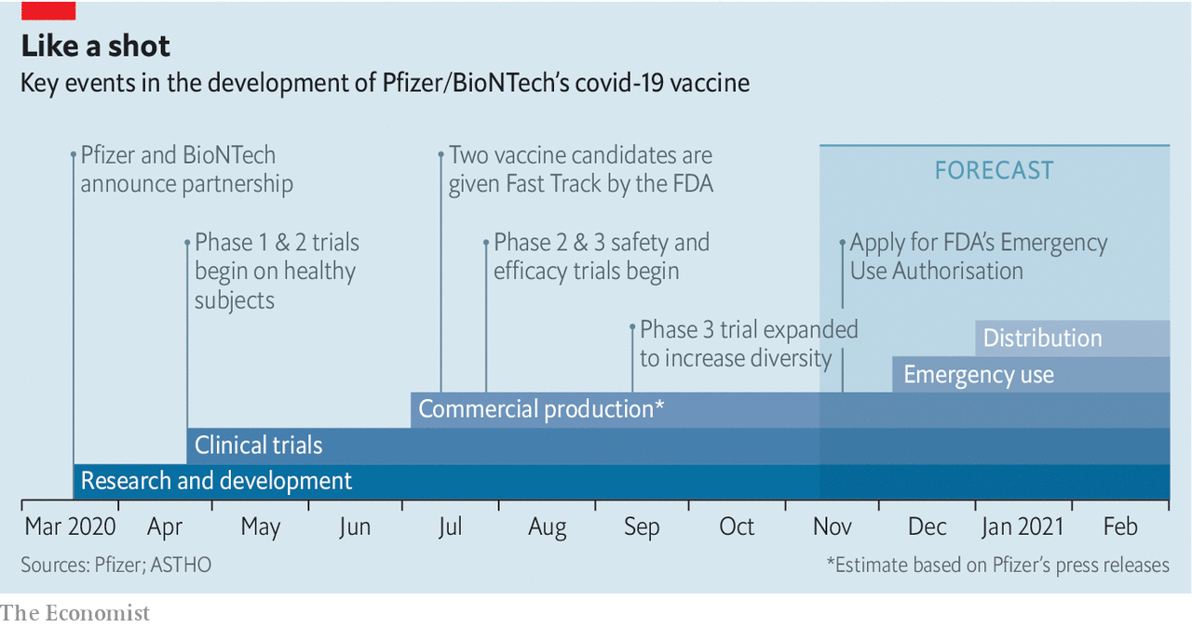

Such questions will be on the minds of regulators at the FDA and EMA when they are asked to consider the Pfizer vaccine for emergency use later this month and when Pfizer and the makers of other vaccines submit all the data from their trials next year. Their opinions will have worldwide effects, as the World Health Organisation (WHO) will use the analytical capabilities of those authorities to accelerate the review of vaccines for use in low- and middle-income countries.

If emergency authorisation is granted it is likely the agencies will restrict the use of these vaccines, initially, to those at highest risk of death or serious disease. If after seeing the full data the regulators still have worries they may continue to limit the vaccines’ use. Whatever they decide they are very likely to insist on years of follow up.

Andrew Pollard, director of the Oxford Vaccine Group, says it is important that all developers carry on with trials as long as possible. But this may be hard unless early use is restricted to specific groups. If a vaccine is approved for use in the general population, few will volunteer to take part in a trial for another vaccine that uses a placebo as a control (if Pfizer and BioNTech receive an emergency authorisation they plan to offer all the volunteers who were given a placebo the active vaccine). A trial that compares an experimental vaccine with one that is already approved needs to be very large to get results, since both wings can be expected to show comparatively few infections. Such trials are under discussion, but they will take a long time.

If vaccines are approved for widespread use, the world will face what some have called the largest supply-chain challenge in history. There is normally little spare vaccine-manufacturing capacity to repurpose. And production is not the only limiting factor. Analysts at UBS, a bank, warn that “fill and finish”, where the vaccine is put into vials and packaged, could be one of the most significant bottlenecks.

Pfizer says it will only be able to make enough vaccine to inoculate 25m people in 2020. Up to 1.3bn doses are possible, in theory, next year—enough for another 650m people. If other vaccines are approved then the supply will increase. In even the most optimistic scenarios, though, Dr Hatchett expects demand to exceed supply throughout 2021.

Various countries have already set up purchase agreements with vaccine developers (see chart). The COVAX facility set up by CEPI, GAVI and the WHO will buy vaccines for 150 countries, and aims to procure enough for them to get 20% of their populations vaccinated over the course of 2021. UNICEF, the UN’s children’s agency, will take a leading role in distribution. It normally procures 600m-800m syringes for routine childhood immunisations every year. The demands of covid are likely to treble or quadruple that number.

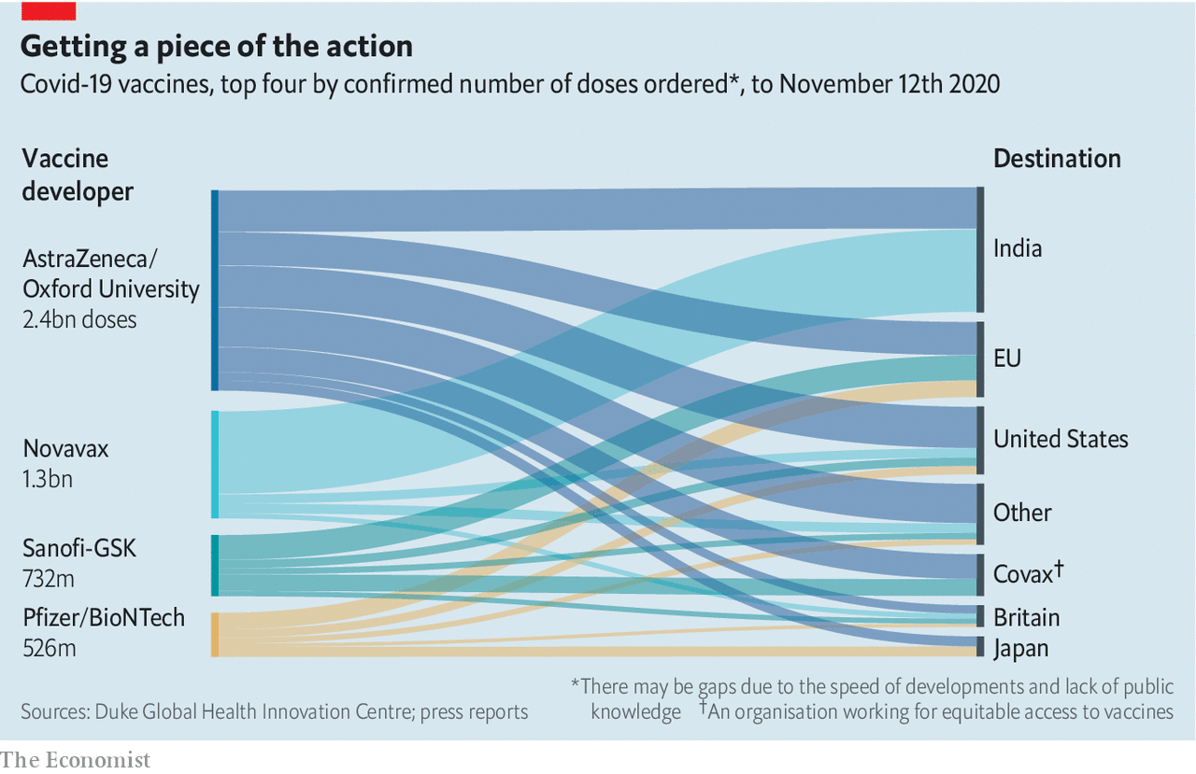

There is clearly a risk that nations will hoard some vaccine for their own use rather than that of the most needy, but it is not easy to say how large the problem will be. Pharma firms have cleverly placed manufacturing sites around the world, including in small countries such as Belgium and Switzerland which can quickly produce more vaccine than these countries could ever want. And the COVAX framework has wide international support.

That framework follows advice from the WHO in identifying three priority groups for early vaccination: front-line health- and social-care workers; the over 65s; and those under 65 who have underlying health conditions, such as diabetes, which put them at particular risk. Countries setting their own priorities are by and large prioritising the same groups. This means that young and middle-aged people not in any risk categories are unlikely to be vaccinated until well into next year. Social distancing and mask wearing will stay important for some time to come even after vaccination becomes widespread. But a more normal form of life looks unlikely to be too long delayed.

For vaccination to work as well as it can requires a widespread willingness to be vaccinated—something that cannot be taken for granted in a world where anti-vaccine disinformation has a strong foothold. The data on this front, though, are broadly encouraging. A survey of 20,000 adults in 27 countries undertaken for the World Economic Forum this August found that 74% would get a vaccine if it were available. In China the figure was 97%, in India 87%, in America 67%. Countries with low rates of acceptance were Russia (54%), Poland and Hungary (both 56%) and France (59%).

## A cold coming

Better testing, new antibody treatments and improvements in care will continue to drive down the death rate for coronavirus both before widespread vaccination and after it. Vaccination will instead change the fundamentals. Its advent marks the beginning of the end of covid-19 as a pandemic.

But for all the hope that diligence and science have kindled, there are hard winter months to face before that spring. The official tally of daily deaths round the world is now for the first time higher than it was in the pandemic’s first peak, and the spread of the virus in America appears to be out of control (see article). In the next three months hundreds of thousands of people look likely to die. Not only will their loved ones have to come to terms with this loss, they will also have to live with the knowledge that a vaccine that could have saved them, even though developed at breakneck speed, arrived just too late.■

This article was downloaded by calibre from <https://www.economist.com/briefing/2020/11/14/an-effective-covid-19-vaccine-is-a-turning-point-in-the-pandemic>

|  |  |  |  |
| --- | --- | --- | --- |
|  | Articles | Sections | Next |

|  |  |  |  |
| --- | --- | --- | --- |
| Previous | Articles | Sections | Next |

#### Diminishing value

# Value investing is struggling to remain relevant

The main reason is the inexorable rise of hard-to-analyse intangible assets

Nov 12th 2020 |

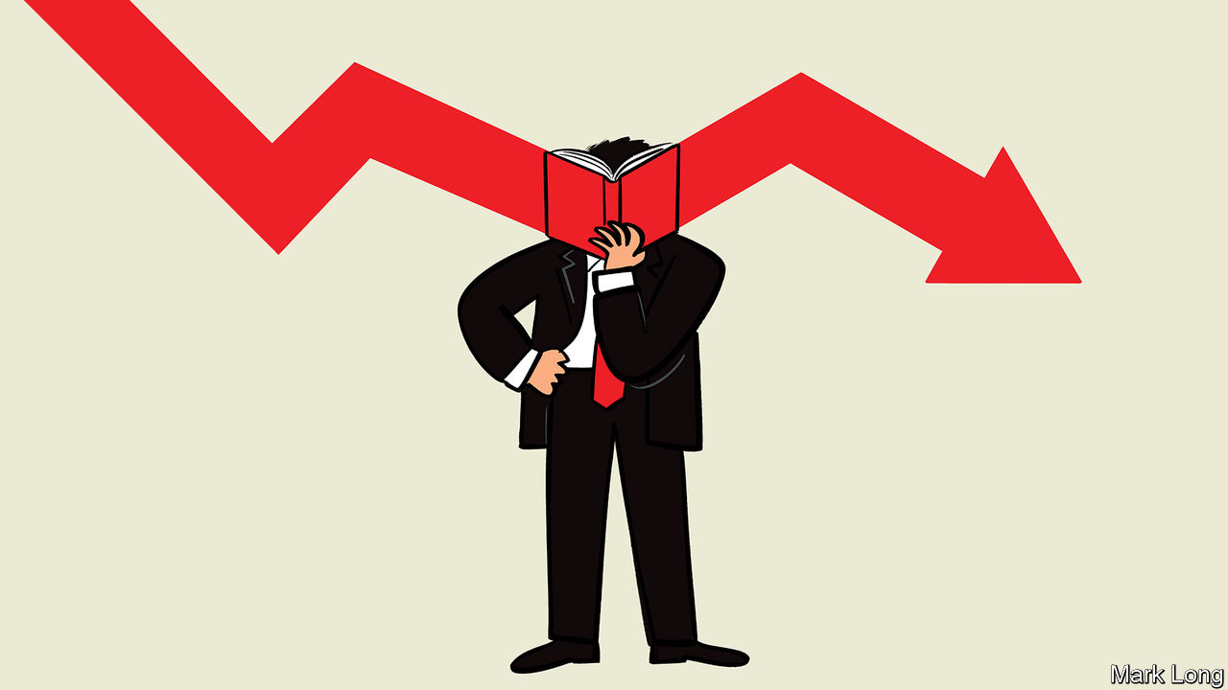

IT IS NOW more than 20 years since the Nasdaq, an index of technology shares, crashed after a spectacular rise during the late 1990s. The peak in March 2000 marked the end of the internet bubble. The bust that followed was a vindication of the stringent valuation methods pioneered in the 1930s by Benjamin Graham, the father of “value” investing, and popularised by Warren Buffett. For this school, value means a low price relative to recent profits or the accounting (“book”) value of assets. Sober method and rigour were not features of the dotcom era. Analysts used vaguer measures, such as “eyeballs” or “engagement”. If that was too much effort, they simply talked up “the opportunity”.

Plenty of people sense a replay of the dotcom madness today. For much of the past decade a boom in America’s stockmarket has been powered by an elite of technology (or technology-enabled) shares, including Apple, Alphabet, Facebook, Microsoft and Amazon. The value stocks favoured by disciples of Graham have generally languished. But change may be afoot. In the past week or so, fortunes have reversed. Technology stocks have sold off. Value stocks have rallied, as prospects for a coronavirus vaccine raise hopes of a quick return to a normal economy. This might be the start of a long-heralded rotation from overpriced tech to far cheaper cyclicals—stocks that do well in a strong economy. Perhaps value is back.

This would be comforting. It would validate a particular approach to valuing companies that has been relied upon for the best part of a century by some of the most successful investors. But the uncomfortable truth is that some features of value investing are ill-suited to today’s economy. As the industrial age gives way to the digital age, the intrinsic worth of businesses is not well captured by old-style valuation methods, according to a recent essay by Michael Mauboussin and Dan Callahan of Morgan Stanley Investment Management.

The job of stockpicking remains to take advantage of the gap between expectations and fundamentals, between a stock’s price and its true worth. But the job has been complicated by a shift from tangible to intangible capital—from an economy where factories, office buildings and machinery were key to one where software, ideas, brands and general know-how matter most. The way intangible capital is accounted for (or rather, not accounted for) distorts measures of earnings and book value, which makes them less reliable metrics on which to base a company’s worth. A different approach is required—not the flaky practice of the dotcom era but a serious method, grounded in logic and financial theory. However, the vaunted heritage of old-school value investing has made it hard for a fresher approach to gain traction.

## Graham’s cracker

To understand how this investment philosophy became so dominant, go back a century or so to when equity markets were still immature. Prices were noisy. Ideas about value were nascent. The decision to buy shares in a particular company might by based on a tip, on inside information, on a prejudice, or gut feel. A new class of equity investors was emerging. It included far-sighted managers of the endowment funds of universities. They saw that equities had advantages over bonds—notably those backed by mortgages, railroads or public utilities—which had been the preferred asset of long-term investors, such as insurance firms.

This new church soon had two doctrinal texts. In 1934 Graham published “Security Analysis” (with co-author David Dodd), a dense exposition of number-crunching techniques for stockpickers. Another of Graham’s books is easier to read and perhaps more influential. “The Intelligent Investor”, first published in 1949, ran in revised editions right up until (and indeed beyond) Graham’s death in 1976. The first edition is packed with sage analysis, which is as relevant today as it was 70 years ago.

Underpinning it all is an important distinction—between the price and value of a stock. Price is a creature of fickle sentiment, of greed and fear. Intrinsic value, by contrast, depends on a firm’s earnings power. This in turn derives from the capital assets on its books: its factories, machines, office buildings and so on.

The approach leans heavily on company accounts. The valuation of a stock should be based on a conservative multiple of future profits, which are themselves based on a sober projection of recent trends. The book value of the firm’s assets provides a cross-check. The past might be a crude guide to the future. But as Graham argued, it is a “more reliable basis of valuation than some other future plucked out of the air of either optimism or pessimism”. As an extra precaution, investors should seek a margin of safety between the price paid for a stock and its intrinsic value, to allow for any errors in the reckoning. The tenets of value investing were thus established. Be conservative. Seek shares with a low price-earnings or price-to-book ratio.

The enduring status of his approach owes more to Graham as tutor than the reputation he enjoyed as an investor. Graham taught a class on stockpicking at Columbia University. His most famous student was Mr Buffett, who took Graham’s investment creed, added his own twists and became one of the world’s richest men. Yet the stories surrounding Mr Buffett’s success are as important as the numbers, argued Aswath Damodaran of New York University’s Stern School of Business in a recent series of YouTube lectures on value investing. The bold purchase of shares in troubled American Express in 1964; the decision to dissolve his partnership in 1969, because stocks were too dear; the way he stoically sat out the dotcom mania decades later. These stories are part of the Buffett legend. The philosophy of value investing has been burnished by association.

It helped also that academic finance gave a back-handed blessing to value investing. An empirical study in 1992 by Eugene Fama, a Nobel-prize-winning finance theorist, and Kenneth French found that volatility, a measure of risk, did not explain stock returns between 1963 and 1990, as academic theory suggested it should. Instead they found that low price-to-book shares earned much higher returns over the long run than high price-to-book shares. One school of finance, which includes these authors, concluded that price-to-book might be a proxy for risk. For another school, including value investors, the Fama-French result was evidence of market inefficiency—and a validation of the value approach.

All this has had a lasting impact. Most investors “almost reflexively describe themselves as value investors, because it sounds like the right thing to say”, says Mr Damodaran. Why would they not? Every investor is a value investor, even if they are not attached to book value or trailing earnings as the way to select stocks. No sane person wants to overpay for stocks. The problem is that “value” has become a label for a narrow kind of analysis that often confuses means with ends. The approach has not worked well for a while. For much of the past decade, value stocks have lagged behind the general market and a long way behind “growth” stocks, their antithesis (see chart 1). Old-style value investing looks increasingly at odds with how the economy operates.

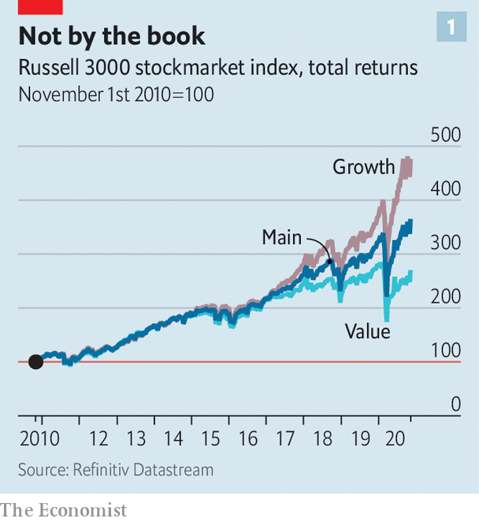

In Graham’s day the backbone of the economy was tangible capital. But things have changed. What makes companies distinctive, and therefore valuable, is not primarily their ownership of physical assets. The spread of manufacturing technology beyond the rich world has taken care of that. Any new design for a gadget, or garment, can be assembled to order by contract manufacturers from components made by any number of third-party factories. The value in a smartphone or a pair of fancy athletic shoes is mostly in the design, not the production.

In service-led economies the value of a business is increasingly in intangibles—assets you cannot touch, see or count easily. It might be software; think of Google’s search algorithm or Microsoft’s Windows operating system. It might be a consumer brand like Coca-Cola. It might be a drug patent or a publishing copyright. A lot of intangible wealth is even more nebulous than that. Complex supply chains or a set of distribution channels, neither of which is easily replicable, are intangible assets. So are the skills of a company’s workforce. In some cases the most valuable asset of all is a company’s culture: a set of routines, priorities and commitments that have been internalised by the workforce. It can’t always be written down. You cannot easily enter a number for it into a spreadsheet. But it can be of huge value all the same.

## A beancounter’s nightmare

There are three important aspects to consider with respect to intangibles, says Mr Mauboussin: their measurement, their characteristics, and their implications for the way companies are valued. Start with measurement. Accounting for intangibles is notoriously tricky. The national accounts in America and elsewhere have made a certain amount of progress in grappling with the challenge. Some kinds of expenditure that used to be treated as a cost of production, such as R&D and software development, are now treated as capital spending in GDP figures. The effect on measured investment rates is quite marked (see chart 2). But intangibles’ treatment in company accounts is a bit of a mess. By their nature, they have unclear boundaries. They make accountants queasy. The more leeway a company has to turn day-to-day costs into capital assets, the more scope there is to fiddle with reported earnings. And not every dollar of R&D or advertising spending can be ascribed to a patent or a brand. This is why, with a few exceptions, such spending is treated in company accounts as a running cost, like rent or electricity.

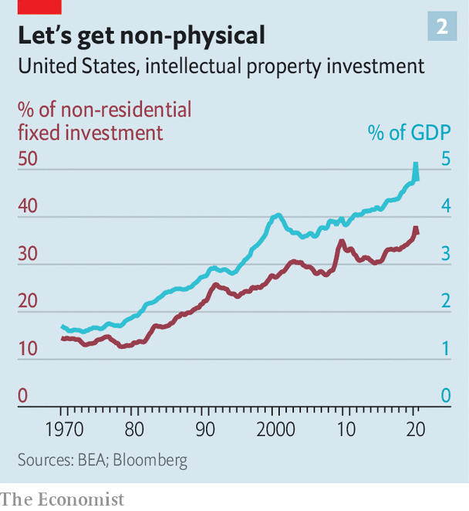

The treatment of intangibles in mergers makes a mockery of this. If, say, one firm pays $2bn for another that has $1bn of tangible assets, the residual $1bn is counted as an intangible asset—either as brand value, if that can be appraised, or as “goodwill”. That distorts comparisons. A firm that has acquired brands by merger will have those reflected in its book value. A firm that has developed its own brands will not.

The second important aspect of intangibles is their unique characteristics. A business whose assets are mostly intangible will behave differently from one whose assets are mostly tangible. Intangible assets are “non-rival” goods: they can be used by lots of people simultaneously. Think of the recipe for a generic drug or the design of a semiconductor. That makes them unlike physical assets, whose use by one person or for one kind of manufacture precludes their use by or for another.

In their book “Capitalism Without Capital” Jonathan Haskel and Stian Westlake provided a useful taxonomy, which they call the four Ss: scalability, sunkenness, spillovers and synergies. Of these, scalability is the most salient. Intangibles can be used again and again without decay or constraint. Scalability becomes turbo-charged with network effects. The more people use a firm’s services, the more useful they are to other customers. They enjoy increasing returns to scale; the bigger they get, the cheaper it is to serve another customer. The big business successes of the past decade—Google, Amazon and Facebook in America; and Alibaba and Tencent in China—have grown to a size that was not widely predicted. But there are plenty of older asset-light businesses that were built on such network effects—think of Visa and Mastercard. The result is that industries become dominated by one or a few big players. The same goes for capital spending. A small number of leading firms now account for a large share of overall investment (see chart 3).

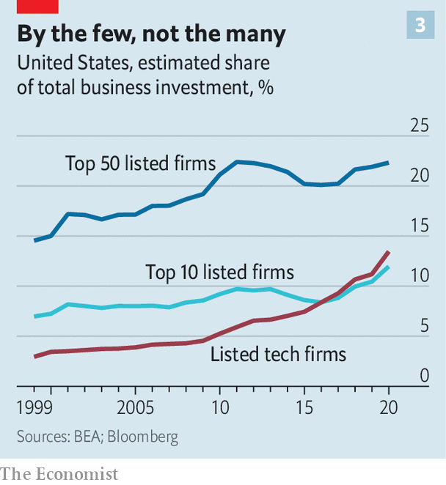

Physical assets usually have some second-hand value. Intangibles are different. Some are tradable: you can sell a well-known brand or license a patent. But many are not. You cannot (or cannot easily) sell a set of relationships with suppliers. That means the costs incurred in creating the asset are not recoverable—hence sunkenness. Business and product ideas can easily be copied by others, unless there is some legal means, such as a patent or copyright, to prevent it. This characteristic gives rise to spillovers from one company to another. And ideas often multiply in value when they are combined with other ideas. So intangibles tend to generate bigger synergies than tangible assets.

The third aspect of intangibles to consider is their implications for investors. A big one is that earnings and accounting book value have become less useful in gauging the value of a company. Profits are revenues minus costs. If a chunk of those costs are not running expenses but are instead spending on intangible assets that will generate future cashflows, then earnings are understated. And so, of course, is book value. The more a firm spends on advertising, R&D, workforce training, software development and so on, the more distorted the picture is.

The distinction between a running expense and investment is crucial for securities analysis. An important part of the stock analyst’s job is to understand both the magnitude of investment and the returns on it. This is not a particularly novel argument, as Messrs Mauboussin and Callahan point out. It was made nearly 60 years ago in a seminal paper by Merton Miller and Francesco Modigliani, two Nobel-prize-winning economists. They divided the value of a company into two parts. The first—call it the “steady state”—assumes that that the company can sustain its current profits into the future. The second is the present value of future growth opportunities—essentially what the firm might become. The second part depends on the firm’s investment: how much it does, the returns on that investment and how long the opportunity lasts. To begin to estimate this you have to work out the true rate of investment and the true returns on that investment.

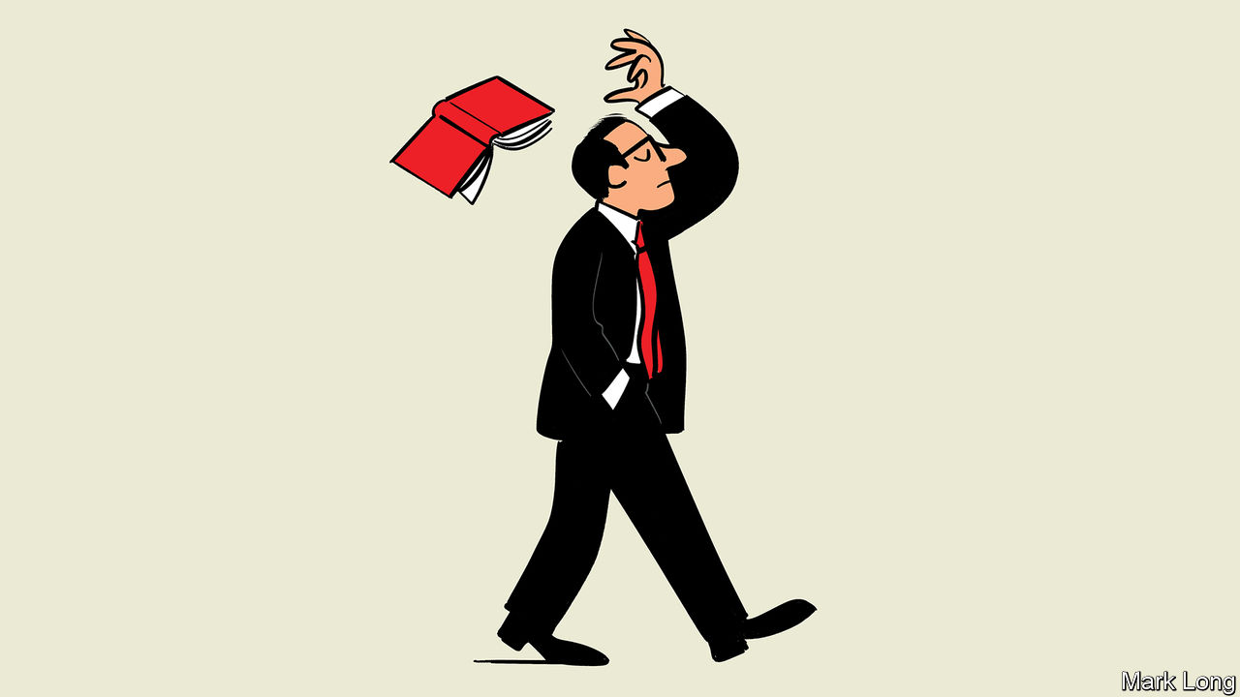

The nature of intangible assets makes this a tricky calculation. But worthwhile analysis is usually difficult. “You can’t abdicate your responsibility to understand the magnitude of investment and the returns to it,” says Mr Mauboussin. Old-style value investors emphasise the steady state but largely ignore the growth-opportunities part. But for a youngish company able to grow at an exponential rate by exploiting increasing returns to scale, the future opportunity will account for the bulk of valuation. For such a firm with a high return on investment, it makes sense to plough profits back into the firm—and indeed to borrow to finance further investment.

Picking winners in an intangible economy—and paying a price for stocks commensurate with their chances of success—is not for the faint-hearted. Some investments will be a washout; sunkenness means some costs cannot be recovered. Network effects give rise to winner-takes-all or winner-takes-most markets, in which the second-best firm is worth a fraction of the best. Value investing seems safer. But the trouble with screening for stocks with a low price-to-book or price-to-earnings ratio is that it is likelier to select businesses whose best times are behind them than it is to identify future success.

## Up, up and away

Properly understood, the idea of fundamental value has not changed. Graham’s key insight was that price will sometimes fall below intrinsic value (in which case, buy) and sometimes will rise above it (in which case, sell). In an economy mostly made up of tangible assets you could perhaps rely on a growth stock that had got ahead of itself to be pulled back to earth, and a value stock that got left behind to eventually catch up. Reversion to the mean was the order of the day. But in a world of increasing returns to scale, a firm that rises quickly will often keep on rising.

The economy has changed. The way investors think about valuation has to change, too. This is a case that’s harder to make when the valuation differential between tech and value stocks is so stark. A correction at some stage would not be a great surprise. The appeal of old-style value investing is that it is tethered to something concrete. In contrast, forward-looking valuations are by their nature more speculative. Bubbles are perhaps unavoidable; some people will extrapolate too far. Nevertheless, were Ben Graham alive today he would probably be revising his thinking. No one, least of all the father of value investing, said stockpicking was easy. ■

This article was downloaded by calibre from <https://www.economist.com/briefing/2020/11/12/value-investing-is-struggling-to-remain-relevant>

|  |  |  |  |
| --- | --- | --- | --- |
| Previous | Articles | Sections | Next |

|  |  |  |
| --- | --- | --- |
| Briefing | Sections | China |

Asia

Politics in Kyrgyzstan: A crowd-sourced commander-in-chief

.

Australia’s trade with China: Down under and out

.

State elections in India: Against daunting odds

.

Myanmar’s election: Mother knows best

.

Banyan: Money but not a class

.

|  |  |  |
| --- | --- | --- |
| Briefing | Sections | China |

|  |  |  |  |
| --- | --- | --- | --- |
|  | Articles | Sections | Next |

#### A crowd-sourced commander-in-chief

# Is Kyrgyzstan’s president saving or smashing the rule of law?

He insists it would be impossible to become a strongman, even if he wanted to

Nov 14th 2020 | ALMATY

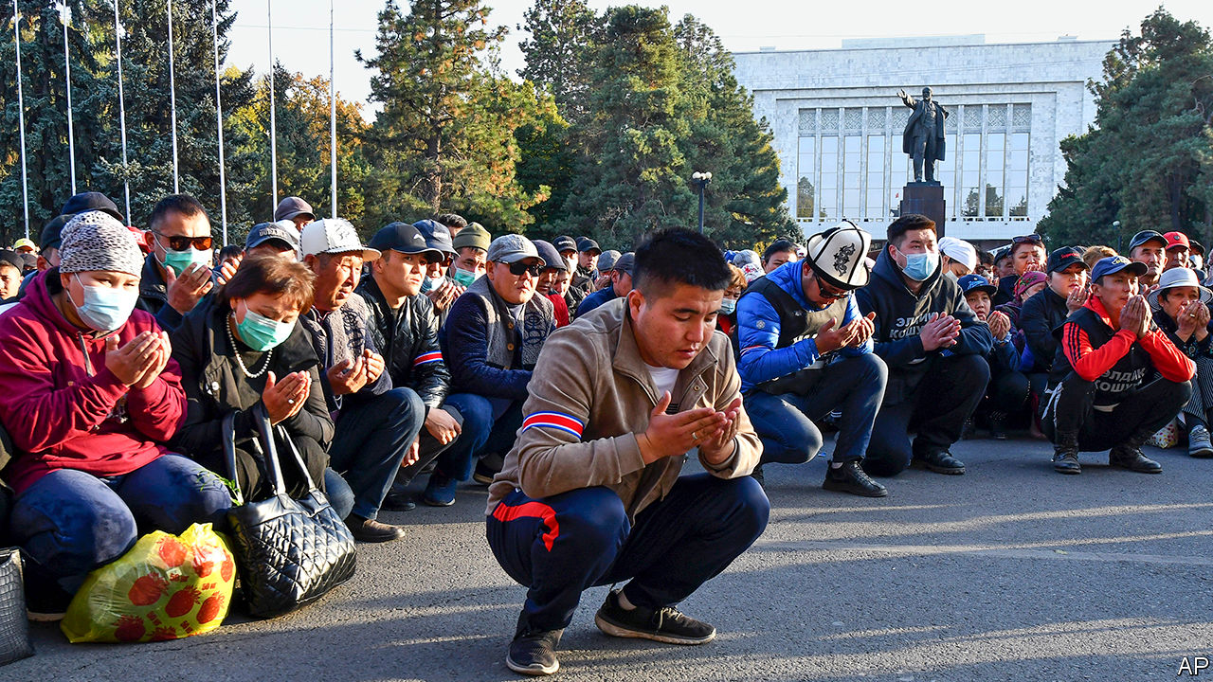

AMERICAN DIPLOMATS warned of an “attempt by organised crime groups to exert influence over politics and elections”. The acting mayor of the capital city stepped down in protest at a “wave of ochlocracy”—mob rule. MPs complained that they were being coerced into acceding to an illegitimate power grab. A candidate for prime minister was knocked unconscious when thugs attacked a political rally.

Yet the man who has benefited most from the tumult in Kyrgyzstan, Sadyr Japarov, denies that his meteoric rise, from prison to the presidency in ten days, has any sinister underpinning. It was popular protests that brought him to power, he says. Those who claim “that I’m a bandit, that I came out of prison and seized power” are simply political rivals trying to smear him, he insisted this week in an interview with The Economist over WhatsApp. Far from trying to hijack Kyrgyzstan’s shaky democracy, he intends to “establish justice, transparency, honesty and legality, and eradicate corruption at the root”, he said.

In early October crowds protesting about tainted parliamentary elections sprang Mr Japarov and several other politicians from prison. When the prime minister resigned to appease the protesters, Mr Japarov got MPs from the outgoing parliament to award him the job, though there were rows about quorums and proxy votes. He then persuaded the president to resign and the speaker of parliament to decline the role of acting president, which therefore fell to Mr Japarov instead.

Mr Japarov next convinced MPs to delay fresh elections for parliament, to allow for a presidential poll in January first—to the consternation of many officials and political parties. As acting president he would not be allowed to stand, so he plans to resign, handing the reins to an ally he has helped install as speaker of parliament. And he wants to amend the constitution to strengthen the presidency and reduce the clout of parliament.

Mr Japarov, a former MP, rose to prominence by campaigning for the nationalisation of Kumtor, a Canadian-owned gold mine. He has twice been convicted of crimes in connection with his political activism: once for leading a crowd that stormed the grounds of the White House, which houses parliament and the president’s office, and once for orchestrating the kidnapping of a local official as part of a protest, although he was not present at the time and denied any involvement. He is more comfortable speaking Kyrgyz than Russian, which sets him apart from the Russophone elite. His nationalism goes down well in a country that fears becoming an economic dependency of neighbouring China and has suffered strife between the Kyrgyz majority and the Uzbek minority.

The uprising that brought Mr Japarov to power is the third since 2005. Although the mountainous country of 6m is sometimes described as the only democracy in Central Asia, in practice it has run through a series of presidents whose behaviour gradually became more autocratic until they were turfed from office by public protests. With politics in constant turmoil and competing politicians in search of financial backing, organised crime has flourished. Journalists last year exposed a smuggling ring which laundered at least $1bn of its proceeds abroad (GDP last year was $8bn). America has labelled Kyrgyzstan a “major money-laundering country”.

Mr Japarov insists he marks a break with all that. He has ordered the arrest of two alleged crime bosses whom the previous government left be: Raimbek Matraimov, who has been accused of involvement in the smuggling ring, and Kamchybek Kolbayev, whom America has labelled a “significant foreign narcotics trafficker”. Mr Kolbayev remains in detention, but Mr Matraimov was allowed to return home after promising to pay the state $24m in a vague penalty for unspecified abuses. The opacity and arbitrariness of this step (Mr Japarov concedes it was a political decision, although he denies links to Mr Matraimov) have prompted some to question Mr Japarov’s sincerity. Keneshbek Duyshebayev, a former senior security official, dismisses his attack on organised crime as a “show”.

By the same token, when Mr Japarov speaks of the need for constitutional reforms to ensure strong, stable government, some see a naked power grab. The present constitution was intended to guard against strongman rule. Its architect, Omurbek Tekebayev, an MP, says Mr Japarov’s proposals will set Kyrgyzstan’s politics back 30 years, to their state at the time of independence from the Soviet Union in 1991. This week journalists issued a statement expressing “extreme concern” about Mr Japarov’s vilification of outlets that have criticised him—“distorted information” is his constant retort to uncomfortable questions—which presents a “risk to the free press”. Last month a mob of his supporters threatened to burn down the offices of an obstreperous radio station and website.

Yet Mr Japarov is trying to present himself as a moderate, unifying force. Tilek Toktogaziyev, the politician attacked by Mr Japarov’s supporters, has been named minister of agriculture. Mr Japarov has also won over Omurbek Babanov, a liberal opposition leader who ran for president in 2017. Mr Babanov says he won’t run in the coming election and has endorsed Mr Japarov instead. Mr Japarov promises not to pursue the politics of revenge “because I’ve been through that myself”. In early November he invited the only two former presidents who are not in exile or in prison—Sooronbay Jeyenbekov, whom Mr Japarov has just elbowed out of office, and Roza Otunbayeva, the elder stateswoman of Kyrgyz politics—to attend an event with him.

Mr Japarov is also toning down his jingoism. “I am not a nationalist,” he insists, promising to rule for Kyrgyz and minorities alike. He says he is not sure whether it is worth nationalising the Kumtor mine any more, given its dwindling reserves. He has urged protesters to end their attacks on Chinese firms. Locals must understand the value of such investments, he says, and keep the country open for business.

Mr Japarov seems likely to win the election, given the reluctance of possible rivals to run. His flair for populism is evident: he has ordered the removal of the fence around the White House, to reduce the distance between politicians and the governed. And whatever constitution the country ends up with, he insists, he could never become a strongman, thanks to the ultimate safeguard: the Kyrgyz people. “They can put up with things for a year, or two, or three, then chase out any president,” he says. “You can’t establish a dictatorship in our country.” ■

This article was downloaded by calibre from <https://www.economist.com/asia/2020/11/14/is-kyrgyzstans-president-saving-or-smashing-the-rule-of-law>

|  |  |  |  |
| --- | --- | --- | --- |
|  | Articles | Sections | Next |

|  |  |  |  |
| --- | --- | --- | --- |
| Previous | Articles | Sections | Next |

#### Down under and out

# China is curbing imports of more and more Australian goods

It may have more than one motive

Nov 14th 2020 |

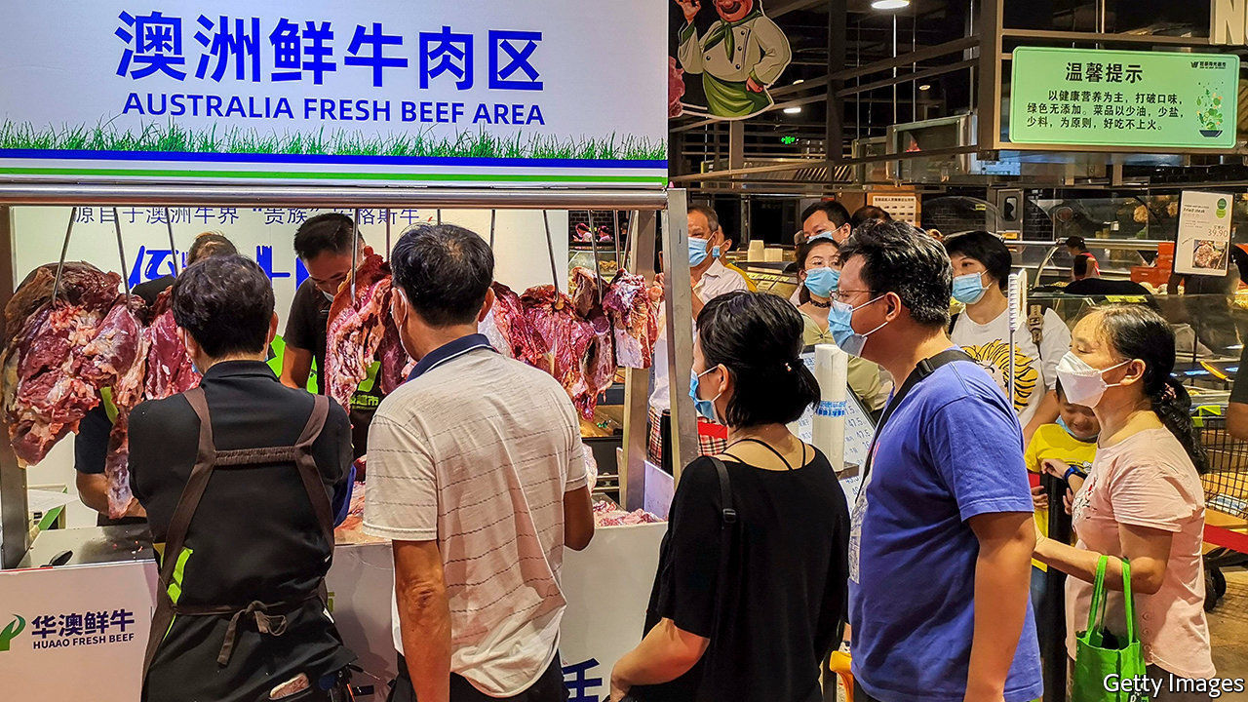

THE ROW is already six months old and is steadily intensifying. In May China imposed an 80% tariff on imports of Australian barley and restrictions on imports of Australian beef. More recently shipments of Australian lobsters have been subject to delays. Aussie wine has been formally threatened with higher tariffs. The Chinese authorities are reportedly discouraging firms from buying Australian coal, cotton and timber. There are fears that more Australian goods will soon feel the squeeze. On November 9th Australia’s trade minister, Simon Birmingham, said that rumours of an outright, if unofficial, ban on seven big exports did not appear to be correct.

China hoovers up a third of Australia’s exports of goods. Belinda Allen of the Commonwealth Bank of Australia calculates that 7% of the total have now been affected by or threatened with restrictions. (China is also a massive consumer of Australian services such as education and tourism.)

In theory, China has distinct and unrelated reasons for each step it has taken. The tariffs on wine and barley are supposedly because those products are being exported below cost. Concerns about hygiene have been used to justify impediments to food imports, and so on. The Australian government assumes there is a bigger grievance at work, though Mr Birmingham’s Chinese counterpart won’t even speak to him, much less explain.

The spat started shortly after Australia led international calls for an inquiry into the origins of covid-19. Australia has also annoyed China by rejecting its claims in the South China Sea, legislating to prevent Chinese interference in Australian politics and cosying up to the likes of America, Japan and India—with which it is holding joint naval exercises this month.

China could also be angling for specific concessions. Its investigation into the “dumping” of barley came after Australia launched 33 anti-dumping probes of Chinese goods between 2006 and 2018. The two countries began talks on a trade deal in 2005 on the condition that Australia treat China as a market economy, making dumping claims harder to sustain—but Australia never followed through.

Restrictions on agricultural products may have another benefit for China, too. The Chinese government has pledged to buy $37bn of agricultural goods from America as part of a recent trade deal, but is badly behind schedule. Pushing Chinese importers away from Australian suppliers could help to get it back on track.

Whatever the explanation, the Australian government has been encouraging exporters to find other buyers, and has been pursuing trade deals that might help, including the reportedly imminent Regional Comprehensive Economic Partnership, which involves other 14 countries, including China. A recent poll by the Lowy Institute, a think-tank, found that 94% of Australians supported government efforts to reduce dependence on China.

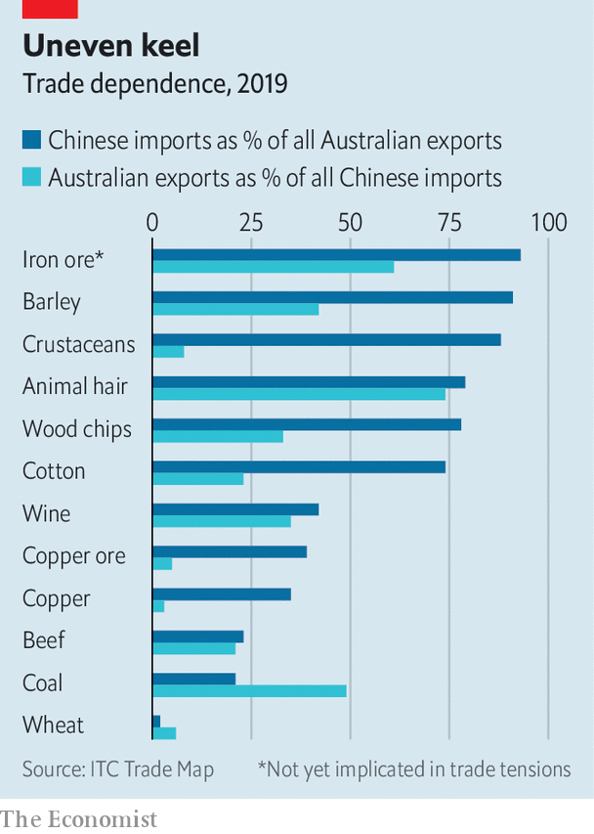

Realistically, though, China is too big a market for Australian exporters to replace very quickly. For most of the affected products, China, in contrast, can easily find other sellers. For some goods, such as coal, it may want to succour its own producers. Iron ore is the only big Australian export of which China would struggle to find alternative suppliers (see chart)—and trade in it, oddly enough, has not been curtailed. ■

This article was downloaded by calibre from <https://www.economist.com/asia/2020/11/14/china-is-curbing-imports-of-more-and-more-australian-goods>

|  |  |  |  |
| --- | --- | --- | --- |
| Previous | Articles | Sections | Next |

|  |  |  |  |
| --- | --- | --- | --- |
| Previous | Articles | Sections | Next |

#### Against daunting odds

# Despite the pandemic, India’s ruling party triumphs again

An alliance led by Narendra Modi’s BJP wins an election in Bihar, the second-biggest state

Nov 14th 2020 | DELHI

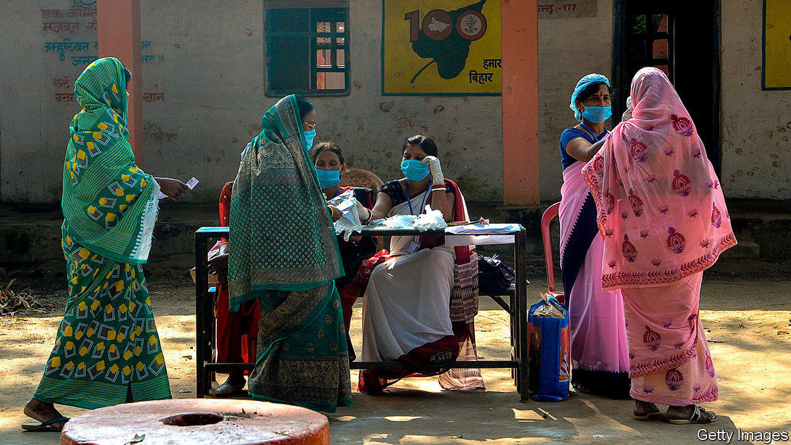

AS THE STATE of Bihar went to the polls at the end of October, its 125m citizens were contending with both the pandemic and the associated economic slump. Would they punish the Bharatiya Janata Party (BJP) of the prime minister, Narendra Modi? Exit polls suggested they might.

But when the results were released on November 11th, they showed the BJP and its local ally, the Janata Dal (United) (JDU), winning roughly the same share of the vote as their biggest challengers, a coalition of the local Rashtriya Janata Dal (RJD), leftist parties and Congress, a much enfeebled party that nonetheless remains the only nationwide rival to the BJP. In terms of seats in the state assembly, the BJP’s alliance actually won a narrow majority. And within the alliance it was the BJP that performed best, winning most of the seats it contested. The JDU, whose leader, Nitish Kumar, has served three near-consecutive terms as Bihar’s chief minister, floundered.

“The BJP has achieved exactly what it wanted in Bihar, which is to have a government but to cut Nitish Kumar down to size,” says Pavan Varma, a former adviser to Mr Kumar. To make things sweeter for the BJP, Congress won only a meagre 19 of the 70 seats it fought. Better yet for Mr Modi, the Election Commission declared his party the winner in dozens of local by-elections that were held simultaneously in 11 other states. Most significantly it strengthened its hold on the pivotal state of Madhya Pradesh, returning under its banner a clutch of deputies whose defection from Congress last year gave the BJP a narrow majority in the state assembly.

Given that India’s economy has shrunk perhaps by 10% since covid-19 hit and that more than 128,000 people have died from the disease, this was a stellar performance. Six years into office and 18 months after winning a landslide national election, Mr Modi has not only kept his own sheen bright but has also expanded his party’s influence. The serial humiliation of Congress, now widely blamed for dragging down the opposition’s “grand alliance” in Bihar, will further shrink its bargaining power in other states where it needs allies to challenge the BJP. And by outshining his own ally in Bihar, Mr Modi has again shown the effectiveness of a tactic that has transformed the BJP from a regional party to the dominant political force across India. In state after state it has gained power with the help of a local partner, only to eclipse it gradually with the help of its vastly greater financial resources and the disciplined ground troops provided by Hindu-nationalist groups allied to the party.

To be fair, the BJP’s narrow victory in Bihar owes as much to the fragmenting of its opponents in a first-past-the-post system as to its own potency. Congress’s ally, the RJD, a local party led by the 31-year-old scion of a political dynasty, won 75 seats, one more than the BJP. With a slightly broader coalition it might have carried the day.

Four more states are due to elect new assemblies in the first half of next year. Several of the contests promise to be big and brutal. The BJP has vowed to seize West Bengal in particular. If Mr Modi had begun to worry that he was losing his famous hawa, or tailwind, he will be resting easier now. ■

Editor’s note: Some of our covid-19 coverage is free for readers of The Economist Today, our daily [newsletter](https://my.economist.com/user#newsletter). For more stories and our pandemic tracker, see our [hub](https://www.economist.com/news/2020/03/11/the-economists-coverage-of-the-coronavirus)

This article was downloaded by calibre from <https://www.economist.com/asia/2020/11/14/despite-the-pandemic-indias-ruling-party-triumphs-again>

|  |  |  |  |
| --- | --- | --- | --- |
| Previous | Articles | Sections | Next |

|  |  |  |  |
| --- | --- | --- | --- |
| Previous | Articles | Sections | Next |

#### Mother Suu does it again

# Aung San Suu Kyi’s party claims victory in Myanmar’s election

Its main opponent, an army-backed party, refuses to concede defeat

Nov 11th 2020 | YANGON

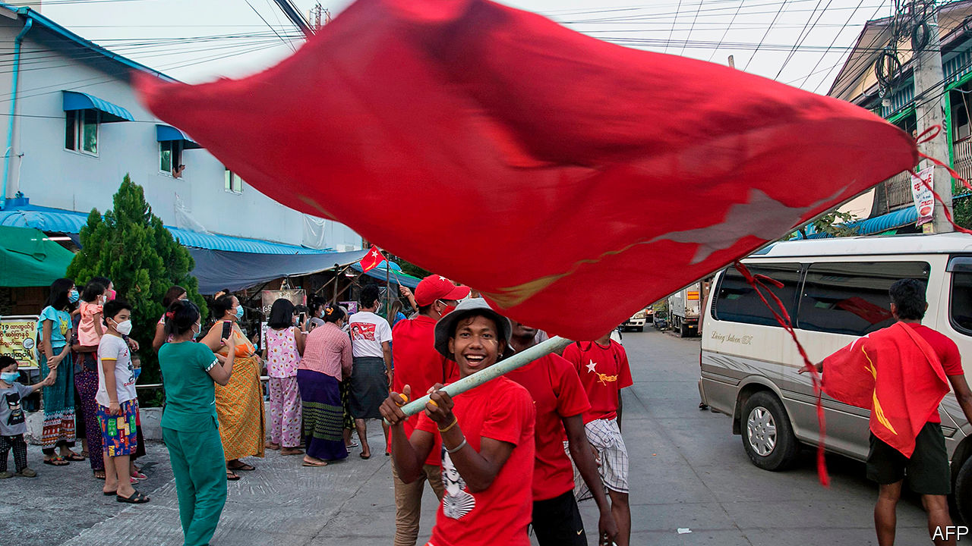

SU PON CHIT had to contain her excitement. It was November 8th, the day of Myanmar’s second election since the end of military rule in 2015. A poll observer, she was duty-bound to be impartial. But she is also an ardent supporter of Aung San Suu Kyi, Myanmar’s de facto leader, and her party, the National League for Democracy (NLD). She watched as voters queued and ballots were counted in her neighbourhood in Yangon, the commercial capital. The NLD’s tally, scrawled on a blackboard, soared past its opponents’. Exhausted but jubilant, Ms Su Pon Chit went home to write her report. Hundreds of NLD supporters, sharing her confidence, flocked to party headquarters to celebrate.

The Union Election Commission, which organised the poll, has not yet released all the results, but Monywa Aung Shin, the NLD’s spokesperson, says it has won 399 of the 476 elected seats in the two chambers of the legislature. That is enough to form a government and name the president, and nine more than the NLD won in its big victory five years ago. Once again the NLD appears to have trounced its biggest opponent, the army-backed Union Solidarity and Development Party (USDP), and it has beaten expectations in states dominated by ethnic minorities.

The USDP, however, claims that the poll was unfair. The election commission is an easy target. It is appointed by the president, an NLD stalwart. It did not publish the final number of registered voters until after voting started. It disqualified candidates well into the campaign. Citing security worries, it did not hold elections in several states, disenfranchising 1.5m voters, mainly from ethnic minorities. Yet on the day itself, the Carter Centre, an NGO that monitored the election, found “no major irregularities”.

Nevertheless, the scale of the NLD’s victory is surprising. Its record in office has been lacklustre. Economic growth has been disappointing. Efforts to end the civil wars simmering on the country’s periphery are flagging. Discontent with the NLD has been mounting, especially among ethnic minorities.

After their poor performance in the previous election in 2015, many parties championing ethnic minorities merged, in order not to split the opposition vote. The number of covid-19 cases sharply increased in September, just as campaigning began, stirring fears about turnout.

But “Mother Suu” remains hugely popular in Myanmar, especially among the ethnic-Bamar majority, but also with some minorities. Win Lae Shwe Yee, an ethnic Shan, voted for the NLD in this election and in 2015. She vehemently disagrees with those who have come to see the NLD as a party of the Bamar, rather than all Burmese, saying Ms Suu Kyi works “tirelessly” for the whole country. It helps that the NLD tends to field candidates from the dominant ethnicity in each constituency. Moreover, it controls government budgets, notes Salai Jimmy Rezar Boi, secretary of the Chin National League for Democracy (CNLD), an ethnically based party. He says that in Chin state, the NLD, having promised to build schools, bridges and the like, took 35 out of 39 seats in the state parliament, up from 28 in 2015. The CNLD won just one.

The army may have given the NLD an unintentional fillip just days before the election, when Min Aung Hlaing, the commander-in-chief, impugned the integrity of the election and accused the government of making “unacceptable mistakes”, prompting fears that the top brass might repudiate the election result (it is anyway guaranteed 25% of the seats in parliament, enough to block constitutional reform). The general, perhaps realising his mistake, later said he would accept the outcome. But Moe Thuzar of the ISEAS-Yusof Ishak Institute, a think-tank in Singapore, suspects that his intervention helped to turn out the vote. On November 11th the USDP demanded that the election commission “hold a new election again, co-operating with the military”. That will only strengthen Mother Suu’s appeal. ■

This article was downloaded by calibre from <https://www.economist.com/asia/2020/11/11/aung-san-suu-kyis-party-claims-victory-in-myanmars-election>

|  |  |  |  |
| --- | --- | --- | --- |
| Previous | Articles | Sections | Next |

|  |  |  |  |
| --- | --- | --- | --- |
| Previous | Articles | Sections | Next |

#### Banyan

# Filipinos working abroad are a source of money, not reform

They tend to admire strongman politics

Nov 12th 2020 |

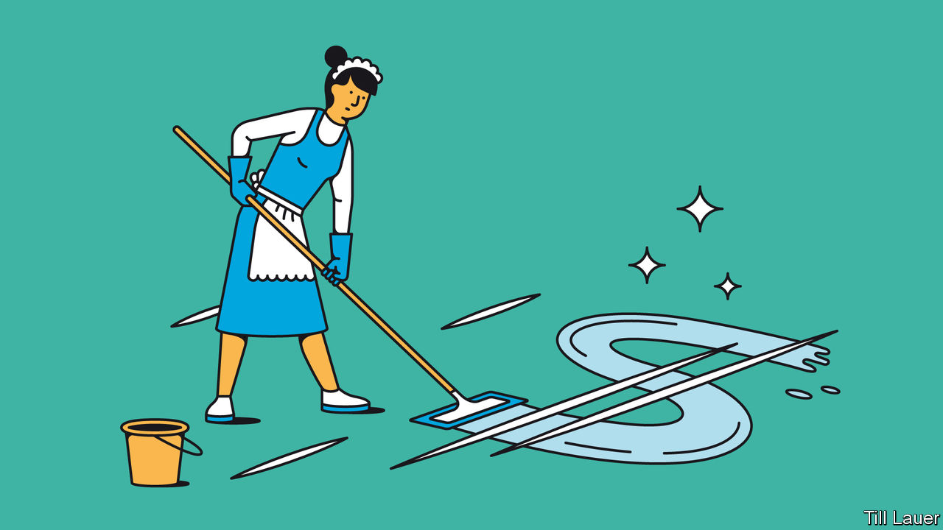

NINE MONTHS after Taal volcano erupted, life in the Calabarzon region of the Philippines, south of the capital, Manila, is slowly returning to normal, despite the raging pandemic. Cinders buried houses, destroyed papaya plantations and sent tens of thousands fleeing. Today, the roads have been cleared and the power is back on. Evacuees have returned to patch up homes. Local distilleries producing lambanog, a fierce spirit made from fermented palm sap, have sputtered to life. Few locals, though, are holding their breath for the promised splurge of government assistance. That leaves only one sure source of income: remittances from relatives working abroad.

The 2.2m Overseas Filipino Workers (OFWs, as they are typically known) are feted nationally for their sacrifices. Nearly half toil in Saudi Arabia or the Gulf states as maids, drivers or hotel staff. All hotel bands in China seem to have a Filipina singer. Hong Kong has more than 150,000 OFWs and Singapore 120,000, most of them women working as domestic helpers and nannies. Central Hong Kong on a Sunday is like the Philippines writ small: a pavement map of the country’s many languages as Filipinas gather with friends from their region.

A fifth of all OFWs are from Calabarzon. One, Bernadette, is a nanny in Hong Kong. Her home in Calaca, in the shadow of the volcano, escaped the worst of the ash fall. But many of her friends have been sending what money they earn (just over HK$5,000, or $645, a month) to help rebuild homes and livelihoods destroyed by the eruption.

In other respects, Bernadette’s story is typical. The 40-year-old has worked in Hong Kong for a decade, far from her husband and son. She supports not only them but an elderly father with big medical bills. She has put the son, now 17, through boarding school. Her six siblings call on her when they have a financial emergency. Through all this, she has bought a plot of land back home and built a two-storey house. She and many other OFWs are immensely proud of what they have accomplished. They are welcomed on their annual Christmas trip home (cancelled this year because of the pandemic) as bayani, or heroes. Huge parties are thrown for them. They nearly always pay.

OFWs are only one part of a 10m-strong Philippine diaspora. Without the Philippines’ 378,000 seafarers, the global merchant fleet would be sunk. Nurses, doctors and oil and mining engineers the world over make up an expatriate professional class. In all, the diaspora sends home $30bn a year, a tenth of GDP.

Politicians recognise the political and economic clout of expatriates. In Calaca, says Bernadette, they woo OFWs with promises of jobs when they return, scholarships for their children or health insurance—“but they are just trying to get our vote.” Presidential candidates or their proxies come to Hong Kong for rallies. Not only do OFWs’ votes count, but loved ones at home will listen to them.

On occasion, expats’ social-media campaigns have drawn attention to government corruption or incompetence, such as after the deadly Typhoon Haiyan in 2013. Some academics hope that expatriates, when they return, can in future help reshape the country’s politics, demanding better government and a more responsive approach to the country’s inequalities in the place of graft and the cult of the strongman. There are too few signs of that happening. OFWs do not yet represent the kind of middle class capable of urging change. While remittances can enable upward mobility—Bernadette’s son plans to study aeronautical engineering—they can just as easily be spent by husbands on booze, roast pigs, gambling and lovers. Professionals, meanwhile, are more likely to emigrate permanently.

One professional returnee, Ronald Mendoza, dean of the school of government at Ateneo de Manila University, posits another factor: OFWs work largely in authoritarian places, where the model of the strongman is rarely questioned.

Most Filipinas in Hong Kong, for example, were bemused by recent pro-democracy protests and approve of their suppression. As for President Rodrigo Duterte, who embodies personal rule and promotes vigilante justice, he remains wildly popular among OFWs. When, at home, this columnist lamented that 18 journalists have been murdered while Mr Duterte has been unremittingly hostile to the press, his Filipina cleaner was indignant, taking it as an insult to her president. Banyan was impelled to mutter an apology.

This article was downloaded by calibre from <https://www.economist.com/asia/2020/11/12/filipinos-working-abroad-are-a-source-of-money-not-reform>

|  |  |  |  |
| --- | --- | --- | --- |
| Previous | Articles | Sections | Next |

|  |  |  |
| --- | --- | --- |
| Asia | Sections | United States |

China

Politics in Hong Kong: Leaving in despair

.

Self-help books: Highly effective people’s republic

.

Chaguan: Tea before dawn

.

|  |  |  |
| --- | --- | --- |
| Asia | Sections | United States |

|  |  |  |  |
| --- | --- | --- | --- |
|  | Articles | Sections | Next |

#### Leaving in despair

# Hong Kong’s legislature has been stripped of a vocal opposition

Expulsions and resignations have left the body almost entirely toothless

Nov 14th 2020 | HONG KONG

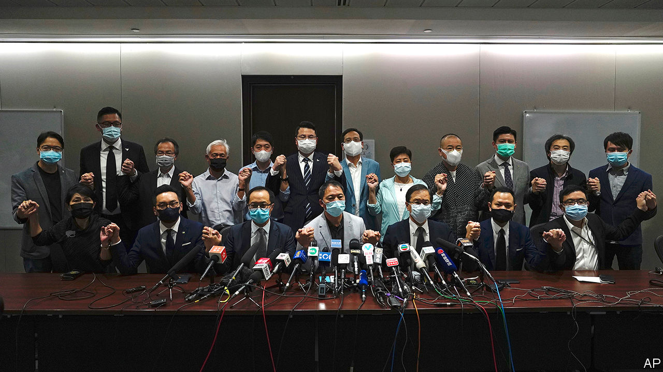

THERE IS “nothing to be ashamed of”, said Hong Kong’s leader, Carrie Lam, when asked how she would feel about the territory’s legislature passing controversial bills after being stripped of an opposition by the expulsions and resignations of pro-democracy lawmakers. “We are more excited when bills are passed more efficiently.” Mrs Lam’s remarks on November 11th signalled a dark new phase of China’s campaign to snuff out Hong Kong’s freedoms and usher in rule by rubber stamp as practised on the Chinese mainland.

Storm clouds had been gathering over the Legislative Council (commonly known as Legco) ever since China imposed a draconian national-security law on Hong Kong on June 30th. In July the local government barred 12 politicians, including four sitting members of Legco, from standing in elections that were due to be held in September. It accused them of opposing the new law and other political misbehaviour. Shortly afterwards it postponed the elections for a year, citing the pandemic.

Early this month police arrested eight opposition politicians, including five Legco members, for their alleged involvement in a scuffle in the chamber. Then came the ruling by the parliament in Beijing, the National People’s Congress (NPC), that resulted in the final purge and, on the same day, Mrs Lam’s chilling response. It said Hong Kong’s government could disbar any legislator who did not accept Chinese rule in Hong Kong or who otherwise violated national security.

The Hong Kong authorities responded swiftly to the NPC’s edict. It declared that the four legislators who had been barred from re-election would also be stripped of their seats. In response, 15 other opposition lawmakers held a press conference to announce they would resign in sympathy (see picture). With two others from their camp having already stepped down in September in protest against the postponement of the polls, their move would leave Legco with no opposition voice for the first time in decades. The legislators were formally submitting their resignations as The Economist went to press.

Just a year ago prospects looked much brighter for pro-democracy politicians. In local-council elections, held in November 2019 during anti-government unrest that had been sweeping the city since mid-year, they made unprecedented gains. It was widely believed that they would have achieved similar success in this year’s Legco polls, if they had been held—even though only half of the body’s 70 seats are directly elected. By issuing this week’s ruling the NPC has made it clear that even if opposition politicians were to win a majority of seats (in the most recent elections in 2016 they fell just short), their numbers could be whittled down again at the government’s whim.

The four legislators who were disbarred following the NPC’s ruling were Dennis Kwok, Kwok Ka-ki, Kenneth Leung and Alvin Yeung. They are hardly radicals. “We follow the rules of procedure, we wear suits. The four of us—two lawyers, one doctor, one accountant—are the most moderate of moderates,” says Dennis Kwok. The government has not spelled out why they were kicked out. But in July, when they were disqualified from standing again, they were variously accused of signing petitions against the national-security law, pledging to block passage of the budget were democrats to gain a majority and supporting American sanctions on Hong Kong. In March Mr Leung travelled to California to attend a conference about such sanctions. But he says he did not encourage the imposition of them, fearing they would harm Hong Kong’s economy.

Pro-democracy politicians—at least those not disqualified—may still stand in next year’s elections. Mr Leung says the next Legco must have an opposition. But the trend is clear. Vocal opposition in Legco, which increasingly has involved filibustering by democrats, will be throttled. The opposition “may have to shift to venues outside the establishment” to express discontent, says Eliza W.Y. Lee of the University of Hong Kong—although, as she notes, opportunities for street activism are being shut down, too. The national-security law, along with coronavirus-related restrictions, have all but stamped out unrest.

It is unlikely that many members of the public will be upset by the democrats’ departure from Legco. Those who support the government have long regarded them as troublemakers bent on disrupting legislative proceedings. Opinion polls suggest the government’s many critics have little hope that the legislature will ever be democratic. So, as the Communist Party tightens control over Legco, they increasingly regard the involvement of pro-democracy politicians in it as meaningless, says Ho-Fung Hung of Johns Hopkins University. In September the Hong Kong Public Opinion Research Institute canvassed views on the decision to delay the elections. It found an almost even split among opposition supporters between those who wanted their camp’s legislators to carry on working during Legco’s extended term, and those who preferred that they resign. “I’ve been receiving a lot of messages of support from members of the Hong Kong public saying they don’t want us to give credence to this institution anymore. They tell us that by remaining, we give it some sort of credibility,” says Mr Kwok.

Such pessimism is easy to understand. Since the security law was adopted there has been a steady stream of news that has spooked Hong Kong’s democrats. Several outspoken academics have been forced to quit, or have not had their contracts renewed. Earlier this month a television journalist was arrested after helping to produce a story for Hong Kong’s public broadcaster, RTHK, that was critical of the police response to an attack by thugs on anti-government protesters during last year’s protests. Her alleged offence was obtaining car-ownership details from a government database using a false pretext.

But the existence of an opposition in Legco, however frustrated by the electoral system (almost half of the seats are reserved for interest groups such as industries and professions), has long made Hong Kong’s political system stand out from the mainland’s. The prospect of a Legco deprived even of the few teeth it has is indeed a bleak one. ■

This article was downloaded by calibre from <https://www.economist.com/china/2020/11/14/hong-kongs-legislature-has-been-stripped-of-a-vocal-opposition>

|  |  |  |  |
| --- | --- | --- | --- |
|  | Articles | Sections | Next |

|  |  |  |  |
| --- | --- | --- | --- |
| Previous | Articles | Sections | Next |

#### Highly effective people’s republic

# Why self-help books are so popular in China

To cope with rapid change, some people crave pointers

Nov 14th 2020 |

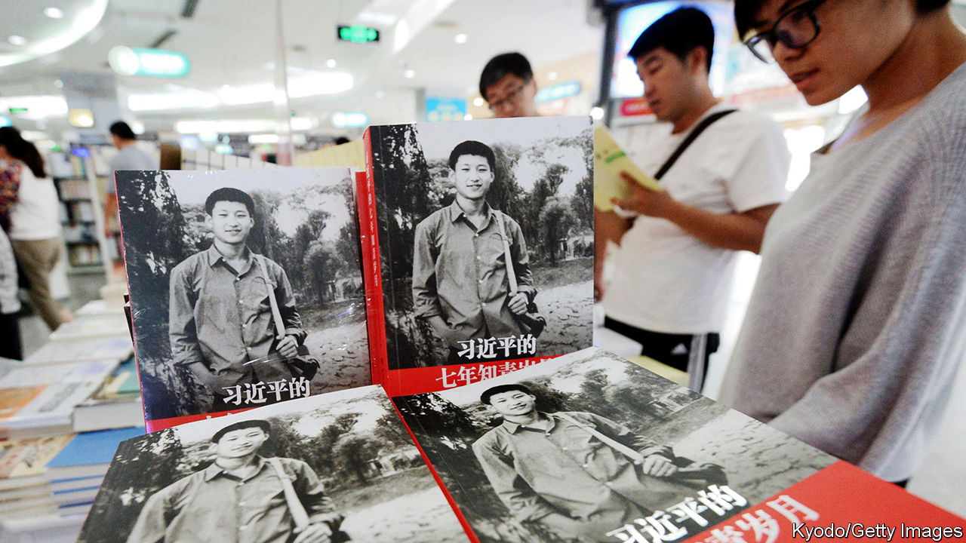

BOOKSHOPS IN CHINA are replete with works offering advice on self-betterment. Topics range from coping with shyness (“How to Make Friends with Strangers in One Minute”) to succeeding in business (“Financial Management in Seven Minutes”). The title of one recent bestseller urges: “Don’t Opt for Comfort at the Stage of Life that is Meant to be Difficult”. Their popularity and contents reflect the stresses of a society in rapid flux—one in which paths to wealth are opening up in ways barely imaginable a generation ago and competition is fierce (see [article](https://www.economist.com/node/21795328)).

Reliable statistics on China’s book market are hard to find. But according to a study by Eric Hendriks-Kim, a sociologist at the University of Bonn, self-help books may account for almost one-third of China’s printed-book market. In America they make up only 6% of adult non-fiction print sales, reckons NPD Group, a research firm.

Although China’s leaders keep stressing the need for China to be “self-reliant”, seekers of advice on how to succeed often turn to American books for guidance. In China last year the top ten self-help sellers included translations of several American works, such as “How to Win Friends and Influence People”, “Peak: Secrets from the New Science of Expertise” and “The Seven Habits of Highly Effective People”.

Chinese readers appear more eager for such imports than people in many other countries that are culturally closer to America. That may be because both China and America are “hyper-competitive and materialistic regimes”, argues Mr Hendriks-Kim, who has described this in his book “Life Advice from Below: the Public Role of Self-Help Coaches in Germany and China”. In the early 2000s a Chinese translation of “Who Moved My Cheese?”, a motivational book by an American, Dr Spencer Johnson, became so popular that a play based on it toured theatres and the Chinese word for cheese acquired a new meaning: one’s own self-interest. Books proliferated in China with cheese in their titles.

China has a long tradition of reading for practical purposes. In 2018 fiction accounted for 7% of sales, compared with more than 30% in Germany. “One of the most striking features of China’s market for books is its absolute and passionate relevance to life,” said a report in 2006 by Arts Council England. The exam-focused education system leaves little time to develop interpersonal skills, so people, desperate for advice on how to sell themselves, turn to self-help books instead.

That may suit the Communist Party, eager as it is to promote “positive energy”. But the party would prefer native-born role models. State media have touted a book by President Xi Jinping, “Seven Years as an Educated Youth”, as the kind of tome people should study (see picture). It describes Mr Xi’s hard life in the countryside during the Cultural Revolution of the 1960s and 1970s. “Is there really any self-help book better than Xi’s?” asked one headline.

Mr Xi is also fond of the classics, some of which are being repurposed for self-improvement purposes. Yu Dan, perhaps China’s best-known pop philosopher, has sold 11m legal copies (millions more may have been peddled in photocopied form) of “Confucius from the Heart”. Some Chinese have mocked it for making the sage sound “much like the masters of American self-help”, says Mr Hendriks-Kim.

Perhaps the self-help industry has come full circle. After all, China’s 6th-century-BC masterpiece for would-be generals, “The Art of War” by Sun Tzu, was arguably the self-help prototype. Its title has been echoed, consciously or otherwise, in the names of countless other books of the genre. One such is Donald Trump’s “The Art of the Deal”. Its fifth and most recent translation in China was published in 2016 by the Communist Youth League. ■

This article was downloaded by calibre from <https://www.economist.com/china/2020/11/14/why-self-help-books-are-so-popular-in-china>

|  |  |  |  |
| --- | --- | --- | --- |
| Previous | Articles | Sections | Next |

|  |  |  |  |
| --- | --- | --- | --- |
| Previous | Articles | Sections | Next |

#### Chaguan

# For the 100th Chaguan column, customers at a chaguan muse on life

China is a restless, brutally unequal place—but the tea is excellent

Nov 14th 2020 |



DECADES SPENT brewing tea in rural Sichuan have left Li Qiang with firm views on what makes for an authentic chaguan, or Chinese teahouse. If age and beauty were the only tests, his shop, the Old Teahouse in Pengzhen, would pass easily. A place to drink tea for more than a century, the grey-roofed, timber-framed building dates back to the Ming dynasty, when it was a temple to Guanyin, a Buddhist immortal. Maoist slogans painted on the walls, in characters of faded red, reflect Pengzhen’s history as a people’s commune. Hours before dawn the air is already thick with tobacco smoke and fumes from a coal-fired stove, for the first customers arrive for “early tea” at half past three in the morning. Human companionship makes a teahouse, says Mr Li, who rented the hall from a collective enterprise in 1995. Only when customers treat a teashop like a home is it a chaguan, he declares. Until then, in Mr Li’s withering judgment, it is merely “selling tea to passers-by”.

Your correspondent visited Pengzhen this week to mark the 100th Chaguan column, a name that pays homage to China’s teahouses and their history as places where ideas are exchanged. Mr Li’s establishment draws a stream of locals. Many are old men in farmers’ blue cotton jackets and caps, puffing on pungent cheroots or cigarettes in sturdy bamboo armchairs. Those photogenic customers lure Chinese urbanites, who carry expensive cameras and look for images of rural life or selfies to post on social media. Such a diverse customer base makes Mr Li’s teahouse a good place for an experiment: an unscientific survey of how Chinese think. It being unsafe and unfair to ask Chinese citizens directly, in public, about Communist Party rule, this columnist spent a happy (if painfully early) few hours asking people two questions often used to assess morale in different countries. The first concerns a subject’s own economic circumstances. The second is about whether future generations are likely to be better off than their parents.

The exercise generated strikingly consistent answers. Despite wide differences of age and education, patrons in the Old Teahouse are optimistic about China as a whole, after decades of rising prosperity. Yet many also describe modern life as stressful, with too many families chasing too few chances to secure a good education, a good job and other paths to success.

Jiang Huiyun, an 82-year-old widow, sits in a prime window-seat each morning from four o’clock. Crop-haired and chain-smoking, Ms Jiang married in 1957 at a time of scarcity and hunger. Her wedding feast consisted of carrot porridge, but only after she had pleaded tearfully with her production-brigade leader for an advance on her vegetable ration. None of her four children finished junior high school. Her eldest son dropped out in his first year of primary school after being unjustly accused of vandalism. He earned money by “collecting dog shit and chicken shit”, remembers Ms Jiang. In the 1950s toughs attacked anyone with a side business as “capitalists”, she recalls. During the Cultural Revolution, from 1966 to 1976, Red Guards smashed Buddhist statues in Pengzhen’s temple-teahouse and “nobody dared to stop them”.

Unsurprisingly, she thinks life today is far better. As a rural pensioner she receives social insurance and old-age payments of over 2,000 yuan ($300) a month. Her grandchildren, having graduated from university, are upwardly mobile like many young people these days. A quarter-century ago just one-in-twenty Chinese attended university. Today half of all Chinese youngsters of undergraduate age are in higher education. Ms Jiang no longer lives in fear of hunger or political violence. Still, some forms of scarcity involve things that are harder to spot, such as equal access to opportunity. Like many in Pengzhen, Ms Jiang’s family have rural household-registration, or hukou. As a result, her grandchildren are second-class citizens, able to live and work in big cities but denied many public services there. Notably, they will have to find fees of 30,000 yuan a year to send Ms Jiang’s great-grandchildren to high school. “If we didn’t borrow money from others, how could we afford that?” she asks. Ms Jiang is emphatic: “We have a good life now.” But she adds: “Young people face a lot of pressures.”

## In China to get rich is glorious, but daily life is a slog

A middle-aged man sipping tea before work will give only his surname, Huang. He praises modern China, declaring that “Each generation is doing better than the last.” Yet Mr Huang’s own life remains precarious. Now 59, he has no retirement fund. So he saves 1,000 yuan from his monthly pay as a cleaner in a factory, which ranges from 2,000 to 4,000 yuan depending on overtime. He went unpaid while covid-19 closed his factory for nearly three months, and has not forgotten the terror of worrying if his savings would run out before work resumed. His hopes rest on enabling his five-year-old grandchild to land a good job one day, though he worries about school fees. Taking early tea is one of his few indulgences. His daughter is too busy working to visit teahouses, he sighs.

Two 20-year-old women photographing tea-drinkers turn out to be undergraduates from Sichuan University of Media and Communications, on a class assignment. “There is definitely a lot of pressure” on the young, says one. She has an internship but no job lined up after graduation. Her mother’s uncomplicated childhood memories—“stealing bananas in the countryside”—make her almost envious. Still, the students are confident that life is better today, though not confident enough to give their names to a foreign reporter asking almost-political questions.

Mr Li, 55, suggests that some people create pressure for themselves by setting their sights too high. A devotee of the simple life, his menu consists of a single item: jasmine tea from Ya’an, in the foothills of the Tibetan plateau. He charges locals one yuan for unlimited refills, and everyone else ten yuan. “You chat a bit, drink some tea every day, that’s happiness,” he says. Pengzhen’s uneventful pleasures are not for everyone, for modern China is a restless, brutally unequal place. The tea, however, is excellent. ■

This article was downloaded by calibre from <https://www.economist.com/china/2020/11/14/for-the-100th-chaguan-column-customers-at-a-chaguan-muse-on-life>

|  |  |  |  |
| --- | --- | --- | --- |
| Previous | Articles | Sections | Next |

|  |  |  |
| --- | --- | --- |
| China | Sections | Middle East & Africa |

United States

Covid-19 and the next president: Transmission and the transition

.

Digesting the election: Nothing to see here

.

Firings and hirings: Going, going, Pentagone

.

Fox News and Donald Trump: Season two is cancelled

.

Rewilding the prairie: Where the wild things are

.

The urban-rural divide: City v hills

.

Lexington: A Democratic defeat in victory

.

|  |  |  |
| --- | --- | --- |
| China | Sections | Middle East & Africa |

|  |  |  |  |
| --- | --- | --- | --- |
|  | Articles | Sections | Next |

#### Transmission and the transition

# What the Biden administration would do differently on covid-19

And how much difference it would make

Nov 11th 2020 | WASHINGTON, DC

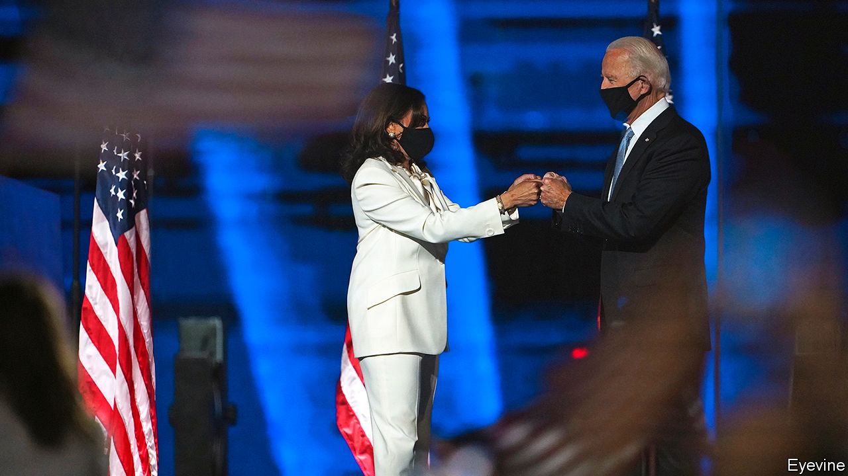

PARTISANSHIP HAS long coloured American perceptions of covid-19. Even so, the contrast between the top echelons of the main parties was striking on November 9th, the day the country passed 10m recorded cases of the disease. On that day the White House of outgoing President Donald Trump was dealing with reports that it may have hosted a second superspreading event in the span of a month—this one for an election-night party that may have sickened Ben Carson, the housing secretary, among others. The same day, President-elect Joe Biden announced the members of the coronavirus advisory board for his transition, staffed by the sort of public-health experts the president likes to mock.

While national attention was otherwise diverted, an extraordinary third surge in covid-19 infections began in the weeks before the presidential election. There are now 1,000 new deaths reported each day along with 120,000 new infections. Even though testing has been ramped up to nearly 1.5m per day, the test-positivity rate is approaching 10%—suggesting that even now, many infections are being missed. In all but a handful of states, there seems to be uncontrolled transmission, limiting the efficacy of contact-tracing. Hospitalisations had been declining up until the end of September, when they bottomed out under 30,000. Now they have doubled to over 60,000—higher than the previous peak in April. In North Dakota, the location of the worst outbreak in the country, nearly every intensive-care bed is occupied.

The argument that Mr Trump has handled the epidemic uniquely terribly may just have cost him the election. However, this most recent surge is not an America First phenomenon. It has roughly coincided with a second wave in Europe which, measured both by deaths and by cases per person, is even more severe. European countries have reimposed harsh lockdown measures, whereas the president and America’s governors have been less draconian. France’s intensive-care wards look almost as strained as those of North Dakota. But whereas President Emmanuel Macron has declared a second national lockdown, Governor Doug Burgum, a Republican, recently declined to impose even a mask mandate in his state.

Forecasting the course of the disease has proved supremely difficult. It is therefore unclear how bad a situation a newly inaugurated President Biden would inherit on January 20th 2021. But current signs do not augur well. Ashish Jha, dean of the Brown University School of Public Health, reckons that there may be 100,000 new deaths between now and then. The Economist’s best estimate of total deaths in America, including those we think are missed by official reporting, is nearly 300,000. After nine long months of living with the virus, Americans and their elected officials seem tired of restrictions on movement and businesses. With no new curbs, exponential growth could continue for weeks. Cold weather may push more people to move their gatherings indoors, where transmission is much more likely. Many Americans will travel for Thanksgiving and Christmas; no politicians will want to take the blame for cancelling the holidays.

Federal action on the economy does not seem imminent either. Democrats and Republicans in Congress have been deadlocked over a new economic stimulus since many supports expired in July. The stalemate has not yet been broken. Nancy Pelosi, the Democratic leader in the House of Representatives, may wish to hold out for the larger package her party could achieve if Democrats win two run-off Senate elections in Georgia, thus flipping control of the chamber. Mitch McConnell, the Republican leader in the Senate, may not want to concede a pre-emptive victory to the Biden administration.

A virus spreading fast with no compensating stimulus would be a brutal starting position for a Biden administration. Even with expedited approval and distribution, getting a vaccine to every American who needs it would take months (see Briefing). Mr Biden has announced plans to take more serious federal action. He has named Ron Klain, who co-ordinated Obama White House’s response to an Ebola outbreak in 2014, as chief-of-staff. Mr Biden would use his executive authority to create a Rooseveltian Pandemic Testing Board to compel companies to produce more tests, laboratory materials and personal protective equipment. He probably lacks the authority to impose a mask mandate nationwide, but would push states to do so.

Most Republican governors are already wary about implementing public-health measures. They might see the chance to defy Mr Biden’s recommendations as an additional incentive to stay that course. Democratic ones seem averse to a European-style response too. The ban announced by Phil Murphy, the Democratic governor of New Jersey, on indoor dining in restaurants between 10pm and 5am, typifies the urge to do something, but not too much.

In her vice-presidential debate with Mike Pence, Kamala Harris expressed some distrust in the imminent vaccine Mr Trump had been hyping ahead of the election. “If the doctors tell us we should take it, I’ll be the first in line to take it. Absolutely. But if Donald Trump tells us to take it, I’m not taking it,” she said. Republican voters offered a new vaccine by President Biden might be similarly sceptical. Already, 33% of Republicans tell pollsters that they would not take a coronavirus vaccine when it becomes available, compared with 18% of Democrats and 31% of independents.

While campaigning, Mr Trump liked to talk about covid-19 as though it were almost over. “It is disappearing” he said on October 10th, shortly after contracting it himself. “We are rounding the corner,” he argued on October 22nd. The assessment of Mr Biden’s transition team is more in tune with reality, which is a good start. “Our country is facing an unprecedented time with covid-19 cases accelerating nationwide,” says Marcella Nunez-Smith, a Yale epidemiologist who is co-chairing Mr Biden’s advisory board. Anyone who hopes the virus will go away once America installs a president who follows scientific advice is likely to be disappointed.■

Editor’s note: Some of our covid-19 coverage is free for readers of The Economist Today, our daily [newsletter](https://my.economist.com/user#newsletter). For more stories and our pandemic tracker, see our [coronavirus hub](https://www.economist.com/news/2020/03/11/the-economists-coverage-of-the-coronavirus). For analysis of the presidential transition, explore our [US elections hub](https://www.economist.com/us-election-2020)

This article was downloaded by calibre from <https://www.economist.com/united-states/2020/11/11/what-the-biden-administration-would-do-differently-on-covid-19>

|  |  |  |  |
| --- | --- | --- | --- |
|  | Articles | Sections | Next |

|  |  |  |  |
| --- | --- | --- | --- |
| Previous | Articles | Sections | Next |

#### Nothing to see here

# The Republican Party and Donald Trump’s alternative election fantasy

Four fifths of Trump voters think Joe Biden’s win was illegitimate

Nov 14th 2020 | WASHINGTON, DC

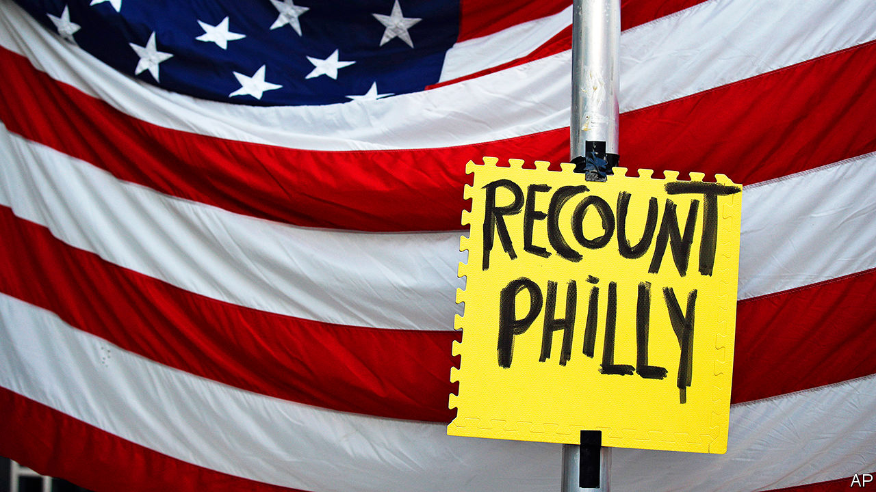

AMONG REPUBLICANS’ favourite grievances over the past four years is a claim that Democrats never accepted the results of the 2016 election. In fact, nine hours after the Associated Press called the election for Donald Trump, Hillary Clinton took to a much smaller stage than she had hoped to command to say that she had “congratulated Donald Trump, and offered to work with him on behalf of our country.” Soon afterward, then-President Barack Obama said he would “make sure that this is a successful transition...we are now all rooting for [Mr Trump’s] success in uniting and leading the country.” Democrats may not have liked the result, but they did nothing to prevent Mr Trump from taking office.

Things have gone differently this time. The Associated Press called the election for Joe Biden on November 7th. Mr Trump has spent the time since insisting that he won and tweeting evidence-free conspiracy theories. His campaign has filed lawsuits in five states that Mr Biden won, and his administration has refused to co-operate with Mr Biden’s transition team. And although four Republican senators have congratulated Mr Biden and his running-mate, Kamala Harris, most elected Republicans have remained quiet or supported Mr Trump’s effort to challenge the result, an effort which looks doomed to failure.

Typically, the head of the General Services Administration (GSA), the federal government’s non-partisan procurement agency, issues an “ascertainment” letter, which gives the incoming president’s transition team access to federal funds and space, within 24 hours of an election being called. Emily Murphy, whom Mr Trump appointed GSA head in 2017, has yet to do so. White House officials note precedent from 2000, in which a disputed election delayed the start of a transition until December.

Then the election hinged on just 537 votes in a single state, Florida. Of the five states where the Trump campaign has filed post-election lawsuits—Nevada, Arizona, Michigan, Georgia and Pennsylvania—Mr Biden’s smallest margin of victory is over 11,000 votes (in Arizona). His lead in Michigan is nearly 150,000 votes. His campaign has produced no evidence of fraud or irregularities large enough to shift tens of thousands of votes in multiple states.

A few prominent Republicans, notably senators Mitt Romney, Susan Collins, Lisa Murkowski and Ben Sasse, have acknowledged Mr Biden’s victory. Other senators have implicitly done so. Roy Blunt noted that Mr Trump’s legal challenges will probably fail. Marco Rubio has urged the GSA to begin its transition process.

Most have fallen back on, in the words of Mitch McConnell, the Senate majority leader, defending Mr Trump’s “rights to look into allegations...and weigh his legal options”. Some Republican Senate staffers explain this reticence by saying that allowing the courts to rule in these cases will build trust in the result. Larry Hogan, Maryland’s anti-Trump Republican governor, calls his party’s response “a train wreck,” but says that behind the scenes, a growing number of Republicans have “had some pretty frank conversations with him, and he doesn’t seem to be listening.”

So far, Mr Trump’s lawsuits have fared poorly. But as long as he keeps fighting, most Republicans see more political risk in accepting Mr Biden’s victory—and thus inviting the wrath of Mr Trump—than in humouring him. Another goal of his lawsuits may be to raise just enough doubt about the outcome in key states to pressure Republican-held state legislatures to put forth their own sets of electors, substituting their will for the voters’.

And continuing to fight keeps the pressure on other Republicans. Brad Raffensperger, Georgia’s secretary of state, has acceded to the Trump campaign’s demand for a hand recount, to be conducted by all of Georgia’s 159 counties at taxpayer expense. Recounts rarely change more than a few hundred votes, but Georgia’s will be difficult to complete before the state’s certification deadline of November 20th—particularly for the state’s larger and more Biden-friendly counties. That, in turn, raises the risk of the state legislature appointing a Trump-friendly slate of electors.

Mr Trump’s administration has also backed him. Asked about transition plans at a briefing on November 10th, Mike Pompeo, the secretary of state, made what seemed to be a joke about “a smooth transition to a second Trump administration”. One day earlier Mr Barr, who previously compared line prosecutors to preschoolers, authorised them to investigate allegations of electoral irregularities.

Mr Trump is fundraising on the back of his refusal to concede. His campaign sends out several texts each day, warning that “the Left will try to STEAL this election”, and urging recipients to “step up & FIGHT BACK” by sending cash—most of which will go to a Trump’s political action committee.

Going along with it makes some sense for elected Republicans, at least in the short term. Most of their voters like Mr Trump more than they like their congressman or senator. In the medium term, though, if the party wants to get back into the business of winning over a majority of Americans it needs to move past him. This will become harder if Republican elites send their voters a signal that he is the rightful president, rather than Joe Biden.

Republican timidity risks long-term damage. Mr Pompeo’s hilarious gags may hamper American diplomats’ work on transitions of power in younger democracies abroad. At home, Mr Trump’s doubt-sowing about the election has damaged Americans’ faith in their own institutions. The most recent Economist/YouGov poll shows that 86% of Mr Trump’s voters believe Mr Biden’s victory to be illegitimate. Mr Trump will leave office on January 20th, but the distrust he has sowed will not.■

Dig deeper:  
For the latest on the election, see our [results page](https://www.economist.com/graphic-detail/2020/11/03/the-us-2020-election-results), read the [best of our 2020 campaign coverage](https://www.economist.com/us-election-2020) and then sign up for Checks and Balance, our [weekly newsletter](https://www.economist.com/checksandbalance/) and [podcast](https://www.economist.com/checks-and-balance-our-weekly-podcast-on-american-politics) on American politics.

This article was downloaded by calibre from <https://www.economist.com/united-states/2020/11/14/the-republican-party-and-donald-trumps-alternative-election-fantasy>

|  |  |  |  |
| --- | --- | --- | --- |
| Previous | Articles | Sections | Next |

|  |  |  |  |
| --- | --- | --- | --- |
| Previous | Articles | Sections | Next |

#### Going, going, Pentagone

# Another Defence Secretary is sacked, most likely for insufficient subservience

The president brings a bizarre cast into the Department of Defence

Nov 14th 2020 |

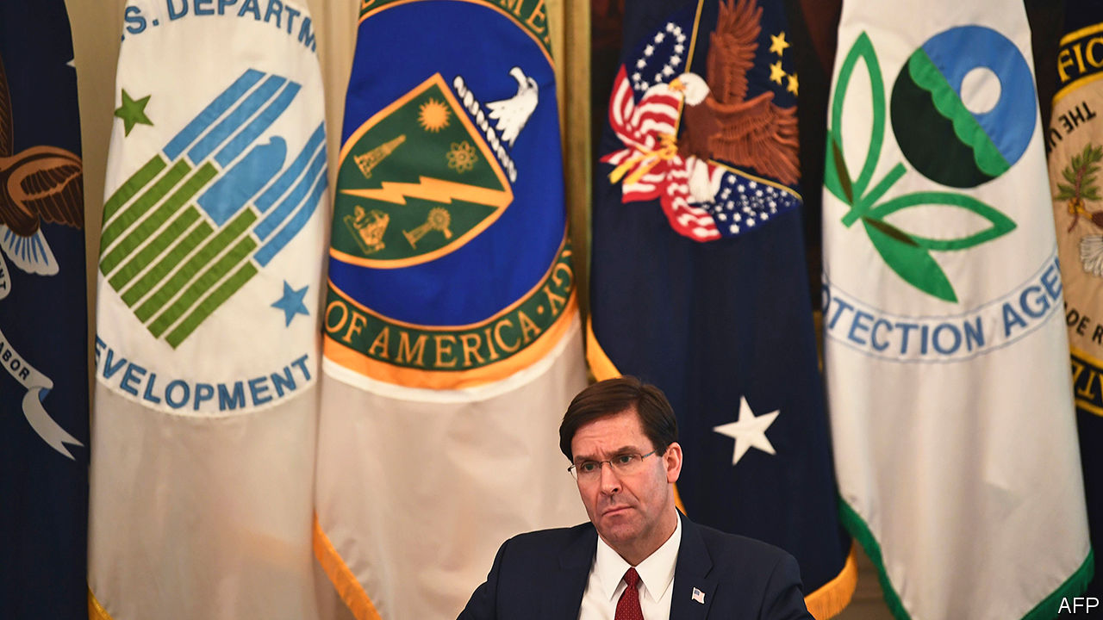

ANTHONY TATA, a retired brigadier-general, wrote in 2018 that Barack Obama was a Muslim “terrorist leader”. Shortly afterward he accused John Brennan, a former director of the CIA, of sedition, asking Mr Brennan to choose between “firing squad, public hanging, life sentence as a prison b*tch, or just suck on your pistol”. On November 10th Mr Tata was appointed policy chief at the Department of Defence.

His arrival was part of a wider clear-out which also ousted the Pentagon’s chief-of-staff, intelligence chief—and the defence secretary himself. “Mark Esper has been terminated”, tweeted Donald Trump on November 9th. That leaves a vacuum of experienced civilian leadership just as America plunges deeper into a political crisis.

Mr Esper’s dismissal was not out of the blue. When protests over racial injustice rocked the country in June, Mr Esper had outraged protesters first by encouraging governors to “dominate the battlespace” and then by appearing alongside Mr Trump in Lafayette Square in Washington, DC, shortly before the area was forcibly cleared of peaceful demonstrators. Mr Esper quickly apologised for his bellicose language and—contradicting the president—said that he did not support invoking the Insurrection Act, a centuries-old law that would allow the domestic use of federal forces to put down unrest. Mr Trump was furious at that act of modest dissent.

In July Mr Esper provoked the president further. First, he approved a promotion for Lieutenant-Colonel Alexander Vindman, who as director for European affairs on the National Security Council had been a key witness during Mr Trump’s impeachment hearing in November 2019 (Colonel Vindman chose to retire). Then he issued an order that in effect banned the Confederate flag, a symbol of the pro-slavery South in America’s civil war, from military facilities. Days later, Mr Trump insisted that “when people proudly have their Confederate flags, they’re not talking about racism…It represents the South.”

That largely settled Mr Esper’s fate. In August the president publicly belittled his defence secretary, calling him “Mark Yesper” (having earlier dubbed him “Mark Esperanto”). In an interview with the Military Times conducted on November 4th and published after his firing, Mr Esper took pride in his record of standing up to the president, asking: “Who’s pushed back more than anybody? Name another Cabinet secretary that’s pushed back.” He went on: “I could have a fight over anything, and I could make it a big fight, and I could live with that—why? Who’s going to come in behind me? It’s going to be a real ‘yes man’. And then God help us.”

Mr Esper’s fears are not unfounded. Like Mr Tata, many of the Pentagon’s new leaders are better known as partisan ideologues than serious policy wonks. Kash Patel, the new chief-of-staff, worked for Devin Nunes, a fervently pro-Trump congressman. In 2018 Mr Patel sought to discredit the FBI investigation into Mr Trump’s ties to Russia. Ezra Cohen-Watnick, the new intelligence chief, worked for Michael Flynn, Mr Trump’s first national security adviser, who later pleaded guilty to lying to the FBI.

Christopher Miller, picked to succeed Mr Esper, carries less political baggage—he served for three decades in the army, retiring as a colonel in 2014—but has little experience. He led the National Counterterrorism Centre for less than three months. Before that, he was a lowly deputy assistant secretary of defence with responsibility for special forces. It is not clear why he has superseded David Norquist, Mr Esper’s formal deputy, as federal statute demands. Because he has been retired for less than seven years, he may also require a waiver from Congress.

“This is a legal move, but it is not a wise one,” says Peter Feaver, an expert on civil-military relations at Duke University who served in Bill Clinton’s and George W. Bush’s administrations. “Normally, administrations are begging the talent to stay through the lame-duck session so they can continue to govern responsibly.” Mr Biden’s transition team will have to deal with officials who have only just turned up themselves. The change of leadership will also disrupt the department’s budget submission for 2022, which is in preparation.

Perversely, the best-case scenario is that Mr Trump has cleaned out the Pentagon “for the petty joy of settling a score”, as Mr Feaver puts it. A more worrying possibility, entertained by some former senior defence officials, both in and out of the Biden camp, is that he is planning a radical policy move, such as an accelerated withdrawal of troops from Afghanistan, Syria or Iraq.

The darkest scenario is that Mr Trump is consolidating control of America’s security forces to frustrate a peaceful transfer of power. Insiders suspect that the heads of the CIA and FBI may be fired next. Mark Milley, the chairman of the joint chiefs of staff, America’s most senior uniformed officer, is said to be in the cross-hairs, too. “It all has a terrible ‘burn it down’ on the way out feeling,” tweeted James Stavridis, a former admiral and commander of NATO. ■

Dig deeper:  
For the latest on the election, see our [results page](https://www.economist.com/graphic-detail/2020/11/03/the-us-2020-election-results), read the [best of our 2020 campaign coverage](https://www.economist.com/us-election-2020) and then sign up for Checks and Balance, our [weekly newsletter](https://www.economist.com/checksandbalance/) and [podcast](https://www.economist.com/checks-and-balance-our-weekly-podcast-on-american-politics) on American politics.

This article was downloaded by calibre from <https://www.economist.com/united-states/2020/11/14/another-defence-secretary-is-sacked-most-likely-for-insufficient-subservience>

|  |  |  |  |
| --- | --- | --- | --- |
| Previous | Articles | Sections | Next |

|  |  |  |  |
| --- | --- | --- | --- |
| Previous | Articles | Sections | Next |

#### Fallen star

# As the Trump show is cancelled, what next for Fox News?

The conservative cable network prepares for a spell in opposition

Nov 14th 2020 |

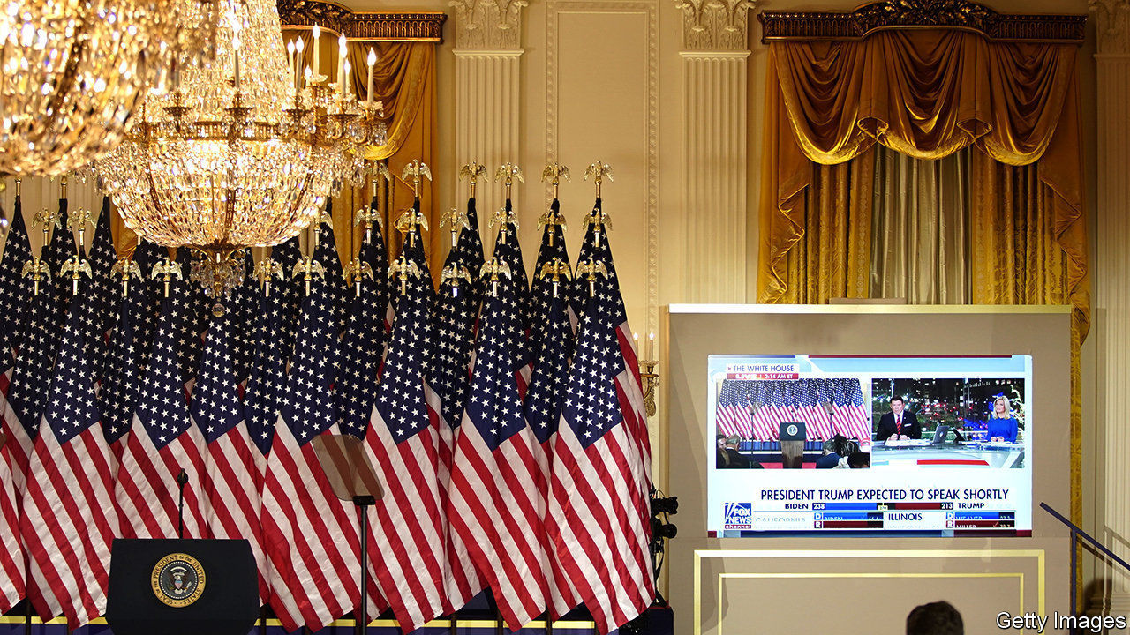

WITH FLORIDA in the bag, at 11.20pm on election night the party at the White House was in full swing. Then Fox News, playing on large television screens around the building, punctured the mood, calling Arizona for the Democrats—the first time a network had projected a Republican state to flip. Despite a complaint from the White House to Rupert Murdoch, Fox’s boss and one-time friend of the president, the Fox decision desk did not budge.

Fox has been the most reliable mainstream-media ally of Donald Trump’s administration. Its hosts have given the president unchallenged airtime and amplified pro-Trump conspiracy theories from the internet. The relationship has been mutually beneficial: since 2015 the network’s ratings have risen by one-third (see chart), and in the latest financial year Fox News and Business generated 80% of Fox Corp’s gross operating profit. Now, with the credits ready to roll on the Trump show, the network must figure out how to deal with the exit—and wrath—of its star.

Fox has influence like no other news outlet. About 60% of Republicans watch it weekly, double the share of any other network. When the Pew Research Centre asked in September whether mail-in ballot fraud was a “major problem”, 61% of Republicans who got their TV news from Fox agreed, compared with 23% of Republicans who got their news elsewhere. Mr Trump, a Fox addict, hired its producers into the White House and sent staff in the other direction.

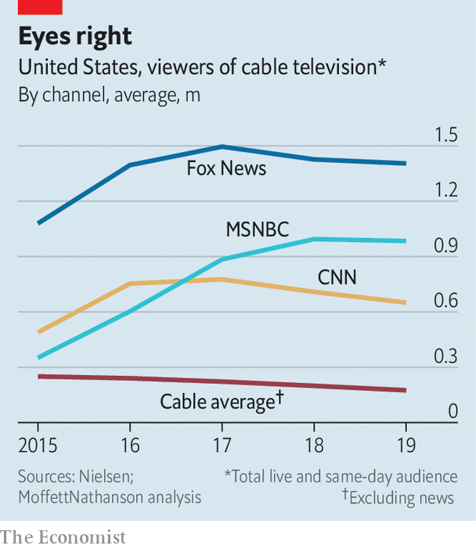

But the lost election has broken the relationship. Prime-time hosts have largely stuck to the White House’s script, Sean Hannity declaring that “it will be impossible to ever know the true, fair, accurate election results.” But Fox’s news anchors have got gutsier. On November 9th Neil Cavuto abruptly cut away from footage in which the White House press secretary was claiming fraud. After the election was called, Fox’s website’s headline read: “Americans take to streets in celebration after Biden projected to win White House”.

Other Murdoch-owned outlets, including the New York Post and Wall Street Journal, have taken a similar line. Mr Murdoch’s friendship with Mr Trump, like most of his alliances, appears pragmatic. In 2015, ahead of the Republican primaries, he tweeted: “When is Donald Trump going to stop embarrassing his friends, let alone the whole country?” When his British newspapers switched their support from the Conservatives to Labour in 1997, he described it as “like two porcupines making love: very slowly and very carefully”.

Fox is already having a prickly time. Outside one Arizona vote-counting centre, Trump fans chanted, “Fox News sucks!”. Despite reporting strong earnings on November 3rd, Fox Corp’s share price dipped. “There appears to be something below the surface that is torpedoing the stock,” wrote Michael Nathanson, a media analyst. “That something might be the potential launch of a new Trump News Network.”

Rival conservative channels that could form the basis of such a venture are gleeful. “Fox News viewers have been writing us and expressing frustration with the fundamental shift…to a more liberal slant,” says Charles Herring, head of One America News, whose website has a story entitled: “Trump Won, Fox News Admitted Its Leftist Agenda”. “We’ve arrived at Waterloo, and the battle is about ready to take place,” declares Chris Ruddy, head of Newsmax. Mr Ruddy says revenues from advertising—for hearing aids, testosterone pills, hats that prevent hair-loss, and so on—have doubled in the past six months.

Yet Fox looks buoyant. Even if Mr Trump became the star of another network, the damage would be to advertising, which makes up only about 30% of Fox News’s revenue. The rest comes from the fees cable companies pay to carry it, and 90% of those deals are locked down for at least two years.

The Trump presidency has been a gift to all news media. “It may not be good for America, but it’s damn good for CBS,” Leslie Moonves, its then-boss, remarked in 2016. But if anything it has been better for the liberal rebels. MSNBC has seen its ratings almost treble since 2015. The New York Times, leader of the resistance in print, has seen subscriptions soar. Fox’s ratings under Mr Trump have been sky high, but its share of the total was greater in the Obama years. The outrage business works better when you’re not in power. ■

Dig deeper:  
For the latest on the election, see our [results page](https://www.economist.com/graphic-detail/2020/11/03/the-us-2020-election-results), read the [best of our 2020 campaign coverage](https://www.economist.com/us-election-2020) and then sign up for Checks and Balance, our [weekly newsletter](https://www.economist.com/checksandbalance/) and [podcast](https://www.economist.com/checks-and-balance-our-weekly-podcast-on-american-politics) on American politics.

This article was downloaded by calibre from <https://www.economist.com/united-states/2020/11/14/as-the-trump-show-is-cancelled-what-next-for-fox-news>

|  |  |  |  |
| --- | --- | --- | --- |
| Previous | Articles | Sections | Next |

|  |  |  |  |
| --- | --- | --- | --- |
| Previous | Articles | Sections | Next |

#### Where the wild things are

# America’s answer to the Serengeti is spreading in Montana

In the contest between wildlife and ranchers, the bears have the upper paw

Nov 14th 2020 | LEWISTOWN, MONTANA

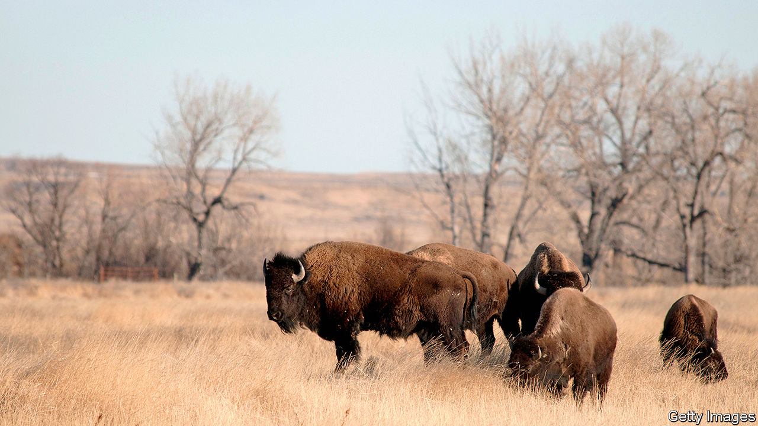

DEANNA ROBBINs and her husband, ranchers in a wild patch of central Montana known as the Missouri Breaks, fought a blizzard this week. They ploughed through knee-deep snow, spending hours to find a herd of black Angus cattle. Then, to feed the cows, they had to dig out bales of buried hay. “We were trudging through drifts, it’s hard work,” she says, but she relished every moment of it. “It has to be in your blood,” she says. Her family have been ranchers in Montana for the past century.

Could anything chase her out? She dislikes change among her neighbours. Abutting her sprawling ranch on three sides is federal land that is being incorporated into a wildlife park. The American Prairie Reserve (APR) was founded as a charity in 2001 and aspires to become the largest park in the Lower 48 states. Already it stretches over nearly 420,000 acres (from 29 ranches it has bought so far), and will eventually grow and stitch together another 2.75m acres of public land. Its aim is for prairie dogs, sage grouse, coyote, bighorn sheep and other species of native plants, birds and mammals to thrive in a contiguous space the size of Connecticut.

For environmentalists, scientists and the APR’s donors—notably wealthy Silicon Valley folk—this is a bold, market-friendly experiment in massive conservation. The area is precious: one of only four vast, temperate, grassland ecosystems left on Earth (steppe land in Mongolia, Kazakhstan and Patagonia are the other three). This territory of shortgrass prairie could become America’s answer to the Serengeti, along the upper reaches of the Missouri River.

In the view of many ranchers, whose beef industry is worth $1.5bn annually in Montana, that is a grim prospect. They worry about more ranch land disappearing into the reserve. “They’d be idling 3.5m acres from food production,” complains Mrs Robbins. She helps to run a campaign against the “elite” APR, known as “Save the Cowboy”. It opposes the sale of ranches to the reserve and argues that the Bureau of Land Management is wrong to allocate federal lands to it. Its placards, showing the silhouette of a big-hatted horserider in an orange sunset, are ubiquitous in central Montanan towns.

A large one is in Lewistown, where the APR will open a centre for tourists. Residents sound less than keen. “We’re trying to preserve the ranching way of life against a bunch of billionaires who came in and got control”, says Kari Weingart. Her husband’s family is unhappy that its old ranch has been sold to the reserve. She says younger Montanans, unexcited by city ways, are growing interested in farming again but struggle to find land. A rancher’s wife, Joann Bristol, suspects the project is a ruse by outsiders to take over from locals. The spending power of the reserve is “scary” while promises of gains from tourism are “overblown” says another.

Then there are long-standing fears of dangerous animals. The odd prairie dog may be cute, but ranchers long ago exterminated wolves, mountain lions and grizzly bears which threatened their stock. Now the APR wants them all back. Wolves and bears may return on their own, from Canada or Yellowstone. The first 850 bison have already been reintroduced; they could eventually number 10,000. Farmers worry bison could trample fences or spread a disease, brucellosis, to cattle. Worse could be the impact of huge increases in elk numbers. The APR wants 40,000 of them, ten-times more than now, to serve as tasty prey for predators. Ranchers fear escaping elk will chomp grass their own cattle need.

Beth Saboe, of the APR, says complaints are overblown. Land prices are rising in Montana, she agrees, but not because of the deep-pocketed charity. One recent factor is that outsiders, fleeing cities because of covid-19, are keen on second homes or land in Big Sky Country. Nor is the APR hostile to agriculture, she says. It lets farmers, for now, graze 14,000 head of cattle on its land and runs a company to sell bison meat. With 63m acres in Montana for farming, it also sees plenty of space for cowboys. Nowhere else in America, however, could host a prairie wildlife reserve of this scale.■

Editor’s note: This article has been changed to clarify that Ms Robbins dislikes change among her neighbours, not the neighbours themselves

This article was downloaded by calibre from <https://www.economist.com/united-states/2020/11/14/americas-answer-to-the-serengeti-is-spreading-in-montana>

|  |  |  |  |
| --- | --- | --- | --- |
| Previous | Articles | Sections | Next |

|  |  |  |  |
| --- | --- | --- | --- |
| Previous | Articles | Sections | Next |

#### The city and the hills

# Our analysis of the election results suggests that 2020 accelerated a long-running trend

American politics is even more split along urban-rural lines than it was four years ago

Nov 14th 2020 | WASHINGTON, DC

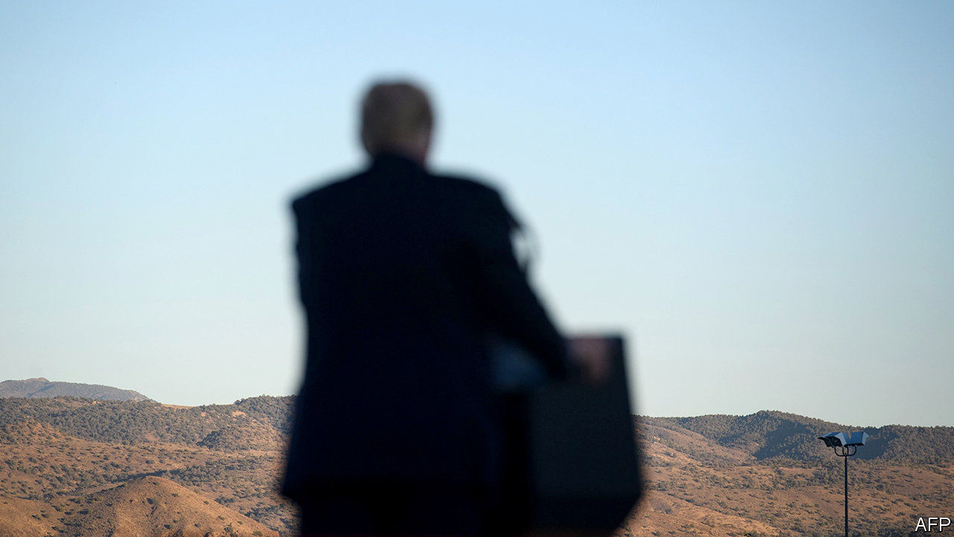

FOR A MOMENT, it looked as if voters were starting to find some common ground. In the weeks leading up to the elections on November 3rd, polls showed that many of the fault lines dividing Democrats and Republicans—including age, race and education—were beginning to narrow. Even the gap between city dwellers and rural folk seemed to be shrinking. According to a poll conducted by YouGov between October 31st and November 2nd, voters in rural areas favoured President Donald Trump over Joe Biden, his Democratic opponent, by a margin of ten percentage points. Four years ago, this gap was 20 points.

But an analysis of the election results by The Economist suggests that the partisan divide between America’s cities and open spaces is greater than ever. Preliminary results supplied by Decision Desk HQ, a data-provider, show that voters in the least urbanised counties voted for Mr Trump by a margin of 33 points, up from 32 points in 2016. (Specifically these are the bottom 20% of counties by population density. Counties which are more than 10% Hispanics, which shifted right for reasons unrelated to density, have been excluded.) Meanwhile, voters in the most urbanised counties—the top 20%—plumped for Mr Biden by 29 points, up from Hillary Clinton’s 25-point margin in 2016. More broadly, the greater the population density, the bigger the swing to the Democratic candidate (see chart). Even after controlling for other relevant demographic factors, such as the proportion of whites without college degrees or Hispanics in each county, the data suggest that urban and rural voters are more divided today than they were in 2016.

Preliminary results also show that Mr Biden gained most ground in counties that swung hardest toward Democrats between Barack Obama’s re-election in 2012 and Hillary Clinton’s failed bid for the White House in 2016. One possible explanation for this trend is the tendency for Democrats and Republicans to live among their own kind. Americans are still sorting themselves into politically like-minded communities, a movement noted by Bill Bishop in “The Big Sort” published in 2008. For liberals, this means diverse, densely populated cities; for conservatives it is places that are mostly white, working-class and where the neighbours are a .22 round away.

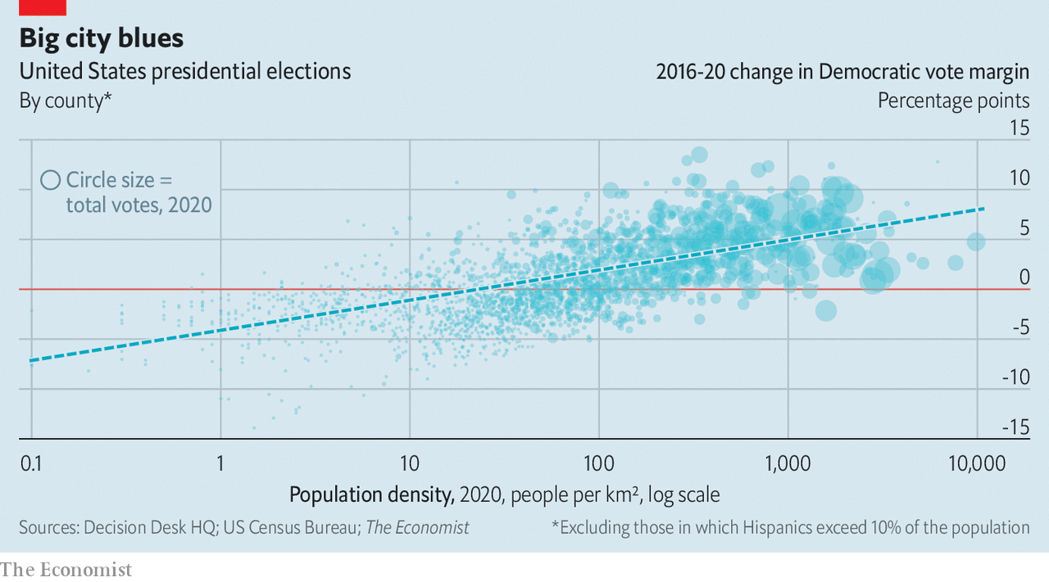

Such sorting has two major consequences. Jonathan Rodden, a professor at Stanford University and author of “Why Cities Lose”, a book about geographic polarisation, says that the partitioning of America by density has led to an underrepresentation of Democratic votes. Because the seats in the House of Representatives and the Senate are awarded on a winner-take-all basis, rather than in proportion to the popular vote, they can end up skewing the allocation of legislative seats away from the party whose voters are crammed into just a few states or congressional districts. As Democrats cluster in cities, the system reduces their political clout. It can be thought of as a natural gerrymander.

Geographic polarisation also hurts Democrats’ chances in the electoral college, America’s system of choosing its president. In this year’s election, for example, Mr Biden will win the national popular vote by about five percentage points. But his margin in the “tipping-point” state that ultimately gave him enough votes to win the election, Wisconsin, will be less than one point. That four-point advantage for the Republicans is the biggest in at least four decades. So long as Democrats continue to be the party of the cities, and Republicans the party of small-town and rural America, those biases will persist.■

Dig deeper:  
For the latest on the election, see our [results page](https://www.economist.com/graphic-detail/2020/11/03/the-us-2020-election-results), read the [best of our 2020 campaign coverage](https://www.economist.com/us-election-2020) and then sign up for Checks and Balance, our [weekly newsletter](https://www.economist.com/checksandbalance/) and [podcast](https://www.economist.com/checks-and-balance-our-weekly-podcast-on-american-politics) on American politics.

This article was downloaded by calibre from <https://www.economist.com/united-states/2020/11/14/our-analysis-of-the-election-results-suggests-that-2020-accelerated-a-long-running-trend>

|  |  |  |  |
| --- | --- | --- | --- |
| Previous | Articles | Sections | Next |

|  |  |  |  |
| --- | --- | --- | --- |
| Previous | Articles | Sections | Next |

#### Lexington

# A Democratic defeat in victory

If Joe Biden’s party cannot wrest power from the Republicans now, when ever will it?

Nov 14th 2020 |

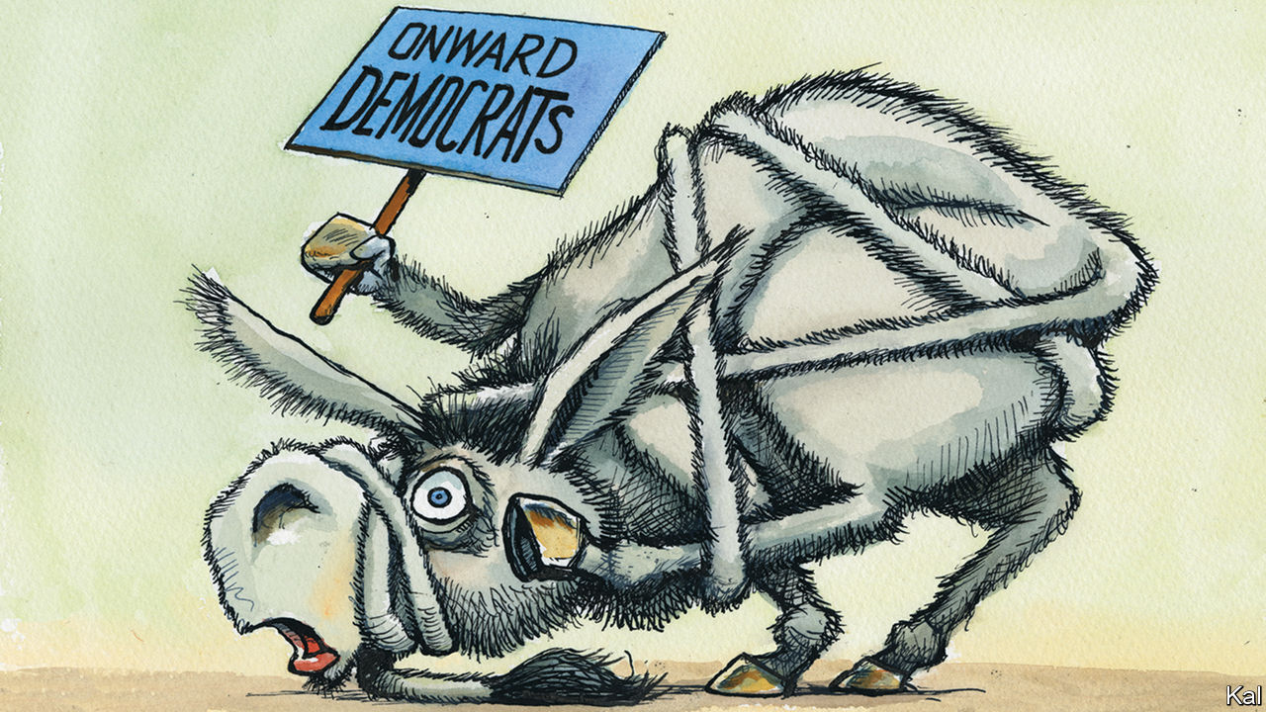

BESIDES DONALD TRUMP, the election’s big loser was the Democratic Party. Having been predicted to win a governing trifecta, it retained its House majority with around six fewer seats, won the White House by a nerve-jangling margin and has probably fallen short in the Senate. Joe Biden can expect to sign little legislation as a result. He may be constrained in his cabinet appointments. If he nominated as attorney-general Stacey Abrams, the hero of his probable win in Georgia and a hate figure on the right, for example, Mitch McConnell might give her the Merrick Garland treatment.

Unlike the president, Mr Biden’s party is already reckoning with its failure. Bruised members of the centre-left—a faction that includes almost all the party’s candidates in the battleground states—blame the activist left for making them seem radical and untrustworthy. The left, in particular its 31-year-old standard-bearer, Representative Alexandria Ocasio-Cortez, is hitting back.

A leaked record of a meeting between House Democrats last week—before Mr Biden’s victory had been called—included angry exchanges between the two groups, which have continued on social media and in the pages of the New York Times. Abigail Spanberger, a narrowly re-elected Virginian moderate, warned that the party must resolve among other things “to not ever use the word socialist or socialism again”. Ms Ocasio-Cortez, a proud democratic socialist, responded by suggesting the centre-left losers didn’t understand how to campaign on social media (unlike her, presumably, with her 10m Twitter followers). Moderates were outraged.

Understandably so. The Democratic losses were in spite of a huge cash advantage and against a Republican opponent that over the past four years appeared to have given up on governing. The Trump party passed no major law besides a tax cut. It has no health-care policy. Yet Democratic candidates ran behind Mr Biden almost everywhere. And there are signs—beyond what Ms Spanberger and other battleground Democrats heard from their constituents every day—that the party’s perceived “radical leftism” was a big reason why. The Democrats lost most ground with two groups that have a special loathing of socialism, Cuban-Americans and Venezuelans. Their shift to the Republicans cost the Democrats two House seats in Florida and Mr Biden the state.

Ms Ocasio-Cortez says this is wrong because it is unfair. No Democrat ran on socialism, “defund the police” or other leftist slogans, she notes. Any damaging impression to the contrary was confabulated by right-wing attack ads—which Democrats should therefore do more to counteract. Point by point, she is right. But as a proposed solution to the Democrats’ problems, it suggests that “AOC”, who won her own district in Queens by a comfortable 38 points, has little conception of how hostile the battlegrounds have become for Democrats.

That chiefly reflects the imbalances in the electoral system, which mean that Democrats, the most popular party, need to filch votes from the other side in a way that less-popular Republicans need not. Democrats’ inflated—as it turned out—hope for this election was to ride an anti-Trump wave big enough to compensate for the over-representation of rural, conservative voters in the Senate and electoral college that is the cause of the imbalance. Some hoped the president’s unpopularity might even give them a big enough Senate majority to reform it. Instead, the Republicans’ structural advantage appears to have grown so large as to have dashed even the Democrats’ more modest expectation of power.

Mr Biden is on course to win the election by more than 5m votes, but the presidency by less than 100,000 across a handful of increasingly conservative states. Wisconsin—the indispensable last component in his electoral-college majority, which he won by a whisker—is more than three points more Republican than the country at large. That is a measure of Mr Biden’s achievement; it may also suggest how unrealistic it was for Democrats to have counted on adding Senate seats in even more conservative states.

If all the battlegrounds continued on their current electoral trajectory, North Carolina and Texas, where they had such hopes, might not turn Democratic until after the ageing, white rustbelt has become so reliably Republican that Democrats will have lost their five Senate seats there. Having approached the election hoping to win sufficient power to reform the system, Democrats are now contemplating a bleak struggle to stay competitive in it.

The early Democratic feuding is mainly a response to the grimness of that prospect. Ms Ocasio-Cortez makes herself an easy target for the aggrieved centre-left. Her claim that Democrats mainly need a better Facebook strategy is as dilettantish as the “defund the police” insanity she signally failed to disavow. The election also suggests the left’s bigger idea to change the political tide, by weaning working-class voters off right-wing identity politics with populist economic policies, may be no more feasible. An electorate that has embraced Mr Biden personally but rejected his agenda as too radical seems unlikely to warm to the left’s actual radicalism. Yet that was already off the menu, following Mr Biden’s thumping win in the Democratic primaries. The dejection of battle-hardened moderates such as Ms Spanberger chiefly reflects the overthrow of their more promising effort to break the partisan deadlock.

## Change the record

If the left dreams of moving America with the power of its ideas, the centre-left places its hope in compiling a solid governing record. The evidence of previous bouts of populism suggests there is no better way to re-establish the centre. It is also a bolder approach than the Sandernistas allow. The Democrats’ historic weakness, devastatingly exploited by the Tea Party movement, is its reputation for defending bad government against small government. The centre-left’s commendably daunting ambition is to compile a reputation for modern, effective government. But to do that, it must have power. And Mr McConnell is likely to give it none.■

Dig deeper:  
For the latest on the election, see our [results page](https://www.economist.com/graphic-detail/2020/11/03/the-us-2020-election-results), read the [best of our 2020 campaign coverage](https://www.economist.com/us-election-2020) and then sign up for Checks and Balance, our [weekly newsletter](https://www.economist.com/checksandbalance/) and [podcast](https://www.economist.com/checks-and-balance-our-weekly-podcast-on-american-politics) on American politics.

This article was downloaded by calibre from <https://www.economist.com/united-states/2020/11/14/a-democratic-defeat-in-victory>

|  |  |  |  |
| --- | --- | --- | --- |
| Previous | Articles | Sections | Next |

|  |  |  |
| --- | --- | --- |
| United States | Sections | The Americas |

Middle East & Africa

South Africa: Ace in the hole?

.

Zambia: Slouching towards Zimbabwe

.

Feminism in Egypt: Speaking up about sex crimes

.

Saeb Erekat: A negotiator in winter

.

|  |  |  |
| --- | --- | --- |
| United States | Sections | The Americas |

|  |  |  |  |
| --- | --- | --- | --- |
|  | Articles | Sections | Next |

#### Ace in the hole

# The arrest of Ace Magashule is good news for South Africa

A ruling-party bigwig who stood in the way of graft-busting reform

Nov 14th 2020 | BLOEMFONTEIN

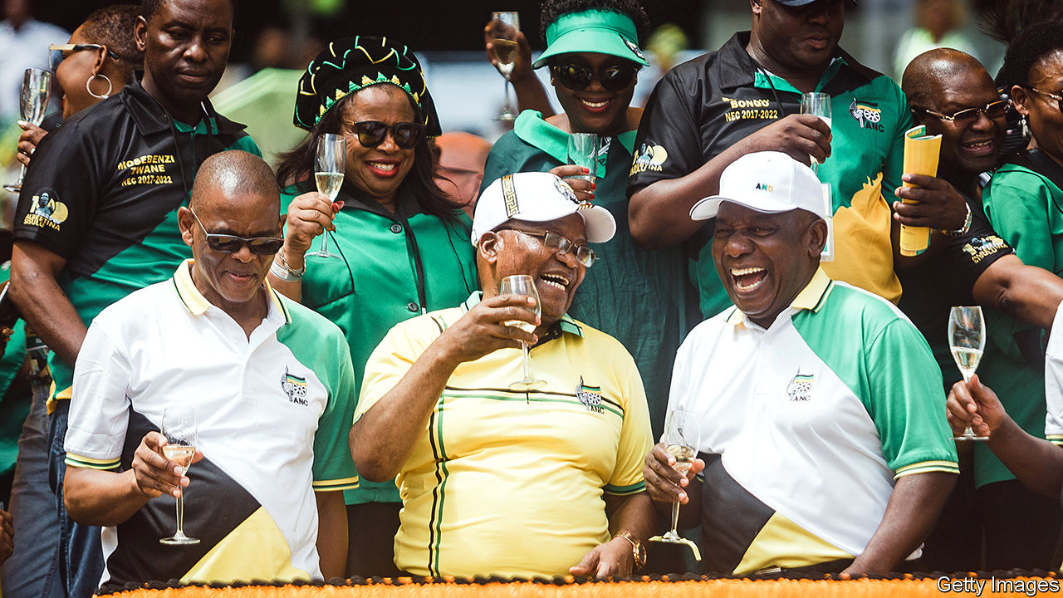

THE RESIDENTS of the township in Bloemfontein call it Dark City. The area was one of many segregated neighbourhoods built during apartheid. Today it is a microcosm of the failures of the ruling African National Congress (ANC): pockmarked roads, sporadic electricity, erratic rubbish collection and house after house of people unable to find work. And, on the top of most, roofs made of asbestos.

These should be long gone. In 2014 the regional government awarded a contract worth 255m rand ($23.5m) to survey and remove the health hazards. But in Dark City, as in most of Free State province, there is nothing to show for it. Geelbooi Mzaza, who has lived in the area since 1995, says that nurses have told him that asbestos is worsening his tuberculosis. “They said I had to move, but I have nowhere to go.”

Corrupt procurement deals are ubiquitous in South Africa. So much so that the country coined the term “tenderpreneur” to describe politically connected winners of public contracts. Under Jacob Zuma (pictured, centre), president from 2009 to 2018, the corruption reached such kleptocratic levels it became known as “state capture”.

One of the former president’s closest allies was Ace Magashule (pictured, left). Today Mr Magashule is the secretary-general of the ANC, one of the most powerful people in the party and the locus of internal resistance to Mr Zuma’s successor, Cyril Ramaphosa (pictured, right). For several years there has been speculation that Mr Magashule would be brought to book for corruption in Free State, where he was premier during the Zuma presidency. On November 10th he was issued with a warrant for his arrest on corruption charges related to the asbestos case. (He denies any wrongdoing.) The move by the country’s National Prosecuting Authority (NPA) and the Hawks, a police unit, may therefore prove good news not just for people like Mr Mzaza, but also for Mr Ramaphosa.

Mr Magashule’s alleged role in the asbestos deal was described in “Gangster State” by Pieter-Louis Myburgh, a journalist. The book, published in 2019, drew on leaked documents and a spreadsheet used by Igo Mpambani, one of two businessmen given the contract (and who was murdered in his Bentley in broad daylight in 2017). Last month the other businessman, Edwin Sodi, was arrested. “Gangster State” alleged that Mpambani shared the proceeds of the tender with various insiders, including Mr Magashule, whom Mr Myburgh placed close to the businessman soon after the latter made large withdrawals of cash. The author later estimated that just 3% of the funds went to the clean-up.

The case is one of many scandals from Mr Magashule’s time as premier. Others include a taxpayer-funded trip to Cuba for him and fellow “comrades”, and shoddily completed contracts for low-cost housing that involved Thoko Malembe, his daughter. Then there is the other major case being aggressively pursued by the NPA: a state-subsidised dairy costing hundreds of millions of rand linked to Mr Zuma’s close allies, the Gupta brothers, for whom Mr Magashule’s son, Tshepiso, worked.

That much is known about state capture is testament to many of South Africa’s institutions. Investigative journalists, NGOs, civil servants such as Thuli Madonsela, the former public protector, and dogged opposition politicians, especially from the Democratic Alliance, have all helped reveal the extent of the graft. But whether anyone goes to jail will depend on a criminal-justice system eviscerated in the Zuma era.

Upon taking office, Mr Ramaphosa pledged to revive organisations like the NPA, the Hawks and the South African Revenue Service. He has replaced party hacks with competent leaders and let them get on with their jobs. South Africans are understandably impatient. But prosecutors are finally racking up arrests. And if the state wins its case against Mr Magashule, it would be the clearest sign yet that the president’s anti-corruption drive is serious.

History suggests that a successful prosecution will not be easy. No ANC politician has so far been convicted for taking part in state capture. For 15 years Mr Zuma has been in and mostly out of court for his alleged part in a corrupt arms deal dating back to the late 1990s. Mr Magashule may try to copy the mix of denial and delay that has served the former president well. And although the relevant law defines corruption fairly broadly, it may be hard to prove Mr Magashule’s involvement; his former colleagues note that he had a habit of using other people’s mobile phones.

Mr Ramaphosa should benefit from having his rival occupied, even if Mr Magashule refuses to step down from his post while he is facing charges. Since Mr Ramaphosa took office his (over)cautious reformism has been hobbled by internal opponents. Though these include more than just allies of Mr Magashule, the secretary-general’s arrest should give the president greater power in negotiations with party factions and trade unions, for example concerning his efforts to slow the growth of the public wage bill.

Mr Ramaphosa nevertheless has much to do to convince increasingly sceptical South Africans that the ANC can change. State capture was about more than just individuals, however powerful. It was about an entire system of corruption, deployment of party members and patronage.

Back in Dark City, the residents’ mood is also sombre. Most scoff at the notion that arrests would signal a change in their fortunes. The best some people hope for is to be next in line for the spoils of a rotten system. Approaching your correspondent, a young man calls out: “Write it down—we want the next tender!” ■

This article was downloaded by calibre from <https://www.economist.com/middle-east-and-africa/2020/11/14/the-arrest-of-ace-magashule-is-good-news-for-south-africa>

|  |  |  |  |
| --- | --- | --- | --- |
|  | Articles | Sections | Next |

|  |  |  |  |
| --- | --- | --- | --- |
| Previous | Articles | Sections | Next |

#### The wheels come off

# Zambia is starting to look like Zimbabwe, the failure next door

The government blames covid-19. It should look in the mirror

Nov 14th 2020 | LUSAKA

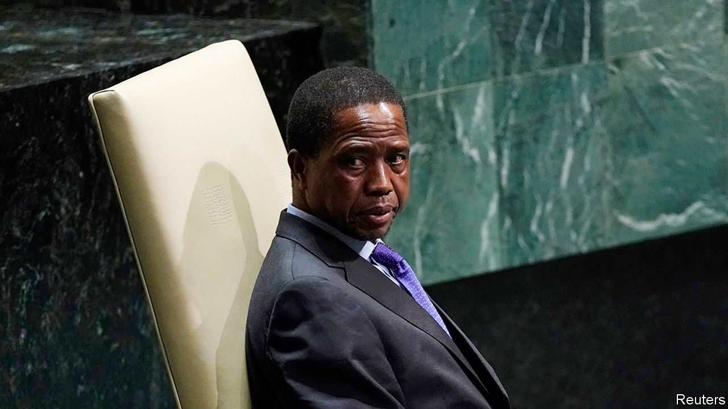

IN HIS STUDIO Fumba Chama gets ready to play his new song. Unlike in most Zambian workplaces there is no photograph on the wall of Edgar Lungu, the president since 2015. Looking down instead is a young Kenneth Kaunda, who led Zambia for 27 years after independence from Britain in 1964.

If that is a silent protest, then out of the speakers comes a louder one. In “Coward of the County” Mr Chama raps laconically about Mr Lungu’s failings over—why not?—a sample of the song of the same name by the late Kenny Rogers, a bearded American country star. It is his latest track about how the ruling Patriotic Front (PF) has crushed civic freedoms and crashed the economy. As if to prove his point, the authorities have repeatedly arrested and intimidated Mr Chama, whose stage name is PilAto. “People say I have no fear,” he says, “but I’m scared.”

Mr Chama is not alone. Unless it pays an overdue $42.5m coupon, or bondholders give it more time, on November 13th Zambia will officially default on its debt. Though it would be the first African state to do so since the start of the pandemic, covid-19 is not the root cause of its troubles. More important is the PF’s misrule, which will worsen ahead of elections in August 2021. “We are heading in the same direction as Zimbabwe,” says Laura Miti of Alliance for Community Action (ACA), an NGO.

Any such comparison to the failing state on its southern border is cause for alarm. Since 1991, when Mr Kaunda eventually made way for multiparty democracy, the country has held regular, if flawed, elections. In the 2000s GDP grew by an average of 7% per year, thanks in part to a soaring price for copper, which accounts for four-fifths of exports.

After it took office in 2011 the PF was not helped by droughts and a fall in the copper price. Yet it made matters worse by ramping up borrowing. Government debt as a share of GDP has risen from 21% to 120% (see chart). External debt has increased seven-fold, as Zambia borrowed in dollars from Western bondholders and Chinese state banks. It now spends four times as much on external debt as on health care.

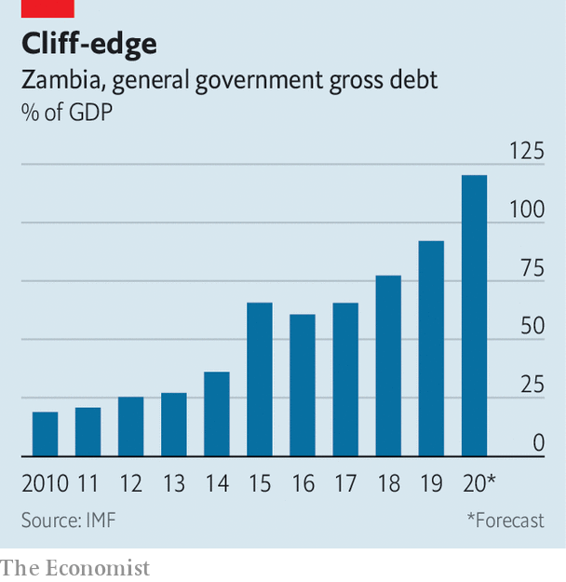

Much of the money has been wasted. A dual carriageway north from Lusaka estimated to have cost $1.2bn stops on the outskirts of the capital. Other roads have been commissioned at inflated prices (roughly twice the African average per kilometre), suggesting ample opportunities for the well-connected to take a cut. An order for fire engines and a cash-transfer scheme for the poor are among many fishy tenders. The Financial Intelligence Centre, an official watchdog, found $520m worth of money-laundering or suspicious transactions in 2018, up from $382m in 2017. Institutions meant to oversee borrowing—the finance ministry and parliament—have been bypassed as departments and agencies within the presidency have racked up debts.

Ordinary Zambians are paying the price. Annualised inflation was 16% in October, versus 11% a year ago. The local currency, the kwacha, has lost almost a third of its value against the dollar this year. Civil servants are not paid on time. Graduates struggle to find jobs; such is the plight of teacher-training graduates that the Unemployed Teachers Association of Zambia represents tens of thousands of people.

Zambia has asked the IMF for a cheap loan to tide it over. An IMF programme would also reassure creditors who worry that any relief they provide will only bolster the PF’s election war chest or the accounts of Chinese lenders. Yet the antics of the Lungu regime have done little to convince creditors that it can be trusted.

In August Mr Lungu fired Denny Kalyalya, the governor of the central bank, and replaced him with Christopher Mvunga, a political ally. Mr Kalyalya was dismissed partly because he rebuffed efforts to have the central bank print money, according to people familiar with the decision. Mr Mvunga “does not have the power to resist”, says a former senior central banker.

Zambia’s latest budget, passed on September 25th, also raised eyebrows. It included 5.7bn kwacha ($275m) for farm inputs, such as fertiliser—a 300% increase on the previous year. It may win over some of the 56% of Zambians who live in the countryside. Another crafty tactic is cancelling the voter roll and replacing it with a new one. Zambians have been given just 30 days to sign up. Many fear it will be harder to register in opposition strongholds. “Lungu hopes to disenfranchise as many opposition supporters as possible,” argues Sishuwa Sishuwa of the University of Zambia.

Mr Lungu has not had it all his own way. On October 29th parliament rejected a bill that would have removed constraints on the president and made it easier for him to win re-election. The defeat suggests that he does not have an iron grip on his party, especially among its Bemba-speaking elites hailing mainly from the north-east.

But weak “strongmen” are often the most dangerous. After the bill’s demise, a further anti-democratic backlash may occur, fears Ms Miti. The ruling party has shown itself willing to throttle freedoms. It has put allies of Mr Lungu on the constitutional court, which in 2018 ruled that he could stand a third time for president, contrary to the views of many Zambian jurists. Authorities have shut Zambia’s main independent newspaper and a television station. PF thugs harass journalists and opposition campaigners.

And musicians. In his studio Mr Chama points out that many of his friends are paid to play by the PF, or have received money from a youth “empowerment” fund, announced in August. Though he worries about what will happen next, he would never take the cash. “Better to be dead than alive in a dead country,” he says. ■

This article was downloaded by calibre from <https://www.economist.com/middle-east-and-africa/2020/11/14/zambia-is-starting-to-look-like-zimbabwe-the-failure-next-door>

|  |  |  |  |
| --- | --- | --- | --- |
| Previous | Articles | Sections | Next |

|  |  |  |  |
| --- | --- | --- | --- |
| Previous | Articles | Sections | Next |

#### Rebelling against rape

# Egyptian women speak up about sex crimes

They are fed up of state media that call a gang-rape a “group sex party”

Nov 14th 2020 | CAIRO



WHEN NADEEN ASHRAF was walking through a wealthy part of Cairo last month, she was not surprised to hear sexual comments aimed her way. Most women in Egypt have experienced sexual harassment or violence. But her catcaller was surprised when the 22-year-old philosophy student jumped into the taxi he was driving. “I had an hour-long conversation with him,” she recalls. “It was so foreign to him that this was sexual harassment.”

For much of this year Egypt has wrestled with the problem of sexual violence and the issue of women’s rights. Men there have long policed women’s behaviour, using antiquated notions of morality, while tolerating crimes by men against women. But lately young women like Ms Ashraf (pictured) have been challenging the country’s conservative, male-dominated culture, using social media to amplify their voices. It has not always gone well.

The reckoning began in June, when a student at the American University in Cairo (AUC) posted a warning on Facebook about a former student, Ahmed Bassam Zaki, whom she accused of sexually harassing and blackmailing women. Days later, after that post disappeared, Ms Ashraf launched an account on Instagram called Assault Police, which repeated the allegations against Mr Zaki—and listed more. He was soon arrested. Assault Police was born out of anger, says Ms Ashraf, who also attends AUC. “I was very frustrated that women’s voices were not being taken seriously.”

Around the time of Mr Zaki’s arrest, other cases began making headlines. A woman alleged that a group of wealthy young men drugged and gang-raped her at a five-star hotel in Cairo in 2014. Another woman, called Aya Khamees, accused a man of rape—and accused the police of ignoring her claims. It seemed as if Egypt was having a #MeToo moment. The National Council for Women, a government body, urged other victims of sexual violence to come forward. Parliament approved a law guaranteeing them anonymity. Assault Police now has over 200,000 followers.

But the progress was largely illusory. Take the alleged gang rape, which was reportedly recorded by the attackers. It took weeks of campaigning by activists before the Public Prosecution Office moved, allowing some of the suspects to flee the country. Five men have since been arrested; at least two suspects are still at large. Three of the men arrested have been charged with rape, which they deny. Absurdly, the authorities also charged four people who came forward as witnesses (and two of their acquaintances) with violating laws on “morality” and “debauchery”. The media have characterised the incident as a “group sex party”, smearing all involved, including the alleged victim. This has had a chilling effect: once-vocal women have gone into hiding.

After Ms Khamees was turned away by the police, she broadcast her accusations on TikTok, an app for sharing short videos, where she had more than 100,000 followers. Days after the video went viral, the police picked up the entire group who had been partying with her that night. The authorities seemed as concerned with their use of hash and the mixing of unmarried men and women, as with Ms Khamees’s claim that a man had held a razor to her face and raped her. Her attackers (she accused a group of people of facilitating the rape) were charged with rape and other offences. But Ms Khamees was also charged—with prostitution, drug use and “violating family values”. Only after she completed a programme to “correct her concepts” were the charges against her dropped.

These cases are indicative. Egypt has laws against sexual violence and harassment (the latter enacted only in 2014), but victims keep quiet for fear they will be blamed and shamed. The authorities have been known to subject women to so-called “virginity tests” and to ask about their sexual history, often using the information to muddy a case. The law is vague and, anyway, “it is just what you write on a piece of paper,” says Salma El Tarzi, a film-maker who focuses on sexual violence. The real problem is the attitude of Egyptian men.

Most of Egypt’s judges and prosecutors are men. They decide what violates Egyptian values. Lately they have been using a cyber-crime law to crack down on women dancing and clowning around on TikTok. Since April the authorities have arrested ten female TikTok influencers on charges of violating family values and inciting “indecency” and “debauchery”. Six have been sentenced to two years each in prison; two have received three-year sentences. Part of what panics the old arbiters of morality is how the internet has empowered young, often lower-class women.

The country as a whole, though, remains deeply conservative. Many Egyptians supported the arrests of the TikTok stars. A survey released in 2017 by the UN and Promundo, an advocacy group, showed that 64% of Egyptian men (and 60% of women) believe that a woman should marry her rapist. Almost three-quarters of men (and 84% of women) said women who dress provocatively deserve to be harassed. Only in Egypt are the views of young men as conservative as those of older men when it comes to gender, says Amel Fahmy, who worked on the survey.

“There are millions of men in Egypt who have no clue about their sexuality and the ideas of boundaries and consent,” says Ms Ashraf. She grew more disillusioned after talking to her catcalling cab driver. He ultimately apologised, she says, but then claimed he would never get married. Asked why, he responded, “Because you told me I shouldn’t compliment girls.” ■

This article was downloaded by calibre from <https://www.economist.com/middle-east-and-africa/2020/11/14/egyptian-women-speak-up-about-sex-crimes>

|  |  |  |  |
| --- | --- | --- | --- |
| Previous | Articles | Sections | Next |

|  |  |  |  |
| --- | --- | --- | --- |
| Previous | Articles | Sections | Next |

#### A negotiator in winter

# Saeb Erekat, a Palestinian who talked to Israel, dies of covid-19

His life’s work is on life support as well

Nov 14th 2020 | BEIRUT



IT WAS 1991, and dozens of men were huddled around a long white table in Spain, clad in the formless dark suits that are de rigueur at diplomatic functions. Only one stood out: a bearded, bespectacled university professor, shoulders draped in a keffiyeh, the chequered scarf that has become a symbol of Palestinian nationalism. Saeb Erekat caused a stir at the Madrid conference, the first direct talks between Israel and the Palestinians. Binyamin Netanyahu, then a mere spokesman for the Israeli delegation, suggested that his dress was a “provocation”. But, for Mr Erekat, the summit would start a diplomatic process that became his life’s work.

On November 10th Mr Erekat died in Jerusalem at the age of 65. He tested positive for covid-19 in October, a grim diagnosis for a man who had a lung transplant in 2017. Israel allowed him to receive treatment at Hadassah hospital, but he never recovered.

Born in 1955, he grew up in Jericho, an ancient city nestled in the Jordan valley. After university studies in America and Britain he returned to the West Bank and became a loyal member of Fatah, now the territory’s ruling party. A mediator rather than a militant, he would play an integral role in the earliest agreements between Israel and the Palestinians, including the second Oslo accords, signed in 1995.

The two-state solution became an obsession. He never bought into the idea of a binational state where Jews and Arabs would coexist under a single political system: in his mind Israel would never relinquish its Jewish majority. Only divorce—territorial partition—would grant his people their rights. In public he could be obstinate, prone to legal diatribes and occasional outbursts. In private, though, he often recognised that he had a bad hand.

Palestinian critics accused him of playing it badly. A batch of leaked memos, published in 2011 by Al Jazeera, revealed that Mr Erekat and his team offered to cede nearly all of east Jerusalem when negotiating with Israel in 2008. The Palestinians claim that land as the capital of their future state. In Mr Erekat’s words, though, he was ready to give Israel “the biggest Yerushalayim in Jewish history” (the Hebrew name for the city). He got nothing in return—and resigned soon after the documents were published, something he did every few years. His departures were always short-lived.

In its immediate ramifications, Mr Erekat’s death may say more about domestic politics than about the moribund peace process. Mahmoud Abbas, the Palestinian president, turns 85 on November 15th and has been ailing for years. His term should have ended 12 years ago. Yet he clings jealously to his post and views would-be successors with suspicion. Mr Erekat was one of the few to stay in his good graces and had been a contender to replace the ageing president. Instead Mr Abbas will have to replace him; his choice may hint at who leads in the succession struggle.

Still, it is hard to escape the symbolism of his death. In Jordan last year your correspondent asked Mr Erekat about his health. “I’m fine,” he replied. “On two feet, working for two states.” Typical Saeb: earnest and folksy, even at a time when there was little for him to negotiate. The Obama administration dispatched John Kerry, its secretary of state, on a quixotic quest to broker an agreement. Talks stalled in 2014 and never resumed. President Donald Trump had his “deal of the century”, unveiled in January and dead on arrival.

Mr Trump’s successor, Joe Biden, is unlikely to spend much time on his own effort, likely to be futile. Mr Netanyahu, now the Israeli prime minister, has devoted his career to obstructing an agreement that would lead to a Palestinian state. The Palestinians are mired in divisions and increasingly cast doubt on the two-state idea. Mr Erekat will be mourned as a fighter for the Palestinian cause. When the eulogies are done, many Palestinians will wonder if his is a fight worth continuing. ■

Editor’s note: Some of our covid-19 coverage is free for readers of The Economist Today, our daily [newsletter](https://my.economist.com/user#newsletter). For more stories and our pandemic tracker, see our [hub](https://www.economist.com/news/2020/03/11/the-economists-coverage-of-the-coronavirus)

This article was downloaded by calibre from <https://www.economist.com/middle-east-and-africa/2020/11/14/saeb-erekat-a-palestinian-who-talked-to-israel-dies-of-covid-19>

|  |  |  |  |
| --- | --- | --- | --- |
| Previous | Articles | Sections | Next |

|  |  |  |
| --- | --- | --- |
| Middle East & Africa | Sections | Europe |

The Americas

Peru: Early retirement

.

Central America: Greek tragedy

.

Bello: The problem of proxy presidents

.

|  |  |  |
| --- | --- | --- |
| Middle East & Africa | Sections | Europe |

|  |  |  |  |
| --- | --- | --- | --- |
|  | Articles | Sections | Next |

#### Early retirement

# Peru’s Congress topples Martín Vizcarra on its second attempt

The country chose a tricky time to change presidents

Nov 10th 2020 | LIMA

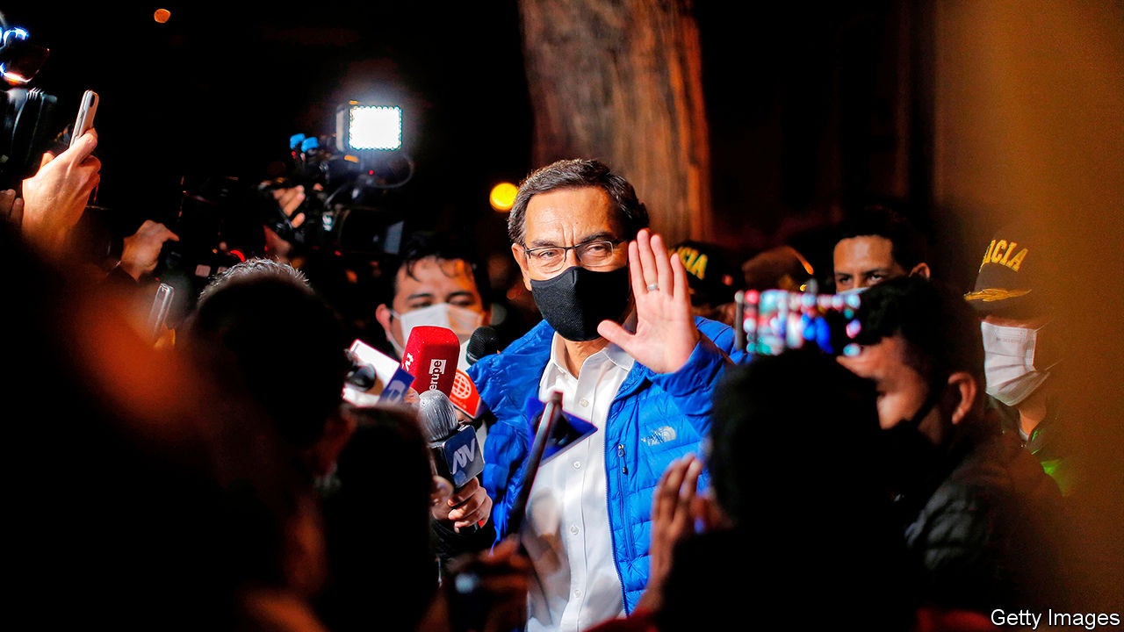

PERU’S CONSTITUTION makes it relatively easy for Congress to get rid of a president. The legislature need only decide that he or she is “morally unfit”, and, by a two-thirds majority of its single chamber, evict the chief executive from the Pizarro Palace. On November 9th, by a vote of 105 to 19 with four abstentions, Congress did just that to Martín Vizcarra (pictured). That marks the second time in less than three years that it has toppled a president. (Mr Vizcarra took over from Pedro Pablo Kuczynski, who quit before he could be impeached.)

Manuel Merino, who was Congress’s speaker until he took over as president on November 10th, will probably hold on to the office until his term expires next July. But that does not mean Peru will enjoy stability. It is dealing with an outbreak of covid-19 that has killed 35,000 people. As a share of the population, that is the third-worst in the world. The economy contracted by 15.7% in the first eight months of 2020 compared with the same period a year earlier, and is expected to shrink by 12% for the full year. There is little reason to believe that the presidential and congressional elections scheduled for next April, in which by law none of the current office-holders may seek to hold on to their jobs, will produce leaders who can manage the economy or the pandemic better.

Mr Vizcarra fell over allegations that he took kickbacks from public-works projects during his one term as governor of the southern department of Moquegua from 2011 to 2014. Although he clearly has questions to answer, nothing has been proved. His critics say he has been meddling in the judiciary to avoid prosecution and to harm his foes. In his 50-minute self-defence before Congress, Mr Vizcarra agreed that an investigation was warranted but said it should wait until he finished his term. His ousting would cause chaos, he warned.

Rather than debate the merits of the case against him, lawmakers denounced his ethics and his handling of the pandemic. Mr Vizcarra challenged the “legality” and “legitimacy” of the impeachment, but went quietly. He declared his innocence and said he would go home “with my head held high”.

As he left the palace residents of Lima banged pots and pans to oppose his removal. Several thousand people gathered near Congress and outside the capital on November 10th to protest. Riot police used tear gas and water cannon to control the protesters. Some were arrested. More than three-quarters of Peruvians opposed his impeachment, according to one survey.

It is the latest crisis for a political system whose prestige and institutions have been ground down by allegations of graft. All of Peru’s presidents since 2001 have been ensnared in one way or another by the scandal surrounding Odebrecht, a Brazilian construction firm that bribed politicians across Latin America. Two former presidents are under house arrest; one is at liberty while he awaits trial; a fourth committed suicide to avoid arrest. Keiko Fujimori, until recently the most powerful opposition leader, is awaiting trial. The allegations against Mr Vizcarra were the result of a tentative plea bargain by suspects in the Odebrecht investigations.

Peruvians see corruption as the country’s biggest problem, even ahead of the pandemic, according to opinion polls. But they regard Mr Vizcarra as part of the solution. His approval ratings averaged 58% in the three main polls published in October. To many, his war with Congress looked like a valiant battle against graft.

Last year, when Congress resisted enacting political reforms proposed by Mr Vizcarra, he found a pretext to dissolve it and call new legislative elections. The vote in January this year did not produce a more pliant body. The nine parties represented in the chamber extend from the far left of the political spectrum to the religious-fundamentalist right. Mr Vizcarra had hoped for support from a reasonable centre, composed of about 70 lawmakers. But from the beginning the new Congress rowed with him over how to handle the pandemic and the economic crisis that came with it.

Congress made an abortive attempt to impeach him in September, when recordings leaked that appeared to show him meddling in an investigation of contracts between the government and a folk singer who had given him political support. This month’s attempt looked like a long shot at first. It succeeded after Mr Vizcarra angered congressmen by pointing out that many of them, too, are under investigation.

Peruvians now worry that Mr Merino will seek to postpone the election in order to continue enjoying the spoils of office. Others fear an orgy of populism in a previously well-managed economy, in the expectation that this might benefit presidential candidates who are either in Congress or have allies there. Mr Vizcarra’s finance minister, María Antonieta Alva, had fought tenaciously to block populist measures, such as early withdrawals from the pay-as-you-go public pension system (with a fiscal cost of up to 2% of GDP) and a freeze of repayments of bank debts. She has now resigned, along with the rest of Mr Vizcarra’s cabinet. The price of Peru’s foreign bonds slumped after the impeachment vote, and the sol sank against the dollar.

Mr Merino, a congressman from Tumbes, the smallest department, has given few clues as to how he will handle Peru’s overlapping crises. He has promised to appoint an ideologically diverse cabinet and to work closely with Congress. A former speaker, Ántero Flores-Aráoz, is to lead it. His most important pledge in a 13-minute inauguration speech was that elections will happen on schedule.

His successor may find it no easier to govern, even if he or she is free from suspicions of wrongdoing. Twenty-four people have declared their candidacy for the presidency. None is backed by a strong political party. Some hope to boost their chances by echoing popular indignation at Mr Vizcarra’s removal. George Forsyth, a former mayor and football goalkeeper who is the early front-runner, tweeted that it was a “veiled coup”. The eventual winner is unlikely to be able to elicit co-operation from a fragmented Congress. It may eventually find an excuse to usher Peru’s next president out of the door. ■

This article was downloaded by calibre from <https://www.economist.com/the-americas/2020/11/10/perus-congress-topples-martin-vizcarra-on-its-second-attempt>

|  |  |  |  |
| --- | --- | --- | --- |
|  | Articles | Sections | Next |

|  |  |  |  |
| --- | --- | --- | --- |
| Previous | Articles | Sections | Next |

#### Greek tragedy

# The toll of Hurricane Eta in Central America and the Caribbean

The biggest storm of a record-breaking season could lead to a rise in covid-19 cases

Nov 12th 2020 |

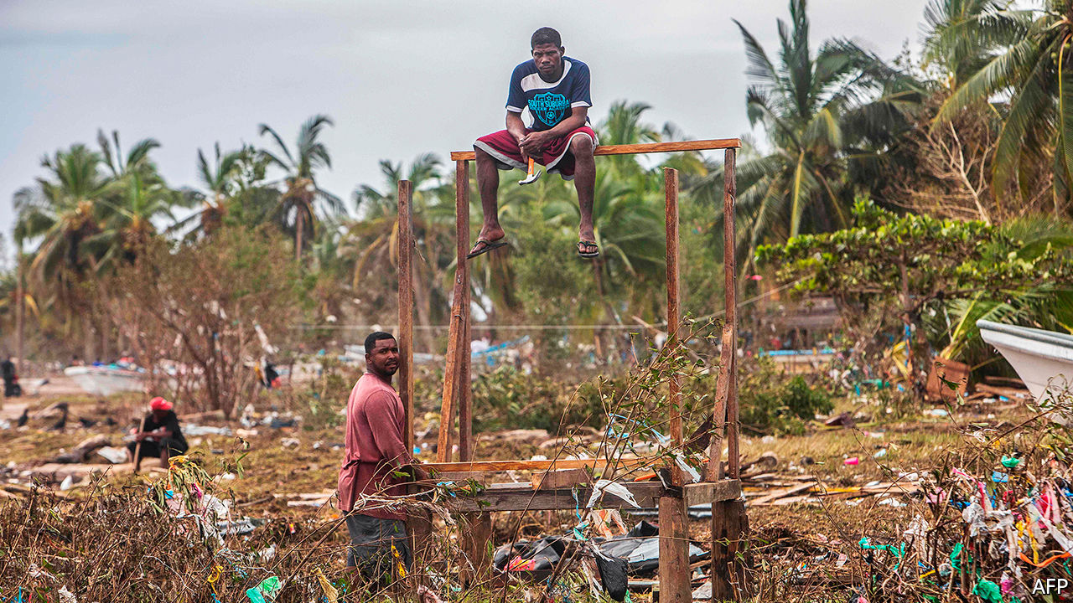

IN ONLY ONE previous year, 2005, have meteorologists resorted to the Greek alphabet to name Atlantic storms. They had run through the 21 names starting with the letters of the Roman alphabet (five uncommon letters are not used). With Hurricane Eta this month the storm-namers have reached further into the Greek-letter sequence than ever before. The strongest storm of this year’s season, Eta made landfall on November 3rd in Nicaragua as a category-four hurricane, with gusts of up to 240km (150 miles) per hour. It proceeded to cause havoc across Central America and the Caribbean (see map).

The winds weakened after landfall, but torrential rain caused floods and landslides in Honduras, Guatemala and Cuba. Scores of Central Americans are confirmed dead and many are missing or injured. Countries on the edge of the storm’s path, including Mexico and Panama, suffered deaths and damage. Flooding disrupted an election in Belize on November 11th. Across the region, perhaps 300,000 people left their homes to seek shelter in community centres or with family and friends.

The death toll in Guatemala—with 18m people Central America’s most populous country—will probably be the highest. So far, 44 people are confirmed dead and nearly 100 are missing. Mudslides engulfed houses in central Guatemala, which bore the brunt of the storm in that country. In Quejá a villager lost 22 members of her family, Reuters reported. In Honduras 1.7m of the country’s 10m people have been affected in some way, says the Red Cross. Hondurans criticised the government for failing to prepare for the storm. Nicaragua had just two deaths but lots of damage to roads and houses. Thirty thousand people were evacuated and 25,000 households have no electricity.

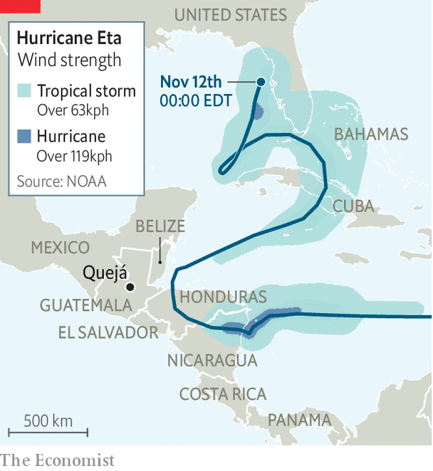

Eta is far less devastating than many past disasters, such as Hurricane Mitch, which in 1998 killed more than 11,000 people in Central America. But it comes at a worse time. Eta adds to the misery caused by the pandemic and makes it more dangerous. Central America appears to have contained the number of cases and deaths from covid-19 better than Brazil, Ecuador, Mexico and Peru. Guatemala’s reported death toll from covid-19 is a fifth of Peru’s as a share of population. Nicaragua is an outlier. It barely attempted to curb the spread of the disease. Its reported death toll is among the lowest in Latin America, though that may be because the government is simply refusing to disclose accurate information. In all the countries battered by Eta doctors and aid workers fear that infections will rise. Thousands of people are crammed into shelters, where the virus can easily spread. In some places that are still habitable water supplies have been cut, so people cannot wash their hands.

The storm has hit livelihoods, especially in farming. In Honduras, where agriculture accounts for a tenth of GDP and nearly a third of employment, coffee and banana estates have been devastated. Food may become scarce. Rebuilding will be even slower than after past disasters. Government finances are stretched by recession and by extra spending to control the pandemic. Guatemala’s budget deficit is forecast to be 6% of GDP, nearly triple what it was last year. The World Bank expects 1m more Guatemalans will fall below its poverty line of $1.90 of income a day.

The combination of Donald Trump and covid-19 had largely stopped the flow of migrants heading from Central America to the United States. It could be restarted by Eta, plus the belief that Joe Biden, the American president-elect, will be friendlier to immigration. Tropical Storm Theta, which has formed in the middle of the Atlantic, seems to be heading away from the Americas. But the hurricane season runs to the end of November, and there are 16 letters to go in the Greek alphabet.■

This article was downloaded by calibre from <https://www.economist.com/the-americas/2020/11/12/the-toll-of-hurricane-eta-in-central-america-and-the-caribbean>

|  |  |  |  |
| --- | --- | --- | --- |
| Previous | Articles | Sections | Next |

|  |  |  |  |
| --- | --- | --- | --- |
| Previous | Articles | Sections | Next |

#### Bello

# The problem of Latin America’s proxy presidents

They are proliferating

Nov 14th 2020 |



ON NOVEMBER 8TH Luis Arce took office as Bolivia’s president following his clear victory in an election last month. A day later the man who picked him as a candidate, Evo Morales, was greeted by adoring crowds as he crossed into Bolivia from Argentina, a year after fleeing his country after protests over electoral fraud. Mr Arce, who was Mr Morales’s finance minister, insists he is his own man. His former boss, who ruled as an increasingly authoritarian socialist strongman for 13 years, “has no role in the government”, he said. But some Bolivians believe Mr Arce will have Mr Morales breathing down his neck.

Mr Arce joins a small but growing band of proxy presidents who owe their jobs to the sponsorship of a more powerful leader. In Colombia Iván Duque was an inexperienced senator when he was elected to the top job in 2018 thanks to the backing of Álvaro Uribe, a conservative two-term former president who was barred from re-election by term limits. In Argentina Cristina Fernández de Kirchner, president in 2007-15, struck a deal with Alberto Fernández (no relation) whereby he ran and won in 2019, with her as his running-mate. Ecuador may be next. Rafael Correa, the country’s strongman between 2007 and 2017, hopes to return to power via a proxy candidate, Andrés Arauz, a young economist. Mr Correa lives in Belgium and has been convicted of corruption in absentia.

The rise of the proxy president is partly a result of term limits and partly a consequence of the commodity boom of the 2000s, which helped leaders fortunate enough to be in office at the time to become popular and politically strong. The gambit sometimes backfires. Mr Correa thought he would control things by choosing Lenín Moreno, his vice-president, as his party’s candidate—only for his successor to turn on him. Mr Uribe reluctantly backed Juan Manuel Santos, his former defence minister, to succeed him in 2010. The two men soon became bitter foes. In Brazil Luiz Inácio Lula da Silva (2003-10) chose Dilma Rousseff to keep the presidential seat warm for him. Ms Rousseff outmanoeuvred him to run for a second term, only to be impeached for breaking budget rules.

When the gambit works it causes even bigger problems. A proxy risks being a weak president, carrying the can for decisions inspired by a sponsor who exercises power without responsibility. Take Colombia: Mr Duque is a moderate who in 26 months has yet to put his stamp fully on his own government. Mr Uribe is seeking to abolish a special court to investigate war crimes set up under the peace agreement with the FARC guerrillas negotiated by Mr Santos. Mr Duque, meanwhile, must defend his implementation of that agreement before the UN and other bodies. Security has deteriorated under Mr Duque. His former and current defence ministers are people close to Mr Uribe with no previous security experience. Prominent members of Mr Uribe’s party campaigned for Donald Trump in Florida. Mr Duque must now deal with his victorious opponent, Joe Biden.

Mr Fernández, a more substantial politician than Mr Duque, is struggling to project authority, too. His controversial vice-president, a leftist-populist, continues to control the street in Buenos Aires’s rustbelt. Mr Fernández has imposed the world’s longest lockdown, which delayed rather than curbed the coronavirus. It increasingly looks like a sign of political weakness. The government pulled off a restructuring of its debt with bondholders but failed to capitalise on that by launching a credible economic plan, perhaps because of the difficulty of getting agreement between the two leaders. Mr Fernández is paying a political price for a plan for a judicial reform that seems designed to save his running-mate from corruption charges.

That is an example of the underlying problem that proxies face. The interests of their sponsors are not necessarily those of the country. Mr Uribe appears to be pursuing a personal vendetta against his enemies and seems to want to install another proxy in 2022 by continuing to polarise Colombian politics. Mr Correa wants revenge, too, and like Ms Fernández wants control of the courts.

As for Mr Arce, he has named a cabinet in which only the defence minister is close to Mr Morales. Their party, the Movement to Socialism, is broad-based, and includes people critical of the former president. Mr Arce has no illusions about Mr Morales. “He’s not going to change,” the new president said. If so, sooner or later Mr Arce will face a choice: impose his own authority or lose it.

This article was downloaded by calibre from <https://www.economist.com/the-americas/2020/11/14/the-problem-of-latin-americas-proxy-presidents>

|  |  |  |  |
| --- | --- | --- | --- |
| Previous | Articles | Sections | Next |

|  |  |  |
| --- | --- | --- |
| The Americas | Sections | Britain |

Europe

Nagorno-Karabakh: Peace, for now

.

Ukraine: Judge not, that ye be not judged

.

Europe’s recovery fund: Turn on the spigot

.

France in the Sahel: Mission impossible but necessary

.

|  |  |  |
| --- | --- | --- |
| The Americas | Sections | Britain |

|  |  |  |  |
| --- | --- | --- | --- |
|  | Articles | Sections | Next |

#### Peace, for now

# A peace deal ends a bloody war over Nagorno-Karabakh

Azerbaijan wins some land, while Turkey and Russia carve out spheres of influence

Nov 14th 2020 |

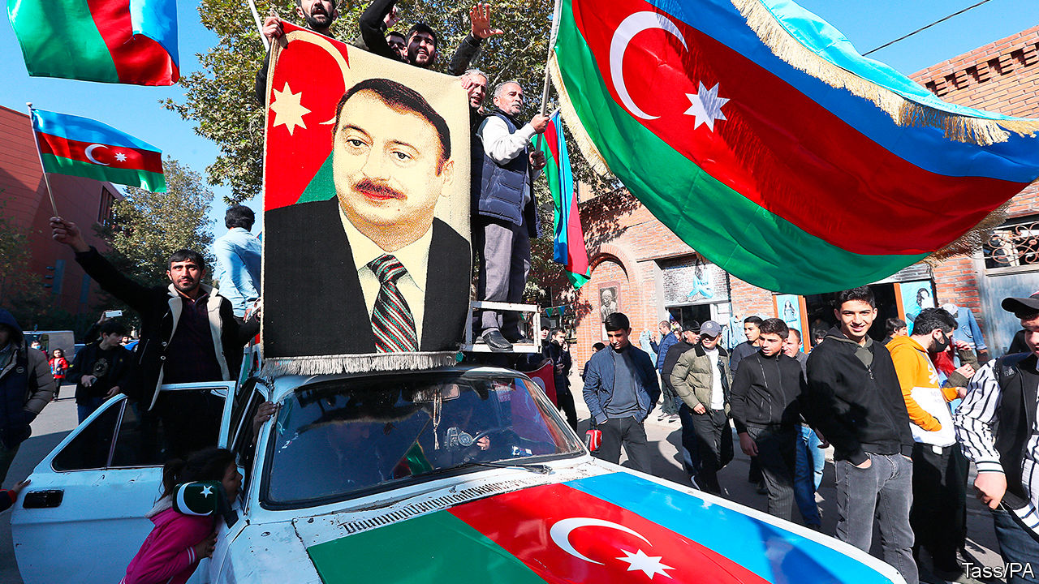

THE TWO capitals erupted at roughly the same time. On November 9th, known as the national flag day in Azerbaijan, Baku burst into jubilation. Crowds swarmed the city and flocked to the Alley of Martyrs, a memorial to fallen soldiers. They wrapped themselves in Azerbaijani and Turkish flags, sang the national anthem and praised their victorious leader, Ilham Aliyev. On the same day in Yerevan, the capital of Armenia, angry crowds stormed the parliament building, cursing Nikol Pashinyan, their prime minister.

The cause of both scenes was the announcement of a peace deal. Brokered by Russia and Turkey, it ended a six-week war over Nagorno-Karabakh. This is an enclave in Azerbaijan, mostly populated by ethnic Armenians but of cultural and historical significance to both sides. A day earlier, Azerbaijan had raised its flag over Shusha, a strategic hilltop citadel inside Nagorno-Karabakh and a cradle of Azerbaijani culture. Within hours Armenia’s exhausted and demoralised forces surrendered, a humiliation for which Mr Pashinyan had done nothing to prepare his country.

The peace deal marks one of the biggest shake-ups in a turbulent region at the crossroads of Europe, Asia and the Middle East since the collapse of the Soviet empire, which also began in Nagorno-Karabakh. In February 1988 a few hundred Armenians came out onto Lenin Square in Stepanakert, the enclave’s capital, demanding to be united with Soviet Armenia. They started a chain of events that catalysed the break-up of the Soviet Union and later led to a two-year war between Armenia and Azerbaijan.

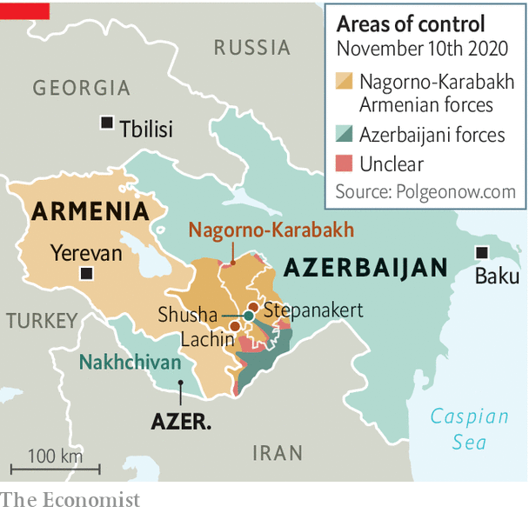

That war ended with the victory of the Armenians, partly because of Russian military support. Armenia captured Nagorno-Karabakh and occupied seven adjacent districts that belonged to Azerbaijan. The conflict was (mostly) frozen but never resolved, leaving Azerbaijan with a sense of trauma and the border between Turkey and Armenia shut.

On September 27th, after 25 years of waiting for the return of its territory, Azerbaijan went back to war. It was aided by Turkey, which provided drones and training. It recaptured most of its lost territory.

The war was all but inevitable. Azerbaijan, a petro-state, had grown richer, more confident and more frustrated at the lack of progress in talks with Armenia. However, three other factors played a role.

One was the growing assertiveness of Turkey. It has shown its willingness to use force and provide military backing to Azerbaijan, in the form of planners and Syrian mercenaries.

The second was Russia acquiescing to Azerbaijan’s advance and to Turkey’s involvement. In the past Azerbaijan had been afraid to launch an all-out offensive because of Russia’s commitment to defend Armenia. But as Azerbaijan correctly guessed, Vladimir Putin cared more about his anti-Western alliance with Turkey and was no longer inclined to side with Armenia’s government after a largely peaceful “colour” revolution in 2018 swept the populist Mr Pashinyan to power. Russia’s president does not recognise the legitimacy of leaders brought to power by uprisings. Mr Pashinyan further angered Mr Putin by imprisoning a friend of his, Robert Kocharian, a former Armenian president. Mr Putin was not allowed to see him during a visit to Yerevan last year.

The third factor has been the gradual disengagement of America from the region, which has accelerated under President Donald Trump. So the autocratic leaders of Russia and Turkey were left alone to hammer out their deal. Under it, Armenia is to withdraw from the remaining districts around Nagorno-Karabakh. Russia will deploy a 2,000-strong peacekeeping force in Nagorno-Karabakh, for the next five and possibly ten years. There was no mention of the status of Nagorno-Karabakh, which in the past had been promised autonomy within Azerbaijan. Tens of thousands of ethnic Armenians fled their homes in Stepanakert during the fighting as Azerbaijan’s army closed in.

Within hours of the announcement, Russia moved in its troops, establishing its long-craved presence in the Lachin corridor linking Armenia to Nagorno-Karabakh. Mr Aliyev had for years resisted this. Having closely observed the use of Russian peacekeepers in the war unleashed by Moscow against neighbouring Georgia in 2008, he had no desire to see Russian troops in Nagorno-Karabakh. Yet he had little choice. Going any further in the war risked a direct confrontation with Russian forces.

Turkey probably helped persuade Azerbaijan to accept the deal. Though not mentioned in the trilateral agreement signed between the two belligerents and Russia, Turkey is a big beneficiary of it. It is to get access to a transport corridor through Armenian territory from the Azerbaijani enclave of Nakhchivan, which borders Turkey, to the main bit of Azerbaijan and the Caspian Sea, thus linking Turkey to Central Asia and China’s Belt and Road Initiative.

Russia will control the road itself, but Turkish and Chinese goods will travel along it, and all parties stand to benefit economically. “This trade route could transform the entire region and become the main staple of a peace settlement,” says Mikayil Jabbarov, Azerbaijan’s American-educated economy minister. Perhaps it is the prospect of this geopolitical transformation that has enticed Mike Pompeo, the American secretary of state, to visit the region in the next few days. After four years of Mr Trump’s presidential neglect, he is very late to the party, and there are many pitfalls ahead. ■

This article was downloaded by calibre from <https://www.economist.com/europe/2020/11/14/a-peace-deal-ends-a-bloody-war-over-nagorno-karabakh>

|  |  |  |  |
| --- | --- | --- | --- |
|  | Articles | Sections | Next |

|  |  |  |  |
| --- | --- | --- | --- |
| Previous | Articles | Sections | Next |

#### Judge not, that ye be not judged

# Ukraine’s constitutional court attacks anti-corruption laws

Campaigners say it has been compromised by Russia

Nov 14th 2020 | KYIV

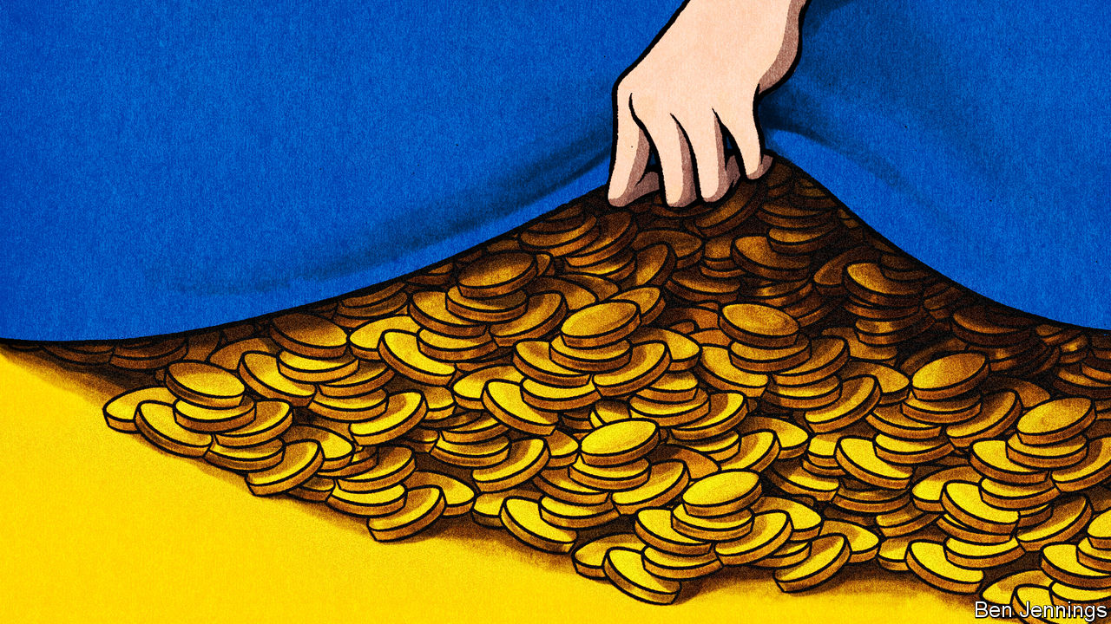

IN 2014 UKRAINIANS got so fed up with the grotesque corruption of their political class that they staged a revolution. Since then, reformers have been trying to build institutions to hold the country’s oligarchs and crooked politicians to account. One big victory was establishing an electronic asset-declaration system, an online registry where officials must list all of their main possessions. But on October 27th Ukraine’s constitutional court found a clever way to cripple this system: it struck down the anti-corruption authorities’ power to punish anyone for lying on it.

Piquantly, four of the court’s 18 justices were being investigated by those same authorities. After the ruling, Schemes, an investigative news outfit, reported that the chief judge had failed to declare property he owns in Russian-occupied Crimea, acquired under Russian law, which would imply recognising Russian sovereignty. In his defence, he said he did not know how to file an e-declaration for land in Crimea.

It has been 18 months since Volodymyr Zelensky went from playing Ukraine’s president on television to being elected president in real life. He now faces a test of his pledge to clean up the country. Bit by bit, the country’s top court is dismantling the anti-corruption infrastructure. In August it partially struck down the National Anti-Corruption Bureau of Ukraine (NABU) and ruled that its head had been appointed illegally. The new ruling strips the National Agency on Corruption Prevention (NACP) of much of its power.

Fighting graft is not just a domestic concern. Ukraine’s economic stability is bolstered by a $5bn loan secured in June from the IMF. It stands to get another €1.2bn ($1.4bn) in economic and covid-19 aid from the EU (as well as continuing to enjoy visa-free travel in it). Both organisations make their assistance conditional on fighting corruption. On November 3rd the EU warned that both aid and visa-free travel could be jeopardised. It says it will first wait to see whether Ukraine restores power to the anti-corruption bodies.

Reformers are divided over how to do this. Mr Zelensky, trying to rally popular support after his party did badly in municipal elections last month, has urgently demanded that parliament pass legislation firing all of the constitutional court’s judges. It is not clear that he has the votes. Even if he does, legal experts say the move would itself be unconstitutional. Another proposal is to pass new laws re-establishing the anti-corruption agencies on firmer ground. But activists, who suspect the court of being corrupt and compromised by pro-Russian interests, fear it will find an excuse to strike down those new laws too. In the short term the court has been slowed by four liberal judges who are refusing to attend, denying it a quorum. Some propose raising the quorum requirement, making it easy for a few reformers to block action.

Those who dislike the clean-up efforts may next attack laws that have let dodgy banks (owned by oligarchs) be nationalised, and a new law opening up the land market. The Anti-corruption Action Centre (AntAC), the country’s premier watchdog, says such legal challenges are a stubborn effort to re-establish the sort of kleptocratic order that existed under Viktor Yanukovych, a disgraced ex-president, and to sabotage Ukraine’s turn towards the West. The constitutional court is “the most protected organ in the country,” says Olena Shcherban, AntAC’s chief legal expert. If Mr Zelensky wants to salvage his presidency, he will have to take it on. ■

This article was downloaded by calibre from <https://www.economist.com/europe/2020/11/14/ukraines-constitutional-court-attacks-anti-corruption-laws>

|  |  |  |  |
| --- | --- | --- | --- |
| Previous | Articles | Sections | Next |

|  |  |  |  |
| --- | --- | --- | --- |
| Previous | Articles | Sections | Next |

#### Turn on the spigot

# The EU’s €750bn recovery plan comes one step closer

It’s part of an overall €1.8trn package

Nov 14th 2020 | BERLIN

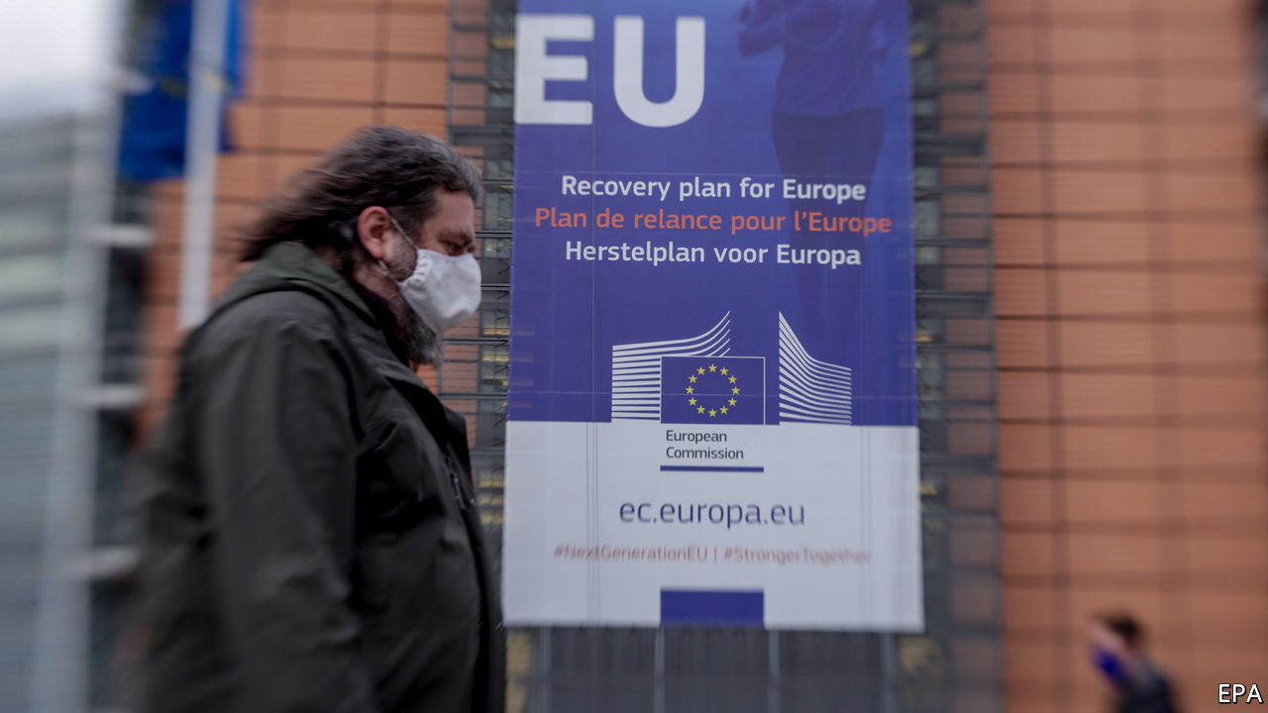

THE PUFF of white smoke came on November 10th. After months of ill-tempered talks between governments and the European Parliament—one French MEP even went on hunger strike to protest against cuts—the two sides at last agreed on a seven-year budget for the European Union. Some hurdles remain. Rules must be thrashed out for running the Recovery and Resilience Facility (RRF), the centrepiece of the covid-19 recovery plan agreed by EU leaders in July. (This, along with the regular budget, makes up an overall €1.8trn package.) Viktor Orban, Hungary’s prime minister, is threatening to veto the whole thing because of rule-of-law conditions attached to the budget. But officials are cautiously optimistic that an end is in sight.

The deal in July empowered the European Commission to borrow €750bn ($886bn) from capital markets and distribute the proceeds, in grants and loans, to EU governments over six years according to specific economic criteria. The plan (see chart) emerged from a fear that the divergent effects of covid-19 could drive a permanent wedge between governments. Its scale sparked talk of a “Hamiltonian moment”—a watershed for EU integration. In truth, it may do more than pessimists had feared, and less than the optimists hoped.

It has slowly dawned on governments that the recovery fund—Next Generation EU (NGEU), to give it its full title—is not there to prop up short-run demand. Real money will not start flowing until the second half of 2021 at best, by when the recovery should be in full swing. The bulk of the grants will not be dished out until 2024. Instead the commission hopes to use NGEU to promote its own vision for long-term reform. The recovery plans governments must submit to Brussels next year will have to identify projects in line with European priorities. Fully 37% of the spending in the RRF, for example, should go on climate-friendly schemes, such as insulating old buildings, and 20% on digital projects. A second, related aim is to promote structural reform in member states to lift long-term growth rates. The commission is quietly helping governments knock their recovery plans into shape, and some are struggling. So far, says an official, they are doing better on the investment part than on reform.

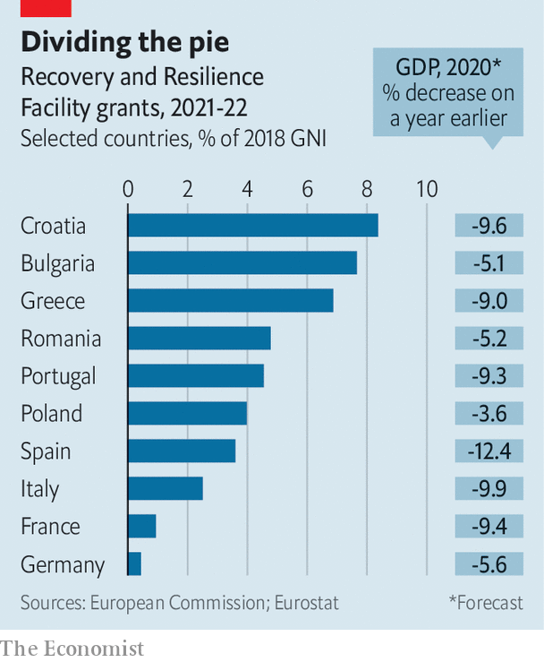

But Brussels will have its work cut out. Governments have their own priorities, and face competing claims on any available cash. Some, such as Italy, have a less than stellar record of investing for the long term. Eastern European countries often have trouble absorbing EU funds as it is. The commission itself will face serious technical and capacity constraints, and there will be pressure to get the scheme up and running soon. “You need strong governments to implement the changes the RRF demands, and you don’t have that in Italy and Spain,” says Mujtaba Rahman of the Eurasia Group, a consultancy.

While they wait for the process to grind on, governments must keep economies afloat themselves. Europe has avoided the mistakes of the early 2010s, when premature fiscal and monetary tightening triggered a needless double-dip recession. Funding furlough schemes and other demands could cause average deficits across the EU to swell to 9% of GDP this year, helped by a suspension of the EU’s fiscal rules and the European Central Bank’s ultra-loose monetary policy. Yet some worry lest governments withdraw stimulus too soon. Shahin Vallée at the German Council on Foreign Relations reckons that, stripped of accounting tricks, the French and German draft budgets for 2021 reveal, at best, a neutral fiscal stance, even as a second covid wave portends a deeper recession and a spate of corporate bankruptcies looms. With the outcome of a suspended fiscal-rules debate unknown, some governments may fear racking up debts too quickly.

As for the Hamiltonian moment, in the long run that will depend in part on whether talks on EU-wide taxes—“own resources”, in the jargon—on matters like financial transactions get anywhere. (A “roadmap” approved this week does not commit governments to anything.) A more pressing question is whether the recovery fund can be made to work in the first place. The commission says NGEU could boost EU output by up to 2% at its peak. But if governments pour money into pensions and public-sector wages rather than electric cars and 5G networks, sceptics in Germany will be reluctant to see the experiment repeated. Success is far from assured, and Brussels is nervous. But at least MEPs should be able to start eating again. ■

This article was downloaded by calibre from <https://www.economist.com/europe/2020/11/14/the-eus-eu750bn-recovery-plan-comes-one-step-closer>

|  |  |  |  |
| --- | --- | --- | --- |
| Previous | Articles | Sections | Next |

|  |  |  |  |
| --- | --- | --- | --- |
| Previous | Articles | Sections | Next |

#### Mission impossible but necessary

# France’s thankless war against jihadists in the Sahel

Unwinnable but still valuable

Nov 12th 2020 | GAO AND MÉNAKA

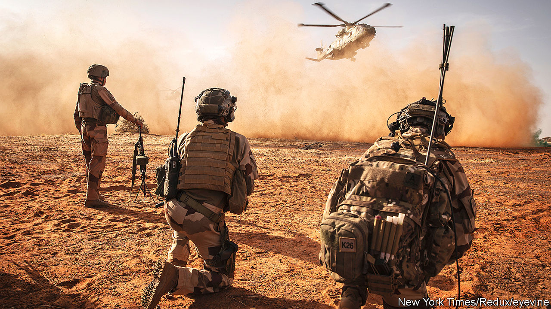

THE TWIN-ENGINE French army helicopter swoops at high speed and low altitude over the arid plains of the Sahel, its side-mounted machineguns trained on the ground. A vast expanse spreads out in each direction, interrupted only by acacia trees and the occasional herd of goats sent scampering by the helicopter’s roar. It is en route from the French military base in Gao, central Mali, to Ménaka, at the heart of a zone where a jihadist insurgency last year killed some 4,800 people.

Arising from the rust-coloured sand, the French forward base at Ménaka is a compound of newly built tents and converted containers. Under a searing sun on a November morning, parachutists and commandos line up to brief Florence Parly, the French defence minister, who is visiting from Paris. The soldiers have just conducted an operation code-named Bourrasque against jihadists from Islamic State in the Greater Sahara (ISGS) in the plains and valleys of the Liptako region.

For a month, troops from France, Niger and Mali, backed by special forces and acting on French and American intelligence, tracked jihadists. Temperatures inside armoured vehicles were at times sweltering. Tyres often blew out, and sand snarled up the mechanics. They killed several dozen insurgents and seized weapons, motorbikes, fuel and food supplies. It was “intense”, says a unit captain, with “violent encounters” at close range on the ground, often at night. “We slept when we could.”

The French government first dispatched troops in 2013 to halt a jihadist advance on Mali’s capital, Bamako. Today it keeps 5,100 soldiers in the Sahel, as part of a counter-terrorism mission called Operation Barkhane, which President Emmanuel Macron this year reinforced. No other European country contributes anything like this number to military activities in the Sahel, even to a parallel United Nations peacekeeping operation. The UN has 13,600 soldiers, among them some 350 Germans, soon to be joined by 250 British.

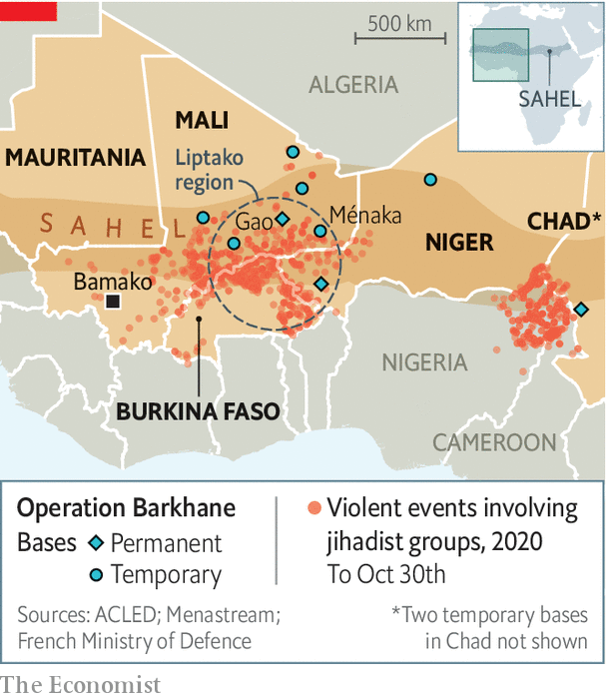

Most combat operations, though, fall to the French-led forces. These campaigns, amid the heat and billowing sand, are gruelling and risky. Last year, described by Mr Macron as “cruel and painful”, was the region’s deadliest for years. The French lost 13 elite soldiers in a single night-time helicopter crash in the “three frontiers” zone between Mali, Niger and Burkina Faso. The French base in Gao, Barkhane’s biggest, was attacked with a car-bomb. The armies of Niger and Mali lost scores of soldiers in terrorist attacks. Across the Sahel, an estimated 4m people have fled their homes.

In January Mr Macron hosted a summit in the French town of Pau with the leaders of the five Sahel countries (Burkina Faso, Chad, Mali, Mauritania and Niger). Amid accusations of neo-colonialism, France’s president partly sought confirmation from regional leaders that they actually wanted French troops to stay, which they gave. But the idea was also to share out the security burden, both by recruiting fellow Europeans to help and getting regional armies to do a better job themselves.

This has brought some successes. In Ménaka and Gao, Estonian special forces took part in operation Bourrasque alongside French commandos, as part of a new joint task-force, Takuba. They worked well together, says an Estonian commando. Czech and Swedish special forces are due to arrive soon. Such forces, explains a French commando, operate discreetly alongside Malian regulars, so that villagers can see their own country’s troops on the job. This is part of a broader plan to improve local confidence and security. The British and Danes help to provide air-lift. During Bourrasque, French soldiers worked with units from Niger and Mali, a form of on-the-job training that went better than expected, a French officer says.

Certainly the mood in Gao, where one recent morning French officers could be found in the canopied mess discussing Nigerian and Malian novelists over croissants, is more upbeat. General Marc Conruyt, who commands Barkhane, declares himself very satisfied with recent operations. The French sense they have dealt a real blow to ISGS. “They certainly haven’t disappeared,” says the general. “But they don’t have the same capacity to cause trouble in this zone that they did at the end of 2019.” The French now consider rival groups affiliated to al-Qaeda to be the greater threat. On October 30th Barkhane killed at least 50 jihadists linked to al-Qaeda in an assault on a night-time convoy.

For all these encouraging signs, however, the French are stuck in an unwinnable war. On motorbikes and pick-up trucks, insurgents are mobile and nomadic. They support themselves by trafficking guns and drugs, and have a talent for disappearing into the bush. Across the north of Mali, they still hold sway. Tactical successes in one zone can push jihadists into another. The operational aim, says General Conruyt, is to harass and weaken them so as to “tip the balance in favour of our allies”. France, suggests Michael Shurkin of RAND, a think-tank in Washington, in a recent paper, “does not aspire to…defeat the jihadists.”

Rocky local politics do not help. As it is, Sahelian armies have themselves been accused of atrocities, which can help jihadists recruit. In August Malian officers ousted the president in a coup. The new leaders have promised elections, and say they want France to stay, even if its mission is unpopular. But they dismayed French observers by freeing 200 jihadists as part of a hostage-liberation deal last month. The new rulers now want to negotiate with armed jihadist groups. France disapproves.

Ms Parly stresses that “France is no longer alone.” Yet the Sahel is nobody else’s priority, despite France’s efforts to persuade its friends that the region’s stability directly affects Europe’s. The French will not be thanked for staying, but nor would they be for packing up. Under Joe Biden, America will still be under pressure to withdraw personnel from Africa. “The bottom line is that the French are actually out there on the ground,” says Charles Kupchan of the Council on Foreign Relations in Washington. “When the US is looking to lighten the load, having a partner ready to step up to the plate is a big deal.”

Next month Mr Macron, who has now put soldiers on anti-terrorist patrol on the streets in France, will take stock. He could decide to bring some troops home. “The objective”, says Ms Parly, “is progressively to be more in a support role than on the front line.” But for now, like it or not, France is stuck there. As Ms Parly says, “This is a long-term job.” ■

This article was downloaded by calibre from <https://www.economist.com/europe/2020/11/12/frances-thankless-war-against-jihadists-in-the-sahel>

|  |  |  |  |
| --- | --- | --- | --- |
| Previous | Articles | Sections | Next |

|  |  |  |
| --- | --- | --- |
| Europe | Sections | International |

Britain

Protest: Small-town revolution

.

Foreign-investment rules: For your protection

.

Brexit negotiations: Joe calling

.

Public spending: Chumocracy

.

Phone-hacking: Hanging on the telephone

.

Energy: Chain reaction

.

Financial services: London calling, at last

.

Bagehot: A populist in the palace

.

|  |  |  |
| --- | --- | --- |
| Europe | Sections | International |

|  |  |  |  |
| --- | --- | --- | --- |
|  | Articles | Sections | Next |

#### Activism

# Protest is spreading to the provinces

Small-town revolutions

Nov 14th 2020 | STROUD, GLOUCESTERSHIRE

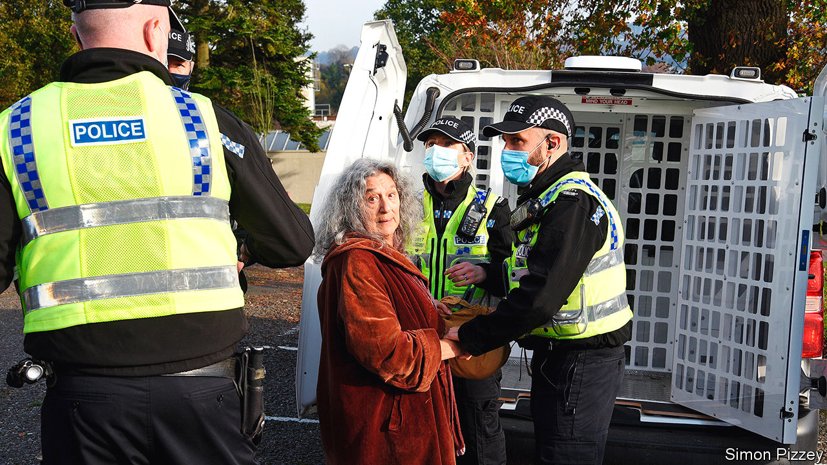

IF THE UNITED NATIONS staffers who drafted Agenda 21 in 1992 had been present at the protest on November 7th in a park in Stroud, a market town carved into the Cotswold hills, they would have been bemused by the vitriol poured on their work. But to those in the know, this non-binding resolution to promote sustainable development conceals a plan for “the Great Reset”, which will change society beyond recognition. Covid-19 has been faked to soften the world up for it and allow a vaccination programme that will render humanity infertile. “I’ve heard this has been planned for 60 years,” says a protester. “Longer than that,” says another. “It’s been planned since Babylonian times.” A third dismisses the conspiracy theories as “bullshit”. He is protesting against “not being able to go to the pub”.

The 200-odd people brought together by the Stroud Freedom Group were an unlikely marriage of cranks and conservatives. Among them, said Bruce Fenton, a local author, were “members of the Green, Labour, Conservative and Brexit parties, XR activists and members of the local Rudolf Steiner community.”

The speeches were fiery, but swiftly disrupted by police. A few arrests were made. An organiser was fined £10,000 ($13,000). Similar scenes played out in 26 other towns that day. Further protests are planned each Saturday until lockdown ends.

These gatherings are a sign not just of the rise of weird ideas during the pandemic, but also of the changing pattern of protest. The route from Marble Arch to Parliament Square is no longer the only venue for people wanting to make a point. The scene in Stroud is increasingly common, as data from police forces show (see chart).

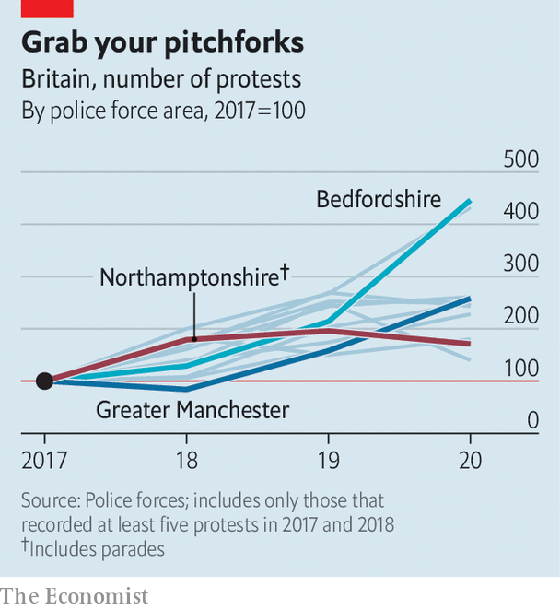

The failure of big marches calling for a second referendum to shift the dial may have encouraged organisers to try other options. For much of this year, huge marches have been out of the question. And current protest movements are local affairs, not top-down operations run from the capital. Extinction Rebellion (XR), for instance, was founded in Stroud and is organised on what it calls a “holacratic” basis, in which local groups operate as loosely regulated franchises. Those who marched for Black Lives Matter (BLM) this year belong to a variety of distinct regional groups. The Democratic Football Lads Alliance (DFLA), whose followers protected statues threatened by activists this summer, is a coalition of football-supporters’ groups.

The anti-lockdown movement includes people with varying motivations—opponents of big government, covid-19 deniers, raging conspiracy theorists and far-right activists—and different competences. StandUpX is better at street activism; Save Our Rights focuses on legislation. Science deniers congregate in Stop New Normal; Piers Corbyn, its figurehead, is a climate-change sceptic whose brother Jeremy is the former Labour leader. The most rapid conspiracies abound in Collective Action Against Bill Gates. And there are adherents of QAnon, a theory that the world is run by a cabal of Satanist paedophiles, blending at protests with the other strands.

The demographics of protest have changed, too. Last year Boris Johnson described XR activists as “nose-ringed…crusties” living in “hemp-smelling bivouacs”. But today’s protest movements have diverse followings, from construction workers to civil servants. A protester is just as likely to resemble Mr Johnson—well-educated, middle-aged and overweight—as an anarchist student from central casting.

Regional tendencies shape protest in different parts of the country. In Cornwall, rural conservatism has rubbed off on the area’s revolutionaries. Black Voices Cornwall, a group set up after the summer’s BLM protests, has abandoned its progenitor’s socialism and doesn’t support police defunding. Devon and Cornwall’s assistant chief constable, Jim Colwell, will be on the assurance board that the organisation is setting up.

The internet’s role in campaigning has changed. Online petitions are out of favour, because politicians pay no attention. Instead people huddle in densely populated chat channels on Telegram, an instant-messaging platform, which is used for organising real-life protest. Patriotic Alternative, a nationalist group with around 15,000 members, now mostly works offline. “Forming ‘in real life’ communities is much better than operating only online,” says Laura Towler, its deputy leader. “The relationships you form are more authentic and long lasting.”

Digital communication encourages proliferation. When a messaging group gets too big to manage, it spawns new groups. XR Kettering was first part of XR Northampton, but numbers swelled and it seceded. That process of localisation ensures that there are battalions ready to respond to a local incident, says Paul Mason, a writer who tracks protest movements. “It’s not like they have to assemble the network from scratch; it’s already there.”

Despite the lockdown, the pandemic has accelerated these trends. Michelle McDonald, a StandUpX organiser in Brighton, says that it motivated her to find out the disturbing truths behind the new world order. “We’re waking up to all the darkness that’s going on… I feel like I’m living under a mix of communism and the Taliban.”

The provincial protesters have not yet changed the world. XR’s target of making Britain carbon neutral by 2030 has had no more uptake than BLM’s call to defund the police. Yet both have, arguably, shifted the way people think about the climate and about Britain’s culpability in the slave trade. The anti-lockdown protests may, similarly, have contributed to the finding of a recent research study, that a quarter of Britons think covid-19 was manufactured in a Wuhan laboratory and an eighth think it is a plot to vaccinate humanity.

Whether or not these protests change policy, they change people’s lives. Those involved now belong to vast social networks, formed by, and reliant on, protest. For some, that is part of the appeal. “I feel quite on my own with my neighbours locally, who don’t see the agenda for what it is,” says Dominic Graville, a Stroud protester whose acting work dried up during the pandemic. “It’s a way to form new bonds and connections: we’re stronger together.” The campaign to roll out a covid-19 vaccine is likely to bind them tighter.■

This article was downloaded by calibre from <https://www.economist.com/britain/2020/11/14/protest-is-spreading-to-the-provinces>

|  |  |  |  |
| --- | --- | --- | --- |
|  | Articles | Sections | Next |

|  |  |  |  |
| --- | --- | --- | --- |
| Previous | Articles | Sections | Next |

#### Foreign direct investment

# The law on foreign takeovers is being tightened

It’s not about China, honest

Nov 14th 2020 |

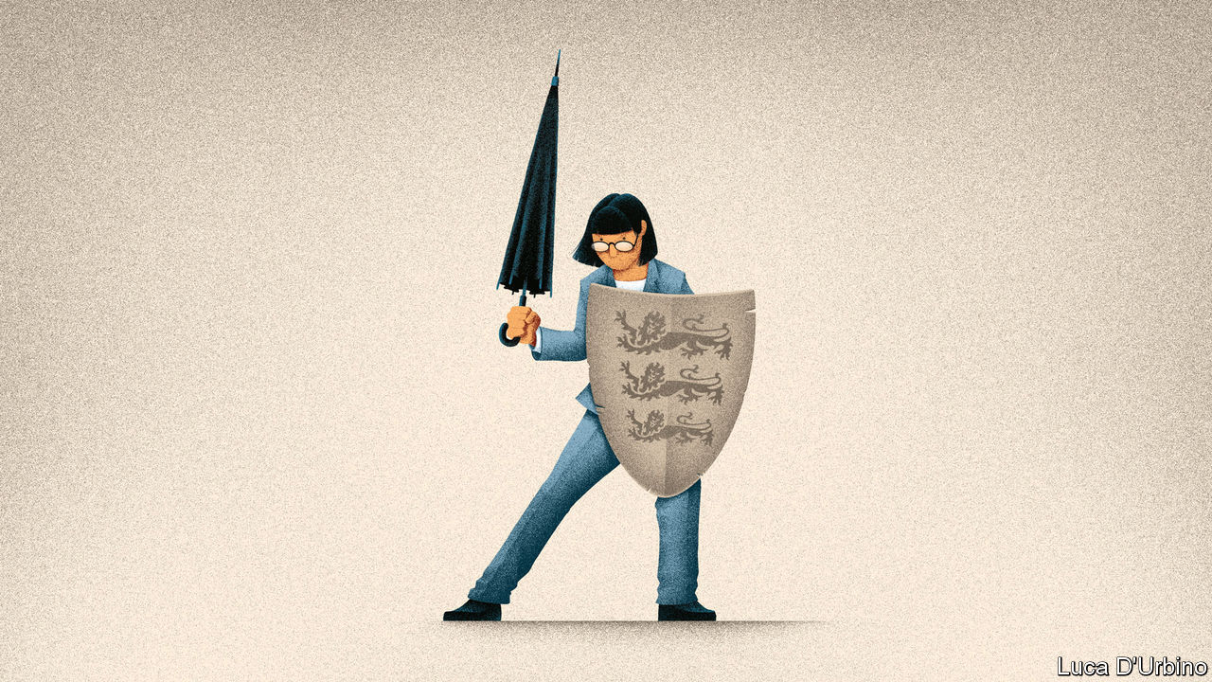

IN SEPTEMBER 2016, Theresa May approved a plan allowing a state-owned Chinese company to take a minority stake in a project to build Hinkley Point nuclear power station, but her government was uncomfortable with the decision. It carried out a review of its power to control foreign investments from a national-security standpoint, and found it wanting.

On November 11th Boris Johnson’s government introduced legislation stemming from that review process to Parliament. The bill would require companies to tell the government about any planned transactions within 17 areas of the economy, focused on technology, including categories as broad as “computing hardware”, “artificial intelligence” and “data infrastructure”. The government will also have the power to unwind any transaction completed within the last five years if it deems that transaction to be a matter of “national security”.

Chinese investment is the principal concern. Britain’s new rules look very similar to America’s Foreign Investment Risk Review Modernisation Act (FIRRMA), passed in 2018. Both rely on the application of the rather loose term, “national security”, and have sweeping remits over broad categories of technologies. Chinese inbound investment to the United States has plunged in the two years since FIRRMA was passed. Australia, France and Germany all have similar laws.

Although Alok Sharma, the business secretary, says that the new legislation will ensure that Britain remains attractive to foreign capital, problems loom. The biggest is an open question over the extent to which the law would give the government control over any economic activity involving the flow of data, which underpins most of the 17 categories targeted.

It is unclear whether deals like Ctrip’s £1.4bn purchase in 2016 of Skyscanner, a flight-booking service based in Edinburgh, would be caught. James Palmer of Herbert Smith Freehills, a London law firm thinks that they would. The proposed purchase of a stake in Nanopore, a genetic-sequencing company based in Oxford, by Tencent, a Chinese messaging and gaming app, is now in question.

If the government insists on reviewing all foreign transactions involving data flows, that would discourage firms from basing themselves in Britain. Why would a tech startup subject its future, and any potential sale, to the national-security determinations of the British government when it could just as easily set up shop in freer jurisdictions in Ireland or the Netherlands? The American government has defined national security so broadly that both a New York Times story on spying and Joe Biden’s criticisms of immigration policy fall into it. If Britain were to follow the same path it would bode ill for foreign investment.

The government has set up an Investment Security Unit which will be the first port of call for notifications when the bill becomes law. Corporate lawyers are in the business of reducing risk, and so will notify it when there is any doubt. At present, there is plenty of it. Foreign control of vital technologies is a serious issue, with genuine national-security risks. But the government must be sure that the damage it does the tech sector in dealing with them does not outweigh the benefits.■

This article was downloaded by calibre from <https://www.economist.com/britain/2020/11/14/the-law-on-foreign-takeovers-is-being-tightened>

|  |  |  |  |
| --- | --- | --- | --- |
| Previous | Articles | Sections | Next |

|  |  |  |  |
| --- | --- | --- | --- |
| Previous | Articles | Sections | Next |

#### Brexit and Biden

# Biden puts pressure on Johnson to do a deal with the EU

Joe calling

Nov 12th 2020 |

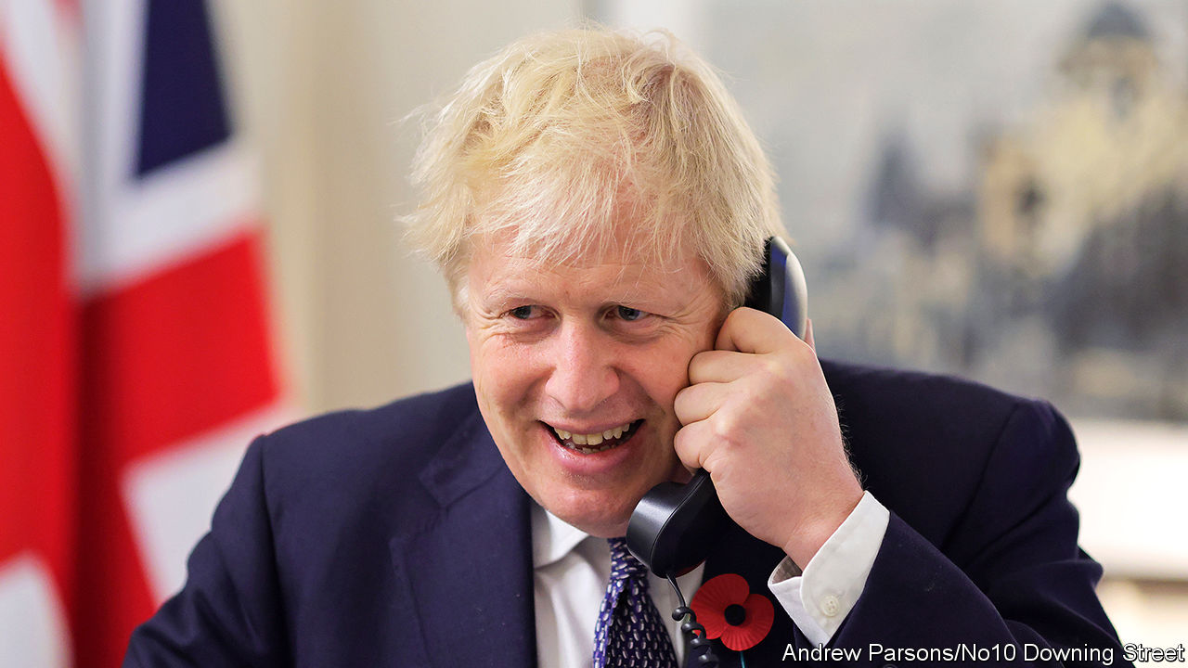

DOWNING STREET was cock-a-hoop on November 10th when Joe Biden, America’s president-elect, telephoned Boris Johnson before any other European leader. Yet the call was not just a friendly one to cement the “special relationship”. There was an implicit threat in it: if Mr Johnson allowed Britain to leave the EU without a deal, thus undermining the Good Friday Agreement (GFA) that brought peace to Northern Ireland, Britain would not get a trade deal with America.

Just seven weeks remain until the end of the standstill transition period, with no trade deal in sight. Talks are continuing, but agreement is elusive on the most contentious issues: a level playing-field for competition (including limits to state aids), fisheries, and dispute resolution. Michel Barnier, the EU negotiator, says the talks are not currently on a path to a deal. David Frost, his British counterpart, insists solutions must fully respect UK sovereignty, a tricky condition since any treaty inevitably impinges on it.

As ever, Northern Ireland looms large. On November 9th the House of Lords decided by 433 to 165 votes to strike out clauses in the internal-market bill seeking to overturn parts of the Northern Ireland protocol in the withdrawal treaty. Mr Johnson vowed to reinstate the clauses when the bill returns to the Commons. He also plans to use the finance bill for other changes to the protocol. This breach of international law has been denounced by all living former Tory prime ministers, as well as by Michael Howard, a former leader who is a passionate Brexiteer.

The EU says that Mr Johnson’s changes undermine the GFA by risking a hard border in Ireland. Mr Biden, who has Irish roots, agrees. Optimists believe his election makes it more likely that Mr Johnson will compromise to get a deal and drop his rewrite of the Northern Ireland protocol. To be out in the cold with no trade deal with either the EU or America would be uncomfortable. And if it involved breaking international law, it would also stymie Mr Johnson’s ambitions for “Global Britain” and make Britain’s chairmanship of the G7 and the COP26 climate-change summit next year more awkward.

Coming on top of covid-19, the disruption and cost of a no-deal Brexit also argue for compromise. Charles Grant of the Centre for European Reform, a think-tank, says the next weeks will see growing pressure for a deal from business and pro-business cabinet ministers and Tory MPs. Mr Johnson’s rising unpopularity and reputation for incompetence also suggest he badly needs to show he can at least get a much-promised Brexit trade deal.

Yet some make the opposite argument. Fabian Zuleeg of the European Policy Centre, a Brussels think-tank, sees a danger that EU leaders may conclude that, since Mr Biden’s victory will push Mr Johnson towards making a deal, there is now no need to offer him face-saving compromises. But Mr Johnson’s troubled relations with Tory MPs leave him wary of giving concessions. Many Brexiteers now criticise those he made in the withdrawal treaty. Mujtaba Rahman of Eurasia Group, a consultancy, notes that almost all members of the new group of lockdown-sceptic MPs are hard Brexiteers who prefer no deal to compromise. As a new National Audit Office report shows, even a deal will bring huge disruption at the borders. It would be easier for Mr Johnson to blame this on the EU if it came after no deal than after a deal.

The other concern is that time is short. The EU is famous for missing deadlines, but its claim that a deal must be done within a week or two is serious. Lengthy trade treaties typically take months to translate, put into legal form and ratify. This one needs to be approved by national governments as well as the European Parliament. Several members of the parliament have said that, unless Mr Johnson drops his plans to change the Northern Ireland protocol, they will reject a deal.

The risk that no-deal may come about because time runs out is not small. If that happens, Mr Johnson has nobody to blame but himself, for in June he had the opportunity to extend the transition period and chose not to do so. ■

This article was downloaded by calibre from <https://www.economist.com/britain/2020/11/12/biden-puts-pressure-on-johnson-to-do-a-deal-with-the-eu>

|  |  |  |  |
| --- | --- | --- | --- |
| Previous | Articles | Sections | Next |

|  |  |  |  |
| --- | --- | --- | --- |
| Previous | Articles | Sections | Next |

#### Public spending

# Boris Johnson’s profligacy problem

Britain’s government is gaining a reputation for waste

Nov 14th 2020 |



IF BRITONS GET a covid-19 vaccine next spring, the government wants them to thank Kate Bingham (pictured). A big shot in venture capital, she is the head of the government’s vaccines taskforce, a body which has placed early orders for 340m vaccine doses. She has also been in the limelight for less favourable reasons: her taskforce spent £670,000 ($883,000) on public relations advisers, she was accused of divulging sensitive information to an investor conference—and, to cap it all, she is married to a Tory minister.

Ms Bingham’s case represents the tensions in Boris Johnson’s government. To its fans, it is bringing in skilled outsiders to do jobs that politicians cannot, and stripping out the penny-pinching bureaucracy that hobbles ambitious programmes. To its critics, it has tossed aside proper spending controls and is becoming a chumocracy.

Jolyon Maugham, a campaigning lawyer, is suing the government over contracts for personal protective equipment (PPE), which he claims were improperly awarded to a pest-control firm and a confectionery wholesaler. Mr Maugham also accuses the government of wrongly handing deals to consultants close to the Conservative Party. The two big pandemic-related jobs went to well-connected people: Ms Bingham and Dido Harding, a businesswoman who is head of the covid-19 testing regime and is also married to a Tory MP. She was hired without a public recruitment process. Peter Riddell, the Commissioner for Public Appointments, said last month that non-executive board memberships, intended to bring business expertise into government, were being used to promote political allies.

The pandemic is part of the explanation, for it has forced the government to spend money and fill jobs with wartime haste. In a reply to Mr Maugham, the government’s lawyers describe a global scramble for PPE which made a normal tendering process impossible. Not surprisingly, the number of ministerial directions—official notices from ministers approving spending on projects that senior civil servants think may be irregular, undeliverable or poor value for money—has increased sharply in the pandemic.

The political climate has changed too. David Cameron’s government made reducing the deficit its central political goal; it hunted out spending on biscuits, air travel and consultants by officials. This government, by contrast, will make a virtue of largesse as it seeks to hold working-class seats it won from Labour in the last election, and believes in state intervention in industry. In June, the business secretary issued a direction to buy a $500m stake in OneWeb, a bankrupt satellite company, saying it would signal “UK ambition and influence on the world stage”. Officials warned the investment may fail. On November 11th the House of Commons Public Accounts Committee (PAC) said ministers had exposed themselves to allegations of political bias when they allocated £3.6bn of grants to provincial towns before last year’s general election by “vague and broad-brush” criteria. Preparations for Brexit also encouraged bad habits: in 2019 the government was sued by Eurotunnel over a hastily-arranged contract for ferries in case of a no-deal exit.

A third factor is Number 10’s attitude to civil-service procedure. Dominic Cummings, the prime minister’s chief aide, has long complained that risk-averse civil servants use European procurement law to choke projects and believes that the state should back high-risk projects that the market won’t fund. The government differs from its predecessors in its obsession with speed and appetite for risk in using public money, reckons Meg Hillier, chair of the PAC. “This is where the civil service has to be robust.” Former mandarins sympathise with Mr Cummings’s frustration at procurement rules, and few doubt the need for haste in the pandemic. But if such processes put a ceiling on dynamism and brilliance, they also provide a floor against waste and graft. ■

This article was downloaded by calibre from <https://www.economist.com/britain/2020/11/14/boris-johnsons-profligacy-problem>

|  |  |  |  |
| --- | --- | --- | --- |
| Previous | Articles | Sections | Next |

|  |  |  |  |
| --- | --- | --- | --- |
| Previous | Articles | Sections | Next |

#### Phone-hacking

# Why the phone-hacking story won’t go away

Hanging on the telephone

Nov 14th 2020 |

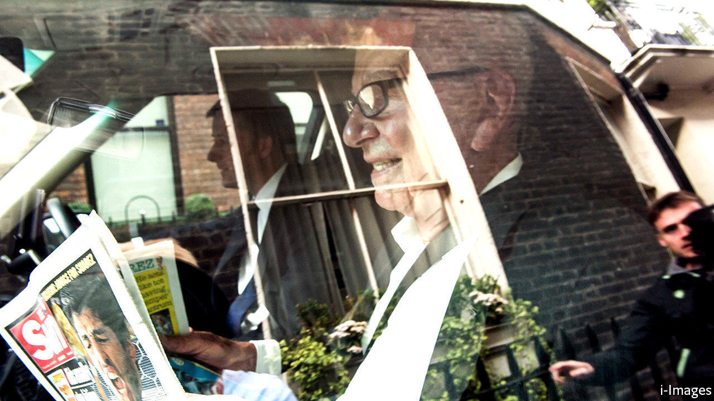

WHEN A NEWSPAPER is written about on a rival’s front page, you can be sure it isn’t good news. So it proved in July 2011, with a flurry of stories about illegal news-gathering techniques at the News of the World, a tabloid that once boasted of shifting more copies than any other English language newspaper and that, thanks to its principal obsession, was known to reporters as the Screws. Within three days Rupert Murdoch ordered the closure of the paper he had bought in 1969, his first acquisition outside New Zealand and his native Australia. “Thank you,” its final headline blared, “& goodbye”. That, it seemed, was that.

Hardly. Nine years later, the paper’s publisher, News Group Newspapers (a division of Mr Murdoch’s News Corporation), is still settling legal claims for past dodgy practices like blagging confidential information about the subject of a story or hacking into their voicemail messages. Mirror Group Newspapers, part of the publisher Reach, also faces scores of claims, some of which are listed for trial next January. “It’s got an incredibly long tail,” says Christopher Hutchings of Hamlins, a law firm representing some of the claimants. “I don’t see any immediate end in sight.”

Thanks to the slow-burning litigation, the High Court sometimes seems stuck in the 1990s and early 2000s. In one judgment, Mr Justice Mann considered the circumstances of a footballer’s row in a supermarket and argued that a story about another player requiring a custom-made seven-foot bed would be “too trivial to attract a sensible claim for damages”, even had the information not already been disclosed by his now wife. The evidence recalls an era predating smartphones, when rambling voicemails were a popular means of communication. “It’s almost going back to Dickens,” says one of the lawyers.

Three factors explain the saga’s length. First, the scale of alleged wrongdoing. When evidence of phone-hacking was first unearthed in 2006, the News of the World insisted it had been commissioned by “one rogue reporter”, Clive Goodman, who was jailed in 2007. In fact, it emerged that the paper targeted not only the royal family—as in the Goodman case—but also celebrities and members of the public such as Milly Dowler, a schoolgirl who was kidnapped and murdered in 2002. A lawyer estimates that News has so far settled about 1,000 cases. The Mirror Group denied for years that its newspapers had hacked any phones at all. It took years of dogged work by journalists, lawyers and campaigners to establish how widespread the practice was.

The second reason is procedural. The Crown Prosecution Service dropped a corporate prosecution of News and individual prosecutions of Mirror staff in 2015. The second phase of the Leveson Inquiry, an official sleuthing exercise into media malpractice, was also dropped. Had it continued, claims one of the campaigners, “this would have been wrapped up a long time ago.” In the absence of a compensation scheme, which News established in 2011 but closed two years later, the civil courts are the only forum left for redress. Since the wrongdoing alleged differs in time, scope and nature in each case, claims cannot be resolved in one go.

The third factor is the clandestine nature of the hacking. There is a six-year limit to such claims, but it runs from the time a claimant discovered—or might be expected to have discovered—the alleged wrongdoing, not when it took place. One case often throws up evidence of phone calls between one of the claimant’s contacts—say, his agent or his mother—and the defending newspaper. A lawyer for the original claimant may then speak to that contact to establish whether there was a legitimate reason for the call. If not, it might indicate that the contact’s phone was hacked, too, potentially adding a new claimant to the roll. “Person Y then puts forward their associates,” says Mr Hutchings. “It becomes a web.”

Justice delayed may be justice denied but the lawyers, at least, are unlikely to complain on that count. Settlements and legal costs already amount to hundreds of millions of pounds. The final bill has yet to arrive but Hacked Off, a campaign group, reckons it could run to £1bn. “I couldn’t genuinely argue that it hasn’t been a lucrative area to be involved in,” says Mr Hutchings, with a lawyerly double negative.■

This article was downloaded by calibre from <https://www.economist.com/britain/2020/11/14/why-the-phone-hacking-story-wont-go-away>

|  |  |  |  |
| --- | --- | --- | --- |
| Previous | Articles | Sections | Next |

|  |  |  |  |
| --- | --- | --- | --- |
| Previous | Articles | Sections | Next |

#### Chain reaction

# Britain’s nuclear industry faces a do-or-die moment

Boris Johnson weighs up whether to throw his support behind a new power station

Nov 14th 2020 |

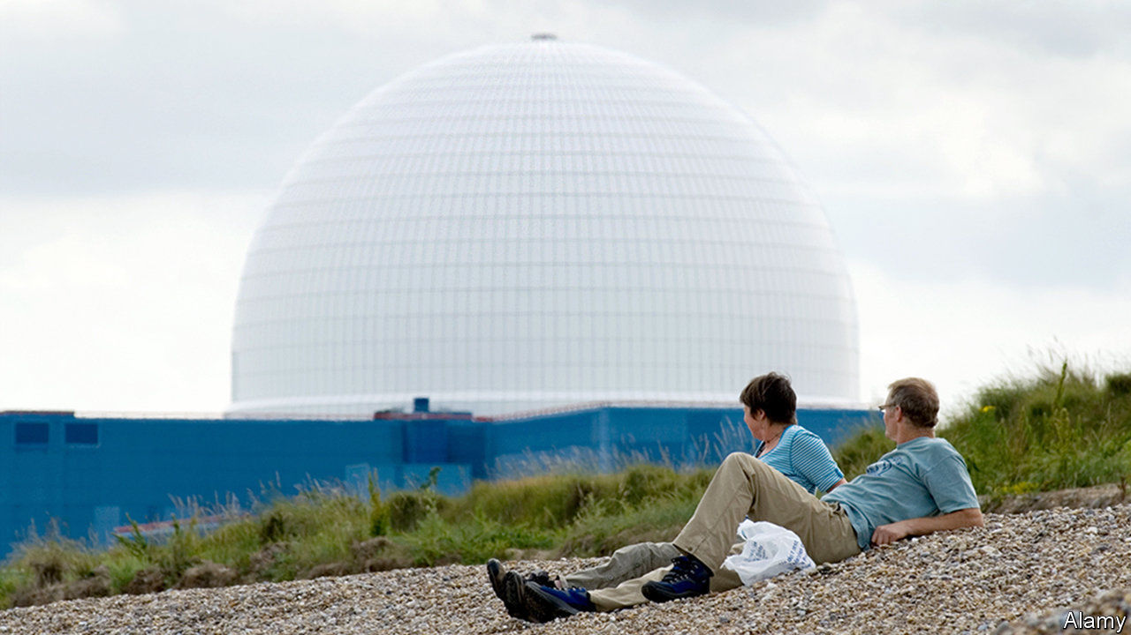

THE VILLAGE of Sizewell, on the east coast of England, has hosted nuclear power stations since 1966. The first is closed. The second, Sizewell B, started feeding power into the grid in 1995. The government is considering whether to back the construction of a third. It would be a replica of the Hinkley C plant that is under construction in Somerset, the first new nuclear power station built in Britain in 25 years. Sizewell C, if it is built, will be the second. The decision is crucial for the future of Britain’s nuclear industry.

Climate change has made the politics of nuclear power even more complex than it used to be. Public concerns about radiation and the disruption caused by construction must now be balanced against the capability of nuclear power to generate large amounts of electricity without the emission of carbon dioxide, which warms the atmosphere.

Unlike the two fast-growing mainstays of zero-carbon electricity generation, wind and solar power, nuclear power’s output is stable, and does not fluctuate with the weather. This makes it valuable to any country attempting to decarbonise. Most of the mathematical models which stay within the confines of the Paris Agreement, which aims to constrain the temperature increase on the planet to less than 2°C, have nuclear power playing a significant role.

Yet the West is abysmal at building new nuclear power stations. Olkiluoto 3, in Finland, is running 12 years behind schedule. Flamanville 3, which is being built in France, is about ten years behind and €10bn ($12bn) over budget. Both use European Pressure Reactors (EPR) from a French company, Areva, which is owned by the French state utility Electricité de France (EDF). Hinkley C and Sizewell C are also being built by EDF. Each contains two EPRs.

Critics of large nuclear-power stations cite EDF’s overruns as reasons why Britain should pull back from its nuclear ambitions. Instead, some say, Britain should focus on offshore wind turbines, diverting the money it will take to build plants like Sizewell C. In just the past few years, the proportion of electricity generated by wind has jumped dramatically (see chart).

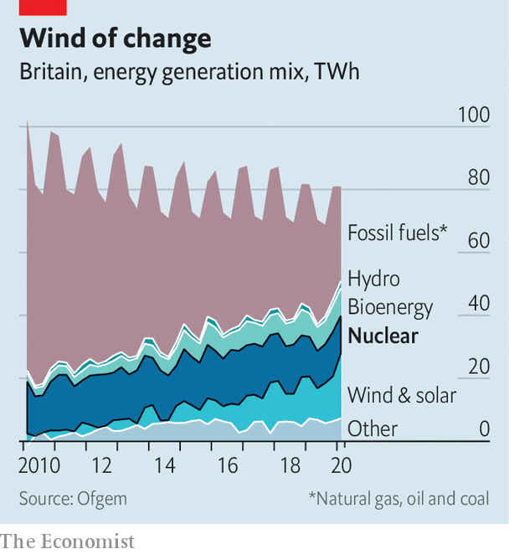

Since Hinkley C is under construction, Sizewell C is the project around which the current debate is playing out. EDF argues that the situation in Britain is different to that in Finland and France, and that its British reactors stand to benefit from cost reductions as it builds more copies of the same design in a way that its European reactors have not. This summer Julia Pyke, an EDF director, said that the second EPR to be used in Hinkley C has had 45% more steel installed than the first unit over the same timeframe, and that the reactor’s cooling components had been installed 50% faster. Sizewell C would benefit from the same dynamic, as well as lower regulatory costs, since the Office for Nuclear Regulation has approved its progenitor.

Even if Boris Johnson announces his support for Sizewell C, additional barriers remain. EDF won’t complete the government’s planning process until 2022 at the earliest. Its approval will also take time. A method of financing the plant’s construction must still be worked out and private investors found.

The risk of overruns is considerable, but the risks of failing to decarbonise are much greater. If Sizewell C does not go ahead, Britain will lose any hope of reducing the cost of nuclear power, and thereby the realistic option of including it in the grid. Its existing nuclear fleet is scheduled for decommissing within the decade. Wind power is cheap and getting cheaper; nuclear power is yet to start moving in the right direction. But it may; and given the danger of global warming, there is an argument for keeping the nuclear option open. ■

This article was downloaded by calibre from <https://www.economist.com/britain/2020/11/14/britains-nuclear-industry-faces-a-do-or-die-moment>

|  |  |  |  |
| --- | --- | --- | --- |
| Previous | Articles | Sections | Next |

|  |  |  |  |
| --- | --- | --- | --- |
| Previous | Articles | Sections | Next |

#### London calling, at last

# Rishi Sunak pitches the City to the world

The Treasury finally lavishes attention on the unloved, but important, square mile

Nov 12th 2020 |

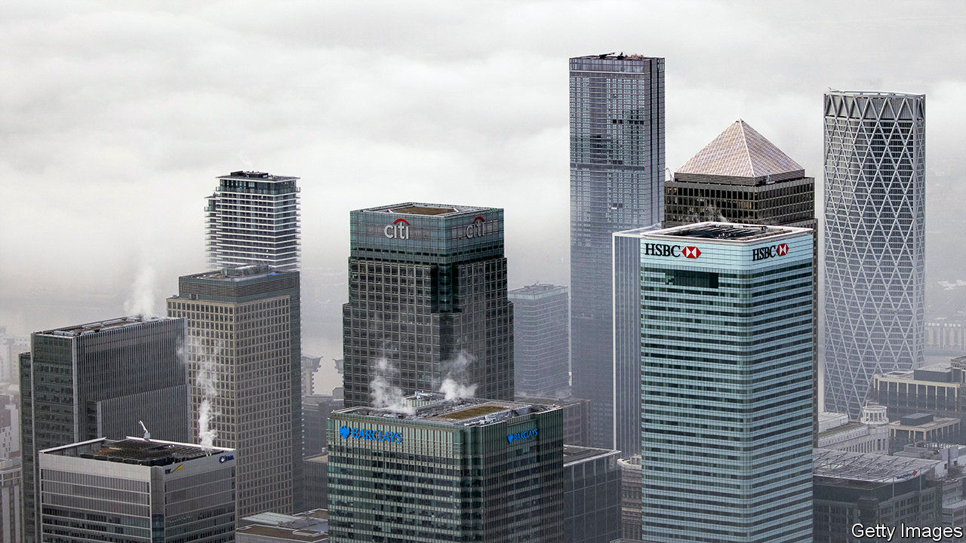

EVEN BEFORE covid-19 sent its workers home and deprived its soulless restaurants of any remaining souls, the City of London was in a funk. In its negotiations with Brussels, the government lavished attention on fishermen but hardly seemed to be putting up a fight for financial services, which account for 7% of Britain’s GDP and 10% of its tax receipts. No wonder, then, that British-registered firms–which at the end of the year will lose “passporting rights” that enable them to sell funds, debt or advice across the EU–were shipping thousands of workers and billions of pounds of financial assets to the continent.

Two developments on November 9th brought a rare smile. The first was a stock-market rally, prompted by promising news on a covid-19 vaccine and Joe Biden’s victory in the American election. The second was a statement by Rishi Sunak, the chancellor, on his ambitions for post-Brexit financial services. City bosses were cheered by his vow to renew Britain’s position as “the world’s pre-eminent financial centre”.

At last, the conversation moved beyond the fiendish business of untangling links with the EU. Mr Sunak spoke of two avenues for growth: climate change and digitisation. Britain will issue its first green bond in 2021, he announced, to fund infrastructure investment. He also proposed to regulate privately-issued digital currencies and blessed efforts to study whether the central bank should mint virtual money.

This is hardly radical stuff. Other countries already issue green bonds and financial watchdogs have been fretting about digital currencies since Facebook said it would launch one last year. But the announcements signalled that the Treasury has its fingers on the pulse and wants to retain Britain’s financial-technology crown.

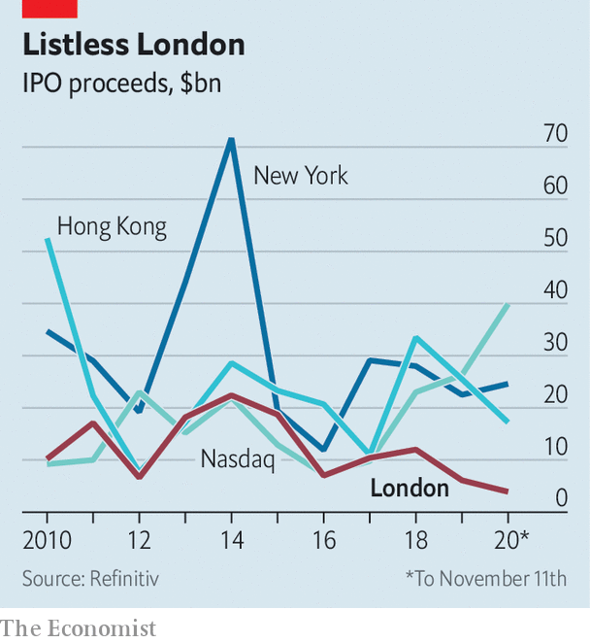

Also significant is his pledge to keep Britain’s international markets open and governed by objective and predictable rules. That is more than a platitude. He promised to grant “equivalence” to a bunch of EU rules, a status that recognises them as valid in Britain, without waiting for the bloc to reciprocate. That will provide clarity to firms on both sides of the Channel and make it easier for foreign firms to operate in Britain. He hinted, too, that Britain’s rules could be tweaked to make the City more attractive. Notably, the government wants to make it easier for innovative companies to list in London—it has lagged behind peers in recent years (see chart)—and for funds to get domiciled there.

That is a clever move. Mr Sunak’s approach stands in flattering contrast to the EU’s own position on access to its market by outsiders, which is looking increasingly unreliable and politicised, says Denzil Davidson, a former adviser to Theresa May now at Global Counsel, an advisory firm. And his promise of a simplified, tailored rulebook seeks to show there are advantages to being outside the bloc. The business the City has lost to the continent will not be recovered. But this statement, however aspirational, is an important first step in making the case for global firms to stay in London. Better late than never. ■

This article was downloaded by calibre from <https://www.economist.com/britain/2020/11/12/rishi-sunak-pitches-the-city-to-the-world>

|  |  |  |  |
| --- | --- | --- | --- |
| Previous | Articles | Sections | Next |

|  |  |  |  |
| --- | --- | --- | --- |
| Previous | Articles | Sections | Next |

#### Bagehot

# How Princess Diana shaped politics

A populist in the palace

Nov 12th 2020 |

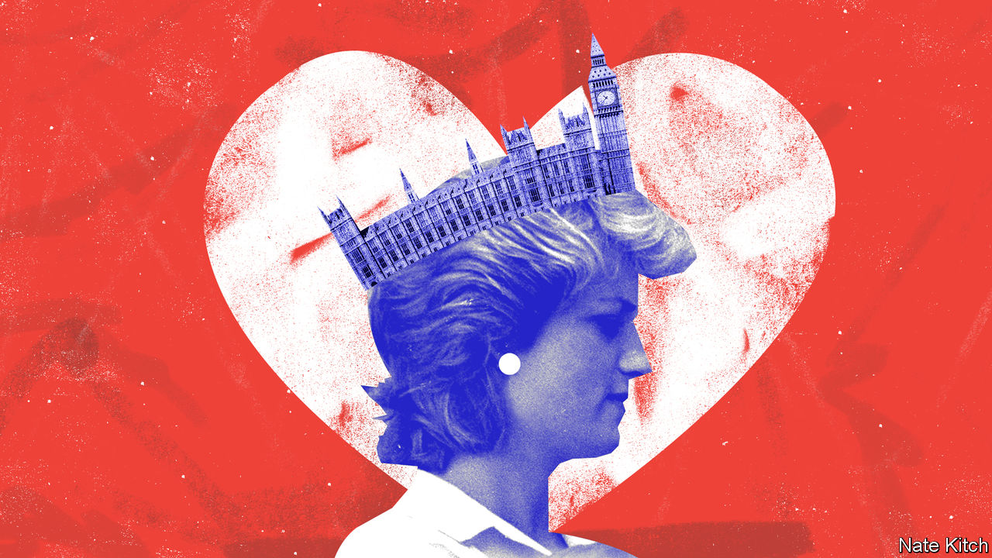

NETFLIX’S FLAGSHIP series, “The Crown”, has done a fine job of telling the story of post-war Britain through the prism of the monarchy. The previous series left viewers in the mid-1970s, mired in the miners’ strike and the three-day week. The new one, which begins streaming on November 15th, introduces us to two women who were destined to change the country in profound ways—Margaret Thatcher and Lady Diana Spencer.

Lady Thatcher made it clear from the first that she was in the business of changing the nation. Lady Diana Spencer was a bird of a very different feather—a shy girl who had failed all her O-levels twice and had no interest in politics. She was brought onto the national stage for the sole purpose of producing (male) heirs to the throne. Yet the country is still living with her political legacy as surely as it is with Lady Thatcher’s.

Princess Diana’s genius was to mix two of the most profound forces of modern politics—emotion and anti-elitism—into a powerful populist cocktail. She was one of the modern masters of the politics of emotion, feeling the people’s pain just as they felt hers. She repeatedly outmanoeuvred Prince Charles during the long “War of the Waleses” because she was willing to bare her soul in public. Her interview with Martin Bashir of the BBC in November 1995 is now the focus of controversy, as her brother, Earl Spencer, claims that it was obtained under false pretences, using forged documents. Whatever the reason for giving it, the interview was a masterclass in emotional manipulation. At one pivotal moment Princess Diana acknowledged that she would never be queen but hoped that she would be “queen of people’s hearts”.

The princess used her mastery of the politics of feeling to turn herself into a champion of the people against the powerful—the “people’s princess” in Tony Blair’s phrase. She patronised charities that helped marginalised folk such as HIV patients, and kept company with pop stars and celebrities rather than with the usual royal waxworks. The most memorable music at her funeral was not an historic hymn but a song by Elton John, adapted for her but originally written about another icon-turned-victim, Marilyn Monroe.

Her anti-elitism was directed not at the monarchy’s wealth—she happily lived in Kensington Palace and received a £17m ($23m) divorce settlement plus £400,000 a year—but at its stunted emotional state. The traditional deal to which royals signed up allowed them to behave as they liked in private—kings have almost always had mistresses because they marry for reasons of dynasty not compatibility—so long as they behaved with decorum in public. Princess Diana regarded this as humbug.

She succeeded in reconciling the most jarring of opposites. Despite being a top-tier aristocrat (her family, the Spencers, looked down on the Windsors as German carpetbaggers) she was universally known as “Di”. Her death in a car crash won her a spectacular posthumous victory against the royal court. It produced the greatest outburst of public lacrymation Britain has ever seen and led to widespread demands that the royals should display more emotion, as if the damp cheek had replaced the stiff upper lip as the definition of Britishness. “What would really do the monarchy good, and show that they had grasped the lesson of Diana’s popularity,” an editorial in the Independent thundered, “would be for the Queen and the Prince of Wales to break down, cry and hug one another on the steps of the Abbey this Saturday.”

Since her death, her emotional populism has threaded through politics. Tony Blair presented himself as the people’s prime minister. He championed “Cool Britannia”, surrounded himself with pop stars and urged his staff to “call me Tony”. The next Conservative prime minister, “Call me Dave” Cameron—a distant relation of Princess Diana’s—adopted this combination of compassion-signalling (hugging hoodies instead of cracking down on juvenile delinquents) and studied informality (chillaxing and kitchen suppers replacing previous Tory premiers’ stiffness).

Both men were too responsible to let emotional populism interfere with the affairs of state. Domestic and foreign policy choices continued to be conducted according to the icy dictates of reason and evidence. Brexiteers, by contrast, followed the Diana-script. They appealed to the heart rather than the head; to win their arguments they used feelings of patriotism and resentment rather than facts about trade flows. They denounced the elites for trying to frustrate the wisdom of the people in much the same way as Dianaphiles had denounced the Palace for ignoring the people’s emotions. They turned on the nation’s core institutions—Parliament, the civil service, the Supreme Court—when they suspected attempts to frustrate their wishes. They succeeded in defeating the establishment in much the same way as Princess Diana had, by claiming to stand for emotion rather than reason and the people rather than the elite. Alexander Boris de Pfeffel Johnson has reconciled the opposites he embodies just as she did. A card-carrying member of the metropolitan elite, he has managed to sell himself as a man of the people. As she was Di, so he is Boris.

The first series of “The Crown” shows a young Queen Elizabeth studying Walter Bagehot’s “The English Constitution” under the guidance of Sir Henry Marten, the vice-provost of Eton, who kept a pet raven in a cage and addressed the young princess as “gentlemen”. Bagehot’s great work distinguishes between the dignified branch of the constitution (the monarchy) and the efficient branch (elected politicians). Implicit in that distinction is Bagehot’s perception that emotions pose a dangerous threat to the proper conduct of politics. The monarchy provides a controlled outlet for them, thus enabling responsible people to get on with the difficult task of running the country.

By using people’s feelings as the fuel for her astonishing career, Princess Diana broke that safety valve. Britain will be living with the consequences of the emotional populism that she helped to release for years to come. ■

This article was downloaded by calibre from <https://www.economist.com/britain/2020/11/12/how-princess-diana-shaped-politics>

|  |  |  |  |
| --- | --- | --- | --- |
| Previous | Articles | Sections | Next |

|  |  |  |
| --- | --- | --- |
| Britain | Sections | Special report |

International

American foreign policy: What does the world want from Joe Biden?

.

|  |  |  |
| --- | --- | --- |
| Britain | Sections | Special report |

|  |  |  |  |
| --- | --- | --- | --- |
|  | Articles | Sections | Next |

#### Predictability, for a start

# What the world wants from Joe Biden

The president-elect will face a torrent of demands

Nov 14th 2020 | BEIRUT, BRUSSELS, PARIS, SÃO PAULO AND TOKYO

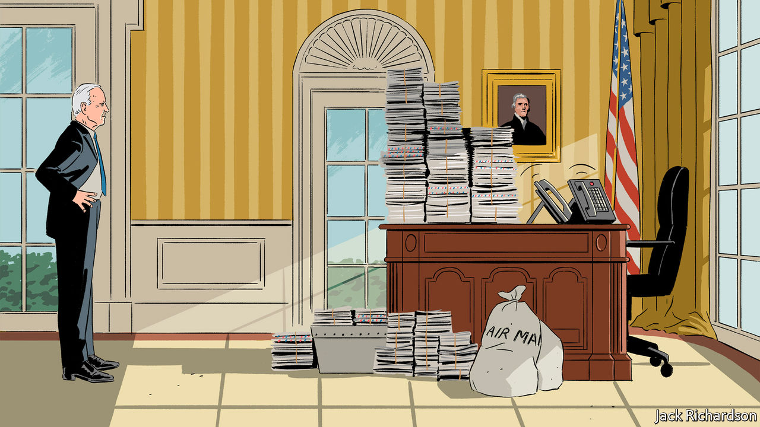

ON THE MORNING after the polls closed last week, America withdrew from the Paris agreement on climate change. The effects will be short-lived. President-elect Joe Biden has promised to rejoin the pact as soon as he enters the White House.

Donald Trump’s defeat has evoked strong reactions around the world. The main one “is relief”, says Andreas Nick, a German MP. But the world will not return to how it was in 2016, and Mr Biden will not please everyone.

Consider climate change. Most countries are eager to welcome America back into the club of those that care about it. In the past eight weeks, China, Japan and South Korea have vowed to reduce net emissions to zero by mid-century or thereabouts. Four of the five largest economies have now committed themselves to emissions cuts that are in line with limiting global warming to 2°C above pre-industrial levels or less (see chart 1).

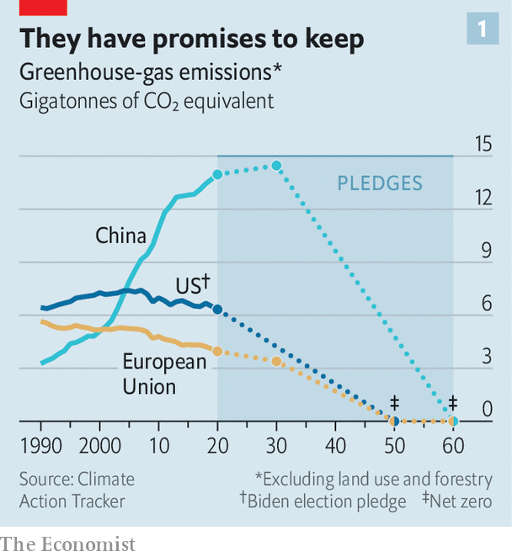

Mr Biden has said he intends to adopt a target of net-zero emissions by 2050, which modellers say will shave 0.1°C off their temperature projections for the end of the century. To rejoin the Paris deal, he will need formally to submit this goal alongside an updated national pledge to slash emissions. Most observers believe a 45-50% decrease from 2005 levels by 2030 would be tough but feasible, fair and commensurate with what Europe is doing.

Mr Biden can re-enter the Paris deal without congressional approval, but he will need some degree of buy-in from both sides of the aisle to make his pledges credible. Integrating green infrastructure, energy, and research and development into any new government stimulus would help. American public opinion is broadly favourable. In exit polls two-thirds of voters said that climate change was a serious problem. Whether they will accept higher energy prices to fix it remains to be seen.

Outsiders are watching to see if Mr Biden structures his team in a way that makes it clear that he wants to integrate climate action across his foreign and domestic policy. The importance of having America back on the climate train is hard to overstate. Over the past four years, voters around the world have noticed not only warmer temperatures, but increasing numbers of floods, droughts and forest fires. Europe is pushing through an ambitious green deal at home and working closely with China, the world’s largest emitter. If Mr Biden can formalise America’s emissions targets for 2030 and 2050 before the COP26 UN climate summit next year, that will help convince other governments that the country intends to pull its weight. That should give others—including China—the guts to decarbonise faster.

However, not all governments will welcome a carbon warrior in the White House. Oil- and coal-producers are wary. So is Brazil’s President Jair Bolsonaro, not least because Mr Biden has threatened “economic consequences” if Brazil continues to tear down the Amazon rainforest. Mr Bolsonaro, who thinks foreign eco-scolds have imperialist designs on Brazilian territory, tweeted “OUR SOVEREIGNTY IS NON-NEGOTIABLE” and spoke vaguely of needing “gunpowder” to defend it. Brazil’s carbon emissions rose by a whopping 9.6% in 2019, mainly due to deforestation.

Another area where the world expects more collaboration is health. Mr Trump announced in July that America was pulling out of the World Health Organisation (WHO), the main global body for fighting pandemics (among other things), grumbling that it was beholden to China. Mr Biden says he will reverse this rash decision on the first day of his presidency.

By executive order, he can stop the clock on the withdrawal process, which was to be completed by July 2021. It is unclear how big the disruption will be. America is the WHO’s biggest donor: in 2019 it provided around 15% of its budget. With Mr Biden in charge, America is also expected to join a global coalition funding the development of covid-19 tests, drugs and vaccines and their distribution to poorer countries. International co-operation is likely to work better than “America First”. The pandemic “won’t be over in the US if it’s not over in Mexico,” notes a Mexican official.

Governments everywhere are asking how Mr Biden will affect their national interest. China’s state media have given him a cautious welcome. Global Times, a tabloid, even called him an “old friend”. China’s regime may have relished the decline of American soft power under Mr Trump, but it also chafed at the capriciousness of his China policy and the hawkishness of his officials. In its view, the Trump administration is to blame for pushback in much of the West against Chinese influence.

China does not expect a Biden presidency to reduce Western anxiety. But it hopes for more predictability. Under Mr Trump, China feared a sudden policy shift towards Taiwan that might have brought the two countries closer to war. It hopes that Mr Biden will be more careful.

China would also like a less choppy trade relationship. It doubts that Mr Biden will ramp up tariffs in a futile effort to make bilateral imports equal to exports, as Mr Trump did. It hopes that he will cut some of those tariffs. It does not expect any change in America’s attitude towards Chinese involvement in building 5G networks, or its military build-up in the South China Sea.

India’s prime minister, Narendra Modi, was quick to fire congratulatory messages both to Mr Biden and to his running-mate. Kamala Harris inspires “immense pride” not just among her chittis (aunties) but among all Indian-Americans, Mr Modi gushed. Indian pundits speculate that he is keen not to be punished for having bet heavily on Mr Trump, his fellow populist.

He probably won’t be. Whoever is in charge, bilateral ties have warmed in recent decades. “The US cannot create an effective balance of power against China without India,” notes Ashley Tellis of the Carnegie Endowment for International Peace, a think-tank. Mr Biden’s campaign website took India to task for its backsliding on democracy and human rights. India’s unspoken retort, in the words of Sadanand Dhume of the American Enterprise Institute, another think-tank, is “Let us do whatever we like, because we are with you on China.”

When it comes to asserting hard power, America’s friends in Asia want Mr Biden to be closer to Mr Trump than to Barack Obama. Mr Obama drew red lines in the South China Sea, but then did little when China crossed them. The Trump administration, by contrast, more vociferously rejected China’s claims in the sea and upped the American naval presence. It reaffirmed America’s defence commitment to Japanese islands harassed by China. And it sold arms to Taiwan. Bilahari Kausikan, formerly Singapore’s top diplomat, says that when Mr Trump told President Xi Jinping of China, his guest at Mar-a-Lago in 2017, that he had just bombed Syria over its use of chemical weapons, he did much to restore the credibility in Asia of American power.

## Say it ain’t so Joe

Some Asians worry that Mr Biden might make security concessions to China in pursuit of other goals, such as co-operation on climate change. Where Mr Obama “put emphasis on engagement first, it’s time to put deterrence first,” says Miyake Kunihiko of the Canon Institute for Global Studies, a think-tank in Tokyo. “They shouldn’t leave China with any illusions it would be able to attack Taiwan,” says Sasae Kenichiro, a former Japanese ambassador to the United States. Still, many would like to see Mr Biden approach China in closer co-ordination with allies, and with less blind rage. For all that Japanese policymakers wish to constrain their huge neighbour, they are, given China’s proximity and the two countries’ enmeshed economic ties, reluctant to confront it. They dread the kind of open break with China that the Trump administration has seemed bent on.

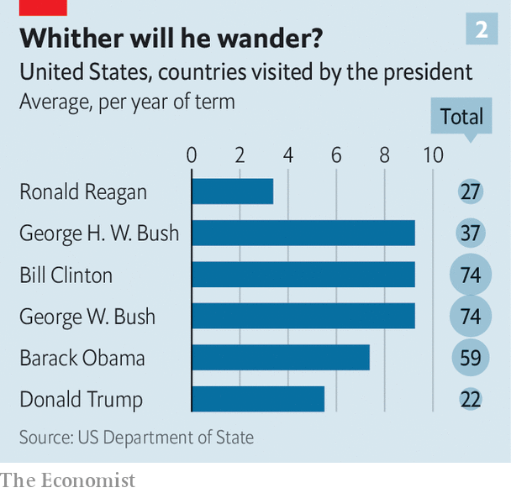

Japan’s new prime minister, Suga Yoshihide, surely hopes for a more conventional relationship with his country’s main ally. “It’s extremely important for us to have professional consultations with the United States, and with a head of government who is knowledgeable about foreign policy,” says Tanaka Hitoshi, a former deputy foreign minister.

South Koreans would agree. Mr Trump tore up a trade deal and constantly threatened to withdraw American troops from Korean soil if Seoul did not pay more for their presence. Mr Biden, in an op-ed for South Korea’s national news agency, called such threats “reckless” and vowed to strengthen the alliance. In a poll before the election, almost two-thirds of South Koreans said they wanted Mr Biden to win.

Likewise, in South-East Asia, Mr Trump’s calls for an ideological crusade against “Communist China”, to be fought on every front, showed an administration out of touch with diplomatic realities, argues Dino Patti Djalal, an Indonesian former ambassador to America, in the Diplomat, a magazine. Yes, China causes headaches in South-East Asia. But it has posed no ideological threat for decades. For now, he says, the region’s priority is to overcome the pandemic (with China’s help) and chart an economic recovery (in which China will be the motor of growth). The American presence is welcome, but having to take sides is not—which is why Indonesia recently refused to offer a home to American spy planes.

As for Mr Biden, Asians are counting on a return of what Kevin Rudd, an Australian former prime minister, calls “strategic and economic ballast” to America’s relationship with Asia, and “a more nuanced diplomacy”. Is that likely? Mr Rudd thinks so. Mr Biden is pulling together a team of Asia experts for whom “the granularity of the Indo-Pacific is like second nature”.

During the Trump years the European Union (EU) unexpectedly found itself the guardian of multilateralism. After Mr Biden’s victory, Europeans hope this burden will be shared. Besides rejoining the Paris agreement, they would like America to stop undermining the World Trade Organisation and to revive the Iran nuclear deal. Mr Biden has suggested he will do so.

In grand strategic terms, the EU’s main aim is to avoid being dragged into a hegemonic struggle between America and China. It wants to be slightly firmer and less credulous with China, but may not support Mr Biden if he pursues confrontation.

Mr Biden will not undermine NATO as his predecessor did. And he will insist that NATO allies, two-thirds of whom fail to spend 2% of GDP on defence, invest more in their own armed forces. Germany hopes that this message will no longer be accompanied by threats to slap tariffs on German cars, and that disputes between allies will be settled quietly, rather than over Twitter.

France hopes for a fresh American push to resolve regional conflicts that affect European security, from Turkish expansionism in the eastern Mediterranean to instability in Lebanon and Libya. Germany and France will welcome a return of American civility and seriousness, and an end to Mr Trump’s efforts to divide Europe.

Yet there is also a clear-eyed recognition in European capitals that, even under Mr Obama, Europe had begun to slip out of American sight. “The Americans are obviously indispensable,” says a French presidential source, “but the world has changed.” France now wants Europe to do more for itself, and differently. Emmanuel Macron, France’s president, will need to persuade the Biden team that his ambitions to build up “strategic autonomy” in Europe are not aimed at sidelining NATO.

## Not your average Joe

Britain hopes to secure a trade deal with America (to offset the damage done by Brexit) and to punch above its weight globally via its “special relationship” with the superpower. However, Mr Biden, who has Irish ancestry, has hinted that Britain can forget about a trade deal if it reimposes a hard border between Northern Ireland and the Republic of Ireland. He has described Boris Johnson, Britain’s prime minister, as “the physical and emotional clone of Donald Trump”, which is not meant as a compliment. That Mr Johnson was the second world leader to speak to Mr Biden after his victory will allay some fears, but Britain will probably lose its role as the bridge between the United States and Europe.

In the Middle East reviving the Iran nuclear deal will not be easy. Most American Republicans and some Democrats revile it. Mr Biden may lift some sanctions and then try to negotiate a follow-up agreement. Israel and the Gulf states will want it to go much further than the original 2015 version—to impose limits on Iran’s ballistic-missile programme and perhaps its support for militant groups. Iran is unlikely to agree to such terms, though, in which case America’s Middle Eastern partners will urge Mr Biden to maintain the sanctions.

Mr Trump had a notable success in persuading Arab states to recognise Israel. Mr Biden will be under pressure to continue the thaw. Israel’s prime minister, Binyamin Netanyahu, was close to Mr Trump, and will have to mend ties with Mr Biden. However, his country retains strong support in America. The Palestinians hope to reverse some of Mr Trump’s more antagonistic moves, such as closing their diplomatic mission in Washington and cutting aid. They are unlikely to convince Mr Biden to move America’s embassy in Jerusalem back to Tel Aviv. Most countries want Mr Biden to slow the drawdown of American troops from Afghanistan, where fighting between the government and the Taliban is intensifying, and to keep a foothold in Iraq, where Islamic State is active (see chart 3).

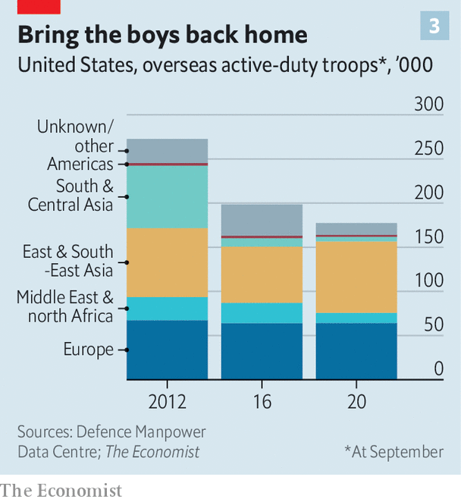

For the world’s populists and nationalists Mr Trump’s presence in the White House was evidence that theirs was the ideology of the future. “The value Bolsonaro derived from Trump was the narrative,” says Oliver Stuenkel of the Fundação Getulio Vargas, a university in São Paulo. Andrés Manuel López Obrador, Mexico’s left-wing populist president, has so far refused to congratulate Mr Biden.

Viktor Orban, Hungary’s illiberal prime minister, supported Mr Trump on the ground that Mr Biden’s party stood for “moral imperialism”. Poland’s rulers did so for similar reasons. Janez Jansa, prime minister of Melania Trump’s native Slovenia, insisted for days that Mr Trump had won and retweeted fake news to that effect.

## Back to life, back to reality

These countries now face a president who sees upholding the rule of law as a foreign-policy priority. As vice-president, Mr Biden repeatedly toured eastern Europe explaining that America saw corruption as a tool of Russian influence, and fighting it as crucial to NATO’s security. Daria Kaleniuk of AntAC, an anti-graft group in Kyiv, hopes Mr Biden will be “much stronger and more involved”.

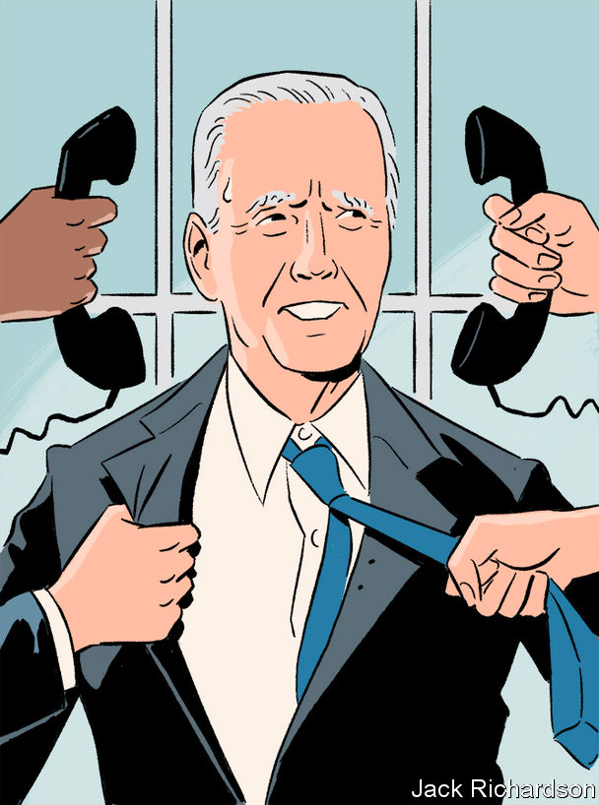

Many autocratic leaders will miss Mr Trump’s tendency to overlook their sins. Saudi Arabia’s crown prince, Muhammad bin Salman, will find his regular WhatsApp chats with Jared Kushner less useful. Vladimir Putin expects frostier relations. Hence, perhaps, the histrionics of Dmitry Kiselev, his propagandist-in-chief. “For a long time, they have been trying to teach us [democracy],” he said. “But now the teacher has staged a debauchery, smashed the windows and shit his pants.”

Many poor countries hope that Mr Biden will notice them. Governments in Africa want support to deal with the economic fallout of the pandemic. Central America wants aid to curb violence and give people an alternative to emigration. Developing countries everywhere would like less bluster about a new cold war with China and more American trade and investment.

Human-rights groups would like a vocal ally in the White House, or even a long-winded one. “We will clearly see a more serious voice on democracy and human rights in Africa,” says Judd Devermont of the Centre for Strategic and International Studies, a think-tank. “The Trump administration’s absence was most deafening on politics and governance.”

Finally, the world expects America to welcome more foreign talent. Mr Biden vows to repeal Mr Trump’s toughest immigration curbs, stop building the wall, stop putting children in cages and offer a path to citizenship for people living in America illegally. Countries that send lots of emigrants, such as India, are pleased.

So are the migrants themselves. Arvin Kakekhani, an Iranian researcher at the University of Pennsylvania, designs catalysts to turn water and carbon dioxide into clean fuels. After Mr Trump’s “Muslim ban” he felt “so insecure”, not knowing whether he would be able to stay in the country, he recalls. He has had to live apart from his Iranian wife for two years. “My dream is to use expertise to tackle the climate crisis,” he says, adding that with Mr Biden’s victory, he is “now much more motivated to stay” and do it in America. ■

Dig deeper:  
For the latest on the election, see our [results page](https://www.economist.com/graphic-detail/2020/11/03/the-us-2020-election-results), read the [best of our 2020 campaign coverage](https://www.economist.com/us-election-2020) and then sign up for Checks and Balance, our [weekly newsletter](https://www.economist.com/checksandbalance/) and [podcast](https://www.economist.com/checks-and-balance-our-weekly-podcast-on-american-politics) on American politics.

This article was downloaded by calibre from <https://www.economist.com/international/2020/11/14/what-the-world-wants-from-joe-biden>

|  |  |  |  |
| --- | --- | --- | --- |
|  | Articles | Sections | Next |

|  |  |  |
| --- | --- | --- |
| International | Sections | Business |

Special report

Asset management: The money doctors

.

Index funds: Passive attack

.

Agency problems: Double trouble

.

Capital allocation: Stewards’ inquiry

.

Private markets: Taking back control

.

Venture capital: Frogs and princes

.

China: The Shanghai Open

.

The end-game: Doctor’s prescriptions

.

|  |  |  |
| --- | --- | --- |
| International | Sections | Business |

|  |  |  |  |
| --- | --- | --- | --- |
|  | Articles | Sections | Next |

#### Asset management

# The money doctors

The asset-management industry is at last sorting the quacks from the true specialists, argues John O’Sullivan

Nov 12th 2020 |



IN MARCH 1868 a prospectus appeared for a new kind of money-market scheme. The Foreign & Colonial Government Trust would invest £1m ($5m at the time) in a selection of bonds. For £85 an investor could buy one of 11,765 certificates giving an equal share. The trust promised a 7% yield. Its aim was to give “the investor of moderate means the same advantages as the large capitalist in diminishing the risk of investing…by spreading the investment over a number of different stocks.” The modern asset-management industry was born.

A week later The Economist ran a leading article broadly welcoming the new trust. But—setting the tone for 150 years of financial punditry—it quibbled about the selected bonds. A chunk was allocated to Turkey and Egypt, countries that “will go on borrowing as long as they can, and when they cease to borrow, they will also cease to pay interest.” Fears were expressed that Europe was disintegrating. “In lending to Italy, you lend to an inchoate state; and in lending to Austria, you lend to a ‘dishevelled’ state; in both there is danger.”

The trust was the brainchild of Philip Rose, a lawyer and financial adviser to Benjamin Disraeli. His idea of a pooled investment fund for the middle class caught on. In 1873 Robert Fleming, a Dundee-based businessman, started his own investment trust, the First Scottish, modelled on Rose’s fund but with a bolder remit. It was largely invested in mortgage bonds of railroads listed in New York. The holdings were in dollars, not sterling. And whereas Rose’s trust was a buy-and-hold vehicle, the trustees of the First Scottish reserved the right to add or drop securities as they saw fit.

Rose’s trust survives to this day, but asset management is now a far bigger business. Over $100trn-worth of assets is held in pooled investments managed by professionals who charge fees. The industry is central to capitalism. Asset managers support jobs and growth by directing capital to businesses they judge to have the best prospects. The returns help ordinary savers to reach their financial goals—retirement, education and so on. So asset management also has a crucial social role, acting as guardian of savings and steward of firms those savings are entrusted to.

It is a business unlike any other. Managers charge a fixed fee on the assets they manage, but customers ultimately bear the full costs of investments that sour. Profit margins in asset management are high by the standards of other industries. For all the talk of pressure on fees, typical operating margins are well over 30%. Yet despite recent consolidation, asset management is a fragmented industry, with no obvious exploitation of market power by a few large firms and plenty of new entrants.

In many industries firms avoid price competition by offering a product distinct from their rivals—or, at least, that appears distinctive. Breakfast cereal is mostly grain and sugar, but makers offer a proliferation of branded cereals, with subtle variations on a theme. Asset management is not so different. Firms compete in marketing, in dreaming up new products and, above all, on their skill in selecting securities that will rise in value.

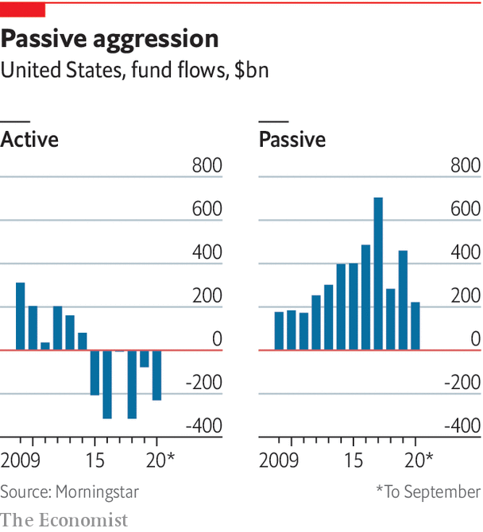

The industry has not performed well. Ever since a landmark paper by Michael Jensen in 1968, countless studies have shown that managers of equity mutual funds have failed to beat the market index. Arithmetic is against them. It is as impossible for all investors to have an above-average return as for everyone to be of above-average height or intelligence. In any year, some will do better than the index and some worse. But evidence of sustained outperformance is vanishingly rare. Where it exists, it suggests that bad performers stay bad. It is hard to find a positive link between high fees and performance. Quite the opposite: one study found that the worst-performing funds charge the most.

Why do investors put up with this? One explanation is that investment funds are more complex than breakfast cereals. At best they are an “experience good” whose quality can be judged only once consumed. But they are also like college education or medical practice: “credence goods” that buyers find hard to judge immediately. Even well-informed investors find it tricky to distinguish a good stockpicker from a lucky one. Savers are keen to invest in the latest “hot” funds. But studies by Erik Sirri and Peter Tufano in the 1990s show that, once fund managers have gathered assets, those assets tend to be sticky. They are lost only slowly through bad performance.

Firms have a fiduciary duty to act in the best interest of customers. Securities regulators (eg, the Financial Conduct Authority (FCA) in Britain and the Securities and Exchange Commission (SEC) in America) oversee asset managers. Unlike banks, which borrow from depositors and markets, asset managers are unleveraged and so not subject to intensive rules. The assets belong to beneficial investors; they are not held on a firm’s balance-sheet. The thrust of regulation is consumer protection from fraud and conflicts of interest. It does not prescribe investment strategies or fees. An investigation by the FCA in 2016 found that investors make ill-informed choices, partly because charges are unclear. The problem of poor decision-making is most acute for retail investors. But even some institutional investors, notably those in charge of small pension schemes, are not very savvy. Around 30% of pension funds responding to a survey by the FCA required no qualifications or experience for pension trustees. Investors are a long way from the all-knowing paragons of textbook finance theory.

## Medical manners

A paper in 2015 by Nicola Gennaioli, Andrei Shleifer and Robert Vishny argued that fund managers act as “Money Doctors”. Most people have little idea how to invest, just as they have little idea how to treat health problems. A lot of advice doctors give is generic and self-serving, but patients still value it. The money doctors are in the same hand-holding business. Their job is to give people the confidence to take on investment risk.

In asset management, as in medicine, manner and confidence are as important as efficacy. “Just as many patients trust their doctor, and do not want to go to a random doctor even if equally qualified, investors trust their financial advisers and managers,” say Mr Shleifer and his co-authors. This may explain why investors stick with mutual-fund managers even in the face of only so-so performance. As long as asset prices go up, a rising tide lifts most boats in the asset-management industry—including a lot of leaky vessels.

But the seas are getting rougher. Over the past decade, investors have placed more capital with low-fee “passive” funds. These funds invest in publicly listed stocks or bonds that are liquid—that is, easy to buy or sell. The most popular are “index” funds, run by computers, that track benchmark stock and bond indices. The industry’s big winners have been indexing giants whose scale keeps costs down and fees low. The two largest, BlackRock and Vanguard, had combined assets under management of $13.5trn by the end of 2019. The losers were active managers that try to pick the best stocks.

High fees have not disappeared. The boom in passive investing has spawned its antithesis: niche firms, run by humans, in thinly traded assets charging high fees. A growing share of assets allocated by big pension funds, endowments and sovereign-wealth funds is going into privately traded assets such as private equity, property, infrastructure and venture capital. What has spurred this shift is a desperate search for higher returns. The management of private assets is an industry for boutiques rather than behemoths. But it has its own big names. A quartet of Wall Street firms—Apollo, Blackstone, Carlyle and KKR—have captured much of the growth in assets allocated to private markets.

The shake-up in asset management owes a lot to macroeconomics. The investors who snapped up certificates in Rose’s trust were dissatisfied with 2% interest in the money markets. Today investors would sell their grandmothers for such a yield. Interest rates in parts of the rich world are negative. In Germany and Switzerland, government-bond yields are below zero across the curve, from overnight to 30 years. Inflation is absent, so ultra-low interest rates are likely to persist. The expected returns on other assets—the yields on corporate bonds, the earnings yields on equities, the rental yield on commercial property—have accordingly been pulled down. The value of assets in general has been raised.

The steady decline of long-term rates is a nightmare for pension funds, because it increases the present value of future pension promises. Industry bigwigs often blame the Federal Reserve and other central banks. But interest rates have been falling steadily since the 1980s. There are deeper forces at work. The real rate of return is in theory decided by the balance of supply and demand for savings. The balance has shifted, creating a bonanza for asset managers, whose fees are based on asset values.

There are competing explanations for the savings glut. Demography is one: people are living longer, but average working life has not changed much. More money must be salted away to pay for retirement, with much of the saving taking place in the years of peak earnings in middle age. A bulge in the size of the middle-age cohort has pushed the supply of savings up. Another factor is the growth of China and other high-saving emerging markets. At the same time, the demand for savings has fallen. When Robert Fleming set up his investment trust, enterprises like railways were capital-intensive. Today the value of firms lies more in ideas than in fixed capital. Big companies are self-financing. Small ones need less capital to start and grow. The upshot is that more money is chasing fewer opportunities. Investors are responding by trying to keep fund-management costs down and putting more money into private markets in hopes of higher returns than in public markets. This response is reshaping the asset-management business.

This special report will consider the outlook for the industry and ask what it means for the economy, for the stewardship of firms, for capital allocation and for savers who place their trust in the money doctors. It will examine whether China’s untapped market can be a source of renewed growth. A good place to start is with the forces shaping the industry’s elite.■

This article was downloaded by calibre from <https://www.economist.com/special-report/2020/11/12/the-money-doctors>

|  |  |  |  |
| --- | --- | --- | --- |
|  | Articles | Sections | Next |

|  |  |  |  |
| --- | --- | --- | --- |
| Previous | Articles | Sections | Next |

#### Index funds

# Passive attack

How index investing is reshaping the asset-management industry

Nov 12th 2020 |

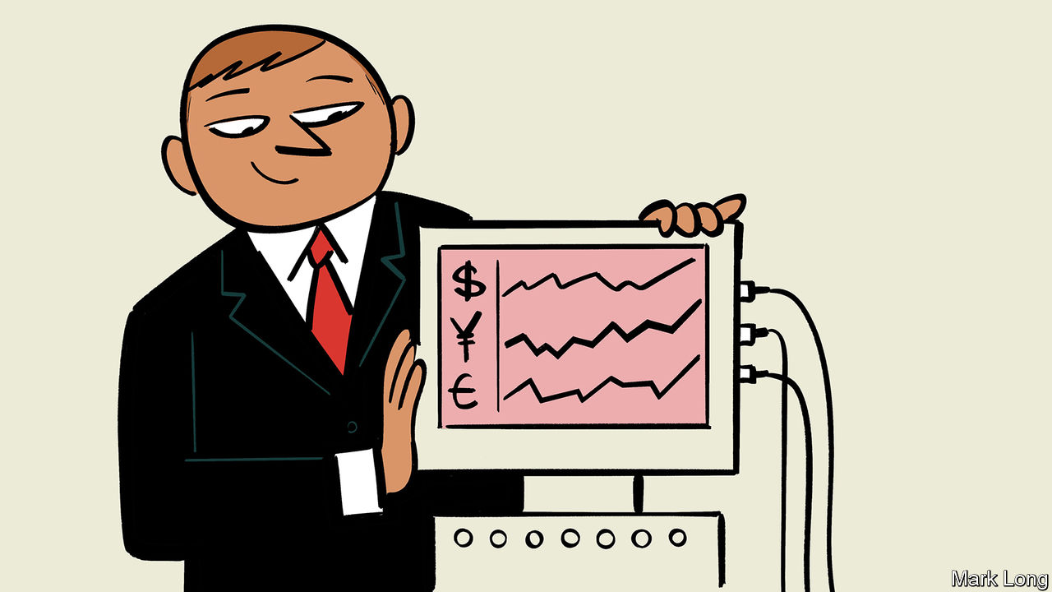

THE STORY of a quiet revolution in asset management begins with Jack Bogle. Actually, it starts in 1974 when Paul Samuelson, an economist and Nobel prizewinner, published an article in the Journal of Portfolio Management arguing that the bulk of mutual-fund managers should go out of business. Most failed to beat the market average and those that did could not be relied upon to repeat the trick. An archetype was required. Someone should set up a low-cost, low-churn fund that would do nothing more than hold the constituents of the S&P 500. Mr Bogle decided that Vanguard, the mutual-fund group he founded in 1975, should take up the challenge. His index fund was denounced on Wall Street as unAmerican. It received only a trickle of inflows. But by the time of Bogle’s death last year, Vanguard was one of the world’s biggest asset managers, largely on the strength of its index funds.

An investor can now buy exposure to the market return (beta, as it is known) for a few basis points. Indeed, “beta is becoming free” is an article of faith among industry bigwigs. Technology allows access to stockmarkets at vanishingly low cost. BlackRock and State Street Global Advisors, the other firms of a leading triumvirate, owe their growing heft to index (or “passive”) investing. These three are the industry’s big winners; everyone else is “fighting for scraps”, as the boss of a midsized asset manager puts it.

These firms benefit from a virtuous circle, in which lower costs mean lower fees, more inflows and yet lower costs. Their dominance is only the most salient sign of consolidation in the asset-management industry. The biggest firms are getting bigger. A global elite has emerged of firms that each manage more than a trillion dollars in assets. Unsurprisingly the idea has taken hold that size is a strategic advantage. If you are not a niche player in an industry, you had better be a scale one, says business-school wisdom. No one wants to be stuck in the middle.

Bigger is not always better in asset management. A point arrives when size becomes a spoiler of performance. The portfolio manager may lose focus. The size of the fund begins to push up trading costs, notably in illiquid assets in which the buying and selling of large tranches tends to move prices adversely. But asset managers benefit from operational gearing. As the value of managed assets goes up, profits rise even faster. Fees are a fixed percentage of assets under management: the bigger the fund, the higher the revenues. But costs—mostly the wages of research analysts, office space, marketing and so on—do not rise in lock-step.

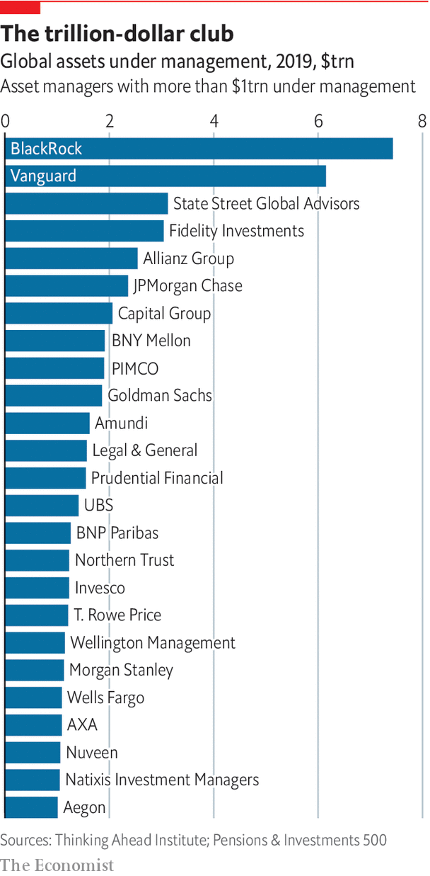

Scale is both a friend and an enemy, says Manny Roman, boss of PIMCO, a giant fixed-income manager. If you have a lot of exposure to bad positions, it is hard to escape. But buying at scale can also mean keener prices—on new corporate-bond issues or from a seller looking to get out of a big position. There are other advantages. Research capabilities and technological muscle can be spread over a large number of similar markets and securities.

Industry types distinguish between manufacturing (managing assets) and distribution (selling funds to retail investors). Fidelity, a family-owned Boston-based giant, does both. Scale matters in retail distribution, where brand is important. In indexing there is also a real scale advantage, says Cyrus Taraporevala, of State Street Global Advisors. Index funds hold stocks in proportion to their market capitalisation—by the value weighting in the index. Trading costs are tiny. The fund buys a stock when it qualifies for the index (as a handful of new ones do each year) and sells any that drop out. In between it simply holds them. The market for large-capitalisation stocks is liquid enough to absorb sales or purchases whenever index funds need to match inflows or redemptions. The marginal cost of running an ever-bigger fund is trivial: it just requires a bit more computing power. There are no expensive portfolio managers.

Beta is not the only passive strategy. Trillions of dollars are also invested in “factor-based” or “smart-beta” strategies. These rely on powerful computers to sort stocks by characteristics, such as low price-to-book (“value”) or high profitability (“quality”), that have been shown to beat market averages in the long run. The churn in these portfolios is higher than for index shares. But the analysis and trading are automated. Increasingly bond investing is going passive, too. The value of bonds held in exchange-traded funds (or ETFs, baskets of securities listed on an exchange like company shares) passed $1trn last year. The largest bond ETFs track an index, such as the Bloomberg-Barclays Aggregate, and are often more liquid than the individual bonds they contain. Factor-based bond ETFs are also growing in popularity.

The growth of the big three passive managers is part of a trend towards greater industry concentration. Of assets managed worldwide by the industry’s leading 500 firms, the proportion managed by the top 20 firms has risen from 37% in 2005 to 42% now. But the search for scale economies to offset pressure on fees is not the only factor behind this. The bigger fund-management groups increasingly look to offer expertise across asset classes, from large-cap equities to private assets. A lot of asset managers, including BlackRock, are betting on the benefits of scope as much as scale.

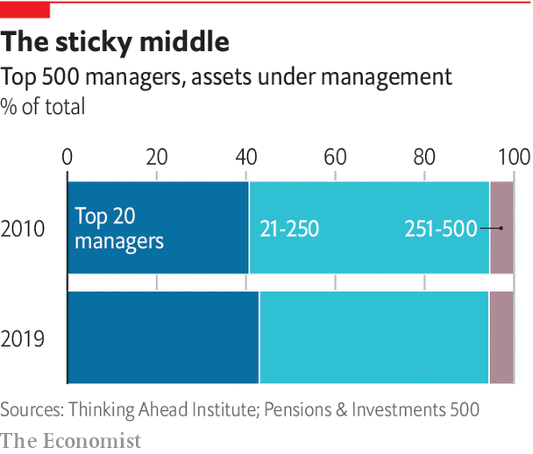

The heads of big pension funds now want three things, says David Hunt, boss of PGIM, the asset-management arm of Prudential Financial, an insurance giant. They want to understand their whole portfolio of assets (to get a sense of how diversified it is); to push fees down by concentrating their buying power; and to have a long-term relationship with asset managers. That means cutting the number they use. So managers offering the full spectrum of products (stocks, bonds, property, private assets and so on) will have an edge. This trend towards fewer managers is happening on the retail side as well. The proliferation of funds sows confusion. There is too much choice. So the retail gatekeepers—the brokerages, online platforms and mobile apps—are starting to cut back the number of funds they carry.

If index funds and ETFs are winning investors, who is losing them? One way to infer this is the spread of fees. The more liquid the assets, the greater the fee pressure. The managers of so-called “core” active funds, generally large-company shares listed in rich-world stockmarkets, have seen fees fall towards the indexers’ level. It is hard to categorise but industry wisdom is that “closet indexers” are gradually being winnowed out. These funds are ostensibly “active” (ie, they are stockpickers) but they manage their portfolios to ensure that their performance does not deviate much from the index.

For all the talk about polarisation, the change in asset management is not that dramatic. The squeezed middle—firms in the top 250 but outside the top 20—have lost around five percentage points of market share since 2005. But they retain a 50% share. Inflows follow performance, but outflows do not. Investors are remarkably conservative. For individuals, a move from one mutual fund to another often triggers capital-gains tax. Institutional investors suffer from inertia, or perhaps from a failure of nerve. What if your underperforming active managers suddenly improve after you drop them? As a consequence, says an executive at a big asset manager, the industry’s market structure “forms like stalactites and stalagmites—drip by drip”.

In any other industry, mergers would speed up the sorting into scale and niche. There has been a spate of tie-ups in recent years: Standard Life and Aberdeen Asset Management in Scotland; the marriage of Janus, an American outfit, with Henderson, a British one; Invesco and Oppenheimer; and Franklin Templeton and Legg Mason. None has been a roaring success. Perhaps that is not surprising. In an industry where human capital plays a big role, it is not easy to find cost savings. People are not as fungible as offices. Integrating IT systems is a headache. Corporate-culture clashes are common. There is a risk of losing clients if things go wrong—and even if they don’t. New clients will steer clear while a merger is pending.

Despite the pitfalls, the merger wave continues. Morgan Stanley recently acquired Eaton Vance to fold into its asset-management business. Nelson Peltz, an activist investor, has taken biggish stakes in Janus-Henderson and Invesco with a view to pursuing mergers. The industry seems set for a shake-up. A bold response for a midsized firm would be to downsize: strip back to the core; cut prices; offer fewer products; and focus on those in which one has a chance to be distinctive. In a different industry Steve Jobs followed something like this strategy when he returned to Apple in 1996. Apple was fighting for its survival, however. Things are not that desperate in asset management. The fee pressure on new business is intense, but a lot of existing customers will stay put. A mediocre firm with a big back-book can stay alive for quite a while.

Perhaps that explains all the talk of “zombie” asset managers—firms from which life is slowly draining as their initially fat margins grow ever thinner. Is there another means of escape? The virtue of passive funds is their low cost; they buy stocks in the index or whatever the quantitative screen prescribes. There is no need to think deeply about the companies behind the securities. But that virtue is also a vice. Investors increasingly care about what companies do. And many active asset managers hope there might be a living from that.■

This article was downloaded by calibre from <https://www.economist.com/special-report/2020/11/12/passive-attack>

|  |  |  |  |
| --- | --- | --- | --- |
| Previous | Articles | Sections | Next |

|  |  |  |  |
| --- | --- | --- | --- |
| Previous | Articles | Sections | Next |

#### Agency problems

# Double trouble

The trouble with delegating choices about what to invest in

Nov 12th 2020 |

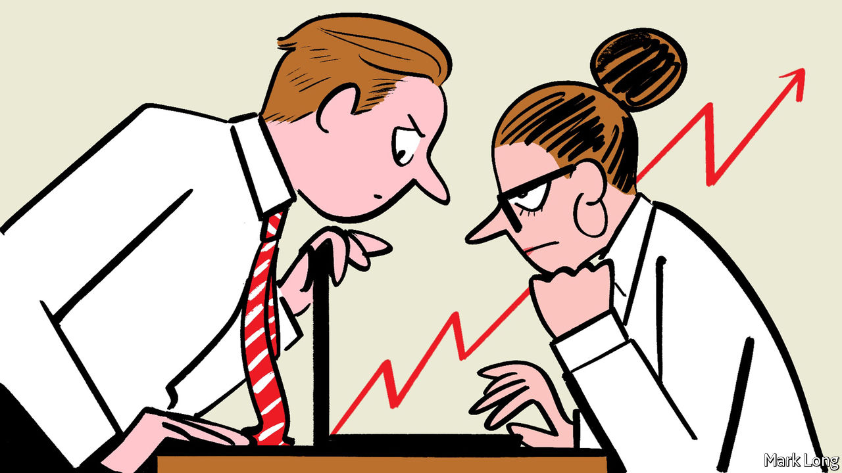

SOMEONE WISE once said that all the problems of capitalism are agency problems. Agency costs arise when somebody (the principal) delegates a task to somebody else (the agent) and their interests are at odds. In the textbook example, the principal is a manager, the agents are employees. It is in the manager’s interest that the agent works hard. The more effort each worker puts in, the higher the firm’s output and the greater its profits. But the employer cannot gauge the true effort of the workers, especially if the results are a team effort. Each worker has an incentive to shirk.

Asset management has a double agency problem. The first lies with the separation of ownership and control in large public companies. Shareholders are the principals, who delegate running the firm to managers. Shareholders care about returns on their investment, but managers have different goals. They may value perks and prestige—a plush office, a company jet, a high-profile merger deal—more than profits. Running a big company is a complex task. It is hard to be sure if the bosses are making a good fist of it. No individual shareholder has a big enough stake to make the effort of monitoring worthwhile.

Mechanisms have emerged to limit such agency costs. A classic paper published in 1976 by Michael Jensen and William Meckling argued that loading a public firm with debt was a useful device to stop managers frittering away shareholders’ cash. Bosses feel greater pressure to cut costs and raise revenues if they must meet regular interest payments. The leveraged buy-out boom of the 1980s was predicated on the idea of debt as a tool to focus the minds of managers. Private-equity firms employ this trick.

Another way to limit this sort of agency problem is to give managers the right to buy discounted shares once their price reaches a predetermined target. Stock options, it is argued, make managers act as if they were shareholders. Yet this device just creates a different sort of agency problem. Traders of shares use quarterly earnings as a rough-and-ready guide to how well a company is run. Managers know this. So they eschew investment projects that are in the long-run interests of shareholders in order to boost short-term profits, lifting the share price and the value of their stock options.

The second agency problem arises from conflicts of interest between asset managers and those on whose behalf they invest. It is in the interests of investors that asset managers seek out the best long-term returns. But fund-management firms are paid a fixed percentage of the value of assets. To attract capital into their funds, they may opt for faddish stocks that do well in the short term, but whose shortcomings become apparent only in the long run. They may shun unfashionable stocks, even if they believe they are good long-term investments. Once an asset manager has captured funds to manage, they tend to stay. A good recent run will lure in more funds. This agency problem has no easy solution—but investors could be quicker to ask searching questions.

This article was downloaded by calibre from <https://www.economist.com/special-report/2020/11/12/double-trouble>

|  |  |  |  |
| --- | --- | --- | --- |
| Previous | Articles | Sections | Next |

|  |  |  |  |
| --- | --- | --- | --- |
| Previous | Articles | Sections | Next |

#### Capital allocation

# Stewards’ inquiry

If investors buy stocks in an index, who watches managers?

Nov 12th 2020 |



ROBERT FLEMING has a claim to be a pioneer of active asset management. His First Scottish investment trust pledged to invest mostly in American securities, with choices informed by on-the-ground research. Fleming saw that shareholders needed to act as stewards in the governance of the businesses that they part-owned. So once the fund was launched, in 1873, he sailed directly to America. It was the first of many fact-finding trips across the Atlantic over the next 50 years, according to Nigel Edward Morecroft’s book, “The Origins of Asset Management”.

The art of asset management is capital allocation. It is easy to miss this amid confusing talk of alpha and beta, active and passive, private and public markets. For investors of Fleming’s kind the work of finding the best investment opportunities and engaging with business was inseparable. Walter Bagehot believed the rapid growth of the mid-Victorian economy owed much to the efficient channelling of capital. In England, he wrote, “Capital runs as surely and instantly where it is most wanted, and where there is most to be made of it, as water runs to find its level.”

Most of today’s financiers will say they are engaged in capital allocation. There are many dedicated stockpickers who take this social role seriously and see it as a vocation. But for the most part ties between suppliers and users of capital have become more tenuous. An index fund does not screen the best stocks from the worst. It holds whatever is in the index. Other passive strategies select stocks or bonds based on narrow financial characteristics. The nature of the entity behind the securities and how well the people running it perform their duties are incidental. Does such disengagement matter? Some evidence suggests that it might.

To understand why, it helps to distinguish two functions of capital allocation. The first is to direct savings to their best use. This involves finding new opportunities, comparing their merits and deciding which should receive capital and on what terms. John Kay, a business economist, calls this role “search”. The second role is stewardship, ensuring that the best use is made of the capital stock that is the product of past investment.

Both matter. Search matters in the early stages of economic development, when ideas are abundant, businesses are capital-intensive and savings are scarce. The late 19th century was such a time. In New York, Fleming’s hunting-ground, most bonds were for railroad companies. In Britain, brewers, distillers and miners were also thirsty for capital. In 1886 Guinness, a century-old beer company, raised £6m in London. A few years later shares in the Broken Hill Proprietary Mining Company (BHP), which began trading in Australia, were owned and exchanged in London.

When search works well and capital runs to “where there is most to be made of it”, relevant information is quickly reflected in asset prices. The case for index investing rests on the idea that the stockmarket is, in this sense, broadly efficient. Prices are set by informed buying and selling by active and engaged investors. But as more money goes to index funds, the market might become less efficient. Whether it does rests in theory on the quality of investors being displaced. If they are “noisy” active managers, who buy and sell on gut feel, expect more efficiency, not less. If they are farsighted stockpickers, the quality of market prices might suffer.

Some empirical studies hint at a problem. A paper in 2011 by Jeffrey Wurgler finds that whether a share is part of an index influences its price. Shares that are included in an index go up in value relative to similar shares that are not. When shares drop out of an index, they tend to fall disproportionately. And once in the index, a share’s price moves more in sympathy with others that are also included. Another paper, by researchers at the University of Utah, finds that index inclusion leads to a higher correlation with index prices. Inclusion also spurs a reduction in “information production”: fewer requests for company filings, fewer searches on Google, and fewer research reports from brokerages. Even so, the authors conclude that more intensive effort by the remaining active investors may counter any adverse effects.

Share prices may no longer matter so much for how capital is allocated. Most big companies are nowadays self-financing. Guinness (now Diageo) and BHP are still among the leading stocks listed in London. Like a lot of businesses, they generate enough cash to cover their investment needs. When a company taps the capital markets, it is usually to tidy up its capital structure (lengthening the maturity of debt, say, or buying back shares) or to build cash reserves in times of stress, such as now. It is management teams that now do most to allocate capital.

This makes stewardship more important. When it works, investors engage with a firm’s managers to verify that the business is well run. The problem is that the incentives to be good stewards are weak. An asset manager that bears the cost of stewardship will capture only a small share of the benefits. A paper in 2017 by Lucian Bebchuk, Alma Cohen and Scott Hirst, a trio of law professors, found that asset managers mostly avoid making shareholder proposals, nominating directors or conducting proxy contests to vote out managers. Index funds are especially at fault. Their business model is to avoid the costs of company research and deep engagement. The law professors reckoned that the big three asset managers devoted less than one person-workday a year to stewardship.

## Bosses and agents

The growth of index investing is likely to have raised the agency costs of asset management. Bosses may be either too timid or too lax, depending on the circumstances, to act in the best interest of shareholders. They may shun profitable projects because it is hard to persuade disengaged owners that the rewards justify the risks. Or they may be careless with shareholders’ money. Some research finds passive ownership aggravates these problems. A paper by Philippe Aghion, John Van Reenen and Luigi Zingales finds that companies with a larger share of active owners are more innovative. They find no such link between index ownership and innovation. Other research suggests that indexing makes it more likely that managers will pursue ill-judged mergers.

Investors now care more about what they are investing in. The growth of environmental, social and governance (ESG) investing, which selects companies on how they score on such matters, reflects this. Some asset managers suspect ESG is a fad, but many do not. An ESG score will soon be a requirement, says one. It will eventually be as important to a firm as its credit rating, says another. “Sustainability” is increasingly seen as a risk factor for long-term performance. “If your firm is more sustainable, you will get the best people, customers and regulators,” says Christian Sinding, boss of EQT, a Swedish private-equity firm. These are the firms you will want to own in ten years’ time, he adds.

ESG looks like a lifeline for active fund managers. “Active has a big advantage over passive when it comes to ESG,” says Ashish Bhutani, chief executive of Lazard Asset Management. Passive funds can only tick boxes. Some environmental matters, such as a firm’s carbon footprint, can be quantified, but others cannot. The social criterion requires qualitative judgment about a firm’s hiring practices, its efforts to reduce inequality or the broader impact of investment projects. Governance is somewhere in between. Good analysts have a deep knowledge of companies and their management. They know things that are hard to quantify and cannot be found on a financial statement or a boilerplate disclosure.

The challenge for active managers is to show that sifting firms by ESG or any other qualitative criteria will make for better portfolios that justify a fee premium over an index fund. A greater focus on the long term would be welcome for both companies and their shareholders. It is a stretch to claim that active managers in the main are great stewards. They are not. Most are (or at least have been) either transient owners, trading in and out of faddish stocks, or closet index-huggers.

The best-performing stockpickers are both patient and strong in their convictions. They hold stocks for long periods in a concentrated portfolio. It is in part a quest for these traits—commitment and patience—that has persuaded a lot of investors to flock into private equity and other closely held assets.■

This article was downloaded by calibre from <https://www.economist.com/special-report/2020/11/12/stewards-inquiry>

|  |  |  |  |
| --- | --- | --- | --- |
| Previous | Articles | Sections | Next |

|  |  |  |  |
| --- | --- | --- | --- |
| Previous | Articles | Sections | Next |

#### Private markets

# Taking back control

Privates are what listed assets are not—niche, illiquid and fee-rich

Nov 12th 2020 |

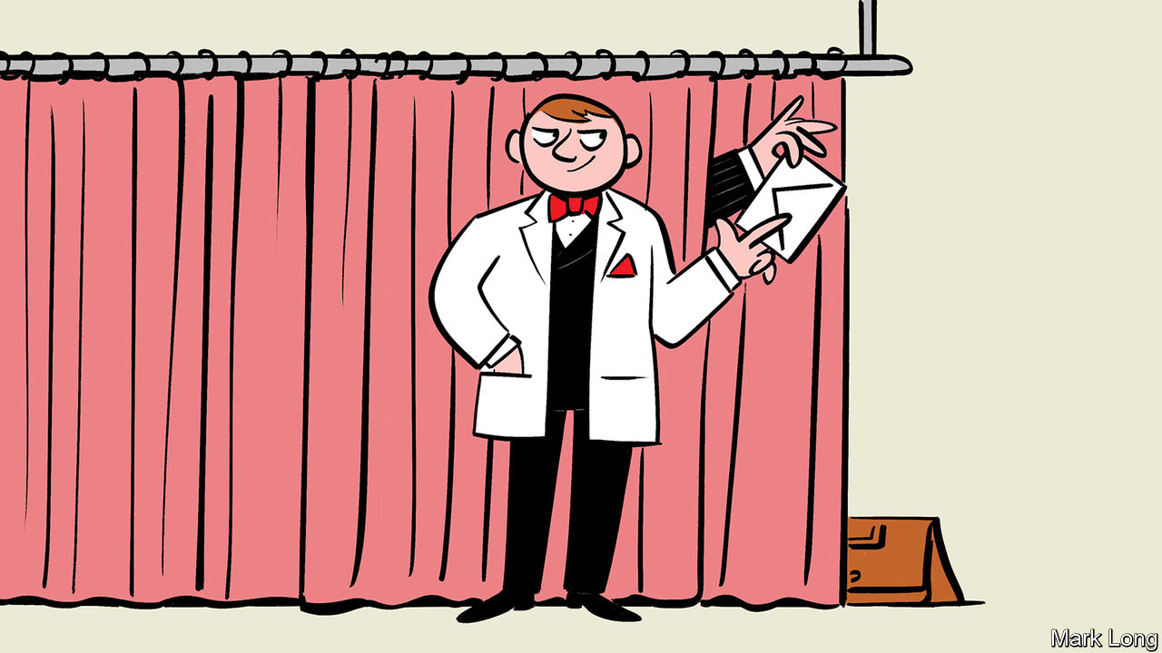

THE NOTION of the “first 100 days” as critical for a new administration goes back at least as far as Franklin Roosevelt. He first used the term in a radio address in 1933, shortly after becoming America’s 32nd president. Private equity has its own version. The 100-day plan sets priorities for a bought-out business. The new owner looks for “quick wins”—standard remedies for the most glaring operating problems. Fixes may include updating computing systems, slimming the array of products or closing loss-making divisions. The plan also prescribes the easiest ways to raise cash to pay off hefty debts used to acquire the firm.

The promise of private asset management (buy-out funds, private debt, venture capital and so on) is that endurance will be rewarded. Investors in private equity must lock up their money for years; they cannot easily sell out. Big stakes in private assets trade quite rarely. But there is an upside. Private managers are able to eke out better returns than would be possible if their assets were traded each day. Investors in the public markets like predictable short-term profits and strategic certainty. They are too skittish to invest in a corporate turnaround. If the boss of a listed company unveiled a 100-day plan, it might spark a run on the shares.

That is the sales pitch—and plenty of investors buy it. Desperate for returns, pension funds have piled into private markets in recent years. A survey by Morgan Stanley finds that 64% of institutional investors plan to increase their allocation to private equity this year and only 5% to reduce it—a net balance of 59%. The balance for venture capital was 39%; for private debt, 33%. For listed assets, the balance was negative. Private markets are at the niche end of asset management. Only around $4trn or so is invested in private equity, about half of total assets under BlackRock’s management alone. But private assets are where the fees are. The question is whether performance and fees can be sustained.

Of several influences behind the growing interest in private assets, three stand out. The first is the example of successful pioneers. In the 1980s and 1990s the endowment funds of a handful of big American universities shifted much of their invested funds into private assets. The largest retirement schemes in Canada, led by the Ontario Teachers’ Pension Plan (OTPP), have a similar approach: run the plan like a business, pay for good in-house fund managers and invest in lots of private assets. This model has been copied by sovereign-wealth funds in other parts of the world. The intellectual leader of such investing was David Swensen, at Yale. He argued that, since life-insurance funds, endowments and sovereign-wealth funds have obligations stretching far into the future, they can afford to take a long-term view. It is hard to be rewarded for diligence in listed stocks. Private markets, in contrast, are inefficient. Data are hard to come by, assets are complex and trickier to appraise and waiting for opportunities to pay off requires patience. But the right homework brings rewards.

A second factor is disenchantment with public markets. The age-old agency problem means that investing in projects with an uncertain payoff can be a career risk for managers of a listed business. It is easier to explain corporate strategy to a few committed backers than to lots of shareholders. Founders of technology firms who are used to getting their own way often struggle in the glare of public markets, and so prefer to stay private for as long as they can. And the costs and hassle associated with being a public company have grown. The Sarbanes-Oxley act, passed in 2002 in the wake of a slew of corporate scandals in America, introduced tougher disclosure and financial-reporting requirements for public companies. The regulatory requirements on private companies are significantly lighter. And the National Securities Markets Improvement Act of 1996 made it easier to set up pools of private investors.

A third factor is changes to banking. The growth of private debt is, in large part, a response to the retreat of banks from lending to midsized businesses and their private-equity sponsors. Asset managers, starved of yield in the government-bond markets, are happy to fill the void. The bigger firms will even take souring loans off the books of banks looking to clean up their balance-sheets. In 2017 PIMCO, the fixed-income giant, led a buy-out of €17.7bn ($20bn) of loans from UniCredit, an Italian bank. There are likely to be more such deals in Europe. China is another potential hunting-ground for distressed debt.

One of the fastest-growing areas of private credit is direct lending to companies which cannot (because they are too small) or will not (for reasons of confidentiality) tap the public markets. A private bond might be sold to only a handful of lenders, or even to just one. Borrowers may feel that they ought to know who their creditors are because they might have to renegotiate with them. That is the case for private-equity firms. Specialist private-credit funds also often prefer to be the sole financiers of a private-equity buy-out if they like the terms and judge the bought-out firm to be a good risk. They might even be the credit division of a buy-out outfit that has lost the bidding war for the borrowing company.

## Private lives

Do the results justify the hype? Private equity uses a lot of debt to make its acquisitions. One suspicion is that allocation to private equity is simply a way for pension funds to get around constraints on borrowing to enhance returns. But the buy-out industry has a decent story to tell on capital allocation. The academic literature finds that private-equity and venture-capital funds mostly add operational nous to businesses. They inspire better management habits than in entrepreneur- or family-owned firms. Buy-outs lead to modest net job losses but big increases in job creation and destruction. They promote efficiency by taking capital off “sunset” firms and putting it into more promising “sunrise” firms.

And returns? Asset managers are adept at presenting statistics in the most favourable light. Dud mutual funds are often quietly merged or folded. Managers can then claim that most of their funds beat the market—these being simply the funds that have survived the cull of underperformers. The private-equity business is notorious for selecting metrics that flatter its performance. Nonetheless, over the long haul, the best private-equity funds do really well. A landmark study led by Steven Kaplan, of the University of Chicago, found that venture-capital and buy-out funds, on average, beat the S&P 500 index over the long term. The range was wide. Funds in the top quartile did much better than average; those in the bottom quartile did a lot worse. Pension-fund managers facing big deficits have an incentive to put money into private assets in the hope that their fund will be one of the winners.

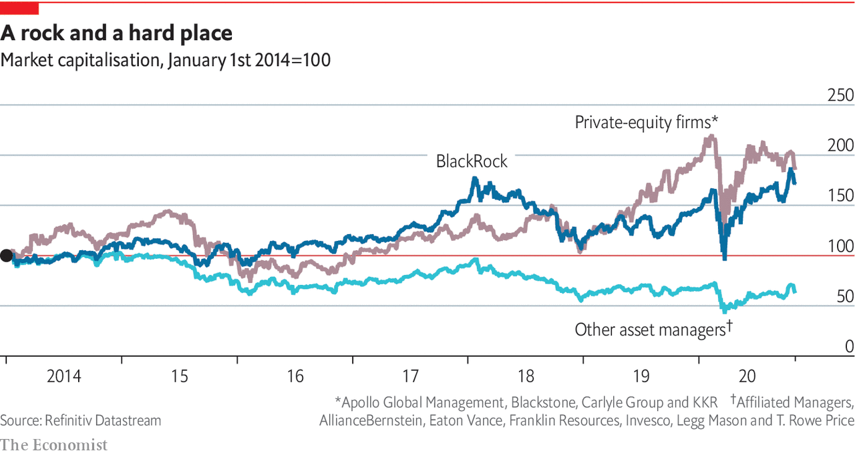

As more capital chases opportunities, the evidence points to diminishing returns. Mr Kaplan and his colleagues find that returns in the buy-out industry beat the stockmarket in nearly all years before 2006, but broadly matched the S&P 500 afterwards. Private-equity funds used to buy businesses that were cheaper than listed firms. But the competition is keener now. The bigger beasts of private equity are becoming even bigger. They have large fixed costs—all those in-house rainmakers, lawyers, analysts and consultants. With so much capital yet to draw from their pension-fund partners, the pressure to do deals that might once have been shunned has increased.

Investors need to be cautious. “Focus and selection are very important” in private markets, says Jo Taylor, CEO of the OTPP. His fund is big enough, with C$200bn ($150bn) under management, to do its own buy-outs. This gives it a big advantage in choosing good managers as well as deals. In general bigger schemes also have more muscle in fee negotiations. The surest way to irritate a private-equity boss is to say the curse words “two-and-twenty”, which was once a common fee arrangement for “alternative” asset managers, meaning a 2% annual fee and 20% of the profits. Private-equity bigwigs claim that such large fees are vanishingly rare. Big clients can usually negotiate lower charges by, for instance, taking a direct stake in an acquired business (a so-called “co-investment”). A typical management fee is “in the low- to mid-ones plus free co-investments”, says a private-equity boss. And, he insists, the 20% performance fee is paid only once returns have cleared a hurdle rate.

Fat fees, outperforming funds, happy clients: from the perspective of asset managers that invest in public equities the buy-out business looks too good to be true. “Hope-and-pray assets,” sneers one. But hope springs eternal in all parts of the asset-management business. A lot of it now rests on China. ■

This article was downloaded by calibre from <https://www.economist.com/special-report/2020/11/12/taking-back-control>

|  |  |  |  |
| --- | --- | --- | --- |
| Previous | Articles | Sections | Next |

|  |  |  |  |
| --- | --- | --- | --- |
| Previous | Articles | Sections | Next |

#### Venture capital

# Frogs and princes

More and more capital is chasing fewer and fewer ideas

Nov 12th 2020 |

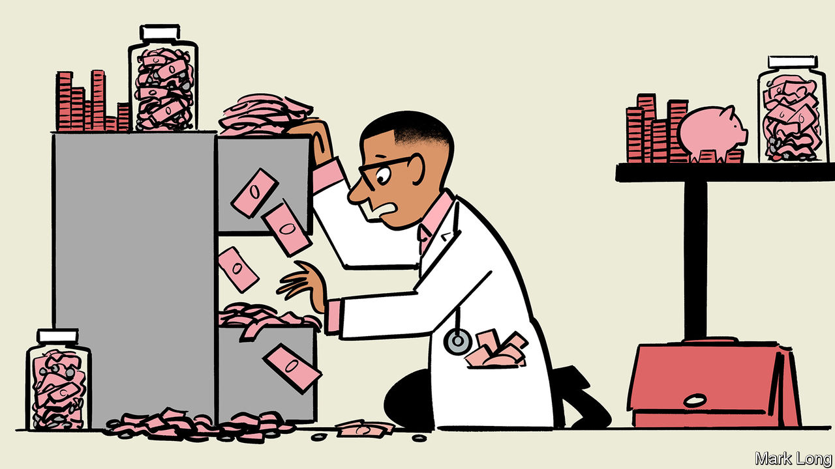

WHO ARE the heirs of Robert Fleming, the 19th-century Scot who saw that America was the coming place to put risk capital? The venture capitalists of Silicon Valley have the best claim. The businesses that loom largest in public equity markets—Amazon, Apple, Facebook, Google, Tesla and the rest—were nurtured by VCs. Venture-backed companies account for around a fifth of the market capitalisation of public companies in America and almost half their research spending. The funds that unearth such gems stand to make pots of money. VCs have on average (an important qualifier) beaten the public market net of fees over the long run.

Most firms that receive VC funding fail. But the winner-takes-all nature of technology markets means those that succeed often do so extravagantly. The VC industry is at the frontier of capital allocation. The typical investor has to kiss a lot of frogs to find a prince (or even a decent-looking frog). The average VC firm screens 200 targets, but makes only four investments, according to a study in the Journal of Financial Economics. Part of the added value, say its authors, is to improve the governance of startups and keep a watchful eye on management.

No wonder pension schemes, sovereign-wealth funds and mutual funds are competing to write big cheques for Silicon Valley’s next generation of stars. But unlike the railways, brewers, distillers and mines of the Fleming era, today’s new firms have no great need of capital. A young technology firm can rent computing power from the cloud, download basic software from the internet and use a range of cheap, outsourced services to help it grow. Startups are staying private for longer. When they list, it is because the founders need to cash out or (as with the latest rash of tech IPOs) when the money on offer in the public markets is simply too good to turn down. It is not to raise capital for the business.

Very few new firms turn out to be world-beaters. Good ideas are scarce. But VC firms that have succeeded in the past may have an edge in finding them. A study by Morten Sorensen finds that companies funded by more experienced VCs are more likely to succeed. And sourcing the best entrepreneurial talent is more important to success than the development of that talent.

In this sense the best venture-capital firms resemble elite universities. Because the brightest turn up at their door, they are able to charge the highest fees. And those fees are mostly for the accreditation and the social networks that the institution can offer.

This article was downloaded by calibre from <https://www.economist.com/special-report/2020/11/12/frogs-and-princes>

|  |  |  |  |
| --- | --- | --- | --- |
| Previous | Articles | Sections | Next |

|  |  |  |  |
| --- | --- | --- | --- |
| Previous | Articles | Sections | Next |

#### China

# The Shanghai Open

The future of finance is Chinese. But what will it look like?

Nov 12th 2020 |

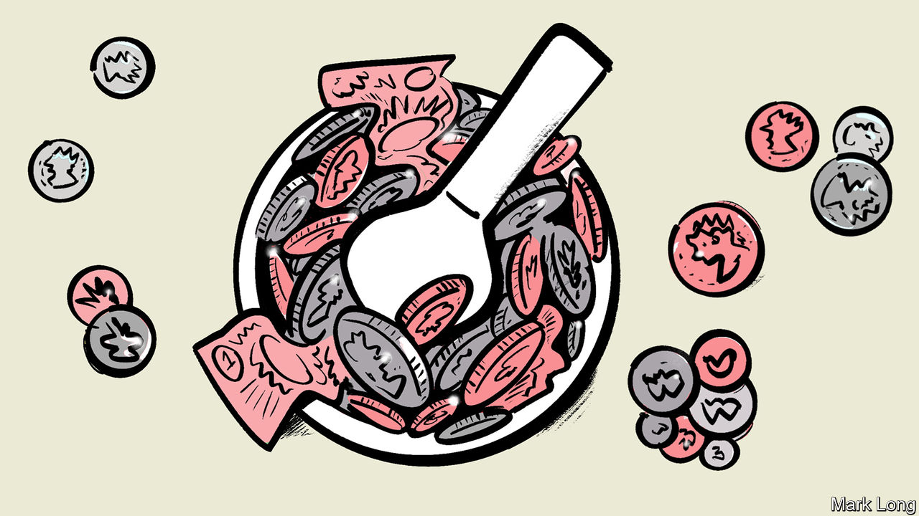

ASSET MANAGEMENT is mostly a rich-world affair. North America, Europe, Australia and Japan between them account for around three-quarters of assets under professional management. The United States is far and away the single most important market. America sets the tone for capital markets everywhere else. Global trading starts when New York opens.

Yet just as London gave way to New York after economic supremacy passed from Britain to America, so it is not hard to imagine a future when the global trading day will begin in Shanghai. China already has the world’s second-largest economy. Its heft in global finance lags, but it is putting much effort into catching up. It has opened its mainland markets to foreign investors in shares and bonds. It is relaxing regulations to allow foreign asset managers to operate more freely. Asset management is growing faster in Asia than in the West. The industry’s balance of power is shifting inexorably. Time, size and momentum are on China’s side.

What is not clear is precisely how asset management will develop in China. No asset manager can offer a global service unless it has a footprint in China and across Asia. If you are selling Chinese equity or bond mutual funds to Western investors, you need people on the ground in China. The same business logic applies to selling global assets to Chinese investors, once outgoing capital controls are relaxed. The big prize—and the big unknown—is “local to local” ie, selling Chinese mutual funds to Chinese investors. And the competition for this prize looks wide open.

China’s financial markets are immature. Much household wealth is on deposit in banks or tied up in homes. The commonest kinds of pooled investments resemble bank deposits: either money-market funds or “wealth-management products”, higher-yielding alternatives to bank deposits, which have a fixed term of a few months but are often used to finance long-term property projects. Stockmarket trading is dominated by retail investors, who trade directly in individual shares via brokerages. Only around a tenth of listed shares are owned through domestic mutual funds.

China’s stockmarket has a very high churn rate. But the market is becoming more institutionalised. Mostly this reflects buying by foreigners, following the inclusion of a selection of shares and bonds listed on China’s mainland markets in the benchmark indices compiled by MSCI and Bloomberg Barclays. The hope is that China’s domestic market will also come under the stabilising sway of asset managers.

If it does, it is an enticing fee pool. As China gets richer, households are likely to change their mix of wealth: less in bank deposits and wealth-management products (which regulators are keen to kill off for reasons of financial stability); more in traded securities, such as shares and bonds. More of those securities, it is hoped, will be held in diversified mutual funds, managed by professionals for a fee. Pension funds will mushroom. GDP is likely to continue to grow faster than in rich countries. A bigger economy implies more savings to be deployed—and more securities to be issued, by both companies and the government.

In short, managed assets will continue to grow faster in China. For active asset managers, it is a dream. Their concern is that fee revenue in America and Europe is diminishing, or at least cannot grow much further. China offers a new frontier. “These are very big and liquid markets that are also inefficient,” says the boss of one European fund. Many of the same conditions are found in other parts of emerging Asia. A secular fall in inflation in India, the other Asian giant, has encouraged the well-off out of inflation hedges like gold and property into the stockmarket.

China appears to want to graduate from a rickety system in which state-backed banks decide who gets capital. Its regulators plan to establish a professional class of asset allocators. They see foreign involvement as a means to this goal. Since 2018 foreign firms have been allowed to take majority stakes in asset-management joint ventures with domestic banks. From April this year, they have been permitted to set up wholly owned subsidiaries in China. Within days of this rule change, JP Morgan Asset Management paid $1bn to buy out its minority partner. Others are moving to take advantage of China’s opening up. Still, most Chinese asset managers have foreign partners. The foreigners bring with them expertise in building portfolios, trading, research, investment process, record-keeping and the management of highly skilled teams. Their partners bring customers and local know-how.

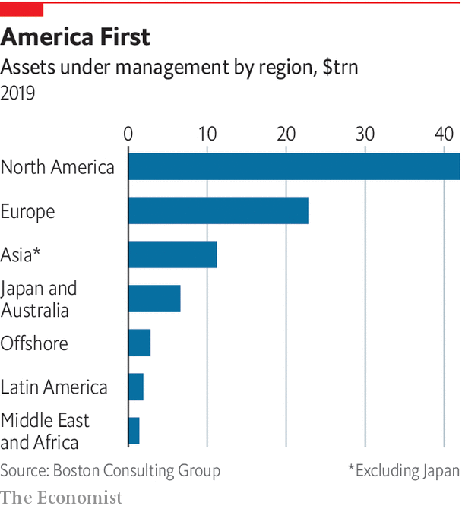

Everyone thinks that China will be a big deal. But industry bosses are not confident about how things will shake out in practice. There are broadly three areas of uncertainty. The first is how to acquire customers. Some of the world’s biggest asset managers became that way partly from having a captive market. They are often offshoots of insurance companies, retail banks or investment banks. A foreign asset manager with no brand in China needs to find another way to build the business. For some a tie-up with a local bank is a good fit. Amundi is an offshoot of two European banks, Crédit Agricole and Société Générale, from whose customer base they have built a formidable market share in France. It has a joint venture with Agricultural Bank of China and another with Bank of China. These are lenders with hundreds of millions of customers. It also has a joint venture with State Bank of India, the country’s largest commercial bank. From such strongholds, Amundi has accumulated an asset base of €300bn across Asia.

But banks are not the only money doctors in China. Some rich-world equity funds have emerged out of life-insurance businesses. They essentially sold equity risk under the guise of an insurance product. Something similar might yet happen in China. China Life, for instance, has a sales force of 1.8m. The two tech giants, Alibaba and Tencent, have mobile-payment platforms that are widely used and trusted. These are potential launching pads for asset-management businesses.

## Very big, China

In 2013 Ant Group, an offshoot of Alibaba, created a fund for its customers to invest the cash piling up in their Alipay mobile-payment accounts. Within a few years it was the world’s largest money-market fund. Vanguard now has a joint venture with Ant Group to offer investment advice. It signed up 200,000 clients in its first 100 days. The choice of distribution channel hinges on whom Chinese investors will ultimately trust. It is not mostly a matter of technology. “People make a distinction between tech platforms and bank networks,” says Yves Perrier, chief executive of Amundi. “But it is a false distinction because the way we bank in France is both human and digital.”

A second uncertainty is how the industry in China will evolve. The bet is that it will become more like America, a market in which mutual funds have the muscle. But there is no guarantee of this. Indeed, in recent months America’s stockmarket has looked a lot like China’s: retail-led, noisy and informed by social-media fads and a gambling mentality. China’s market might stay that way. Or the market for pooled investments might be swiftly captured by index and other kinds of low-cost products.

A third source of uncertainty is policy in China. It is friendly now, but might not always be. “With distribution-driven JVs, sometimes you lose control of the factory,” warns one industry bigwig. That is not the only risk. The prospect of selling rich-world securities to Chinese investors depends on China allowing capital to flow freely outwards. It has been loth to do this because it would mean ceding greater control of the yuan to market forces. China may balk at further opening up. A bigger question lies behind this. One industry executive puts it bluntly: “How serious is it about allowing people to make money?”

Perhaps the trade-and-technology wars will make China inhospitable to American asset managers. Perhaps Europe has an advantage. If Shanghai is to follow London and New York, the yuan must become freely convertible. China has to be open. But economic and financial hegemony may be expressed differently. “Will we make money? We haven’t a clue,” says the executive. But like many of his peers, he sees China as a low-stakes bet with a potentially large payoff. “We still need to be there,” he says. “So we are there.”■

This article was downloaded by calibre from <https://www.economist.com/special-report/2020/11/12/the-shanghai-open>

|  |  |  |  |
| --- | --- | --- | --- |
| Previous | Articles | Sections | Next |

|  |  |  |  |
| --- | --- | --- | --- |
| Previous | Articles | Sections | Next |

#### The end-game

# Doctor’s prescriptions

How will asset management look in 2030?

Nov 12th 2020 |

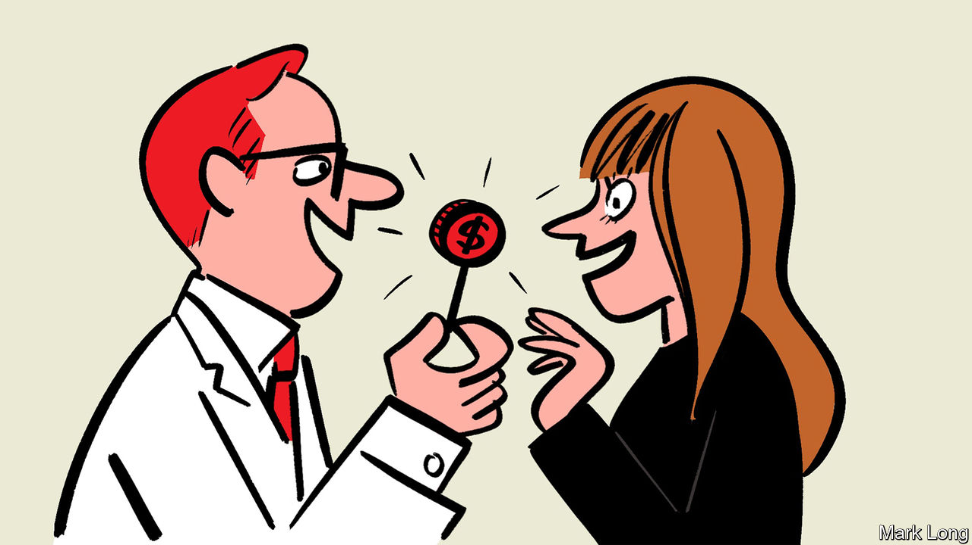

“THERE ARE two kinds of forecasters,” said the economist John Kenneth Galbraith. “Those who don’t know and those who don’t know they don’t know.” Asset management is a business built on the notion that the future is somewhat knowable, even if in large part it is not. So we must look for omens. Today’s “dishevelled” or “inchoate” borrower should not be expected to pay back its debts tomorrow, as The Economist warned in its editorial of March 28th 1868.

Speculations about the future are also often helpful in organising thoughts about the present. In this spirit, this special report finishes with some predictions tied to its main themes. Some are extensions of current trends. Others are more speculative—concerning, say, a trend that may reverse or one that could go in a surprising direction.

The first prediction is the least bold. By 2030 the sorting of the industry into a small club of giant asset managers and a bigger one of niche managers will be largely complete. Already in 2020, index-tracking funds and ETFs account for a majority of pooled investment funds in America. In a decade’s time they may make up the bulk of all stockholdings. Investors will mix beta, the market risk, with exposures picked from a menu of smaller specialists which, to survive the industry’s upheaval, must have a truly distinctive approach. These remaining funds might be thematic, based around increased longevity, say, or climate change. Or they could have a particular investment philosophy. Such specialist funds will be global or regional in scope.

A second prediction is that competition in asset management will revolve around products designed for particular needs. The present-day industry is a creature of the baby-boom era. Many boomers have built up assets in workplace schemes in which benefits depend on the size of a pension pot at retirement. Their needs are changing. A challenge to which the industry has not responded well is to find ways for people to draw on their retirement savings without running out of money too quickly, says Mr Taraporevala, of State Street Global Advisors. Quite so.

Another challenge is to tailor products to millennials. Their share of wealth is still small, but it will grow. And their preferences are different. For baby-boomers a mutual fund was the only way to invest in equities at a reasonable cost. The technology now exists to buy and sell individual shares at virtually no cost. Low-fee “robo-advisers” mechanically allocate savings to a mix of bond and equity index funds according to preset rules. These advances appeal to a generation reared on smartphones. Millennials have less need of the money doctors who tended to the boomers.

A third forecast is that ESG will not be the saviour of active asset management. By 2030 it will be too mainstream to be a source of differentiation. There is likely to be a surfeit of choices for investors who want even the most exacting kinds of ESG. Despite the increased salience of corporate governance, the big passive funds may ultimately choose not to use their vast voting power to influence firms—a fourth prediction. Securities-market regulators will continue to push them to vote their shares, to fulfil their fiduciary duty to investors. But antitrust agencies will increasingly fret about the latent ability of big funds to soften competition among firms they indirectly own. Trustbusting is moving back to the “big is bad” assumption that governed it before the 1980s. It may prove costly and legally messy for funds to exercise their voting power in a way that satisfies all watchdogs.

Some popular predictions about private markets—that they will be “democratised”, and fees will come under pressure—will turn out to be wrong (or premature). Private-equity fees do look out of whack and big pension-fund managers are more inclined to haggle over costs. Returns on private equity are likely to disappoint. Yet fees for public equity came down because there was a cheaper option: buy the index. Private-equity stakes are not as tradable as listed shares, so there is no index. So fees will stay high.

Other popular predictions will prove correct. Private debt will grow in importance. America will slowly lose its lead in venture capital. The big brand-name VCs of Silicon Valley will retain their lustre, thanks to their record of creating billionaire founders. But more new champions will emerge elsewhere.

Finally, there is China, where the uncertainty is perhaps greatest. Sceptics point to China’s record of allowing foreigners to profit only as long as it takes Chinese firms to copy and supplant them. Asset management is different. Unlike with makers of breakfast cereals, it is hard for consumers to judge the merits of an asset manager. It is equally hard for copycat firms to find out what works and what doesn’t.

That is not the only reason the foreign money doctors will stick around in China. Rich-world banks are increasingly contained by national borders. Businesses are less inclined to set up abroad. Offshoring is being replaced by onshoring. Almost by default, capital markets will become the main avenue for diversifying risk by geography. If China’s leadership wants Shanghai to be a global financial centre and the yuan to be an international currency, it needs to keep channels open. Foreign asset managers will be a crucial conduit.

In the quiet revolution of asset management, one thing will remain constant. Philip Rose’s investment trust was composed of exotic foreign bonds traded in London; his idea inspired Robert Fleming, who mostly invested in America. From the start, asset management has been global. Why change that now?■

This article was downloaded by calibre from <https://www.economist.com/special-report/2020/11/12/doctors-prescriptions>

|  |  |  |  |
| --- | --- | --- | --- |
| Previous | Articles | Sections | Next |

|  |  |  |
| --- | --- | --- |
| Special report | Sections | Finance & economics |

Business

Chinese private enterprise: The intimidation game

.

Disney: The streaming kingdom

.

Pasta: On board the spaghetti express

.

Royal Enfield: Kickstart

.

Schumpeter: The big McComeback

.

|  |  |  |
| --- | --- | --- |
| Special report | Sections | Finance & economics |

|  |  |  |  |
| --- | --- | --- | --- |
|  | Articles | Sections | Next |

#### Blown off course

# China takes aim at its entrepreneurs

Private enterprise faces formidable new obstacles

Nov 14th 2020 | HONG KONG

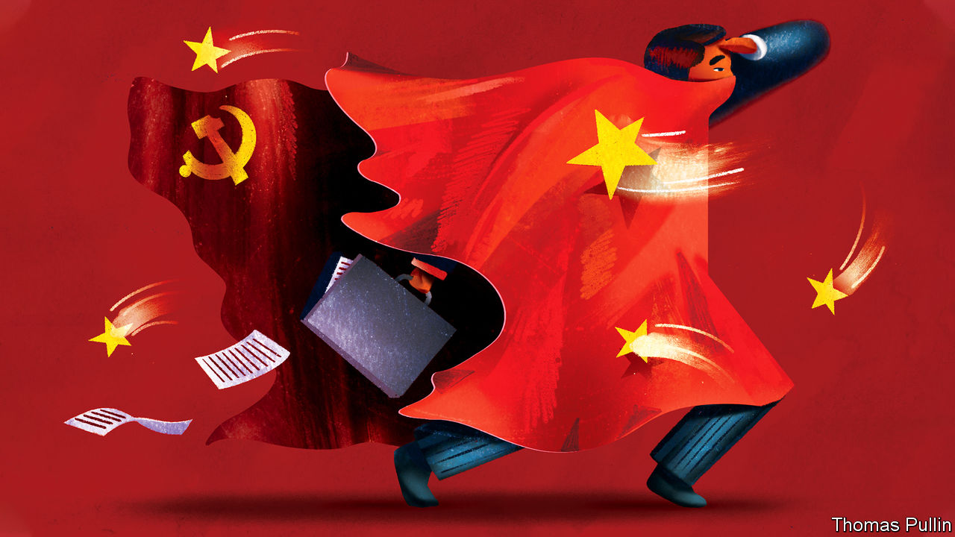

AT A SUMMIT with China’s richest entrepreneurs in late 2018 Xi Jinping sought to allay concerns that the state had declared war on the country’s private sector. Although officials in Beijing had spent the previous year bringing to heel unruly tycoons, China’s president insisted that rumours of a forceful push for party influence in the private sector were untrue. He exhorted the business leaders to “take a pill of reassurance”.

The medicine has been hard to swallow. Since then the Communist Party has sought a more active hand in recruitment and business decisions. And after subduing a band of headstrong bosses at overextended financial conglomerates, the state is now taking aim at China’s tech billionaires, making it clear that outspoken critics will not be tolerated.

Mr Xi’s preoccupation has always been maintaining China’s social and financial stability. Keeping big business in check is part of that plan. It should come as no surprise that the state is now homing in on tech, which has expanded rapidly (see chart). Six of China’s 20 most valuable listed companies are tech firms and with billions of users they touch the lives and wallets of almost all citizens.

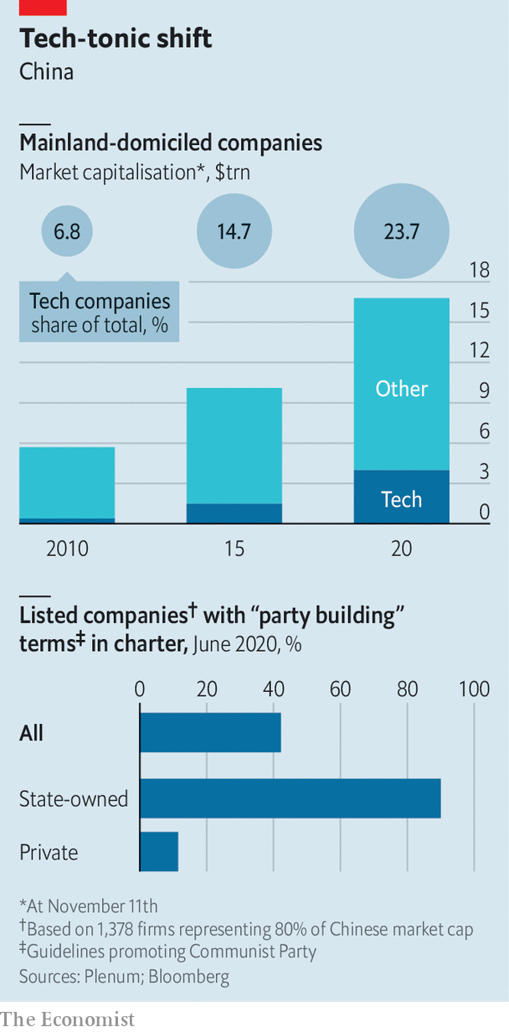

A reckoning for the sector began with what looked like a shot across the bows of China’s largest financial-technology group. The suspension by regulators on November 5th of Ant Financial’s $37bn initial public offering with less than 48 hours’ notice was at first interpreted merely as a warning to its founder, Jack Ma, who had previously criticised China’s state-owned banks. But on November 10th the publication of an extensive draft of new rules for technology groups laid bare the state’s ambitions to bring to heel not just Ant, but the whole of China’s tech industry.

Mr Xi’s relationship with China’s tycoons has always been troubled. When he became president in 2013, he inherited a corporate system replete with fraud, patchy regulation and surging debt. After the success of an anti-corruption campaign that mostly targeted officials, Mr Xi took aim at a group of businessmen who were ploughing huge sums into risky overseas investments. Purchases included SeaWorld, an American amusement-park group, and the Waldorf Astoria, a swish hotel in New York. Officials argued that many of these acquisitions were thinly disguised means to divert capital out of China.

Many of the businessmen who once fancied themselves as a Chinese Warren Buffett are in prison or worse. Wu Xiaohui, the chairman of Anbang, which bought the Waldorf among other assets, was handed an 18-year prison sentence in 2018 for financial crimes. Ye Jianming, who attempted to buy a $9bn stake in Rosneft, a Russian oil producer, was detained in early 2018. His whereabouts is still unknown. Xiao Jianhua, a broker for China’s political elite who once controlled Baoshang Bank, was kidnapped by Chinese agents from his flat at the Four Seasons Hotel in Hong Kong in 2017 and is thought to be co-operating with authorities in the unwinding of his financial conglomerate.

The crackdown has put an abrupt end to a boom in global spending by Chinese firms: in 2016 there were $200bn-worth of overseas mergers and acquisitions, the figure in 2019 was less than a fifth of that. And under government pressure private groups have divested assets worth billions of dollars. HNA, an airlines and logistics group that bought a large stake in Deutsche Bank and Hilton Worldwide, a hotel group, has sold assets worth over $20bn in recent years. Anbang Insurance was nationalised, putting the Waldorf under the ownership of China’s Ministry of Finance. Baoshang was taken over by the state and allowed to file for bankruptcy in August. Acquisitions of European football clubs by Chinese groups have all but ended.

Analysts have praised the way in which systemic risks posed by companies such as Anbang and HNA appear to have been reduced on Mr Xi’s watch. Within China few dare to criticise him for his failings. Those who have done so have been dealt with severely. Ren Zhiqiang, a senior member of the Communist Party who once ran a state-owned property firm, penned a missive to friends earlier this year in which he referred to Mr Xi as a “naked clown”. He was sentenced to 18 years in prison in September for bribery and embezzlement.

The party has also been increasing its influence over private firms in more subtle ways. Under a strategy referred to as “party building”, firms have been asked to launch party committees, which can opine on whether a corporate decision is in line with government policy. The number of committees in publicly traded but privately controlled companies is still low. According to a survey of 1,378 Chinese listed firms by Plenum, a consultancy, of the 61% that were privately controlled only 11.5% had party-building clauses in their charters compared with 90% of state-owned firms.

## Party invitation

Yet the prevalence of such committees looks likely to grow. In September Mr Xi asked for the private sector to “unite around the party”. A day later Ye Qing, vice-chairman of the All-China Federation of Industry and Commerce, a powerful organisation controlled by the Communist Party, issued a more detailed list of demands. He called for private groups to establish human-resources departments led by the party and monitoring units that would allow the party to audit company managers.

This might not affect all firms equally. “For big companies, there’s no negotiation. The party approaches you and you say yes,” says Joe Zhang, a business consultant who has sat on the boards of Chinese private and state corporations. However, he also argues that for most smaller firms, less visible and not as economically important, party cells are little more than a rubber stamp as profits will trump state influence on decision-making. Their influence may not necessarily be unwelcome either. One executive, whose company has a party committee, argues that by growing closer to the thinking of the party leadership, “we can steer the company accordingly”. This heads off potential clashes with the state.

So far there is little evidence to suggest that party committees have hurt profitability, says Huang Tianlei of the Peterson Institute for International Economics, a think-tank. But increased party influence could inhibit some operations. “Innovation may be suppressed. More red tape can emerge. A firm can turn from profit-driven to goal-driven, sacrificing profitability,” says Mr Huang.

It is possible that party committees may soon play a larger role in tech firms. A raft of new regulations presents a more immediate threat. Ant is connected to hundreds of millions of people through its payments and lending platforms. Like other Chinese tech giants it holds precious data on customers as well as controlling a pipeline through which hundreds of billions of dollars are lent and spent. That such power lies in private hands is a source of tension between the party and entrepreneurs.

“These resources need to be tightly controlled and the political loyalty of the firms and entrepreneurs, not only to the regime but also to individual political leaders, needs to be strictly maintained,” says Sun Xin, an academic at King’s College London. “The case of Ant is just one manifestation of this underlying logic.”

The halting of Ant’s IPO was triggered by new draft regulations aimed at online micro lending. For Ant, the rules can only be interpreted as an attack on the firm’s lending platform, its biggest source of revenue. Mr Ma may regret comparing China’s banks to pawnshops in a speech in October. The comments infuriated senior officials and played a part in the hasty suspension of Ant’s IPO. But Mr Ma is not to blame for the latest onslaught of antitrust rules, although he may have sped up their arrival.

## vie-ing for influence

The new rules, under consideration for some while, will for the first time explicitly apply monopoly controls on internet and e-commerce firms. For many years China’s antitrust laws have not exempted the groups but they have also not been targeted in monopoly cases. This has allowed a few companies to control large swathes of the digital economy. They also take aim at the structures that have allowed Chinese tech firms to raise capital overseas. Barred from allowing foreign investors to take direct stakes, for two decades virtually all capital-hungry tech groups have skirted the rules by using a “variable-interest entity” (VIE) to link foreign cash to the Chinese market. The structure creates an offshore holding company into which foreigners invest. That company has a contractual agreement with an onshore firm to receive the economic benefits of the underlying assets.

The VIE structure has long been tolerated by Chinese authorities, but without full legal recognition. Foreigners have virtually no recourse in China to claim rights to the assets they have invested in. Foreign funds have long been wary of the framework but most Chinese tech companies still use it to structure their overseas listings. The new antitrust rules could require companies to seek approval for such arrangements, calling into question whether VIEs will be permitted in the future and so the way that foreign capital will reach Chinese tech firms. The threat of withdrawing tacit approval for a VIE is another way the state can intimidate firms and their owners.

Perhaps the new rules will humble the outspoken Mr Ma. He has not spoken publicly on the matter, but Ant has bent the knee and agreed to embrace the new regulations. Mr Xi has made clear that no company is too big, and no IPO too valuable, to be allowed to challenge the state.■

This article was downloaded by calibre from <https://www.economist.com/business/2020/11/14/china-takes-aim-at-its-entrepreneurs>

|  |  |  |  |
| --- | --- | --- | --- |
|  | Articles | Sections | Next |

|  |  |  |  |
| --- | --- | --- | --- |
| Previous | Articles | Sections | Next |

#### The streaming kingdom

# Disney strikes streaming-TV gold

A spectacular first year for Disney+

Nov 14th 2020 |



DISNEY PROMISED investors in spring 2019 that a new video-streaming service would win between 60m and 90m subscribers by 2024. Disney+ has outperformed that forecast spectacularly, hitting its five-year subscriber target in just eight months. In doing so it is fulfilling the digital-transformation plan set in motion three years ago by Bob Iger, Disney’s longtime boss, now its executive chairman.

Marketing muscle, crucial to success, has been backed up by “The Mandalorian”, a space western inspired by “Star Wars”. Such is its popularity that Disney was late meeting demand for a plush-toy of its baby Yoda character. The pandemic added a turbocharge, dashing fears that Disney+ and other new streaming services, like HBO Max and Apple TV+, might struggle to attract time-starved consumers. Lockdowns mean extra hours to while away, notes Tim Mulligan of MIDiA Research.

Amid school closures Disney+ has been as trusty a baby-sitter as baby Yoda’s nurse droid. Of all the new streaming services Disney+, which launched in western Europe in March, just as lockdowns began, is the clear winner. Even so it has not touched the leader, Netflix, which has 195m subscribers worldwide and over 70m in America alone (see chart).

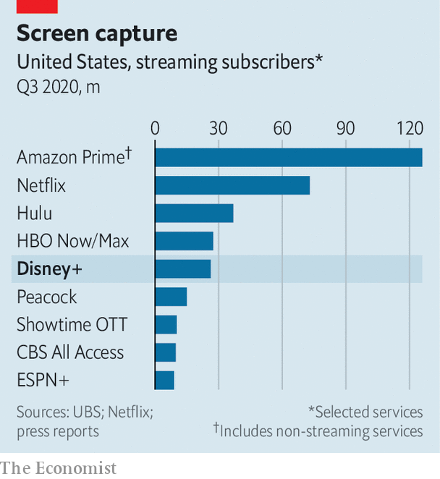

Disney’s other businesses have suffered because of the pandemic. Shuttered theme parks, closed cinemas and cancelled sporting events have taken their toll. In August Disney said covid-19 wiped out $3.5bn of operating profits at its parks, experiences and products division in three months. The company is expected to report another quarterly loss on November 12th, after The Economist went to press. Yet the streaming service’s subscriber gains have helped shield the firm’s share price. It has fallen but by far less than its peers.

Disney+’s rapid success also underlines a doubt about the firm—whether Mr Iger’s choice of successor was correct. The favourite for the top job was Kevin Mayer, who designed and launched Disney+. Mr Iger chose Bob Chapek, a talented operating executive who had been running theme parks. “Given the runaway success of Disney+ it is even harder to understand how the theme park and home-entertainment executive got the top job,” says Rich Greenfield of LightShed Partners, a research firm. Mr Mayer left Disney this summer.

Will Mr Chapek now bet heavily on Disney+? The firm as a whole lavishes nearly $30bn a year on original and acquired content but this year set aside only $1bn for Disney+. Netflix spends $15bn a year. The Disney service’s rich library is enough to keep under-tens engaged but it may lose subscribers unless it regularly offers original grown-up fare. Third Point, an activist investor, wants Disney to stop its dividend and spend the $3bn a year on Disney+.

Disney could do more than that if it went “all-in” on streaming, dropping its current system in which, for example, big-budget films go exclusively to cinemas, and putting everything it makes onto Disney+ at once. The service could then spend as much as Netflix and raise its price from $6.99 per month to over $10.

This would make for a huge global business but there is a danger that it would swiftly cannibalise the existing parts of Disney’s empire. A more likely course is that Disney will move new content more rapidly onto Disney+. It could also combine Disney+ with Hulu, a separate and successful video-streaming service the firm took control of last year.

Disney is expected to announce in December that it will spend a lot more on content for the service. All eyes will be on whether Mr Chapek seems as tuned-in to streaming’s bright future as Mr Iger was. ■

This article was downloaded by calibre from <https://www.economist.com/business/2020/11/14/disney-strikes-streaming-tv-gold>

|  |  |  |  |
| --- | --- | --- | --- |
| Previous | Articles | Sections | Next |

|  |  |  |  |
| --- | --- | --- | --- |
| Previous | Articles | Sections | Next |

#### Recipe for success

# Stockpiling pasta boosts Italy’s foodmakers

A Italian staple is a pandemic favourite

Nov 14th 2020 | BERLIN

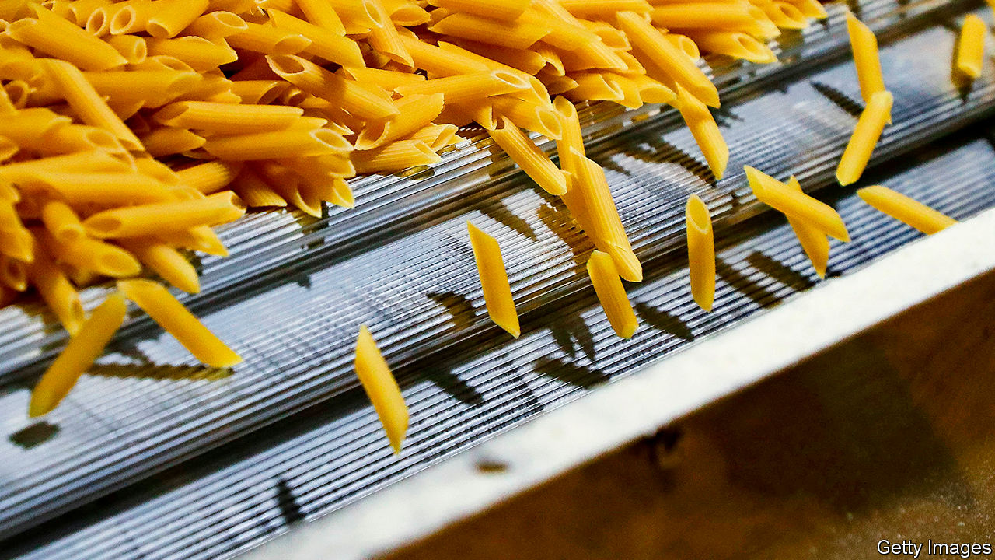

SUPERMARKET SHELVES stripped bare by stockpilers were familiar scenes as anxious shoppers loaded up with toilet rolls and pasta when lockdowns were first imposed. The taste for long-lasting dried food has been a boon for Italy, a country in deep recession. Although Italians remain the biggest eaters of pasta worldwide, munching through 23kg per head annually, the country’s pasta-makers export 60% of their production, mostly to Europe and America. While stuck at home far more cooks made plates of spaghetti, fettuccine and farfalle. According to ISTAT, the Italian statistics agency, exports of pasta increased by 30% in the first six months of the year compared with the same period in 2019.

Barilla, the world’s biggest pasta-maker with sales of €3.6bn ($4.2bn) last year, must keep up with increased demand for its core product. The 143-year-old family firm also owns Wasa, the world’s biggest maker of Swedish crisp bread, as well as a host of smaller snack brands. The company’s high-tech headquarters in Parma operated at close to capacity, producing 1,000 tonnes a day, throughout Italy’s harsh lockdown in spring. Some other Barilla factories produced more pasta than ever, says Bastian Diegel of Barilla in Germany, albeit at significantly higher cost thanks to the additional safety measures. It continued to make all of its 120 varieties.

Maintaining supplies to Germany, one of Barilla’s most important markets, even required dedicated transport. Starting in March the job of providing 22% of the pasta and as much as 39% of the sauces eaten in Germany meant dispatching two trains a week from Parma to Ulm, its main warehouse in the country. Each train has 16 wagons transporting 490 tonnes of pasta, 60 tonnes of sauces and 50 tonnes of pesto. From June the trains ran three times a week; soon they might make four journeys.

The question for Barilla and other pasta-makers is whether the boom will outlast the pandemic. Luigi Cristiano Laurenza of the International Pasta Organisation is confident. Pasta consumption worldwide increased from 7m tonnes in 1999 to 16m tonnes last year, even before it became a pandemic staple. Italy may have lost its appetite a little in recent years but there is room for growth nearly everywhere else, in particular in Africa and Asia. Pasta is cheap, tasty and versatile, says Mr Laurenza, making it especially attractive for cash-strapped families battered by a pandemic.

It is especially important for Barilla that plates remain laden after a series of missteps. In 2002 it spent €1.8bn on a hostile takeover of Kamps, a German baker. It turned out to be a costly mistake and in 2010 Barilla sold Kamps to a private-equity firm. In September 2013, Guido Barilla, the company’s chairman, said that the firm’s family values meant that he would not do a “commercial with a homosexual family”. The comments provoked an outcry, in particular in America, and threats of a boycott. Mr Barilla was forced to apologise and the firm subsequently launched a limited-edition pasta box showing two women sharing a kiss over spaghetti. Although cooking pasta requires plenty of hot water, pasta-makers should stay out of it.■

This article was downloaded by calibre from <https://www.economist.com/business/2020/11/14/stockpiling-pasta-boosts-italys-foodmakers>

|  |  |  |  |
| --- | --- | --- | --- |
| Previous | Articles | Sections | Next |

|  |  |  |  |
| --- | --- | --- | --- |
| Previous | Articles | Sections | Next |

#### Kickstart

# Royal Enfield’s Indian motorbikes are going global

Old-fashioned motorbikes make a comeback

Nov 12th 2020 | KENT, CONNECTICUT



DESPITE THE autumn chill, a group has gathered in front of the Iron Horse Royal Enfield dealership, a small stone building set in the Connecticut hills. A woman sits on a motorcycle, its single-cylinder engine thumping with a distinctive sound. In the window a striking chrome-and-black model looks much like what would have rolled out of Enfield’s original factory in Redditch in the British Midlands in the company’s heyday in the 1950s.

Enfield, dating back to 1901, boasts of the longest lifespan of any motorcycle manufacturer. But Iron Horse only began selling its bikes in 2018 and the name remains relatively unknown in America and other markets outside India. The company’s original British operations closed in 1970; the surviving Indian remnant was heading the same way before a stunning revival that saw annual sales grow from 31,000 units in 2006 to more than 800,000 in 2019, transforming the value of Enfield’s parent company, Eicher Motors, a tractor-maker, from just a few hundred million dollars to $8.5bn. Now the company is accelerating into the wider world.

Enfields are a throwback, devoid of modern frills and with the looks of a classic bike. Engines ranging from 350cc to 650cc are large for India but small compared with machines from firms such as of Triumph and BMW. Enfield declined to enter the largest part of the Indian market, which is for small and cheap bikes, and will not attempt to make the expensive, tech-laden machines that bikers generally hanker after in rich countries. Improvements have tackled mechanical shortcomings without undermining the existing sound, feel and look. They must, says Siddhartha Lal, Eicher’s boss, provide “everything you need and nothing you don’t”.

A consequence of this approach is that production is confined to a limited number of straightforward motorcycles produced at high volume which enhances economies of scale and enables profitability at low prices. The most expensive Enfield in America is $6,400, making the bikes accessible to a wider potential market. Machines from Harley-Davidson, which has suffered falling sales in recent years, often cost more than three times as much.

Enfield is aiming to sell 20% of its production abroad. Over the past five years, it has added 700 dealers worldwide to its 1,600 in India. Exports doubled to 39,000 units in the year to the end of March and in June, admittedly an odd month because of the covid-19 lockdown, an Enfield 650cc motorcycle topped the British sales chart.

A sign that it might succeed as an exporter is that the bikes are becoming part of popular culture outside India. A YouTube diary by a young Dutch woman, for example, begins with her purchase of an Enfield in Delhi and follows her journey back to theNetherlands. More than 100,000 people subscribe to her posts. The urge to cross borders is shared not only by Enfield but, apparently, its customers as well.

This article was downloaded by calibre from <https://www.economist.com/business/2020/11/12/royal-enfields-indian-motorbikes-are-going-global>

|  |  |  |  |
| --- | --- | --- | --- |
| Previous | Articles | Sections | Next |

|  |  |  |  |
| --- | --- | --- | --- |
| Previous | Articles | Sections | Next |

#### Schumpeter

# Takeaways from McDonald’s remarkable comeback

The new boss deserves credit for largely sticking with a successful strategy

Nov 14th 2020 |



CHRIS KEMPCZINSKI is anything but supersized. One year into his tenure, the CEO of McDonald’s is a lean-framed 52-year-old who runs marathons. Hard to believe, then, that he eats a McDonald’s meal twice a day, five days a week. “There are days when I’m indulgent and days when I’m careful about what I’m eating, but I eat a lot of McDonald’s,” he admits in an interview. Indeed he puts many of his best customers to shame. On average, the top 10% of Big Mac bingers visit his restaurants a fifth as regularly as he does.

Perhaps he is making up for lost time. Unusually for a McDonald’s boss, he is not a company lifer. He joined in 2015, hired by his predecessor, Steve Easterbrook, when McDonald’s was on the verge of meltdown. It was floundering in its attempts to compete with innovative American upstarts, such as Chipotle and Shake Shack. Its premises were shabby even as it offered hundreds of items on the menu that many of its customers could not afford. Critics called it a parasite on society, paying low wages and promoting obesity. Mr Kempczinski acknowledges that it suffered from hubris. Under Mr Easterbrook, who took charge in 2015, the mission was to shake it out of its complacency.

What followed was a lesson in corporate renewal that could have made Mr Easterbrook a megastar CEO had he not been fired last year for having a consensual relationship with an employee. (McDonald’s has recently sued him for allegedly concealing other sexual relationships and wants to recover a big pay-off.) Yet sensibly Mr Kempczinski is sticking to the programme. Unlike many new bosses overeager to tear up the legacy of their disgraced predecessors, he unveiled a new strategy on November 9th that builds on the work started in recent years. In the midst of a pandemic, it offers a valuable lesson of its own. Never let a crisis go to waste.

The seeds of the revival of McDonald’s started with a simple decision that is surprisingly easy to get wrong: go back to basics. From 2015 onwards, it pared back its array of menu offerings and focused on price and quality. It recommitted to Ray Kroc’s beloved business model, increasing the share of franchises last year to 93% (of almost 39,000 restaurants), up from 82% in 2015. That provided it with higher-margin and steadier royalty and rental income. It streamlined its sprawling international operations, selling control of its restaurants in China and Hong Kong. The results were impressive. Across McDonald’s sales exceeded $100bn last year; its operating margins, thinner than a frazzled patty in most of the restaurant industry, ballooned to 43%. And its share price sizzled. Since 2015 its market value has almost doubled to $160bn.

As it recovered its financial footing, it turned to investing in the future. But counter-intuitively, it probably benefited by not rushing. According to John Gordon, a San Diego-based restaurant consultant, its franchisee model makes it hard to move fast—and important to build consensus. It tests new ideas out in local markets before suggesting them to franchisees worldwide. Its ownership of the land under franchisees’ restaurants gives it a joint interest with them in co-investing in refurbishments and technological upgrades. Not only does this help woo customers by reinforcing the brand, it also supports the value of the land. In recent years McDonald’s and its franchisees have invested heavily in installing kiosks for touchscreen ordering and making other improvements such as two-lane drive-throughs. Last year the company made its biggest acquisition in years, buying a tech firm that helps personalise the drive-through experience. The overhauls may have cost franchisees a lot. But over the course of the covid-19 pandemic, they have started to reap the benefits.

That is because McDonald’s has used the crisis to step up the pace of its transformation, resulting in big sales surges in recent months, especially in America. With the interiors of many of its restaurants closed, it has relied on the roll-out of its digital, drive-through and delivery initiatives, all of which encourage a more “contactless” experience that it believes will outlast the pandemic. Recalling Kroc’s aphorism that “We’re not in the hamburger business. We’re in show business,” it has dazzled customers with customised menus by superstar rappers such as Travis Scott. And it has made old favourites, such as Big Macs and Quarter Pounders, central to its menu, which adds to simplicity in the kitchen and speeds up customer service. Over the next two years it hopes a long-awaited digital loyalty programme will enhance sales growth and maintain margins at their elevated levels of 2019. With a covid vaccine, it could do even better.

Many challenges remain for Mr Kempczinski. On food, McDonald’s is a laggard when it comes to chicken sandwiches and plant-based products. It promises a Crispy Chicken Sandwich and non-meat McPlant soon. The former is vital to catch up with competitors such as Chick-fil-A. The company says it is shifting marketing away from sales drives towards promoting itself as a community-focused-brand, but not everyone likes the pious tone. “Social Justice Warriors are now running McDonald’s Corporation. Stuff that has nothing to do with selling Big Macs,” says one franchisee quoted in an analyst’s report. McDonald’s faces two lawsuits from former and current black franchisees, alleging racial discrimination by pushing them into poor areas. It refutes the accusations.

## From Big Macs to big data

Its ubiquity means McDonald’s is often in the news for the wrong reasons. But as a corporate turnaround, it is a compelling story. Instead of suffering from a tech onslaught as many bricks-and-mortar chains have, it has turned itself into a digital pioneer. Instead of hunkering down during the pandemic, it has embraced new ways of doing business. Despite Mr Kempczinski’s baptism of fire, even the leadership transition has been the best the industry has seen in years, says Sara Senatore of Bernstein, an investment firm. He should not be harshly judged for his frequency at the lunch counters. So far he has earned all the Quarter Pounders he can eat.■

This article was downloaded by calibre from <https://www.economist.com/business/2020/11/14/takeaways-from-mcdonalds-remarkable-comeback>

|  |  |  |  |
| --- | --- | --- | --- |
| Previous | Articles | Sections | Next |

|  |  |  |
| --- | --- | --- |
| Business | Sections | Science & ... |

Finance & economics

America’s economy: Giant jab

.

Booster shot: News of an effective vaccine injects optimism into markets

.

Buttonwood: Coming out of the ultracold

.

Turkey: Comings and goings

.

Commodities: Amber wave

.

Klarna: Smooth shopping

.

Free exchange: Field excursion

.

|  |  |  |
| --- | --- | --- |
| Business | Sections | Science & ... |

|  |  |  |  |
| --- | --- | --- | --- |
|  | Articles | Sections | Next |

#### Giant jab

# What a vaccine means for America’s economy

Although the coronavirus is spreading unchecked, there are grounds for optimism

Nov 14th 2020 |

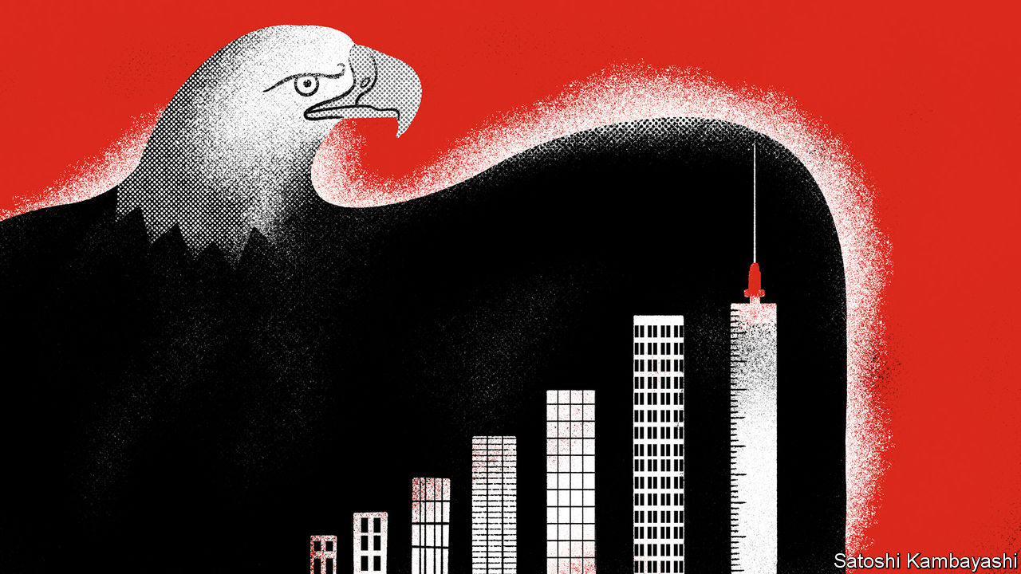

ON NOVEMBER 9TH the end of the coronavirus pandemic came into tantalising sight. Pfizer and BioNTech announced that their vaccine was more effective than expected. Investors’ hopes for a stronger economy sent stockmarkets soaring. Ten-year Treasury yields neared 1%, levels last seen in March (see article).

Even before the vaccine news broke, the speed of America’s economic bounceback was exceeding forecasts and surpassing others in the rich world. In April the IMF reckoned that GDP would shrink by 6% in 2020. It now projects a decline of 4%. Unemployment peaked at 14.7% in April; in June the Federal Reserve had expected it to still be around 9% by the end of the year. It went on to fall below that rate only two months later. In October it stood at 6.9%.

Can a vaccine accelerate the economy’s return to its pre-covid state? The coronavirus is still spreading unchecked, with the burden often falling on the poorest. But many economists had also worried that the pandemic would leave broader economic scars that take time to heal. Here, a look at firms’ and households’ finances offers grounds for optimism.

The resurgence of the virus will put a dampener on the recovery in the months before a vaccine becomes widely available. Infections are rising so rapidly that, in the admittedly unlikely event that current trends were to continue, 1m Americans a day would be catching the disease by the end of the year (see article). Renewed local restrictions on activity seem inevitable. That will lower some types of economic activity and could in turn increase the number of people who have lost their jobs permanently.

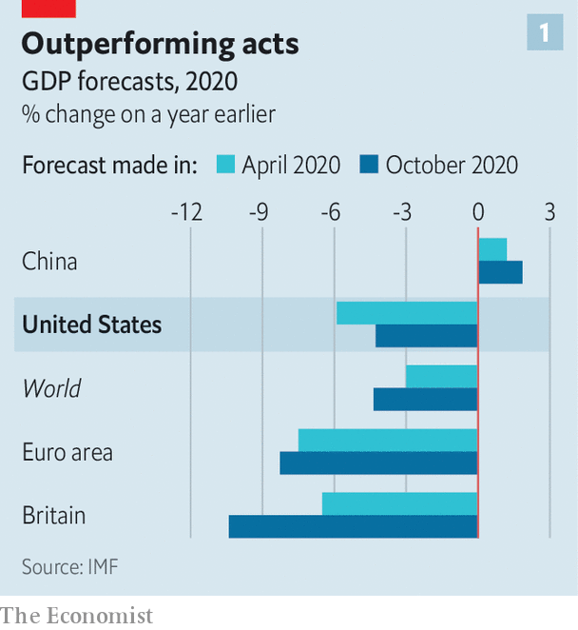

Still, it seems unlikely that America will enter a double-dip recession, as Europe is expected to. For one thing, it probably will not impose lockdowns as severe as those in Britain, France or Germany. High-frequency indicators, including The Economist’s analysis of Google mobility data, suggest that America’s recovery has slowed compared with the summer. But it has not gone into reverse, as it has in Europe. And the vaccine could boost the economy in some ways even before it becomes available. Torsten Slok of Apollo Global Management, an asset manager, argues that “households and firms are going to plan ahead, for example by booking travel [and] vacations”.

On the current growth path, at the turn of the year there will still be 10m fewer jobs than there would have been without the pandemic. Output will be some $700bn, or 4%, lower than otherwise. Most forecasters reckon that income per person will not exceed its pre-covid level until 2022, if not later. But growth will accelerate as jabs are administered. Everything from theatres to public transport will feel safer. That will further revive the labour market. Before the pandemic over a fifth of workers were in jobs involving close proximity to others.

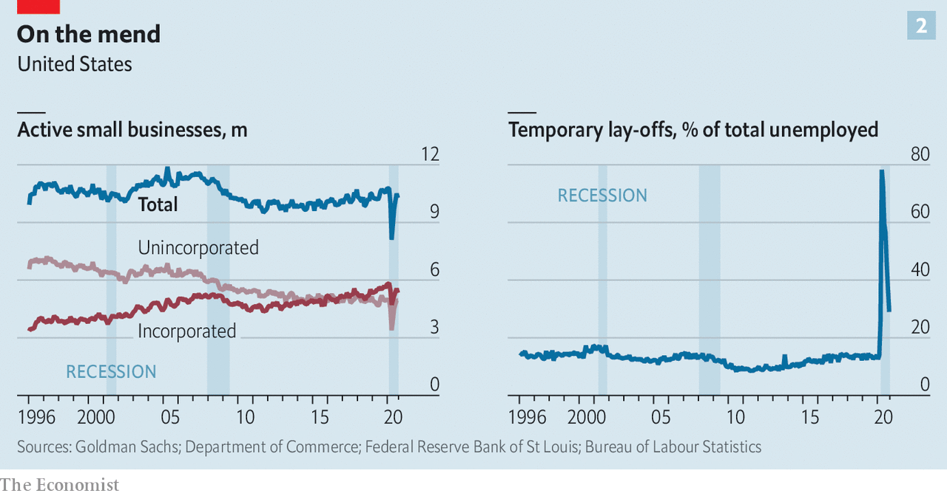

There are other reasons to think America’s recovery may be faster than after previous recessions. History suggests that recoveries are sluggish when downturns leave deep economic scars. The financial crisis of 2007-09 cast a long shadow over subsequent years in part because of its chilling effect on bank lending, for instance. This time around, the effect of school closures on children’s education will be felt for decades to come. But in many other respects there is less evidence of lasting economic damage. A wave of bankruptcies and permanent closures has been avoided—especially of small firms, which employ half the workforce. And families’ finances have been resilient.

Start with small firms. At one point in April nearly half of them were closed, according to data from Opportunity Insights, a research team based at Harvard University, as shelter-in-place orders forced closures and fear of the virus prompted people to stay at home. Six months on, many firms are still struggling. In early October nearly a third of small firms reported that the pandemic had a large negative effect on business, according to the Census Bureau. One quarter of small businesses remain closed.

But these closures may not become permanent. Total commercial bankruptcy filings are running below their pre-pandemic trend, not to mention the levels of the last recession. Such data are not perfect, because not every firm that closes down files for bankruptcy. A new paper by economists at the Fed brings together many different measures of “business exit”, and finds “somewhat mixed” evidence that more businesses have gone bust in 2020.

But these unlucky outfits do not appear to represent a large share of employment. In addition, this bankruptcy ripple seems unlikely to turn into a wave. The share of small firms very late on their debt repayments is currently about half its level in 2009. Moreover, although the number of active businesses fell during the first wave of the pandemic, it has recovered almost all the lost ground, suggesting that new firms may have come up in place of exiting ones.

Firms’ resilience helps explain why unemployment has dropped much faster than expected. The share of unemployed Americans who say they have lost their job temporarily remains unusually high. Such workers expect to be recalled to their old employer, pointing to further declines in the unemployment rate.

What explains small firms’ surprising resilience? It seems hard to credit America’s business-focused stimulus measures. So far less than $4bn (or 0.02% of GDP) has been doled out by the Fed’s Main Street Lending Programme, which is supposed to channel funds to small and midsized enterprises. Economists are also underwhelmed by the Paycheck Protection Programme (PPP), which provided loans to small businesses that are turned into grants as long as recipients do not sack their employees. A paper by David Autor of the Massachusetts Institute of Technology and colleagues found that “each job supported by the PPP cost between $162,000 and $381,000 through May 2020”. But this money was poorly targeted: a lot of it was lapped up by firms that planned to continue operating, come what may.

Other factors are more important. Many small firms have managed to trim their outgoings. A recent paper from Goldman Sachs, a bank, finds that in May rent-collection rates fell to 10% or less for firms such as cinemas and gyms. A growing number of landlords now set rent as a percentage of tenants’ revenues, an arrangement that was uncommon before covid-19.

But perhaps the biggest reason for the lack of small-business carnage relates to consumer spending. In September retail sales were more than 5% up on the previous year. Americans appear to have tilted their spending towards small firms over large ones, on the premise that they are less likely to catch covid-19 in places with fewer people. The latest figures from JPMorgan Chase, a bank, show that credit-card spending in early November was only marginally lower than it was a year ago.

This relatively sturdy consumption in turn reflects the second factor behind the lack of scarring this time around: resilient household finances. Compared with other rich countries, America has directed more of its fiscal stimulus towards protecting household incomes. The federal government sent out cheques worth up to $1,200 per person and temporarily bumped up unemployment benefits by $600 a week. That is not to say that the disadvantaged have not been badly hit: some measures of deprivation have risen sharply. But viewed in aggregate, the financial security of households has proved remarkably stable.

A survey by the Federal Reserve found that 77% of adults were doing “at least OK” financially in July 2020, up from 75% in October 2019, before the pandemic struck. Between March and September households saved 19% of their gross income, up from 6% during the same period the year before, thereby accumulating $1.3trn (6% of GDP) in extra savings.

The stockpile gives consumers a buffer for the coming months, and should help support economic growth. In part for that reason, another blowout stimulus package may not be needed now that a vaccine is near. Lawmakers from the Democratic Party have pressed for spending of $3trn or more. Injecting money into the economy could well hasten the recovery. But another $1trn a year in stimulus may be enough to restore normality, assuming that by the start of next year the gap between America’s current and potential GDP may be around 4% of output, and that increases in government spending will translate somewhat less than one-to-one into extra GDP, as the evidence currently suggests.

A lot could still go wrong. Stringent lockdowns, European style, could still derail the recovery. Stimulus may not be passed at all. Either would worsen the economic scars that have so far been minimised, for instance by making it harder for the 3.6m Americans who have been unemployed for more than six months to find work. America’s many layers of government could delay the distribution of vaccines, just as they have botched the allocation of covid-19 tests. But households and businesses, at least, are in better shape than you might have feared. ■

Editor’s note: Some of our covid-19 coverage is free for readers of The Economist Today, our daily [newsletter](https://my.economist.com/user#newsletter). For more stories and our pandemic tracker, see our [hub](https://www.economist.com/news/2020/03/11/the-economists-coverage-of-the-coronavirus)

This article was downloaded by calibre from <https://www.economist.com/finance-and-economics/2020/11/14/what-a-vaccine-means-for-americas-economy>

|  |  |  |  |
| --- | --- | --- | --- |
|  | Articles | Sections | Next |

|  |  |  |  |
| --- | --- | --- | --- |
| Previous | Articles | Sections | Next |

#### Booster shot

# News of an effective vaccine injects optimism into markets

Share prices and Treasury yields rose on Pfizer’s announcement

Nov 14th 2020 |

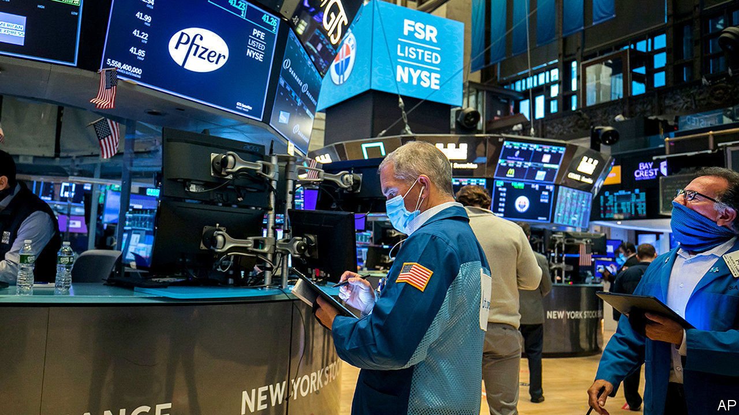

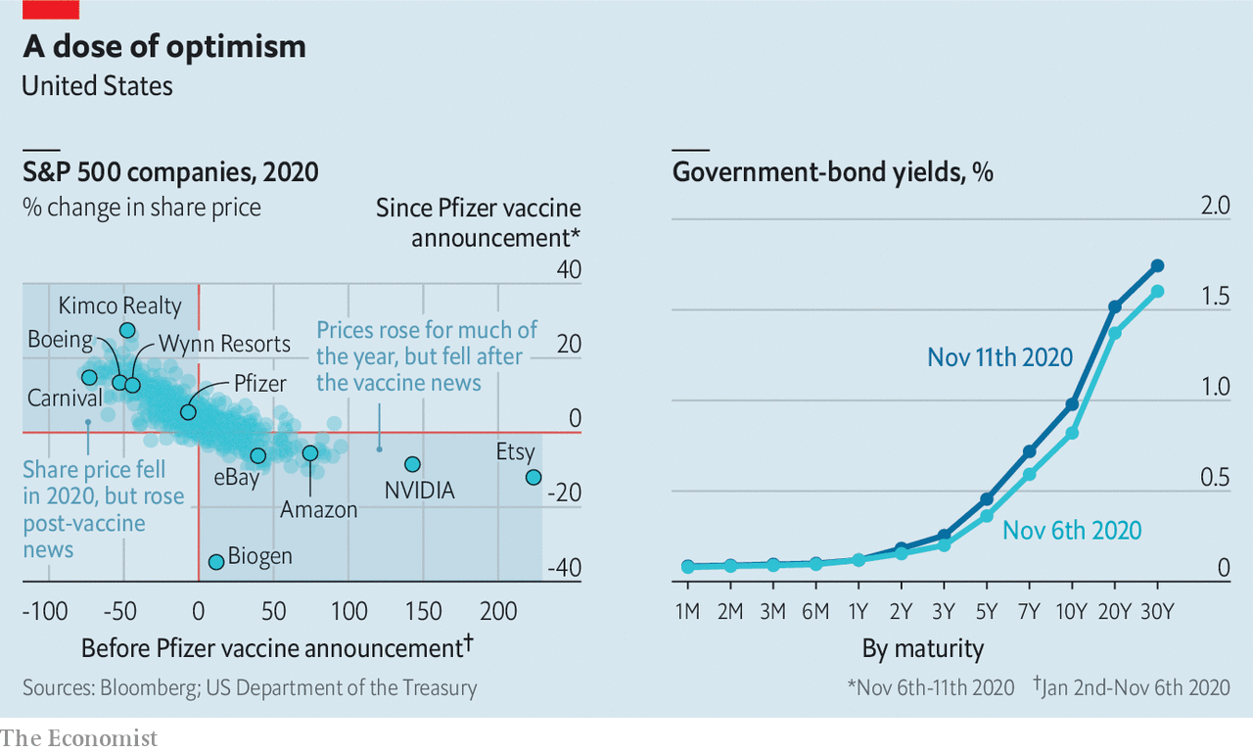

AFTER NEWS of an efficacious vaccine broke on November 9th, investors bet on a partial return to economic normality. Cruise and casino stocks leapt, and e-commerce firms skidded. The yield on ten-year Treasuries climbed to almost 1%.■

This article was downloaded by calibre from <https://www.economist.com/finance-and-economics/2020/11/14/news-of-an-effective-vaccine-injects-optimism-into-markets>

|  |  |  |  |
| --- | --- | --- | --- |
| Previous | Articles | Sections | Next |

|  |  |  |  |
| --- | --- | --- | --- |
| Previous | Articles | Sections | Next |

#### Buttonwood

# Could the vaccine help ailing emerging-market shares?

The American election and the news on the jab have renewed investors’ appetite for risk

Nov 14th 2020 |

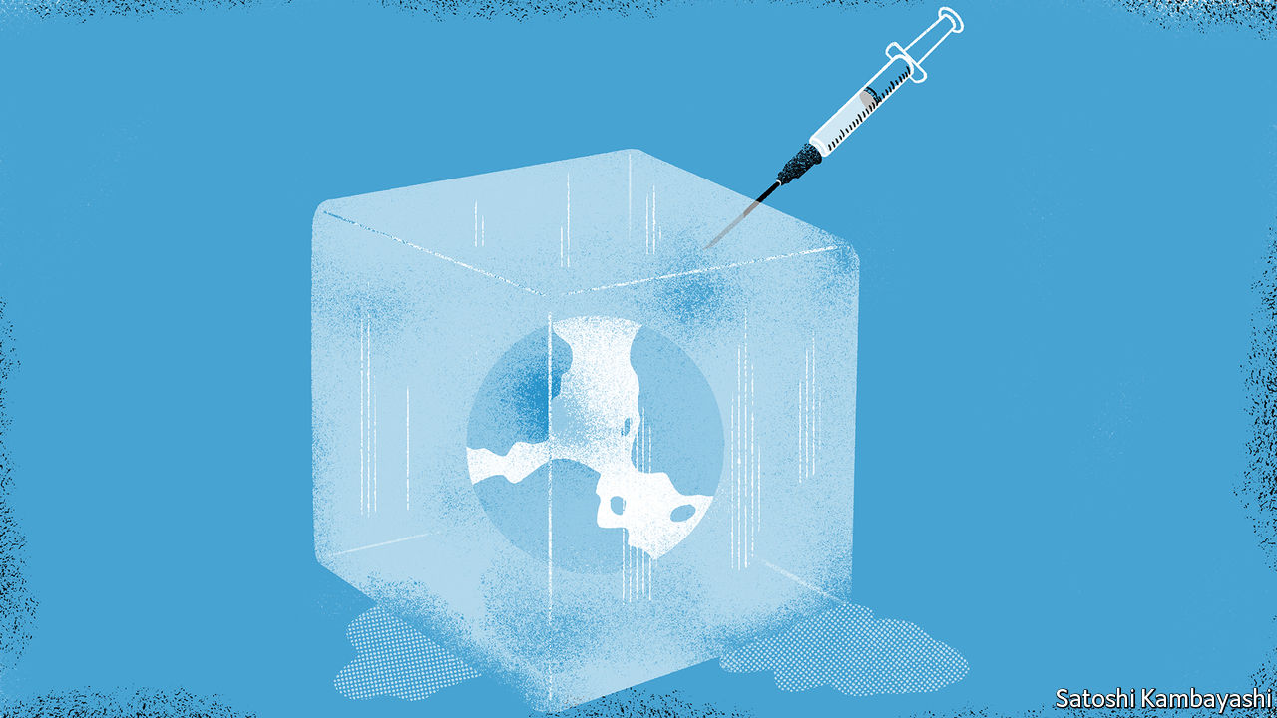

Editor’s note: Some of our covid-19 coverage is free for readers of The Economist Today, our daily [newsletter](https://my.economist.com/user#newsletter). For more stories and our pandemic tracker, see our [hub](https://www.economist.com/news/2020/03/11/the-economists-coverage-of-the-coronavirus)

AN INDIAN ECONOMIC official once remarked to Buttonwood that his country’s economy does best when the rest of the world does well—but not too well. India’s exports benefit from global growth. But when the world economy gains too much momentum, interest rates and oil prices can rise uncomfortably high, hobbling a country that is a net importer of both capital and crude.

His observation came to mind as India’s stockmarket roared to a record high on November 10th, after news that a covid-19 vaccine developed by Pfizer and BioNTech was proving more effective than expected. It will be months before it becomes widely available even in the countries equipped to handle it. But the reproduction number of investors’ exuberance can be very high.

Another spur to India’s stockmarket—and to emerging-market equities more broadly—was America’s election. The result, when it emerged at last, removed one lingering source of uncertainty. That has made room in investors’ stomachs for other types of risk. The renewed appetite for edginess helped lift MSCI’s benchmark emerging-market equity index by over 6% from November 3rd to 9th. It is now up by more than half from its lowest point in March.

Though Wall Street has been setting records, the emerging-market index is still far from the all-time high it reached in 2007 or even its peak in 2018. Indeed over the past decade emerging-market shares have made little forward progress, albeit by the most nail-biting route possible. Big gains in 2012, 2016-17 and 2019 were offset by spectacular falls in the intervening years. Overall the index is just 3% higher than ten years ago.

That underperformance, however, leaves emerging-market stocks looking much better value than their rich-world counterparts. According to Oxford Economics, a consultancy, the ratio of price to earnings, adjusted for the cycle, for emerging markets lies in the bottom half of its historical distribution. America’s ratio, by contrast, is above the 98th percentile.

The valuation gap looks even more glaring when compared with immediate growth prospects. The GDP of emerging markets, weighted according to their stockmarket capitalisation, will shrink by less than 2% this year and grow by about 5% in 2021, according to forecasts by the Economist Intelligence Unit, a sister company of The Economist. America is doing better than most of the rich world, but even so its economy will still shrink by 4.6% in 2020 and grow by less than 4% in 2021. Some members of the MSCI’s index, such as China and Taiwan, have handled the pandemic well, allowing for an early return to growth. Others, such as India, have handled it badly. But precisely because their first attempts at lockdowns were so ineffective, they are unlikely to interrupt growth by trying another one.

These discrepancies have not gone unnoticed. Some strategists think that unloved emerging-market shares might benefit from the kind of “rotation” that in the past few days has propelled investors out of expensive “growth” stocks (such as tech) and into “value” stocks, the revenues of which are more closely tied to the state of the economy.

They also think that the most beleaguered emerging markets might benefit from a rotation within the rotation. John Lomax of HSBC, for example, recommends increasing holdings of countries like Brazil and South Africa (which are still heavily down on the year) at the expense of Asian ones, like Taiwan.

There may be a catch, though. Emerging-market assets may be priced like value stocks. But in another important respect—their sensitivity to bond yields—they more closely resemble growth stocks. When interest rates and bond yields rise, investors become less willing to bear risk or wait for future profits. That hurts growth stocks and emerging markets alike.

Consider the following scenario. The Pfizer vaccine is approved. But because it must be stored at Antarctic temperatures, it never reaches the emerging markets, such as India, that lack the cold chains needed to distribute it safely. The vaccine might therefore spur an uneven recovery, led by rich countries.

That rebound could put upward pressure on bond yields: the Pfizer news alone raised yields on ten-year American Treasuries to almost 1% on November 9th. And the tightening of global financial conditions could hurt emerging economies by more than the improvement in rich-world growth helps them. They could do badly, if the rest of the world does too well.

Editor’s note: Some of our covid-19 coverage is free for readers of The Economist Today, our daily [newsletter](https://my.economist.com/user#newsletter). For more stories and our pandemic tracker, see our [hub](https://www.economist.com/news/2020/03/11/the-economists-coverage-of-the-coronavirus)

This article was downloaded by calibre from <https://www.economist.com/finance-and-economics/2020/11/14/could-the-vaccine-help-ailing-emerging-market-shares>

|  |  |  |  |
| --- | --- | --- | --- |
| Previous | Articles | Sections | Next |

|  |  |  |  |
| --- | --- | --- | --- |
| Previous | Articles | Sections | Next |

#### Comings and goings

# Will Turkey’s new economic officials win over investors?

The new central-bank boss is making changes. But President Erdogan still calls the shots

Nov 14th 2020 | ISTANBUL

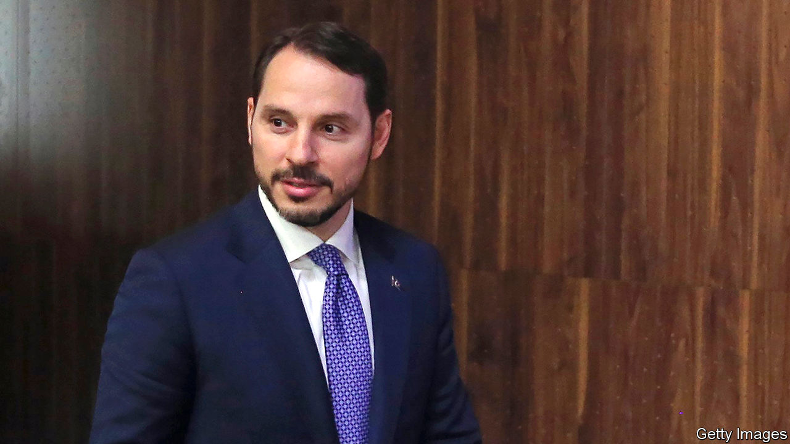

FOR SOMEONE thought to be the second-most-powerful person in Turkey and a possible successor to President Recep Tayyip Erdogan, it was an unseemly exit. In a statement posted on Instagram on November 8th and riddled with grammatical mistakes, Berat Albayrak, the president’s son-in-law, said he was stepping down as finance minister and leaving politics. It took Mr Erdogan and his officials over a day to digest and confirm the news. It took another day to name Lutfi Elvan, a former deputy prime minister, as his replacement.

Mr Albayrak, popularly referred to as the damat (son-in-law), said he was leaving for health reasons. But insiders blame a feud with the new central-bank governor, Naci Agbal, who had criticised the minister’s record. Mr Agbal had been appointed only a couple of days earlier, after Mr Erdogan ousted his predecessor, Murat Uysal, without giving an explanation. (Mr Uysal is the second head of the central bank to be sacked in as many years.) Mr Albayrak was reportedly not briefed on the decision.

Mr Albayrak’s management of the economy was even worse than his grammar. As the minister and his father-in-law leaned on both the central bank and commercial lenders to keep borrowing rates low, the lira set one record low after another. Between the damat’s surprise appointment in 2018 and his shock resignation, the currency lost 46% of its dollar value, eating away at Turks’ buying power. Instead of raising interest rates the central bank sold dollar reserves to relieve pressure on the lira. It threw in the towel this summer, but only after squandering more than $100bn, and had begun to use a byzantine system of multiple interest rates to tighten the money supply indirectly. For his part, Mr Albayrak laughed off concerns about the currency collapse. “For me, the exchange rates are not important at all,” he told reporters in September. “I don’t look at that.”

Investors hope for a return to more orthodox policies. In its first few days of trading since the shakeup, the lira had risen by over 7% against the dollar, reversing a long decline (see chart). Both Mr Elvan and Mr Agbal, who preceded the damat as finance minister, are staunch allies of Mr Erdogan, but experienced technocrats. Both say they will prioritise fighting inflation, which in October approached 12%, almost two percentage points higher than the policy interest rate. Mr Agbal is said to have already begun removing Mr Albayrak’s surrogates from top posts at the central bank and promised to improve communication. In another encouraging move, on November 11th the banking regulator eased restrictions on lira trading by foreigners. The curbs had been imposed to stop outsiders short-selling the currency.

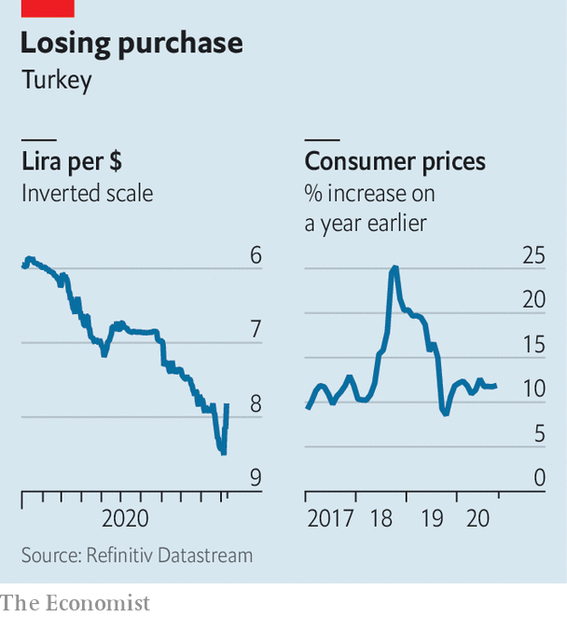

Still, for all of Mr Albayrak’s foibles, the damat only did what all ministers are now used to doing: follow Mr Erdogan’s lead. And the president gives no sign of being ready to loosen his grip on the finance ministry and the central bank, or to dispense with his bizarre economic views, such as that high interest rates cause inflation. “There’s this narrative building that pins all the bad things that happened since 2018 on Mr Albayrak,” says Erik Meyersson of Handelsbanken. “Maybe it was his strategy to start selling foreign reserves, but the reason they resorted to this stupid measure was because they had this stupid directive [from Mr Erdogan] not to increase rates.”

The central bank’s monetary-policy committee convenes on November 19th. It “needs to meet expectations by hiking rates and simplifying the policy framework”, says Hakan Kara, a former chief economist at the bank. If not, the change at the top will have been window-dressing. ■

This article was downloaded by calibre from <https://www.economist.com/finance-and-economics/2020/11/14/will-turkeys-new-economic-officials-win-over-investors>

|  |  |  |  |
| --- | --- | --- | --- |
| Previous | Articles | Sections | Next |

|  |  |  |  |
| --- | --- | --- | --- |
| Previous | Articles | Sections | Next |

#### Amber wave

# Demand for American grain is surging

China’s keen appetite is part of the explanation

Nov 12th 2020 | NEW YORK

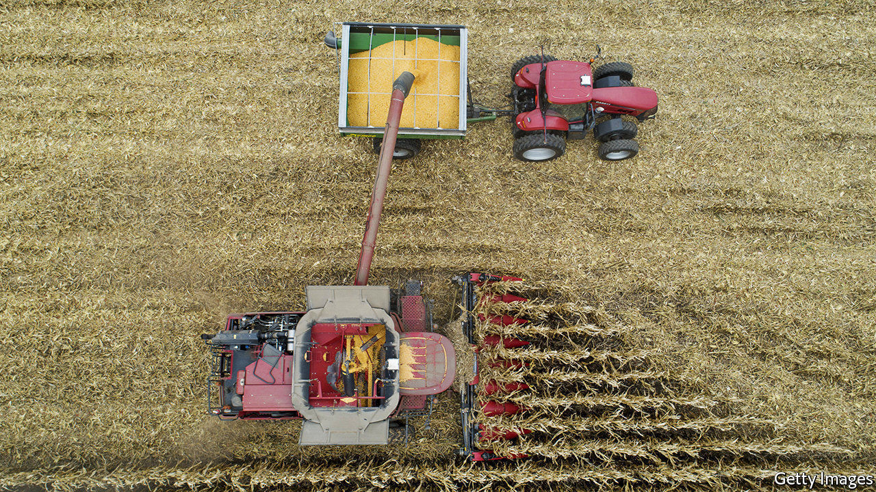

THE HARVEST rush in America’s heartland is subsiding. More than 90% of the country’s corn and soyabeans had been picked by November 8th. Crops moved from cart to trailer to grain elevator. Now a different kind of frenzy is taking hold.

Exports of American corn are poised to reach a record of 67.3m tonnes for the marketing year that began in September, according to forecasts by the United States Departure of Agriculture (USDA) published on November 10th. Demand for corn and soyabeans may push American stocks to their lowest levels in seven years. By the time markets closed after the USDA’s report, the most actively traded corn and soyabean futures contracts had jumped to $4.23 and $11.46 a bushel, respectively, with corn up by more than a third since early August and soyabeans at their highest price in over four years. They may rise higher still.

The surge in prices follows years of turmoil for American farmers. Gripes include: the government’s limit on the ethanol that can be blended in petrol; President Donald Trump’s trade war with China; and the coronavirus, which depressed demand for oil and therefore the biofuels mixed with it.

Prices are climbing, in part, due to bad weather. Wet conditions prompted some American farmers to forgo planting and collect government crop insurance instead, notes Dan Basse of AgResource, a research firm. Other farms suffered a dry August. A derecho, or wind storm, blasted across the Midwest, with gusts of more than 100 miles per hour. Farmers elsewhere have also experienced dismal conditions. Usually fertile fields near the Black Sea are producing less corn than expected. Production in Ukraine is expected to fall by more than 20% compared with last year.

Meanwhile demand from China has soared. In the first phase of Mr Trump’s trade deal, announced in January, China agreed to buy an additional $200bn-worth of American goods in 2020-21. Even without the deal, Chinese demand for crops would probably have been robust. The country is keen to expand its herds of hogs, decimated last year by African swine fever. That is raising demand for animal feed, such as soyabeans. Anxiety about food security means the government is refilling stockpiles, too. The USDA expects Chinese wheat imports to reach the highest level in 25 years, with total imports of corn and other coarse grains setting a new record.

Little surprise, then, that export prices for American corn and soyabeans have sailed above $220 and $470 a tonne, respectively, up by about 60% and 50% from their 52-week lows. But bulls should not be too confident. China’s buying may ebb if it seeks a different trade deal with America’s president-elect, Joe Biden. Agricultural commodities move in much quicker cycles than, say, metals, points out Aakash Doshi of Citigroup, a bank. It is simpler to plant extra beans than it is to start mining for bauxite. Higher prices now may prompt farmers to plant more later; a spell of good weather could boost supply further.

Still, prices may hold up in the short term, for better or worse. In America, says Mr Doshi, “demand is improving well from the covid-19 trough in the second quarter.” Dry weather from La Niña is interfering with planting in Brazil. A spat may prompt China to ban imports of several Australian crops (see [article](https://www.economist.com/node/21795325)). Russia’s government is mulling a quota on wheat exports. For the more than 100m people who have sunk into poverty this year, that is worrying. An index of food prices, published by the United Nations, rose in October for the fifth straight month. The index is now 6% above its level a year ago. ■

This article was downloaded by calibre from <https://www.economist.com/finance-and-economics/2020/11/12/demand-for-american-grain-is-surging>

|  |  |  |  |
| --- | --- | --- | --- |
| Previous | Articles | Sections | Next |

|  |  |  |  |
| --- | --- | --- | --- |
| Previous | Articles | Sections | Next |

#### Smooth shopping

# Klarna, a Swedish payments unicorn, wants to conquer America

The “buy now, pay later” firm has grown rapidly

Nov 12th 2020 | STOCKHOLM

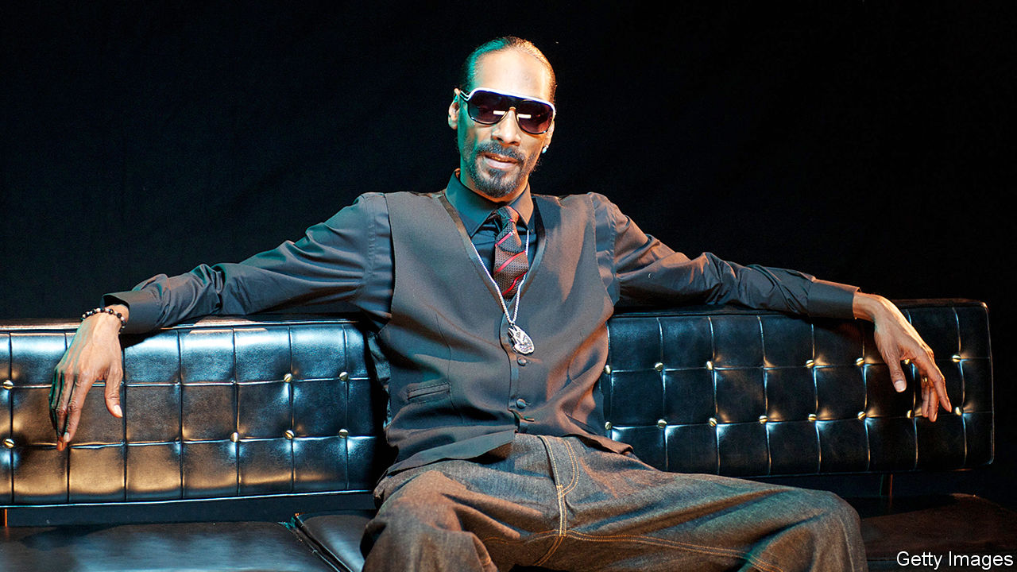

“AS A CHILD, when you see your parents struggling, it creates a drive,” says Sebastian Siemiatkowski, the chief executive and co-founder of Klarna, an online-payment-processing firm. His family moved to Sweden from Poland in 1981, the year he was born; his university-educated father was unemployed for long spells or just got by behind the wheel of a cab. The experience nurtured a strong ambition “to fix the economy for the family”.

Today, just shy of 40, Mr Siemiatkowksi is at the helm of one of Europe’s biggest fintech firms. A funding round in September raised $650m and valued Klarna at $10.65bn. Investors include Sequoia Capital, a venture-capital firm; Visa, a credit-card firm; and Snoop Dogg, a rapper who performs as “Smoooth Dogg” in a pepto-pink ad for the payments firm. Having gained a foothold in Europe, Klarna has its sights set on America.

Klarna is one of several “buy now, pay later” (BNPL) services that have grown rapidly in recent years. Its attraction, for both online retailers and their customers, is simplicity. Instead of entering their card details at checkout, shoppers sign up to Klarna’s app with their email and delivery address, and leave payment to be made in 14 or 30 days. Klarna pays the retailer in the meantime, bearing the risk that shoppers do not pay—something few other fintechs do—while charging the merchant a fee.

Customers are recognised when they use the app again, without needing to re-enter their details. Algorithms use publicly available credit information and details of the size, type and timing of the purchase to calculate the chance of fraud, and offer extended-payment plans, for a charge.

The ease of the process hugely increases the “conversion” rate—the share of customers who go ahead and buy an item after putting it into their virtual basket. That is why Klarna attracts retailers like bees to a honeypot. It has signed up 200,000 sellers in 17 countries and captured 10% of the e-commerce market in northern Europe. Etsy, an online marketplace for arts-and-crafts items, signed up on October 26th.

Last year Klarna’s revenue jumped by almost one-third to Skr7.2bn ($840m) as the value of wares sold through it rose by 32%. Merchant fees are the main source of its income; it also runs checkout infrastructure for some retailers. Late fees from customers make a smaller contribution.

It was Klarna’s success in Britain—where it has almost 10m customers and this year has opened some 95,000 accounts a week—that made it reckon that it could conquer America, where online-payments firms have typically struggled to gain market share. It began 2019 with its splashy “Smoooth Dogg” campaign and poured funds into its operations in New York, Los Angeles and Columbus, Ohio, ahead of its launch in America. The firm now has 9m customers there, and will probably go public there in the not-too-distant future.

It is expanding in other ways, too. Back in Europe, it obtained a banking licence in 2017, and has launched new products in some countries, such as a credit card. It has opened a tech hub in Berlin’s trendy Mitte neighbourhood that employs 500. This helps explain why last year Klarna ran its first loss since it was set up in 2005. “Profitability is for later,” says Mr Siemiatkowski.

Demand is certainly on Klarna’s side. According to Kaleido Intelligence, a research firm, BNPL will grow to $680bn in transaction value in 2025 worldwide, from $353bn in 2019, driven by young, credit-hungry shoppers. Covid-19 has only accelerated the rise in online shopping.

Still, the business model brings risks. One comes from some shoppers’ worsening finances. Klarna reported a net loss of Skr522m between January and June, a sevenfold increase from the net loss of Skr73m in the same period last year. Credit losses almost doubled to Skr1.2bn, more than 25% of revenue compared with 19% in the first half of 2019. The industry is also drawing criticism for encouraging people to overspend. “I am concerned about anything that makes it very easy to sleepwalk into debt,” says Martyn James of Resolver, a British consumer-rights group. In September Britain’s Financial Conduct Authority began a review of the unsecured-credit market, which includes BNPL. Having charmed shoppers and retailers, the firm may have to win over regulators too. ■

This article was downloaded by calibre from <https://www.economist.com/finance-and-economics/2020/11/12/klarna-a-swedish-payments-unicorn-wants-to-conquer-america>

|  |  |  |  |
| --- | --- | --- | --- |
| Previous | Articles | Sections | Next |

|  |  |  |  |
| --- | --- | --- | --- |
| Previous | Articles | Sections | Next |

#### Free exchange

# Why relations between economists and epidemiologists have been testy

Too often, economists are reluctant collaborators

Nov 14th 2020 |

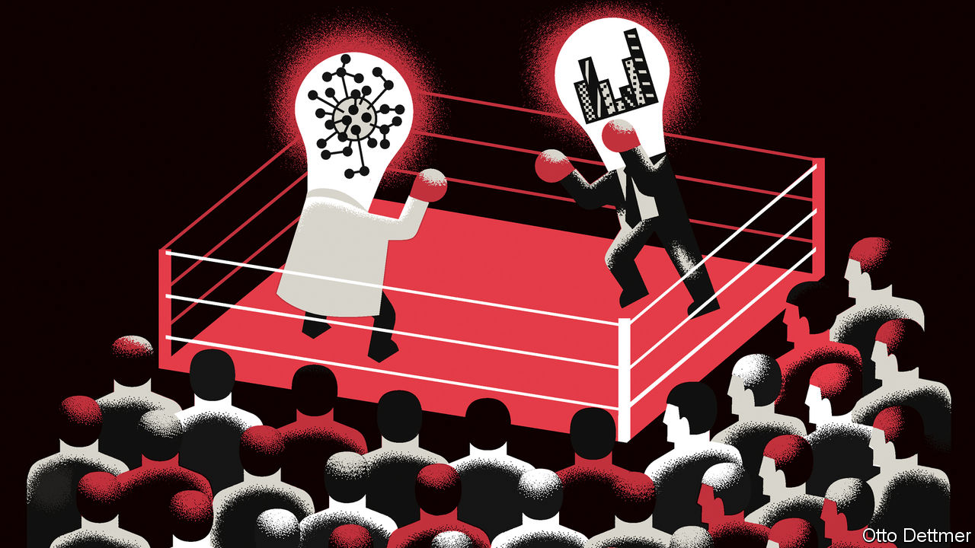

Editor’s note: Some of our covid-19 coverage is free for readers of The Economist Today, our daily [newsletter](https://my.economist.com/user#newsletter). For more stories and our pandemic tracker, see our [hub](https://www.economist.com/news/2020/03/11/the-economists-coverage-of-the-coronavirus)

FOR EPIDEMIOLOGISTS, 2020 has been a trial by fire. Economists should be able to relate; it was just over a decade ago that their own practices and forecasts were subjected to the harsh glare of the public eye in the aftermath of the global financial crisis. Instead the relationship between the two disciplines has been a testy one. Some economists even questioned whether epidemiologists were intellectually equipped for the trial. “How smart are they? What are their average GRE scores?” wondered Tyler Cowen of George Mason University in April. The snootiness is unfortunate. The challenges posed by the coronavirus pandemic—and those that are still to come, as vaccines are distributed—cry out for co-operation. But too often, when economists venture into other academic areas, their arrival often looks more like a clumsy invasion force than a helpful diplomatic mission.

The two fields got off on the wrong foot early on in the pandemic. Back then there was an acute need for models that predicted the possible course of covid-19, in order to inform the policy response. Epidemiologists, like economists, use different sorts of models in their work, each subject to its own limitations and more useful in some contexts than others. In March researchers at Imperial College London used a model to calculate the potential death toll of the virus, assuming that people and governments took no measures to stop its spread. The analysis concluded that perhaps 500,000 Britons and 2.2m Americans would die in such circumstances (roughly ten times as many as have died so far). The numbers frightened governments into taking drastic steps to mitigate the spread of the virus, but they drew intense criticism, much of it from economists. Detractors argued that the model’s assumptions were unrealistic (a strange stone for an economist to throw). People would of course act to protect themselves from harm, they argued, meaning that the death toll would surely be much smaller.

The authors of the Imperial College study had been open about this assumption, though, and even noted that it was unrealistic. In a newly published essay in the Journal of Economic Perspectives Eleanor Murray, an epidemiologist at Boston University, says economists misunderstood the aim of the model, which was to set out a worst-case scenario as a baseline against which to estimate the effects of potential policy interventions. Criticisms of other modelling approaches were similarly rooted in misinterpretation of their intended audience and purpose, she reckons.

Given that building models is a favourite pastime of economists, the perception that epidemiologists’ efforts were not good enough led many to dig into the data themselves. This too proved problematic, writes Ms Murray. Drawing sound conclusions from the available epidemiological data is hard when the scope of potential uncertainty is unknown—because the share of covid-19 cases that are asymptomatic either cannot be determined or changes as the virus spreads, for example. Such ambiguities necessarily apply when dealing with a novel pathogen like the virus which causes covid-19, a fact that economists unaccustomed to dealing with epidemiological data may not have appreciated. Rather than attempting to outdo the experts, Ms Murray writes, economists ought to have taken advantage of specialisation, and focused their efforts on questions epidemiologists are less equipped to address.

This is a bit unfair. Yes, some modelling attempts by economists have been the work of dabblers. But the subfield of economic epidemiology has been studying how social factors influence the spread of a disease for decades. Much of the outpouring of recent economic work on issues related to covid-19 has steered clear of modelling its course, and focused instead on precisely those areas where economists can better add value. Confounding uncertainty notwithstanding, scholars have worked at great speed, producing hundreds of papers evaluating policy measures, analysing the economic costs associated with outbreaks and lockdowns, and assessing how the pandemic is reshaping the global economy—work that this newspaper has relied upon in its coverage of covid-19.

Still, economics could do better. Interdisciplinarity has long been eyed with suspicion. Robert Solow, a Nobel prizewinner, once dismissed critics of his profession by saying that, “When they want economics to be broader and more interdisciplinary, they seem to mean that they want it to give up its standards of rigour, precision and reliance on systematic observation interpreted by theory, and to go over instead to some looser kind of discourse.” Even those scholars interested in wandering off-piste face incentives not to collaborate with researchers in other fields, reckons Tony Yates, an economist formerly of the University of Birmingham. For academics seeking tenure, publication in top economic journals is of paramount importance. Co-operation with a non-economist places some control over research in the hands of scholars for whom acceptance by a top journal is less of a priority. Economists’ forays into other disciplines therefore benefit much less from knowledge-sharing across fields than is ideal.

## A lack of disciplines

All this is especially unfortunate, because epidemiologists’ chief source of frustration in the pandemic is one that also bedevils the economics profession. As Ms Murray notes, the epidemiological community was unprepared for the way in which its policy recommendations would be politicised and its public statements warped by agents of misinformation. Economists should empathise. Their efforts to explain complicated ideas to the masses, from the virtues of trade to the need for bank bail-outs, have often foundered. Such failures encourage economists to become more insular. But, as the pandemic has revealed, sometimes the effects of a policy hinge on how well the public understands what is being done and why. A profession that is more open to collaboration might also learn from the communications struggles of others. ■

This article was downloaded by calibre from <https://www.economist.com/finance-and-economics/2020/11/14/why-relations-between-economists-and-epidemiologists-have-been-testy>

|  |  |  |  |
| --- | --- | --- | --- |
| Previous | Articles | Sections | Next |

|  |  |  |
| --- | --- | --- |
| Finance & economics | Sections | Books & arts |

Science & technology

Fast diagnosis for covid-19: Test match

.

Planetary science: Questions of life

.

Materials science: Would you like sugar cane in that?

.

|  |  |  |
| --- | --- | --- |
| Finance & economics | Sections | Books & arts |

|  |  |  |  |
| --- | --- | --- | --- |
|  | Articles | Sections | Next |

#### Dealing with the pandemic

# Fast tests for covid-19 are coming

They will help, until a vaccine can be deployed

Nov 14th 2020 |

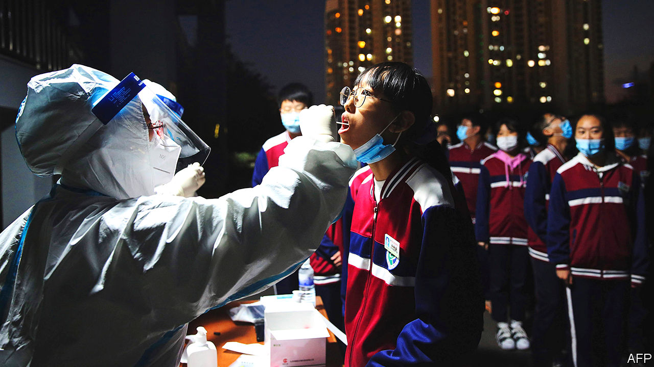

Editor’s note: Some of our covid-19 coverage is free for readers of The Economist Today, our daily [newsletter](https://my.economist.com/user#newsletter). For more stories and our pandemic tracker, see our [hub](https://www.economist.com/news/2020/03/11/the-economists-coverage-of-the-coronavirus)

AS NEWS EMERGED this week that an experimental vaccine against covid-19 has proved effective in late-stage clinical trials, hopes that the pandemic’s days may be numbered are running high (see article). But, even with the best of luck, it will be months before a vaccine starts to make a difference on the ground in those countries that get the first supplies of it, let alone the ones at the back of the queue. In the meantime, the pandemic juggernaut rolls on.

To try to slow it, many countries are starting to deploy tests which, at some cost in accuracy, deliver their results much more rapidly than the polymerase-chain-reaction (PCR) tests that were commonplace at the pandemic’s beginning. These rapid tests will allow greater numbers of infected people than previously possible to be detected and quarantined before they can spread the contagion. They are therefore being used in increasing numbers to screen people for the presence of SARS-CoV-2, the virus that causes covid-19, in settings ranging from airports to nursing homes. In Europe, indeed, they are sometimes used to blitz entire neighbourhoods, cities and even small countries, like Slovakia. But will they change the course of the pandemic?

## Smaller, faster, cheaper

PCR tests look for the genetic sequence of the virus in nose and throat swabs. These swabs have to be processed in laboratories and require machines that take hours to come up with a result. They are extremely accurate. But the delay involved can hobble test-and-trace systems.

Rapid tests, by contrast, are designed to detect certain proteins that SARS-CoV-2 sheds when it replicates during an infection. These proteins, known as antigens, spur the immune system into making other proteins, called antibodies, that go on to disable the virus. Antigen tests need no laboratory backup and can report a result in 15-20 minutes. They work by dipping the swab into a vial containing a solution that extracts the antigen of interest. A few drops of the mix are then applied to a test strip laced with antibodies that recognise that antigen. The test strip displays the results like a home pregnancy test.

The speed with which these tests have been developed is impressive. More than 70 are now on the market in one part of the world or another, according to a catalogue compiled by the Foundation for Innovative New Diagnostics (FIND), a charity in Geneva that supports the World Health Organisation (WHO) with research on diagnostic tools. So far, only two of them have been granted provisional (“emergency use”) approval by the WHO, and seven by America’s federal regulator, the Food and Drug Administration. But more approvals are expected to be forthcoming in the weeks ahead as FIND and other organisations complete validation studies that test the tests in the real-life conditions in which they are likely to be used.

Early antigen tests were not terribly good, but many of the newer ones are extremely accurate. If a PCR test is negative, a modern antigen test on the same individual will agree with that analysis more than 97% of the time, a value called its specificity. The story gets complicated, though, when the virus is actually around. If someone tests positive for covid-19 in a PCR test, the best antigen tests will agree in more than 90% of cases if the testing is happening within a week or so of the onset of symptoms, a value called the sensitivity. But the rate of agreement falls if the antigen test is done at the beginning or end of an infection, when the amount of virus present in the nose and throat is considerably lower. This means that diagnoses relying on antigen tests are unreliable during those periods.

Fortunately, from a public-health point of view this may not matter. The relationship between viral load and contagiousness is not fully understood, but current thinking is that higher loads make people more contagious. Since those with higher loads are most likely to show up as positive in an antigen test and therefore be asked to isolate themselves, the transmission-breaking value of the new tests should not be too badly compromised.

In theory, then, all of this sounds great. But reality is messier. Even a highly accurate test will produce fewer true positives than false positives if the people being tested are unlikely to be infected in the first place (see chart). That would be the kind of problem which arises with mass testing in places that are not covid-19 hotspots. For example, Britain’s Office for National Statistics estimates that on October 28th 0.82% of people in private households in London were infected. If everyone in London that day was given a test that has the minimum “acceptable” accuracy for rapid tests set by the WHO (80% sensitivity and 97% specificity) the number of those with false-positive results will be 353% bigger than those with true positive results.

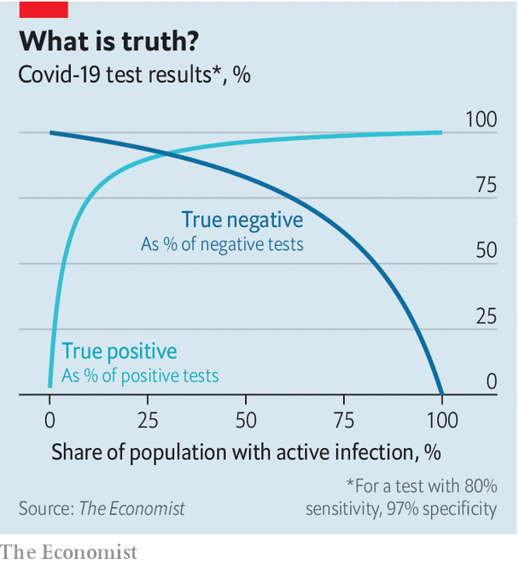

This is why deciding whether to trust the result of an imperfect rapid test—or, indeed, whether it is worth using the test at all—depends on who is being tested, and why. A positive result is more credible for someone with symptoms, or who is a close contact of an infected individual, and perhaps lives in an area with a high covid-19 rate. But testing people when there is no obvious reason to believe they may be infected is likely to be a waste. A positive result in that case will be suspect.

## Do try this at home

Doctors are used to making such decisions when testing for things like cancer, sexually transmitted infections and so on. The guidelines they employ draw on years of research and practice. But for covid-19 things are new and changing rapidly. To deal with that, some test developers are pairing their products with “digital wraparounds” such as apps in which such decision-making algorithms are fed up-to-date data on things like trends in local covid-19 prevalence and the weight of various personal risk factors derived from various analyses. Some of these apps issue a time-limited bar code to those who test negative, for use where proof of a negative test may be required.

For now, rapid tests are licensed for use only by medical professionals. The regulatory bar for stand-alone home tests is set high. They must be 99% accurate and pass extensive usability trials to ensure that people employ them correctly. That would be easier if the secretion being tested was saliva, which is freely accessible, rather than material found high in the nose or deep in the throat. Saliva does work reliably in some PCR tests but no one has yet devised a good antigen test that uses it.

At the current pace of progress, though, this may soon change. Bruce Tromberg of America’s National Institutes of Health (NIH) thinks that a rapid over-the-counter test could be available in America as early as next summer. Rapid antigen tests are, then, likely to become a big part of countries’ covid-19 testing strategies. In particular, they will be used for testing at home, in doctors’ surgeries, and in remote places where PCR laboratories are not available. They will be especially handy for mass testing in places prone to outbreaks, such as prisons and student dormitories.

As more rapid tests are developed and demand for them increases, competition and manufacturing at scale will make them cheaper. Stand-alone antigen tests are now available for as little as $5 apiece, but prices may eventually drop nearer to $1, which is the cost of a rapid test for malaria. Tests that use small machines are about $10-20 each, plus a few hundred dollars for the device. A PCR test now costs around $50, but will be cheaper for automated large-scale testing of samples that come in bulk on a set schedule, such as samples from universities or workplaces.

Even though antigen tests are cheap, however, some people worry that rich countries will corner the market for them until production has ramped up sufficiently, leaving poorer places with a shortage. To avoid this, the Bill and Melinda Gates Foundation, a big charity, has teamed up with the WHO to place an order for 120m rapid tests which will go to 133 developing countries over the next six months.

Dr Tromberg, who leads a project at the NIH which invests in new covid-19 testing technologies that can be scaled up rapidly to mass production, reckons the 22 products in his pipeline which are already at the manufacturing stage will add 2.5m tests a day by the end of this year—helping raise America’s total to 6m-7m. Around the world, several makers of rapid covid-19 tests have said they have the capacity to make tests in the tens or hundreds of millions a year. This sounds plausible, given that 400m malaria test kits are made each year. But expanding into the billions is terra incognita. Though new production lines can be built and existing ones put to work around the clock, making tests requires skilled workers, who are in limited supply.

Whether rapid tests change the course of the pandemic and end the need for lockdowns until a vaccine can likewise be made and distributed at scale will depend on whether those which are available are used wisely. Eventually, such a vaccine will reduce the demand for tests dramatically. But, for now, the world needs them.■

This article was downloaded by calibre from <https://www.economist.com/science-and-technology/2020/11/14/fast-tests-for-covid-19-are-coming>

|  |  |  |  |
| --- | --- | --- | --- |
|  | Articles | Sections | Next |

|  |  |  |  |
| --- | --- | --- | --- |
| Previous | Articles | Sections | Next |

#### Planetary science

# Is there really phosphine on Venus?

Further study casts doubts on a head-turning recent discovery

Nov 14th 2020 |



EXTRAORDINARY CLAIMS require extraordinary evidence. So goes the dictum, usually credited to Carl Sagan, a celebrated astronomer, on the need for caution when interpreting radical new ideas in science. And there are few claims more extraordinary than that of the discovery of life beyond Earth.

Jane Greaves of Cardiff University, in Britain, has not actually made that claim. But she came close to it when, in September, she and her colleagues published research that appeared to show the existence of a gas called phosphine in the clouds of Venus. This substance, a compound of phosphorus and hydrogen, should be able to survive only briefly in an atmosphere like that of Venus. But Dr Greaves’s team reported that it actually seemed to be persistent there, at a concentration of 20 parts per billion. This turned heads because, on Earth, the minuscule amounts of phosphine around have only two sources: chemists and microbes. The former are surely absent from Venus, so the question became whether there was a plausible, natural, but non-biological explanation for the gas being there. Neither Dr Greaves nor anyone else has yet come up with one, so that leaves open the tantalising possibility that it is a sign of life on the planet.

But there is another possibility. This is that the signal Dr Greaves and her team suggest is phosphine isn’t. And, in the weeks since the results were published, other groups have been busy poring over them, conducting their own analyses and attempting to poke holes in the original claims. Their concerns are twofold. One is an inability to find evidence for phosphine in independent observations of Venus’s atmosphere. The other is whether Dr Greaves and her colleagues have processed their data correctly.

## Crucial gaps

Those data came from the Atacama Large Millimetre Array (ALMA), a set of radio-telescope dishes that sit at an altitude of 5,000 metres in the mountains of Chile. The solar radio spectrum reflected from Venus has, according to Dr Greaves, a gap known as an absorption line in it at a wavelength of around 1.1 millimetres. Phosphine molecules are known to absorb radiation of this wavelength.

But phosphine also absorbs other wavelengths. A robust way to verify Dr Greaves’s findings, therefore, would be to find similar characteristic gaps in other parts of Venus’s reflected solar spectrum. Therese Encrenaz of the Paris Observatory set herself this task, and went hunting for appropriate gaps in the infrared region of that spectrum. She combed through data collected using TEXES, a spectrograph at the Gemini Observatory in Hawaii, between 2014 and 2016. But she drew a blank. That result, published in the November issue of Astronomy & Astrophysics, seems to be a contradiction to the original claim of phosphine on Venus.

The second possible contradiction, of Dr Greaves’s data-processing methods, comes from Ignas Snellen of Leiden University in the Netherlands. Any work of this sort requires the data to be passed through a software noise-filter in order to subtract the effects of both Earth’s atmosphere and the telescope array itself. Dr Snellen and his colleagues have reprocessed the original ALMA data using a different noise-filter, to see if similar results emerge.

In a paper posted on arXiv (a website for so-called preprints, which have not yet been peer-reviewed but which their authors wish nevertheless to put into the public domain), they found some evidence for phosphine, but not enough to claim a confident discovery. More troubling, perhaps, was that when they used Dr Greaves’s noise-filter on a wider portion of the Venusian spectrum they found five other strong signals for molecules not actually believed to be present in the planet’s atmosphere.

Dr Greaves’s claim in September was, then, just the starting gun. Investigations about phosphine will continue, probably for years and perhaps for decades, as astronomers spiral in on the truth. Indeed, as if to highlight both the messiness of the current uncertainty and the desire of most scientific researchers to get at the truth regardless, Dr Greaves herself is one of the co-authors of the phosphine-dissenting paper published by Dr Encrenaz.

One way to settle the matter would be to send a spacecraft to Venus and take close-up measurements of its atmosphere. There are hopes here. India’s space agency plans to launch Shukrayaan-1, which is intended to orbit the planet, in 2025. Meanwhile, NASA, America’s space agency, has two Venus probes—VERITAS and DAVINCI+—in the final selection stage for its next programme of missions. Rocket Lab, a private space company with a launch site in New Zealand, is also considering dispatching a mission as soon as 2023. Perhaps it won’t take decades after all. ■

This article was downloaded by calibre from <https://www.economist.com/science-and-technology/2020/11/14/is-there-really-phosphine-on-venus>

|  |  |  |  |
| --- | --- | --- | --- |
| Previous | Articles | Sections | Next |

|  |  |  |  |
| --- | --- | --- | --- |
| Previous | Articles | Sections | Next |

#### Materials science

# Better disposable coffee cups

They can be made with the waste from sugar cane

Nov 14th 2020 |

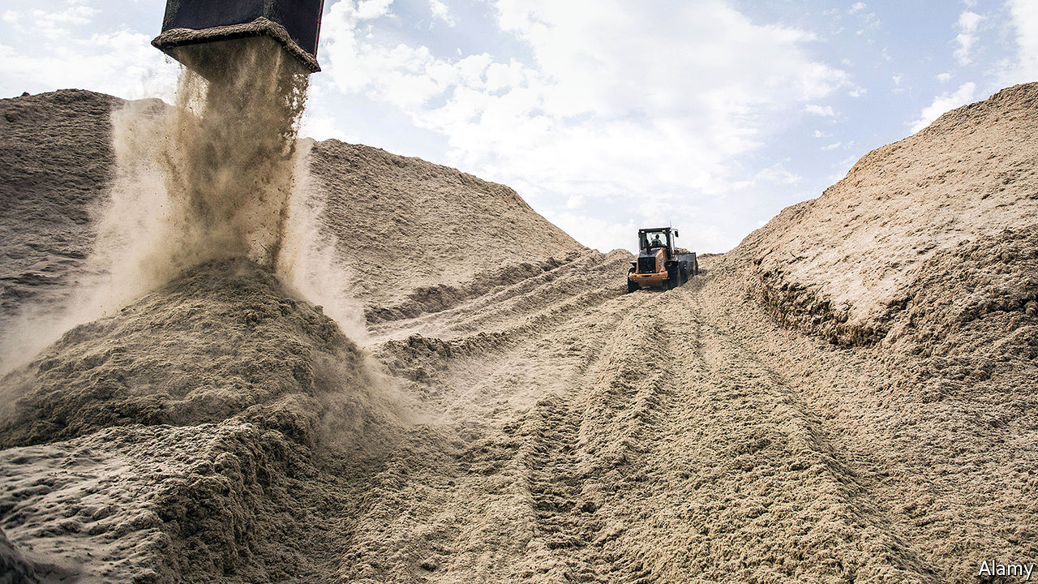

SUGAR CANE contains around 10% sugar. But that means it contains around 90% non-sugar—the material known as bagasse (pictured) which remains once the cane has been pulverised and the sugar-bearing juice squeezed out of it. World production of cane sugar was 185m tonnes in 2017. That results in a lot of bagasse.

At the moment, most of this is burned. Often, it fuels local generators that power the mills, so it is not wasted. But Zhu Hongli, a mechanical engineer at Northeastern University in Boston, thinks it can be put to better use. As she and her colleagues describe in Matter this week, with a bit of tweaking bagasse makes an excellent—and biodegradable—replacement for the plastic used for disposable food containers such as coffee cups.

Dr Zhu is not the first person to have this idea. But previous attempts tended not to survive contact with liquids. She thought she could overcome that by spiking the sugar cane pulp with another biodegradable material. She knew from previous research that the main reason past efforts fell to pieces when wet is that bagasse is composed of short fibres which are unable to overlap sufficiently to confer resilience on the finished product. She therefore sought to insert a suitably long-fibred substance.

Bamboo seemed to fit the bill. It grows quickly, degrades readily and has appropriately long fibres. And it worked. When the researchers blended a small amount of bamboo pulp into bagasse, they found that the result had a strong interweaving of short and long fibres. As a bonus, they also discovered that the hot pressing used as part of the process had mobilised some of the lignin in the fibres, and that this stiff, water-repelling material was now acting as an adhesive that bound the fibres together.

To put their new material through its paces, Dr Zhu and her colleagues first poured hot oil onto it and found that, rather than penetrating the material, as it would have with previous bagasse products, the oil was repelled by their invention. They also found that when they made a cup out of the stuff and filled it with water heated almost to boiling point, the cup remained intact for more than two hours. Though this is not as long as a plastic cup would last (it would survive indefinitely) it is long enough for all practical purposes. Moreover, the new material is twice as strong as the plastic used to make cups, and is definitely biodegradable. When Dr Zhu buried a cup made out of it in the ground, half of it rotted away within two months, and she reckons six months would have seen it gone completely.

Last, but by no means least, she estimates that cups made from the new material would cost $2,333 a tonne. That is half the $4,750 a tonne cost of biodegradable cups made from polylactic acid (fermented plant starch), and only slightly more than the $2,177 a tonne that it takes to make plastic cups. Overall, then, Dr Zhu argues that bagasse is an obvious choice for making coffee cups, straws, disposable plates, lightweight cutlery and so on. Once used, these could be dumped in landfills with a clear conscience.■

For more coverage of climate change, register for The Climate Issue, our fortnightly [newsletter](https://www.economist.com/theclimateissue/), or visit our [climate-change hub](https://www.economist.com/news/2020/04/24/the-economists-coverage-of-climate-change)

This article was downloaded by calibre from <https://www.economist.com/science-and-technology/2020/11/14/better-disposable-coffee-cups>

|  |  |  |  |
| --- | --- | --- | --- |
| Previous | Articles | Sections | Next |

|  |  |  |
| --- | --- | --- |
| Science & ... | Sections | Economic & ... |

Books & arts

Home truths: The human stain

.

Street style: Fashion statements

.

American society: All for one

.

Hollywood fiction: Ready for his close-up

.

Johnson: On natural declension

.

|  |  |  |
| --- | --- | --- |
| Science & ... | Sections | Economic & ... |

|  |  |  |  |
| --- | --- | --- | --- |
|  | Articles | Sections | Next |

#### The human stain

# The myth and reality of Britain’s role in slavery

The country is belatedly grappling with painful truths about its past

Nov 14th 2020 |



Slave Empire. By Padraic Scanlan.Robinson; 464 pages; £25.

The Interest. By Michael Taylor.Bodley Head; 400 pages; £20.

ON JUNE 7TH this year Edward Colston plunged, periwig first, into the waters of Bristol harbour. It was an incongruous scene: at least until recently, Britons immortalised in bronze were rarely toppled or drowned by mobs. Part of the shock of this image, and part of its power, was to see a figure dressed in gentleman’s breeches and a frock-coat being treated as a criminal.

The Victorians who put up this statue had burnished Colston as a philanthropist. And this was true: he had given Bristol, his home city, schools and almshouses. But he did other things too, which the statue and its plaque downplayed. During his decade on the board of the Royal African Company in the late 17th century, it trafficked 84,000 slaves from Africa to the Americas. An estimated 19,000 died en route.

If statues can be misleading, so can perceptions of entire historical periods. The Victorians dressed Colston in an air of unimpeachable respectability; similarly, modern Britain has cloaked the country’s role in the slave trade in a haze of selective memory. It has long celebrated William Wilberforce and his “Saints”, the group who fought to abolish slavery. David Cameron, a former prime minister, once said that one of Britain’s “proud achievements” was its “role in ending slavery”.

Like some others, the country is rather less keen to remember its sinners. Two timely books, by the historians Padraic Scanlan and Michael Taylor, set out to weave a more accurate, less flattering version of this story. Take the idea that Britain worked to reduce slavery from 1807, when the act that abolished the slave trade in the British Empire was passed. That is true. It is equally true that until that date Britain did much to make it thrive. Of the more than 6m enslaved Africans transported across the Atlantic, it is thought that 2.5m were packed into British ships.

Or take the widespread but mistaken notion that the act of 1807 outlawed the institution of slavery itself. It did not: it stopped British slaving. In the flesh—and this was an argument of flesh—the difference was infinitely bigger than it seems on the page. Chains that bound people before the vote held firm after it. The 700,000 souls who had been enslaved in the West Indies remained enslaved, and tormented, for decades.

Traditional accounts of Britain’s role in slavery culminate with Wilberforce and that act. These two are just getting going. Mr Taylor’s book, “The Interest”, switches the focus from the saints to the sinners. His title derives from the West India Interest, a lobbying group of planters and politicians, publishers and intellectuals, which doggedly opposed abolition. Support for slavery pervaded British society. Viscount Nelson declared himself a “firm friend” to the colonies. The Duke of Wellington toiled to frustrate abolitionists. The celebrated cartoonist George Cruikshank caricatured them. John Murray, a publishing house known today for introducing Jane Austen to the world, was so famous for pro-slavery arguments that its Quarterly Review was described as “one of the most effective and mischievous props” of the system.

## Out of sight

Mr Scanlan’s book, “Slave Empire”, concentrates on the financial benefits that slavers reaped. This harvest by no means ended with abolition. The £20m in compensation that was eventually paid by the British government to slavers for the loss of their human property was a vast sum, equating to 40% of the state’s annual expenditure at the time. Until the banking bail-out of 2008, it was the largest specific payout in British history; the loan it required was paid off only in 2015. The money provided the seed capital for mines, banks, railways and more. Britain’s liberal, free-trade empire was, in part, built on human bondage.

Slavers gained not just gold but a fine gilding from their trade. Many were men of status and consequence. Joshua Reynolds painted them; Eton educated them; society opened its doors for them. Until this year, Colston had not only his statue but a fleet of institutions named after him. Even today scholars at Oxford study in the Codrington Library in All Souls College, endowed by the Codrington family who owned plantations in Barbados. The great-grandfathers of George Orwell and Graham Greene were slaveholders. After emancipation, Orwell’s received £4,000 in compensation for the 218 slaves he had owned, which Mr Taylor describes as “a perversion of justice that would have fitted seamlessly into the Orwellian canon”.

“Slave Empire” is lucid, elegant and forensic. It deals with appalling horrors in cool and convincing prose. “The Interest” is more impassioned. Mr Taylor can tell a story superbly and has a fine eye for detail (George IV, readers learn, breakfasted on pigeon and beef-steak pie, washed down with champagne, port, wine and brandy). His argument is a potent and necessary corrective to a cosy national myth. But his writing can be a distraction, peppered as it is with phrases such as “bogus nonsense” and “twisted logic”. Such caustic judgments may be correct but they are superfluous. An argument of this gravity does not require such flourishes.

It never did. One of the most striking things about Britain’s debates over slavery is how unemotional many of the most influential texts were. Take the basic question of how slaves in the West Indies were treated. As in the United States, British abolitionists and slavers had for years quarrelled bitterly over this, the latter painting an image of paradise, the former of hell. There was stalemate.

Then, in 1789, the Board of Trade published a damning report on slavery, filled with statistics and testimony of the tortures inflicted on slaves. “It is no uncommon thing”, the document recorded, “for a Negro to lie by a Week after Punishment.” More damning still was the mass of data published in the Anti-Slavery Monthly Reporter, which sold 1.7m copies in six years. You can read its findings now, online.

Even at a distance of almost two centuries, they make appalling reading: “39 lashes”; “three or four hundred lashes”; “on her bared body fifty-eight lashes of the cart whip”. On and on go the accounts, unemotional, unsparing, utterly unpardonable—50 lashes, 49 more. This was not rhetoric. It was cruelty, quantified. And little was more persuasive. ■

This article was downloaded by calibre from <https://www.economist.com/books-and-arts/2020/11/14/the-myth-and-reality-of-britains-role-in-slavery>

|  |  |  |  |
| --- | --- | --- | --- |
|  | Articles | Sections | Next |

|  |  |  |  |
| --- | --- | --- | --- |
| Previous | Articles | Sections | Next |

#### Fashion statements

# On the catwalk in San Francisco’s Chinatown

For its elderly denizens, style is a matter of survival

Nov 14th 2020 |



Chinatown Pretty. By Andria Lo and Valerie Luu.Chronicle Books; 224 pages; $24.95 and £18.99.

LEN WUEY CHEW’S look involves a layered mash-up of florals and plaids of a kind you might spot on a couturier’s catwalk. Her runway is a steep hill in San Francisco’s Chinatown, which she negotiates with a pink-and-blue cane. Her husband, Buck, favours white gloves and loud ties festooned with parrots or butterflies. In their winningly garish outfits, the nonagenarian couple embody a thrifty yet exuberant way of life.

On every bench in Portsmouth Square, Chinatown’s outdoor living room, elderly people in bright plumage chat, play cards and practise tai chi. Fuchsia scarves top crocheted vests; paisley sweaters wrap formal striped shirts. Jade accessories glint. Impishly stylish, this venerable crowd is “Chinatown Pretty”, in the words of a new book devoted to their sartorial flair.

Valerie Luu, a writer, and Andrio Lo, a photographer, spotted their first “poh poh hou leng”—“pretty grandma” in Cantonese—six years ago. A blog and a photography show in a Chinatown alley followed. Their book collects portraits from six North American Chinatowns, including Chicago, New York, Los Angeles, Oakland and Vancouver. But their heart remains in San Francisco, home of America’s oldest, densest Chinatown.

Five thousand souls, a big chunk of them elderly, are crammed into 30 city blocks. Many emigrated from China long ago, have endured war, revolution and exile and now subsist on fixed incomes in single rooms. Around a third live in poverty. Yet their neighbourhood bursts with colour. Look past the tourists and pagodas, and Chinatown resembles a bustling, open-air senior centre, the denizens of which pay close attention to their clothes. “Going out is dressing up,” Feng Luen Feng, 77, tells the authors.

The eclectic outfits are pragmatic. In the city’s foggy, unpredictable climate, it pays to wear several layers—sometimes up to seven or eight, plus a hat or two. Beyond the insulation, though, the fashions speak volumes about the community’s resourcefulness and joie de vivre. In his bright red suit, for instance, You Tian Wu has been a Chinatown fixture, sometimes seen wearing two bow ties above a Windsor knot. Dressing to the nines on a tight budget is a matter of pride. “When you’re young you don’t have to care about fashion,” says Mr Wu, 82. “But when you’re old, you have to.”

Each garment tells a story. Some were stitched in Hong Kong decades ago; others have been sewn or patched at home, or were handed up or down. One lady sports a hot pink backpack over a tailored blue skirt-suit. Another’s socks bear the slogan “My favourite salad is wine”. The styles may not be to everyone’s taste. But as surrounding neighbourhoods become ever more costly and gentrified, this frugality and grit are both a sign and a means of survival.

This article was downloaded by calibre from <https://www.economist.com/books-and-arts/2020/11/14/on-the-catwalk-in-san-franciscos-chinatown>

|  |  |  |  |
| --- | --- | --- | --- |
| Previous | Articles | Sections | Next |

|  |  |  |  |
| --- | --- | --- | --- |
| Previous | Articles | Sections | Next |

#### All for one

# Robert Putnam and Michael Sandel diagnose America

It has become more egotistical, both scholars conclude. But is there a way back?

Nov 14th 2020 |



The Upswing. By Robert Putnam and Shaylyn Romney Garrett. Simon & Schuster; 480 pages; $32.50. Swift Press; £25.

The Tyranny of Merit. By Michael Sandel.Farrar, Straus and Giroux; 288 pages; $28. Allen Lane; £20.

THE RANCOUR of American politics, say these two distinguished scholars, is a symptom of an even deeper malaise. Robert Putnam charts a rise in economic inequalities, cultural tribalism and frayed social connections since the 1960s—when, he recalls, the spirit of solidarity and reform was by contrast strong. Michael Sandel focuses on the meritocratic rat-race and its justifications, which create, in his words, “hubris among the successful and resentment among the disadvantaged”.

Both blame the ills they identify on widespread acceptance of egotistical go-getting at a cost to common purpose. Their bleak picture of private indifference to public welfare prompts an equally sweeping solution. America needs nothing less, they think, than a recovery of community and rededication to the common good.

Mr Putnam, a political scientist, is well-known for “Bowling Alone” (2000), which reported a drop of clubbability in a nation of joiners. Written with Shaylyn Romney Garrett, “The Upswing” is a reprise that answers critics and laments a yet broader retreat to private concerns. It offers a historical account of trends in public commitment over 120 years.

The narrative arc is simple. A dog-eat-dog Gilded Age at the end of the 19th century prompted ever greater social engagement and reform in three stages—Progressivism, the New Deal and the 1960s. Soon, however, dog-eat-dogism returned and is now again uppermost. To support that analysis, a mass of survey data and statistics is mapped onto what Mr Putnam calls “I-we-I” curves, which show a rise and fall in economic equality, political co-operation, social solidarity and a sense of shared American culture.

“The Upswing” ranges widely, yet its scrupulous survey-mining and curve-fitting is not wholly persuasive, or indeed necessary. Up on the latest research and impeccably open to counterargument, Mr Putnam tends to take away with one study what he has just offered with another. A heartfelt communitarian essay, “What ails America”, without the social-science apparatus, might have been just as convincing.

Mr Sandel’s focus is tighter. His target is meritocratic society and the ideal it aims to realise, equality of opportunity. For true egalitarians, who want fairer outcomes, a uniform starting line has always seemed a fudge. To some rugged conservatives, promising equal opportunity is necessary lip-service to unmeetable popular demands. Mr Sandel, a political philosopher, ends up on the fence. He is not an out-and-out egalitarian, but nor does he dismiss hopes for some degree of genuine civic equality.

He recognises that gauges of performance and success often measure the wrong things—or measure the right things badly. His critique of over-reliance on paper credentials in hiring and university placements is telling. (Similar flaws of ranking mania in medicine, policing, schooling and the armed forces were expertly exposed in Jerry Muller’s “The Tyranny of Metrics”.) Mr Sandel’s larger concern, however, is not whether achievement is properly calibrated but whether its rewards are rightly merited. As he says, that ethical question runs back to theological disputes about the arbitrariness or earnability of God’s grace. These days, free-marketeers and redistributionists tussle over whether and how to offset the lottery of talent and energy that underlies supposedly merited rewards.

Like Mr Putnam’s, the solutions Mr Sandel suggests call for profound changes in prevailing attitudes: acknowledgment of luck in the share-out of rewards, recognition that all work has dignity, new commitment to the public good, and readiness to argue such matters out in a healthier, more deliberative democracy. A sceptic may share the pair’s concerns about American society yet wonder if, in such a vigorously competitive, capitalist place, those profound changes in thinking are probable. And whether, given how long the arguments over unmerited disadvantage have lasted, they are likely to end soon. ■

This article was downloaded by calibre from <https://www.economist.com/books-and-arts/2020/11/14/robert-putnam-and-michael-sandel-diagnose-america>

|  |  |  |  |
| --- | --- | --- | --- |
| Previous | Articles | Sections | Next |

|  |  |  |  |
| --- | --- | --- | --- |
| Previous | Articles | Sections | Next |

#### Film and fiction

# Billy Wilder is ready for his close-up

Jonathan Coe’s novel reimagines the life and work of a legendary director

Nov 11th 2020 |



Mr Wilder and Me. By Jonathan Coe.Viking; 256 pages; £16.99.

IN THE SUMMER of 1977 an international film crew descended on the sleepy Greek island of Lefkada, temporarily casting it into chaos. Billy Wilder (pictured), the legendary director of “Sunset Boulevard” and “Some Like It Hot”, had chosen it as the location for key scenes in what would be his penultimate movie, “Fedora”. In Jonathan Coe’s mischievous and inventive re-enactment, this film about a reclusive, fading star is, at heart, as much about the end of Hollywood’s Golden Age as the ephemeral nature of youth and fame.

Mr Coe’s novels typically fuse politics, satire and the passage of time. This one draws heavily on factual accounts of Wilder and his associates but places a fictitious outsider at the heart of the story. Calista is an aspiring young composer brought up by her bohemian parents in a shabby flat in Athens. She first encounters Wilder while travelling around America in 1976; later he hires her to act as an interpreter and secretary for “Fedora”.

She and the production move from Greece to the final shoot in West Germany. A lack of American backing had meant Wilder, an Austrian-born Jew, was obliged to turn to German investors. In a dramatic and ingenious scene, Mr Coe grafts the transcript of an actual interview with the director onto a swanky dinner in a Munich hotel. Wilder’s reflections in the interview on the fate of his relatives under Nazism become a biting rebuttal of a Holocaust-denying guest.

Calista narrates the novel, largely in flashback from the present day. Now a married woman with twin daughters, she gives a retrospective view of her own life as well as insights into the enigmatic Wilder, who rails against the “kids with beards” (a new generation of film-makers such as Martin Scorsese and Steven Spielberg). Thus “Mr Wilder and Me” is also a coming-of-age story, in which the first sip of a martini is, for the unworldly Calista, “like a gentle slap in the face to bring you round after a faint”. To appear knowledgeable on set, she memorises and quotes every entry in “Halliwell’s Film Guide”, accidentally finding her vocation as a composer of scores.

Mr Coe has drawn on real-life memories of the production, including those of Wilder’s actual personal assistant, to create the composite figure of Calista. “Fedora” flopped on its release in 1978; the New York Times thought it had “the resonance of an epitaph”. It is now widely recognised as an artistic masterpiece about the illusion of cinema itself. In his finely tuned novel Mr Coe has done it, and its director, justice. ■

This article was downloaded by calibre from <https://www.economist.com/books-and-arts/2020/11/11/billy-wilder-is-ready-for-his-close-up>

|  |  |  |  |
| --- | --- | --- | --- |
| Previous | Articles | Sections | Next |

|  |  |  |  |
| --- | --- | --- | --- |
| Previous | Articles | Sections | Next |

#### Johnson

# Like biological species, languages evolve

There are parallels between the two processes—as Charles Darwin saw

Nov 14th 2020 |

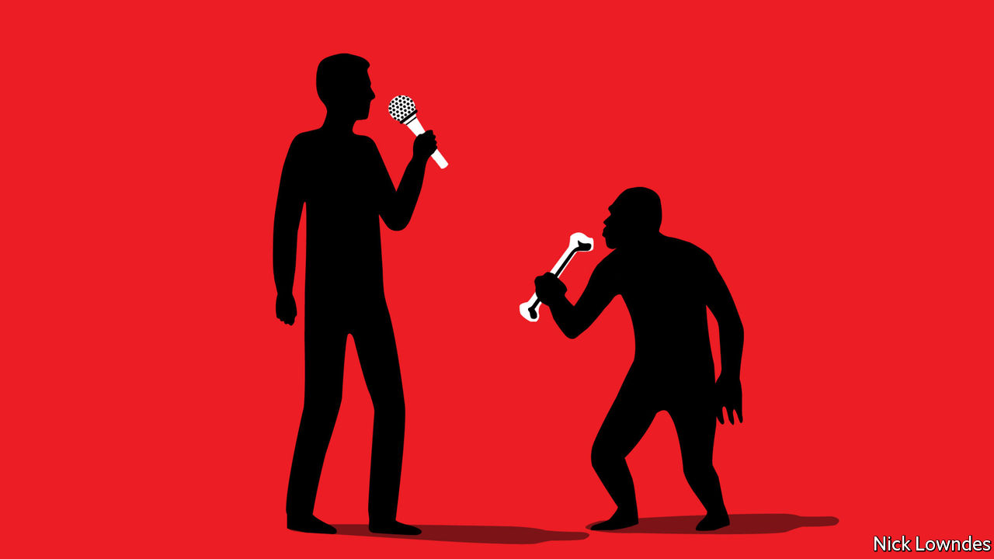

“BECAUSE POLITICS.” “Latinx.” “Doomscrolling.” Language is developing all the time, as new usages like these arise and old ones disappear. One common way to describe this process is to say that “language evolves”. It is an apt formulation, for there is a deep and revealing relationship between linguistic change and biological evolution—along with some big differences.

Linguists today aim to apply methods from other sciences to messy social phenomena. But the influence once ran the other way, with discoveries in linguistic history leaving a mark on evolutionary theory. In the late 18th century William Jones, a British judge in Calcutta, concluded that Sanskrit’s similarity to Latin and Greek was too great to attribute to mere chance. He proposed a parent language, the descendants of which included Sanskrit, Greek, Latin, Persian and other European tongues. Like Columbus, he was not the first to get there, but he made the revelation famous.

As Jones’s findings were elaborated by the philologists who came after him, they also came to the attention of a young Charles Darwin. As early as 1837, looking at the evidence that wildly different languages had once diverged from a single parent, he wrote to his sister that mankind must have been around much longer than the Bible allowed. In 1871 he made the parallel between language divergence and evolution more specific, writing in “The Descent of Man” that “the formation of different languages and of distinct species, and the proofs that both have been developed through a gradual process, are curiously the same.” One language giving birth to both Hindi and English was not so extraordinary if you gave tiny changes time to accrete.

Speciation—the emergence of distinct species—offers one of the closest parallels between linguistic and biological evolution. Darwin found that finches separated on different Galapagos islands had developed into different species, and worked out why. When a homogenous population is split, each subset will be affected by its own genetic changes. Those that contribute, even a little bit, to survival will tend to become more prevalent through the process of natural selection. When such changes accumulate, you no longer have two populations of a single species, but two different species.

Two linguistic populations separated by enough distance, or by a physical barrier such as a mountain range, can undergo a similar experience. Random alterations—to pronunciation, the meaning of words or grammar—are often so small that no one notices them as they are happening. Over the course of many generations, for instance, a t sound might become an s. Or take the terms in the opening lines of this column: using “because” as a preposition, shedding grammatical gender (as “Latinx” purports to do) or forging new words from old pieces (as in “doomscrolling”) may all baffle the uninitiated. As tweaks of these and other kinds mount up in one group, its speakers gradually lose the ability to converse with another—as two speciating populations begin to lose the ability to mate.

Mark Pagel of Reading University has made a list of other compelling parallels between the two processes. Like genes, he notes, words are “discrete, heritable units”. The replication of DNA is akin to language teaching. Physical fossils resemble ancient texts. And so on. But there are contrasts, too, perhaps the biggest being that the chief driver of biological evolution—natural selection—is mostly absent in language.

Nature is red in tooth and claw: a maladaptive mutation can get you killed. Language doesn’t quite work that way. For the most part, changes don’t take hold because they help you avoid a predator, but because they help people communicate. For that, they have to be adopted by others at the same time—which may happen for reasons that have little to do with “fitness”. A celebrity’s coinages will take off quicker than those of a brilliant basement neologist not because they are superior, but because the star has more Twitter followers.

There is, though, a final, important overlap between the two kinds of evolution. In a common visual depiction of the ascent of man, an ape gradually becomes a human through a series of intermediate steps. That gives the impression that evolution is a process of ever increasing sophistication. Not always: rather, organisms, like languages, change to fit their environments. They may not always become more refined. But neither—despite the incessant chorus of grumbles—are they in decline.

This article was downloaded by calibre from <https://www.economist.com/books-and-arts/2020/11/14/like-biological-species-languages-evolve>

|  |  |  |  |
| --- | --- | --- | --- |
| Previous | Articles | Sections | Next |

|  |  |  |
| --- | --- | --- |
| Books & arts | Sections | Graphic detail |

Economic & financial indicators

Economic data, markets and commodities

.

|  |  |  |
| --- | --- | --- |
| Books & arts | Sections | Graphic detail |

|  |  |  |  |
| --- | --- | --- | --- |
|  | Articles | Sections | Next |

# Economic data, markets and commodities

Nov 14th 2020 |

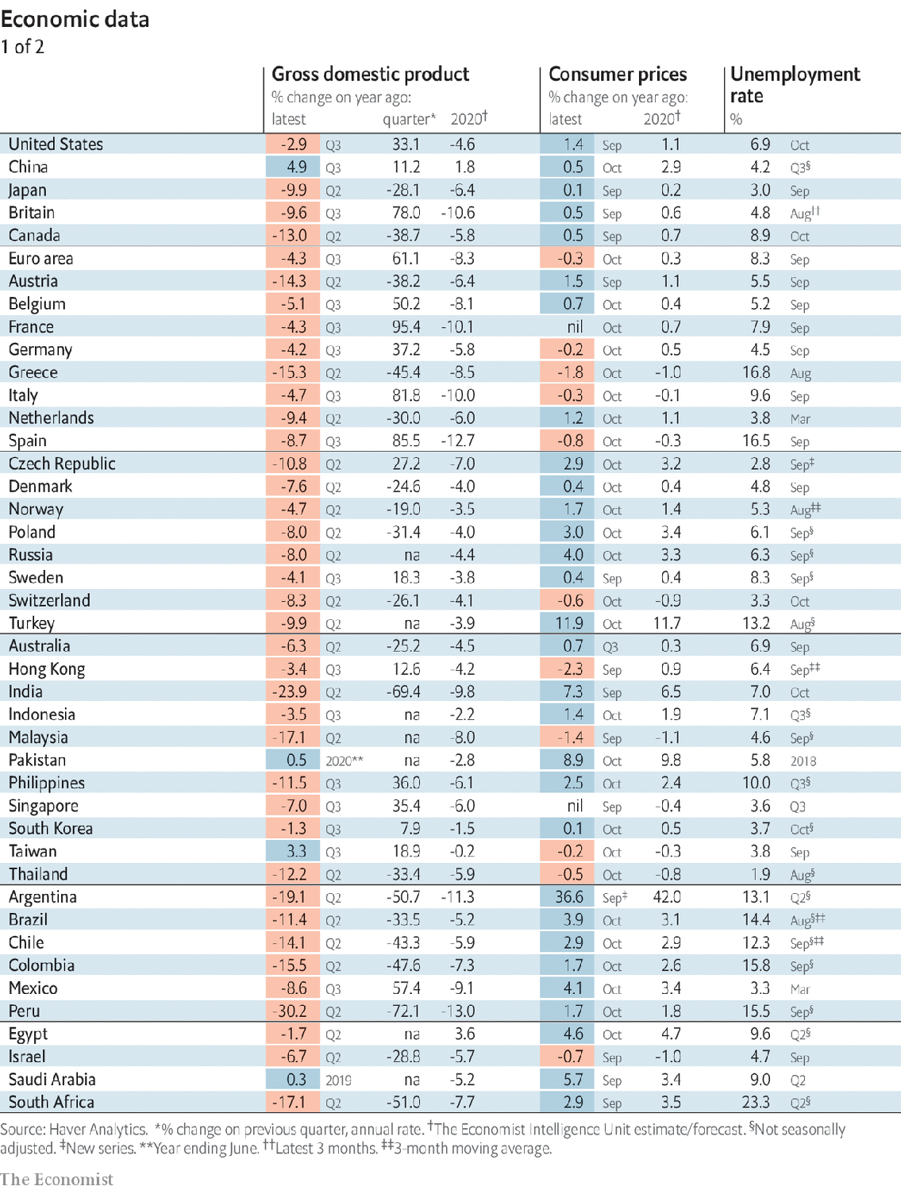

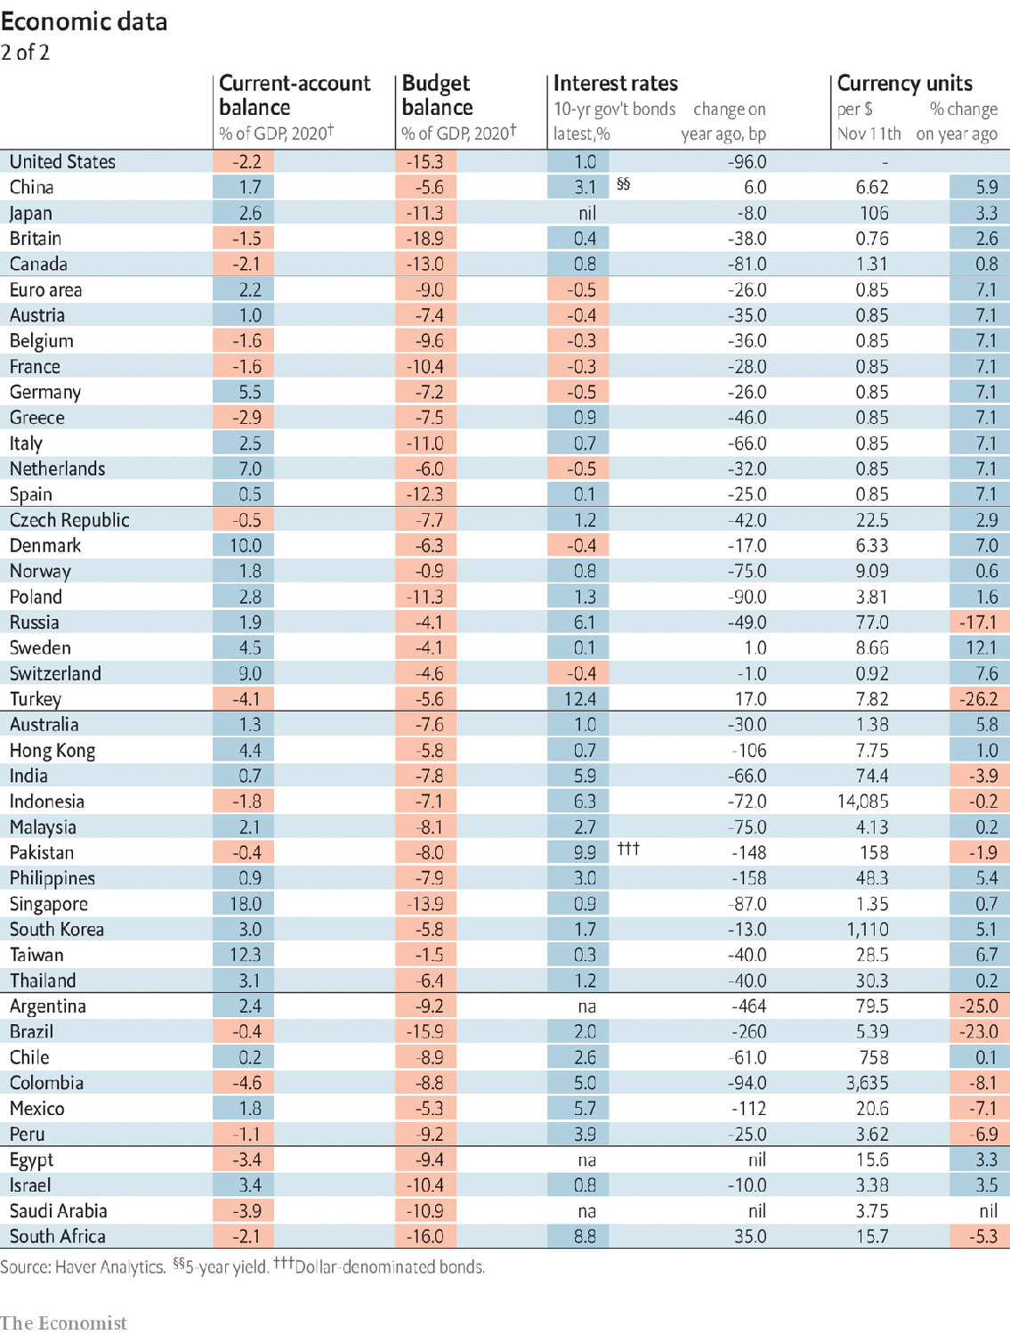

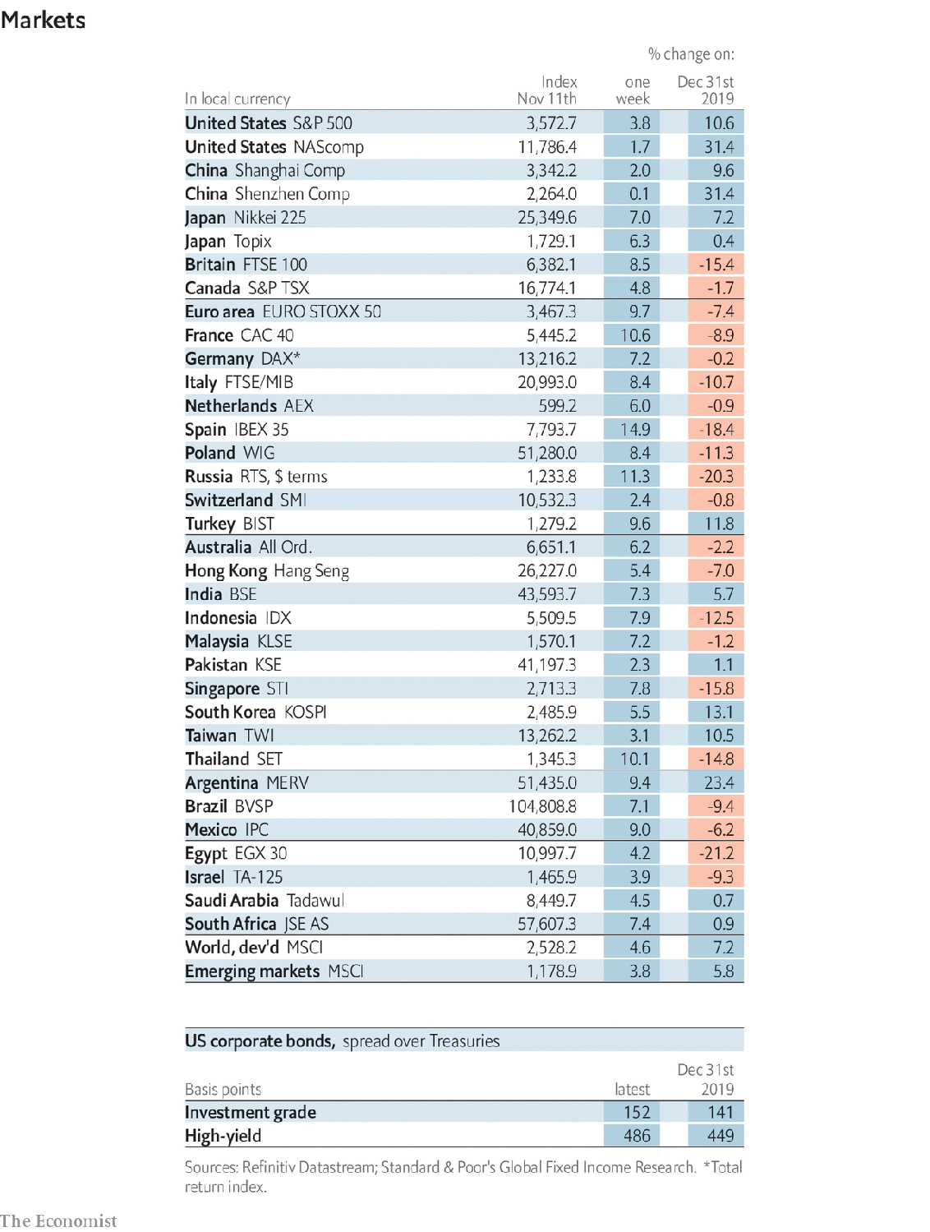

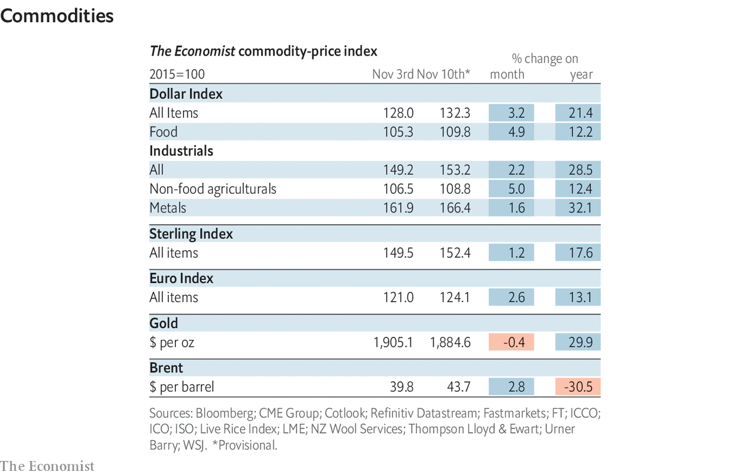

This article was downloaded by calibre from <https://www.economist.com/economic-and-financial-indicators/2020/11/14/economic-data-markets-and-commodities>

|  |  |  |  |
| --- | --- | --- | --- |
|  | Articles | Sections | Next |

|  |  |  |
| --- | --- | --- |
| Economic & ... | Sections | Obituary |

Graphic detail

Polling in America: Déjà vu all over again

.

|  |  |  |
| --- | --- | --- |
| Economic & ... | Sections | Obituary |

|  |  |  |  |
| --- | --- | --- | --- |
|  | Articles | Sections | Next |

#### Déjà vu all over again

# Once again, less-educated whites spurned America’s Democratic nominee

Polls incorrectly predicted that Joe Biden would claw back some of his party’s losses with this group

Nov 11th 2020 |

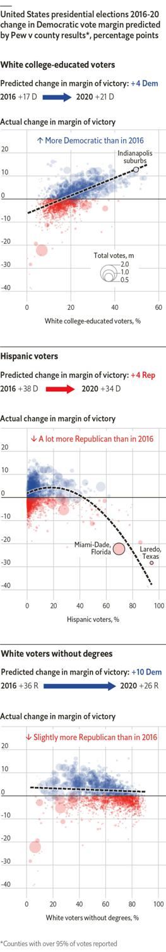

FOR THE second presidential election in a row, polls underestimated support for Donald Trump and the Republicans. In states that have mostly finished counting votes, the error of an average of presidential polls released during the final two weeks of the campaign was 5.5 percentage points, nearly double the average miss of 3.1 percentage points registered in 2000-16. Moreover, whereas both major candidates in 2016 benefited from state-level errors—Hillary Clinton won California by seven points more than pollsters expected—this year, virtually all of the misfires were underestimating support for Mr Trump.

What went wrong? Exit polls do not provide a trustworthy answer: their estimates of vote margins within each demographic category, as well as the share of the electorate each group represents, are often biased and differ vastly from other sources. The final analysis will have to wait until all ballots are counted and rigorous post-election studies can be conducted. However, statisticians can unearth promising clues by exploring the relationships between official vote totals in counties where tabulation is nearly complete and those areas’ demographic makeup. These data show that Mr Biden failed to realise one of his central electoral promises: clawing back some of Democrats’ recent losses among white voters without college degrees.

Among the most reliable analyses of the election of 2016 is a study published by the Pew Research Centre, a polling and research organisation, which surveyed 3,000 voters confirmed to have cast ballots that year. Pew also published a nationwide poll this October, making possible direct comparisons of how voting intentions had changed within each demographic group.

Pew found that Mr Trump had made inroads with black and Hispanic voters, trimming his deficits with these groups by four percentage points, while suffering an offsetting four-point decline among college-educated whites. However, most of Mr Biden’s predicted gains relative to Mrs Clinton came from whites without degrees: he was expected to reduce Mr Trump’s margin with such voters by ten percentage points.

The county-level data affirm some of these findings. Places with lots of college-educated whites, particularly in suburbs, did indeed swing towards Mr Biden this year—a trend that will probably make him the first Democrat to win Georgia or Arizona since Bill Clinton. Similarly, Mr Trump fared far better in majority-Hispanic counties than he did in 2016, padding his advantages over Mr Biden in Florida and Texas.

However, there was scant evidence that white voters without degrees preferred Mr Biden to Mrs Clinton. Mr Trump’s margins of victory in white working-class counties this year were just as large on average, and in some places even bigger, than in 2016. As a result, Mr Biden had to rely mostly on his strength in affluent suburbs to rebuild Democrats’ “blue wall” of Wisconsin, Michigan and Pennsylvania. He won these states by far smaller margins than pollsters expected, and just barely squeaked by in Wisconsin, the decisive state in the electoral college in both 2016 and 2020.

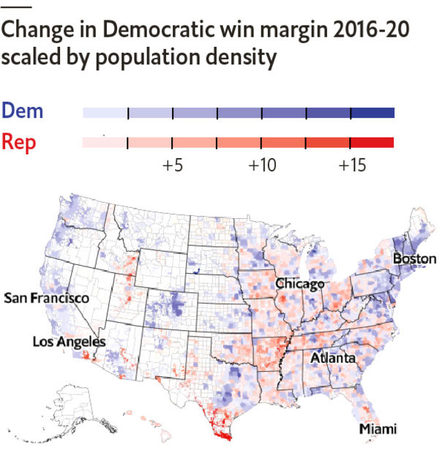

So far, most attention has focused on Mr Trump’s gains among Hispanics, which appear to have been even greater than polls foresaw. However, the durability of his edge among less-educated whites, a much larger group than Hispanics, is far more electorally consequential. No one knows how much of this affinity is specific to Mr Trump, and how much will carry over to other Republican candidates. The party’s electoral future depends largely on its ability to keep these supporters, while making itself more palatable to the college-educated white voters who have abandoned it. ■

Sources: US Census Bureau; Decision Desk HQ; Pew Research Centre; The Economist

Dig deeper:  
For the latest on the election, see our [results page](https://www.economist.com/graphic-detail/2020/11/03/the-us-2020-election-results), read the [best of our 2020 campaign coverage](https://www.economist.com/us-election-2020) and then sign up for Checks and Balance, our [weekly newsletter](https://www.economist.com/checksandbalance/) and [podcast](https://www.economist.com/checks-and-balance-our-weekly-podcast-on-american-politics) on American politics.

This article was downloaded by calibre from <https://www.economist.com/graphic-detail/2020/11/11/once-again-less-educated-whites-spurned-americas-democratic-nominee>

|  |  |  |  |
| --- | --- | --- | --- |
|  | Articles | Sections | Next |

|  |  |  |
| --- | --- | --- |
| Graphic detail | Sections |  |

Obituary

James Randi: The woo-woo catcher

.

|  |  |  |
| --- | --- | --- |
| Graphic detail | Sections |  |

|  |  |  |  |
| --- | --- | --- | --- |
|  | Articles | Sections | Next |

#### The woo-woo catcher

# James Randi died on October 20th

The magician, who had a second career as a professional debunker of flim-flam and trickery, was 92

Nov 14th 2020 |

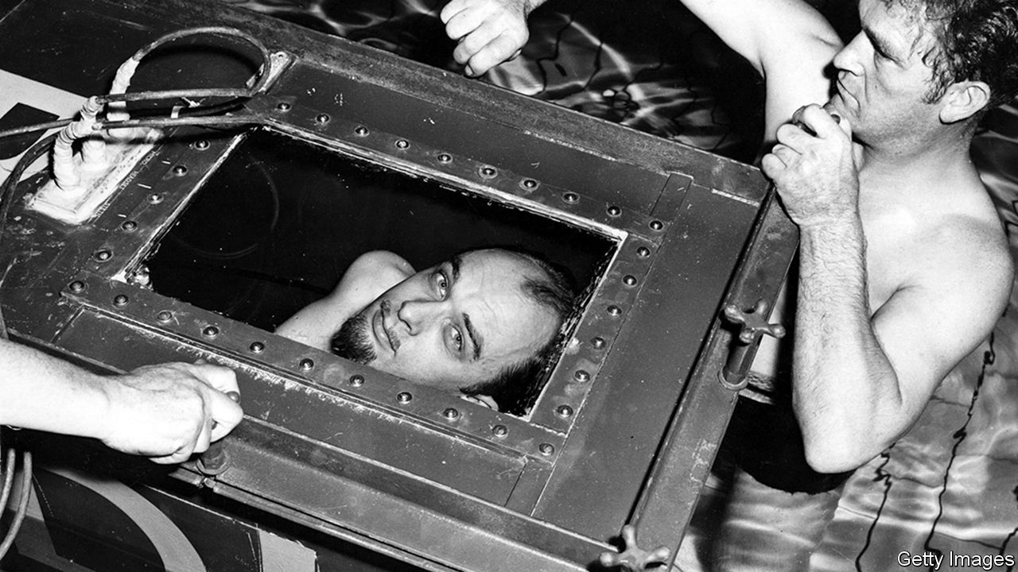

AS A BOY he invented a pop-up toaster. He blew a hole in the floor of the breakfast room while conducting a chemistry experiment in the family basement in northern Toronto. And when, at Sunday school, he queried whether what the Bible claimed was actually true, he was promptly sent home. His parents never knew what he might do next. When they took him to Toronto General Hospital for psychological testing, all they learned was that he was terrifically bright—his IQ was 168, higher than Albert Einstein’s is thought to have been. At least his high school had the right idea. They let him bunk off class and teach himself, coming in only to do his exams.

Before he was able to graduate, though, he was hit by a car while out riding his bike. For 13 months he lay in a full-body cast, beating boredom by reading magic books, unpicking locks and turning card tricks. His doctors thought he would never walk again, but he showed them. And when he did he joined the carnival, where for two summers he called himself Prince Ibis and wore a black turban. He was a small chap, secretly gay and distant from his father. Doing magic made him feel bigger, especially when two policemen who recognised him showed him a pair of handcuffs. Could he get out of them? He could. They drove him to the local jail. Could he break out of there? He could—and did, 28 times over the years from different jails in Canada and America.

His ambition was to beat his hero, Harry Houdini. In 1956 he appeared on television, submerged for 104 minutes in a sealed metal box at the bottom of a hotel swimming pool, which earned him his first entry in the “Guinness Book of Records”. Houdini barely managed an hour and a half. A local newspaper in Quebec christened him “L’Étonnant Randi”—the Amazing Randi. He liked it enough to adopt it as his stage name. In 1973 he went on tour with Alice Cooper, the ghoul-eyed rock star; every night he decapitated him onstage using a fake guillotine. Later he wriggled out of a straitjacket while suspended, in deep midwinter, over the Niagara Falls.

For all the trickery and sleight of hand, he always insisted that magicians were the most honest people in the world. They did exactly what they said they were going to do. It was the hucksters that made him mad: the hoodwinkers and bamboozlers, the card sharps, cozeners and thimbleriggers. Pedlars of woo-woo, he called them. Perhaps he felt a growing need to live by the truth. He was 81 when he finally came out publicly, but when he was almost 60 he fell in love with the man he would eventually marry and he gave up turning tricks of his own to focus on another line of work he’d been developing: looking, with his insider’s eye, at how other people worked their magic.

He could see through them, of course. He knew how. One of the first he had rumbled was an evangelical Christian healer called Peter Popoff who liked to summon forth individuals from his congregation, and tell them they should throw away their crutches and walk. God had told him they would be healed. On “The Tonight Show”, Mr Randi played Johnny Carson a clip in which Mr Popoff appeared to know what each congregant was called and what ailed them even though he’d never seen them before. And then he played the clip again, with the sound turned up, to show how an electrical scanner revealed Mr Popoff was wearing a secret earpiece and being fed the information by his wife who was backstage. “Popoff says God tells him these things,” he would later say. “Maybe he does. But I didn’t realise God used a frequency of 39.17 megahertz and had a voice exactly like Elizabeth Popoff’s.”

Time did not mellow him, as it does others. His ten books—on psychics, faith healers, extrasensory perception and the mask of Nostradamus—were rambling, crotchety and filled with diagrams and long-winded explanations. He did not set out to be a debunker; that presupposed that something deserved to be debunked even before it had been examined. He thought only that people should be open-minded and willing to question what they saw before them. What he wanted most was to inspect and test every claim that was presented to him. Over the years these numbered into the thousands. He offered a $1m reward to anyone who could produce evidence of paranormal powers under controlled conditions. Many tried, but none of them succeeded. He never paid out a cent. Nor did he lose a single libel action brought against him by the angry and the thwarted.

His most devoted adversary was a tall handsome Israeli, who arrived in America in the early 1970s, claiming to be able to bend spoons using psychokinesis, or mind power. With consummate showmanship, Uri Geller travelled across the United States, insisting that he could read minds, foretell events and, with nothing more than psychic energy, distort magnetic fields, streams of electrons and solid metallic objects. Even the venerable Stanford Research Institute was taken in. Shortly afterwards, Johnny Carson again asked Mr Randi for advice on how to test Mr Geller’s claims. Use only your own props, he said; nothing that Mr Geller could have had access to beforehand. As the cameras rolled and Mr Geller realised he was going to be put on the spot, any paranormal abilities he may have had simply vanished. “This scares me,” he said. “I don’t feel strong.”

## The uses of enchantment

“The Truth about Uri Geller” was one of Mr Randi’s most popular books. Mr Geller never forgave his tormentor. At his death, he tweeted: “How sad that Randi died with hatred in his soul. Love to you all.” Such pious glee would have delighted the little magician with the twinkling eyes. As he had said himself many times over the years: “When I die I want to be cremated and I want my ashes blown into Uri Geller’s eyes.”■

This article was downloaded by calibre from <https://www.economist.com/obituary/2020/11/14/james-randi-died-on-october-20th>

|  |  |  |  |
| --- | --- | --- | --- |
|  | Articles | Sections | Next |